GCP ACCURACY REQUIREMENTS FOR QUICKBIRD ORTHORECTIFICATION

D. Jakubowicz∗, P. Jaszczak, W. Wolniewicz PhD

Institute of Photogrammetry and Cartography, Faculty of Geodesy and Cartography,
Warsaw University of Technology, Pl. Politechniki 1, 00-661 Warsaw, Poland,
djak@pf.pl, p.jaszczak@interia.pl, w.wolniewicz@gik.pw.edu.pl

KEY WORDS: Satellite Photogrammetry, QuickBird, Orthorectification, GCP, Accuracy

ABSTARACT:

Satellite images of earth acquired by modern high-resolution sensors like QuickBird or IKONOS have to be geometrically corrected before using them for measurement or data extracting purposes. Omitting this process can cause huge errors in location, shapes and sizes of extracted features. Orthorectification of raw raster data have to be done, next. This process is based on four basic components: image, correction model, GCPs and DEM. GCPs collection method (and accuracy) has very strong influence on results of the orthorectification process. The aim of this research was to evaluate influence of accuracy, distribution and types of GCPs on the orthorectification process. Different types of GCPs with various accuracy, location and types have been applied for image geometric correction in this investigation. Sources, such as topographic maps and GPS techniques were used. Planimetric accuracies of GCPs varied from 0,1 to 5m. Orthorectification has been realized with the aid of commercially available software PCI Geomatica 9, taking into consideration the rigorous model developed at Canada Center for Remote Sensing. This paper can help in choosing correct type, distribution and method of GCPs collection for orthorectification process.

1. INTRODUCTION

Commercial very high-resolution (VHR) satellite imaging has transformed traditional Photogrammetry. Owing to the falling prices, such images are available now for new users and can be fully comparable to middle scale aerial photographs. In fact, in some aspects they are even better than traditional aerial photographs. VHR image radiometric resolution, scene size and satellites disposability cannot be overrated.
This satellite photogrammetric material can be used in many everyday applications. The variety of needs and tasks that VHR are considered to be used for is still rising. The images can become a very good source of actual information about topography. They are seen as possible source for high quality orthophotomaps and digital vector database updating.
In Poland there is a strong interest in very high resolution images because of an urgent need for actual spatial data covering territory of the country. This requirement has resulted in initiating a scientific research project ordered by State Committee for Scientific Research to check possibilities of orthorectification and usage of VHR images for LPIS and digital topographic database. This project is being implemented at the Institute of Photogrammetry and Cartography of the Warsaw University of Technology.
At present there are several commercially available VHR satellite systems. Because of similar parameters of VHR images, differences between them seem insignificant. Each of them can turn out to be best for different purposes and areas. QuickBird images have one advantage, i.e. the smallest pixel size. This parameter allows to distinguish smaller details with better quality. However, the of an image in any application requires its prior processing. Generally, “processing” in this context refers to ortho-adjustment.
The orthorectification process requires several processing components to be performed phases. Image distributor and software creators provide the satellite scene and correction model. Digital elevation model and ground control points are the two other components. It is well known that new SRTM digital elevation model is fully suitable for orthorectification of VHR images. An even more accurate DEM (DTED Level 2) that can be used where very precise orthophotomap is required is available in Poland. Thus, ground control points (GCP) grid becomes the component that limits accuracy. The goal of this investigation is to evaluate impact of accuracy, distribution and types of GCPs on orthorectification process for a selected tested area. A grid of GCPs was used in this experiment for ortho-adjustment to nominate role and requirements for photopoints in the ortho-adjustment process.

2. EXPERIMENT

The study site is in the southern part of Warsaw and the surroundings agricultural area and forest region. The area is flat with small height difference and has an elevation range between 80 to 120 m. Panchromatic QuickBird image acquired 4th May 2003 with deflection from axis in relation to nadir point - 5 degrees was used in this research. QuickBird image was provided as a Basic imagery product, which is the least processed product of DigitalGlobe product suite. Characteristics of used image is presented in table 1.

Imaging data | QuickBird
Scene number | 000000058349_01_P001
Date of acquisition | 4 may 2003
Time of acquisition | 9:35
Off nadir angle [º] | 5°
Type of data | PAN
Type of product | Basic Imagery
Radiometric resolution | 16 bit
Field resolution [m] | 0,61 m
Scene size [km] | 16 x 16 km
Cloud cover | 2 %

Table1. Image characteristic

The ortho-adjustment process was performed using commercially available software PCI Geomatica 9 including an OrthoEngine module. Geometric correction was performed using a parametric model developed by Touitn from CCRS. The Parametric model (PM) reflects exact relations between the land and its image; therefore the terms of this model have a precise geometrical interpretation. DEM – DTED Level 2 was used in the experiment. It was produced in Poland based on digitizing maps 1:50 000 scale and post spaced to 25x25 meter grid.
A grid of 25 locations for GCPs was projected in this study. Several GCP points were projected and measured for each location, using different techniques. All points were measured using the GPS FastStatic method with two Trimble 4700 satellite dual-frequency receivers. Additionally, some points were measured also with hand-held GeoExplorer 3 QuickStart GPS receiver and digitized from 1:10 000 scale topographic maps. Differential GPS measurements using the FastStatic method gave an accuracy 0.1 m in the terrain for X, Y values, and 0.2 m for Z for all points. Hand-held GPS receiver and map digitizing resulted in accuracies 2 – 3 m and 3 – 5 m, respectively. Additional documentation for each point was prepared in course of the measurements. It included graphic confirmation of point identification and numeration on photographic sketches and photographs of antennas on measured points. This kind of documentation was necessary to prevent identification mistakes during measurements made on QuickBird image. In result a unique GCPs base for the QuickBird image was created.

3. PROCESSING

Three experiments were examined for the purpose of estimating the impact of accuracy, distribution and types of GCPs on the orthorectification process. Because of its complexity, the investigation was divided into three main parts. Each part was performed using the same data set, but focused on a different issue, and was done independently. Consequently each part is presented separately.

3.1. GCP CLASSES

128 points were measured for the entire image using differential GPS method. GCP points were projected in 6 separate classes for all of the 25 locations. Each class differed from the other by type of details to identify. And so:
- For class 01: GCP points had to be identified as intersection of two axes. Each axis had to be interpreted within a line width of at least 3 pixels and 10 pixels long. Identification of such points can slightly differ depending on the operator. Typical details for 01 GCP class were intersection of two pavements. Chart and point example of class 01 GCP - see figure 1.
- For class 02: GCP points had to be identified as intersection of axis and edge of an object. Axis had to interpreted within a line width of at least 3 pixels. Typical point in this class was crosswalk axis. Chart and point example of class 02 GCP - see figure 2.

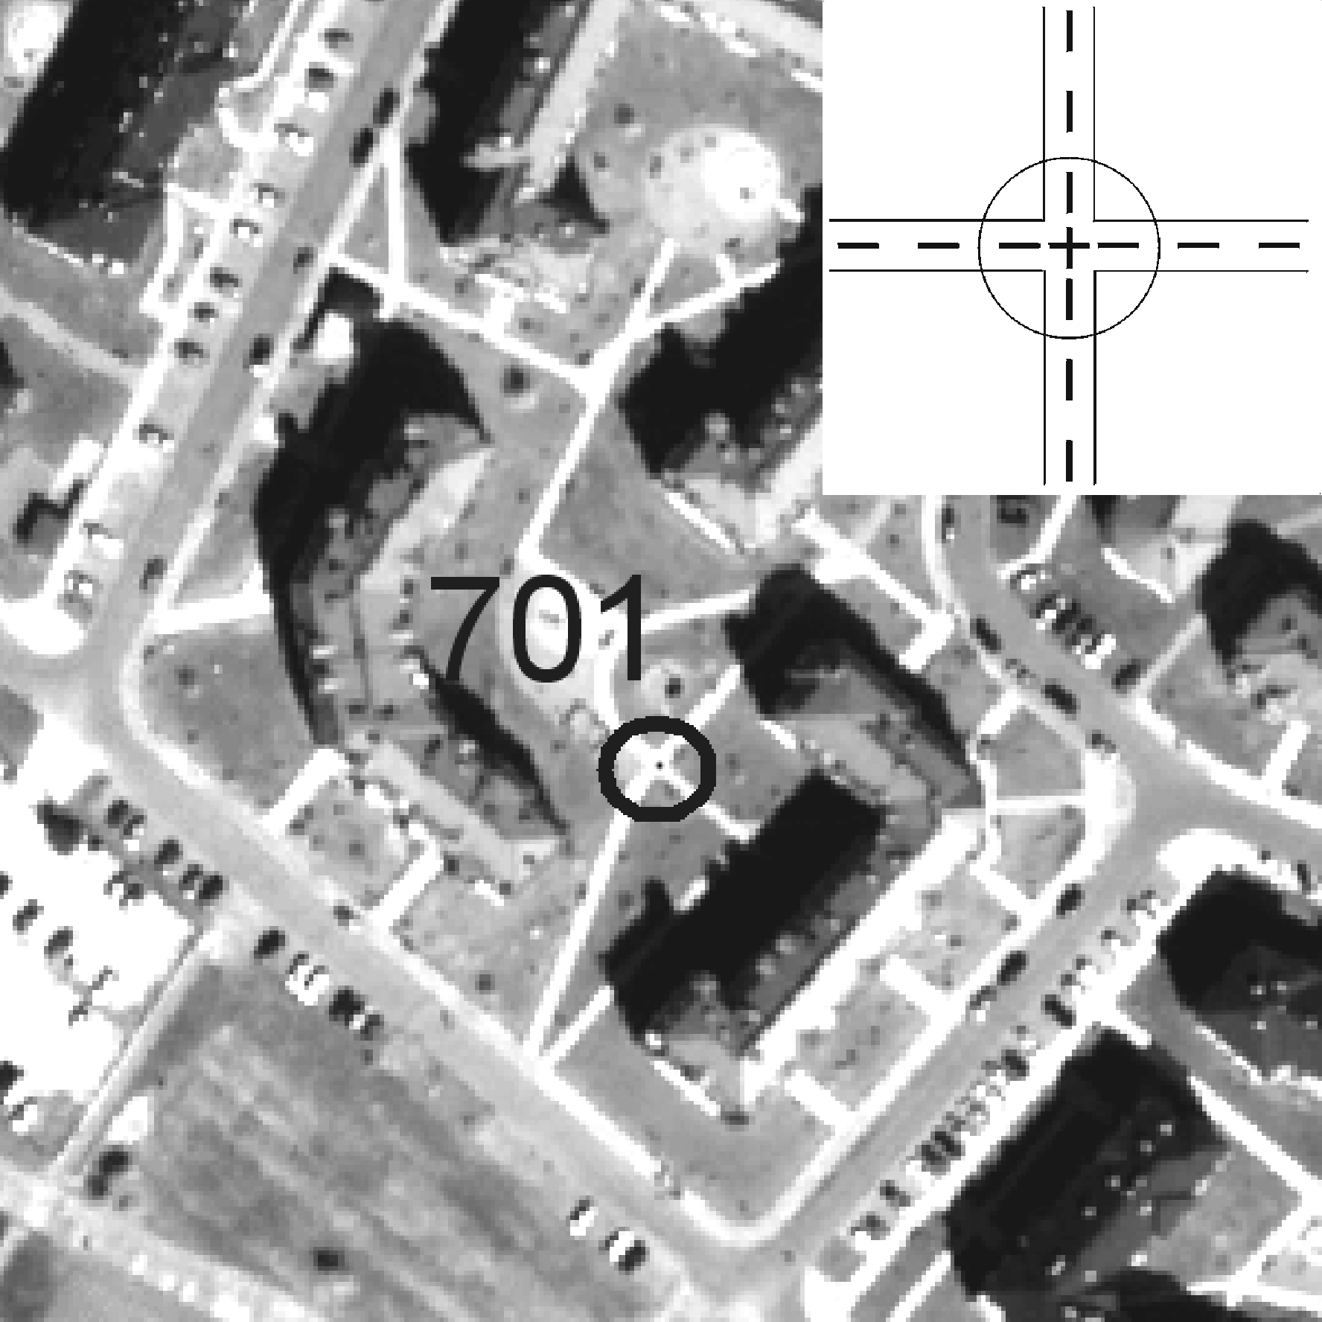
Figure 1. Example of class 01 GCP
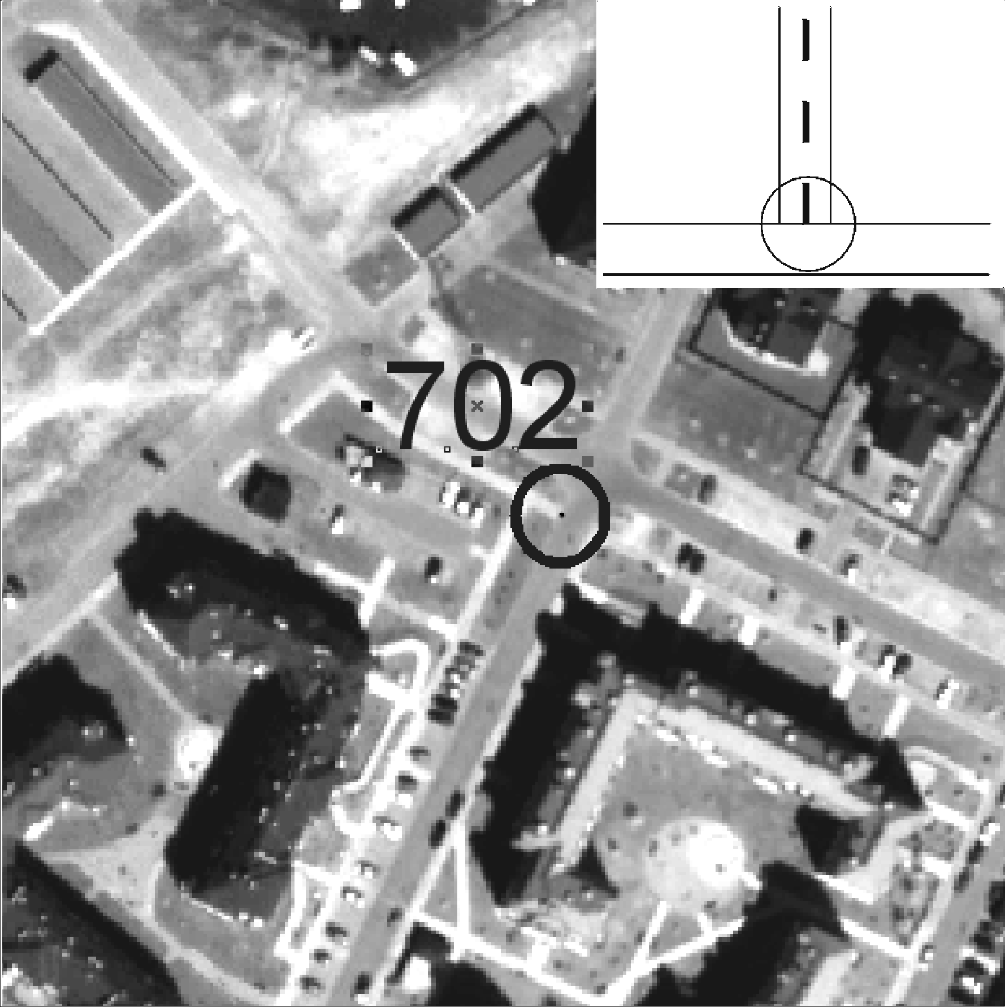
Figure 2. Example of class 02 GCP

- For class 03: GCP points had to be identified as intersection of two edges. There was a 90 degrees angle between edges for 80% of points. Typical object for this class was an edge of a driveway. Chart and point example of class 03 GCP - see figure 3.
- For class 04: GCP points had to be identified as an edge of fence. These kinds of points are problematic because of shadow role on its identification. Chart and point example of class 04 GCP - see figure 4.

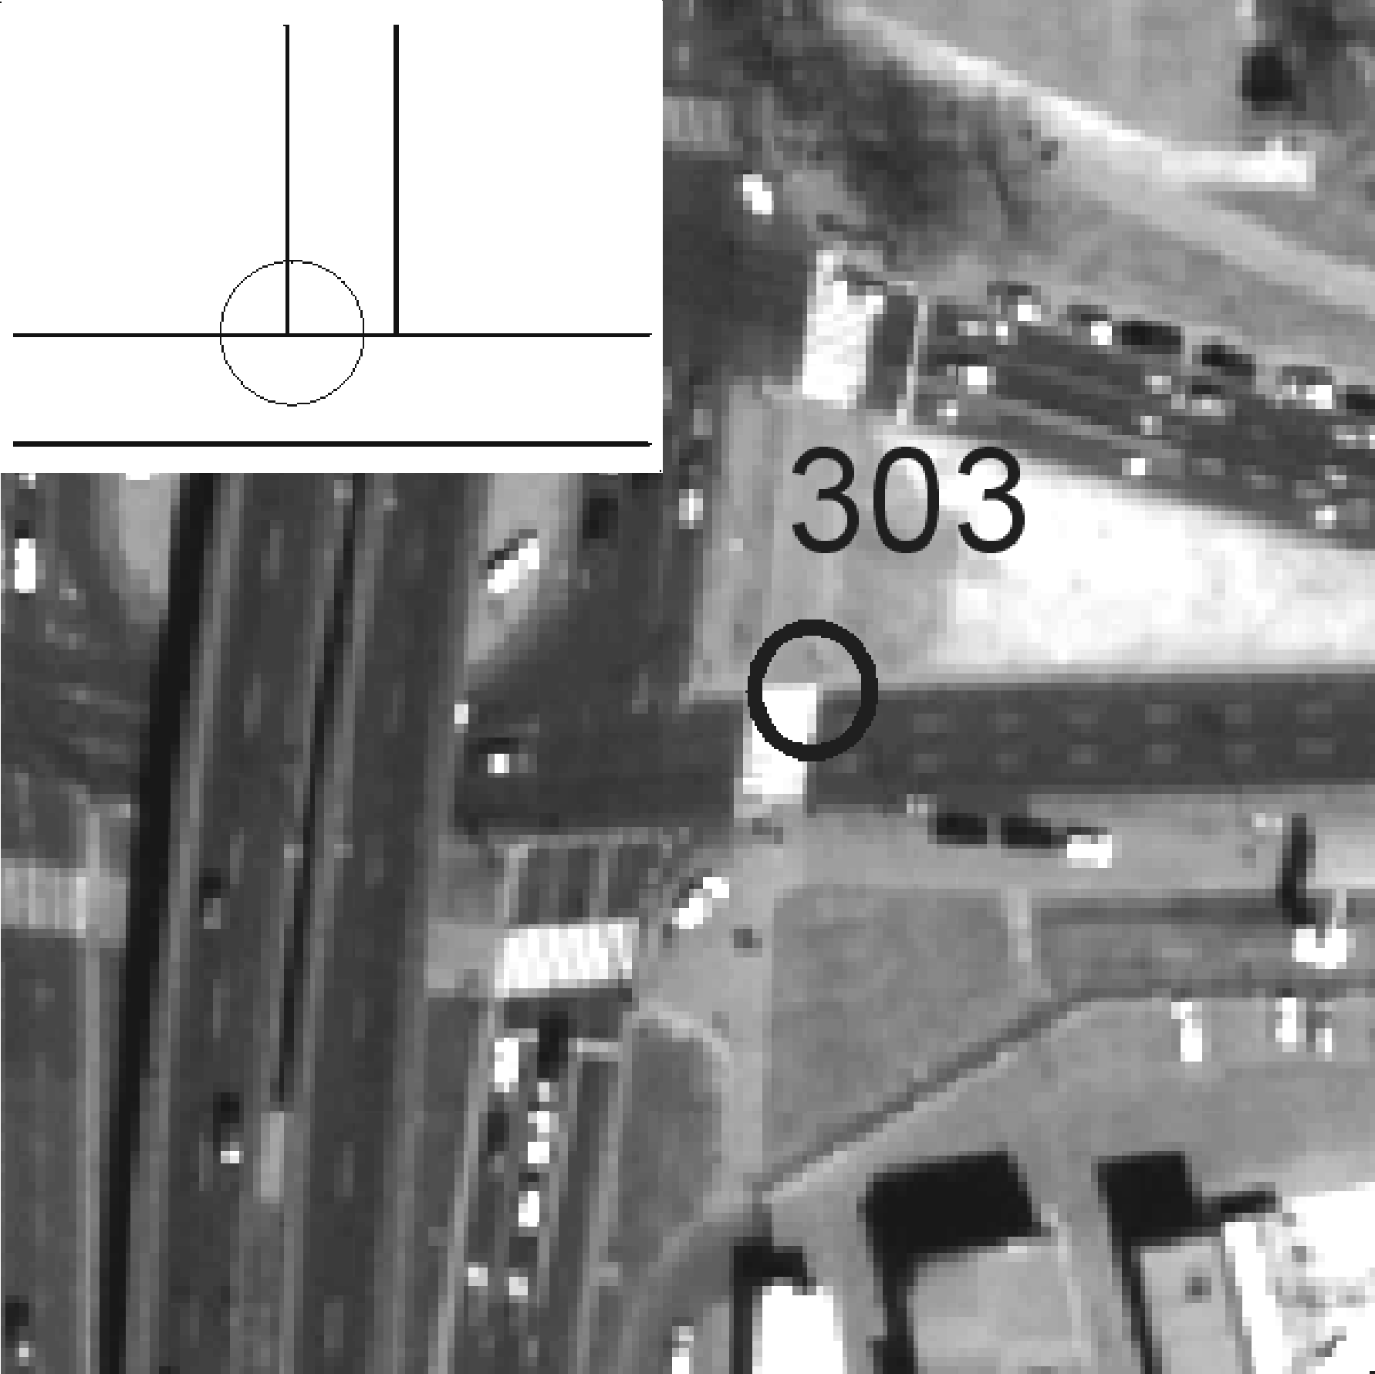
Figure 3. Example of class 03 GCP

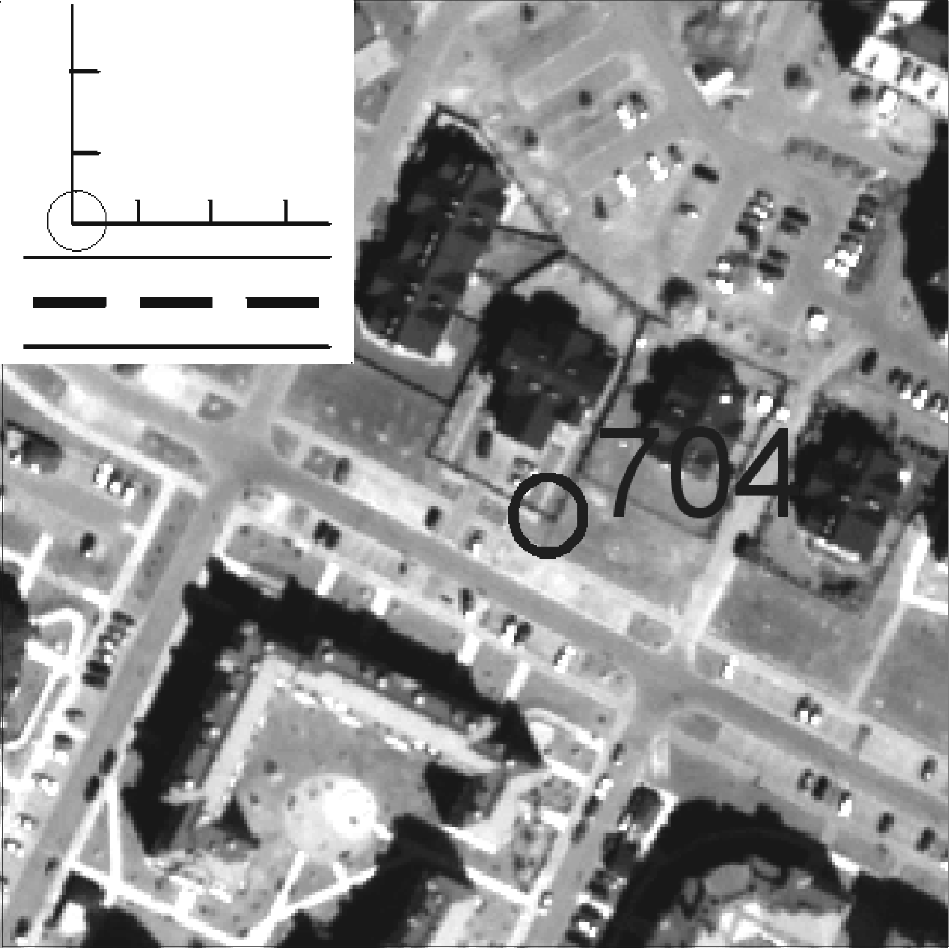
Figure 4. Example of class 04 GCP

- For class 05: GCP points had to be identified as axis or end of thin line. Lines that were used in this class had to be thinner than two pixels. In most cases they were in fact thinner than one pixel. The role of interpretation in identification of these class points was paramount. Typical detail in this class was a parking line. Chart and point example of class 05 GCP - see figure 5.
- For class 06: GCP points had to be identified as point details. Objects of this class were visible as small point ground details or street lamps. Shadow were very helpful in identification in the second case. When using these kinds of points it is very important to know from which side of detail it was measured. Chart and point example of class 06 GCP - see figure 6.

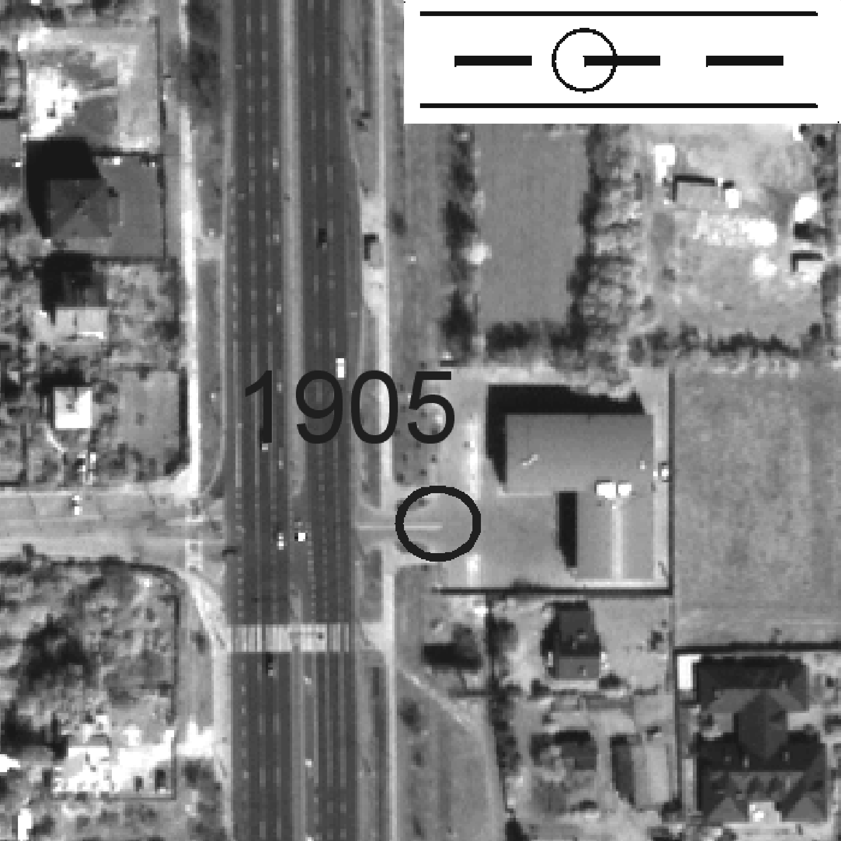
Figure 5. Example of class 05 GCP

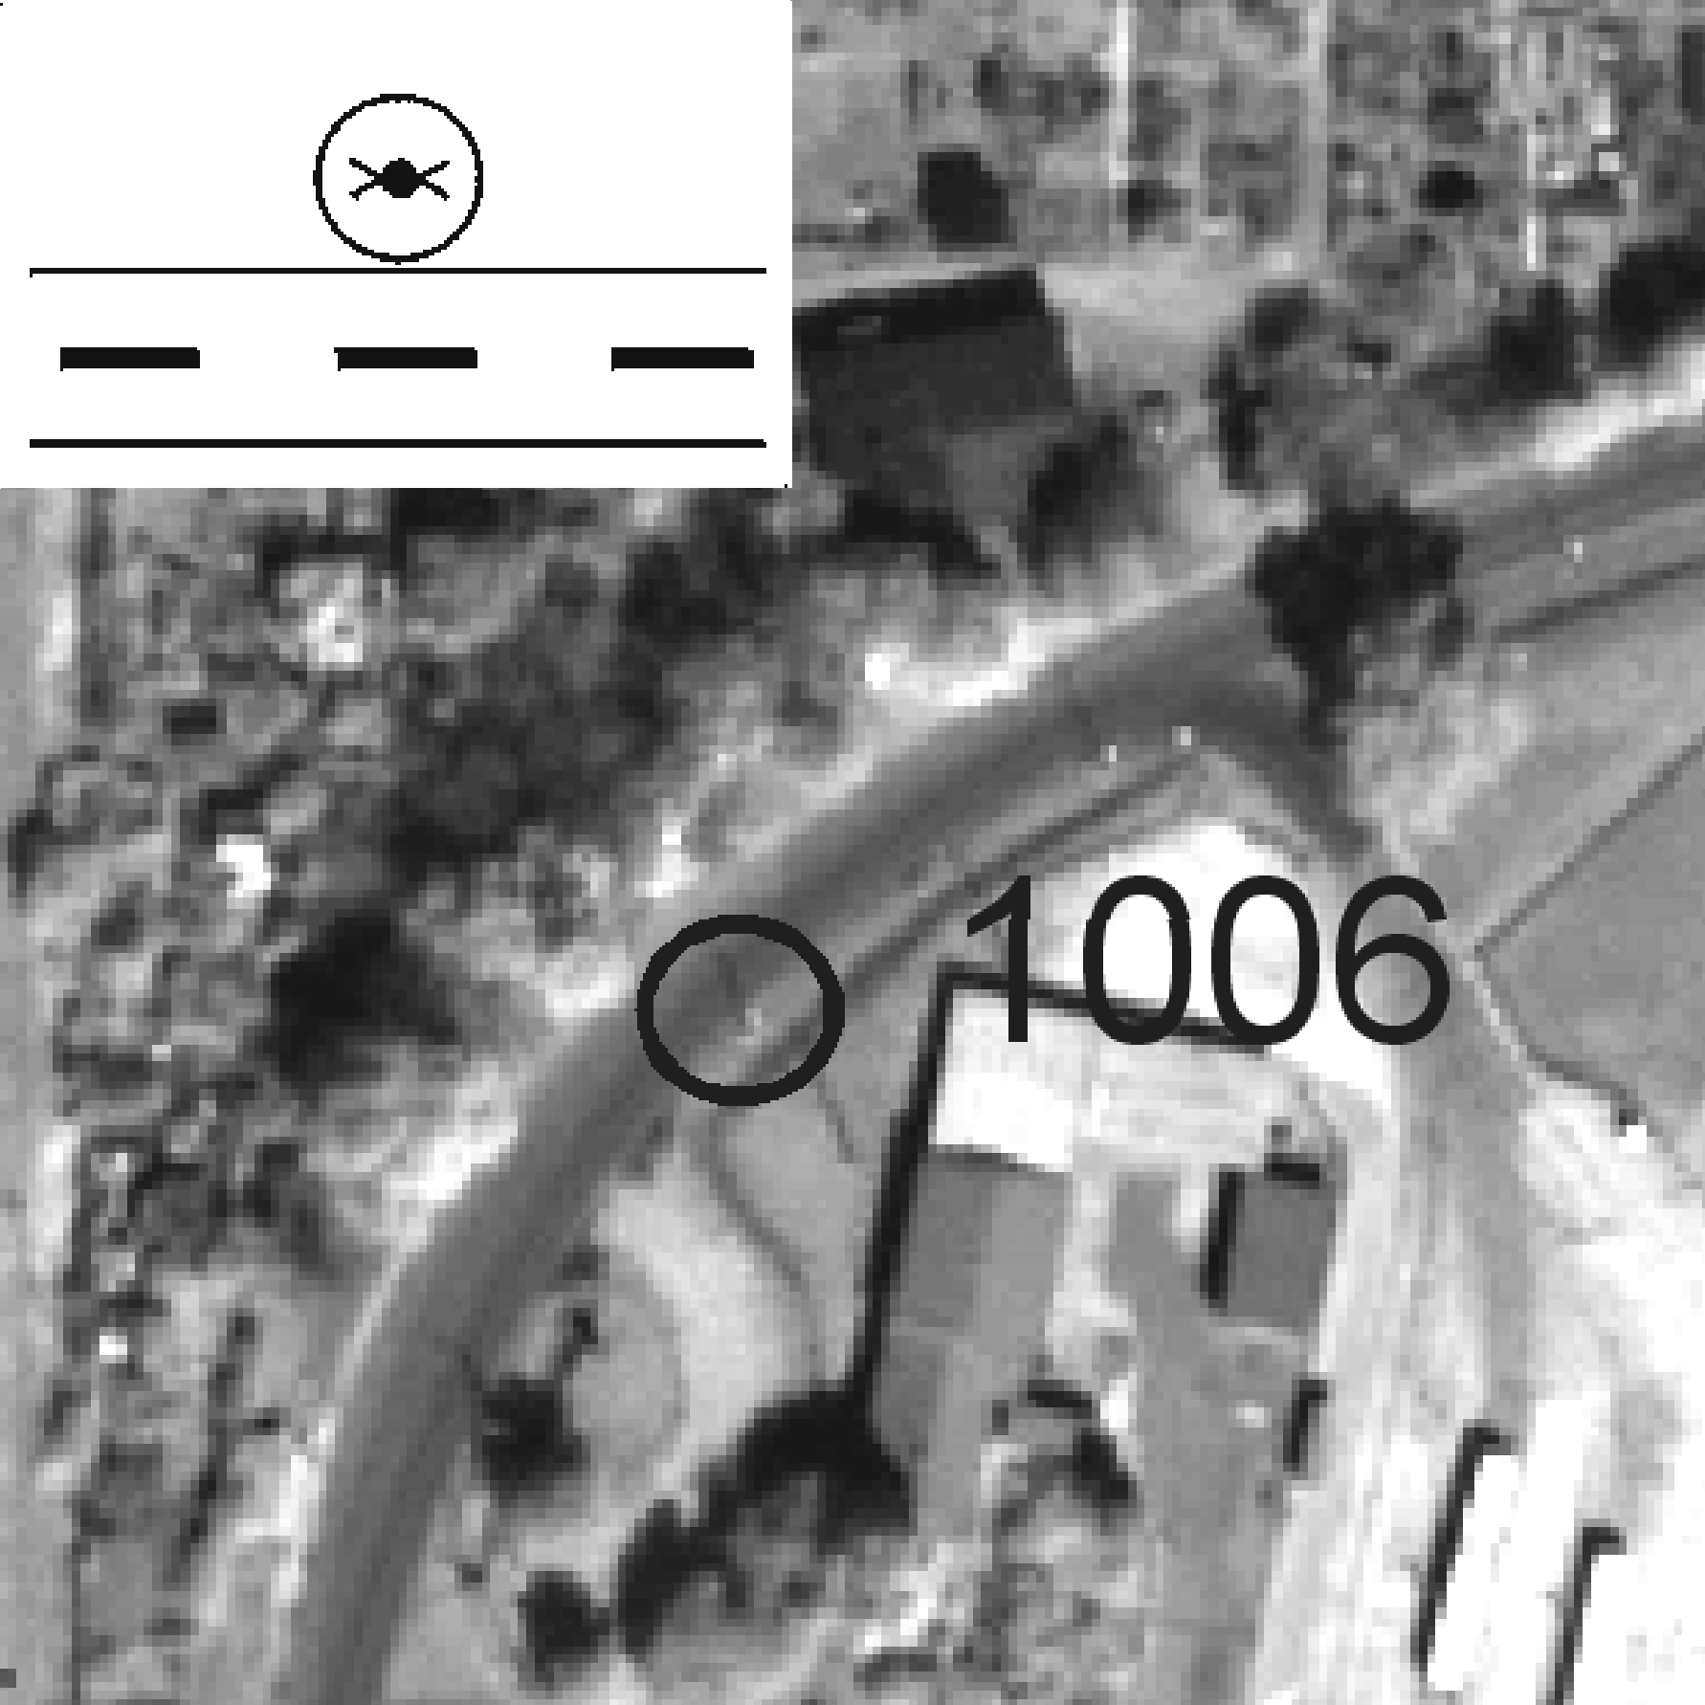
Figure 6. Example of class 06 GCP

In few cases it was impossible to project points in all 6 classes for each location. More than 140 points were projected. Measurements using the GPS FastStatic method were performed within 3 days. Two Trimble 4700 receivers were used in the measurements. An accuracy of better than 10 cm was obtained for all points after adjustment received using two base receivers. Thus, more than 130 points could be used for experiments with standard size QuickBird image.
Four different, independent approaches were used to generate objective results. The regular and full points grid allowed to use two of GCP/ICP configurations completely filling the entire image. Two approaches were used for both configurations:
- All 12/13 GCPs were taken from same class and points independent of classes were used as ICPs.
- Random points from different classes were taken for 12/13 GCPs and points from one class, only were used as ICPs.

To allow comparison, same ICPs were used in each method independently of which GCP class was analyzed. Six projects were done simultaneously to fulfill this condition. The point that was used once as GCP was deleted from other projects. The large number of points available still gave 50 ICPs after this treatment was completed. Thus, all GCP classes were compared on exactly the same ICPs.
Table 2 shows averaged results from all methods and the “Increase of relative error” which constitutes the difference between best average error for one class (05) and average error for analyzed class in percent.

3.2. GCP DISTRIBUTION

10 different cases were analyzed in order to examine the role of GCPs distribution along a QuickBird Image. Each case was compared to reference, i.e. regular distribution that was used in Section 3.1. All cases (figure 7) clearly point to typical, irregular points distributions.

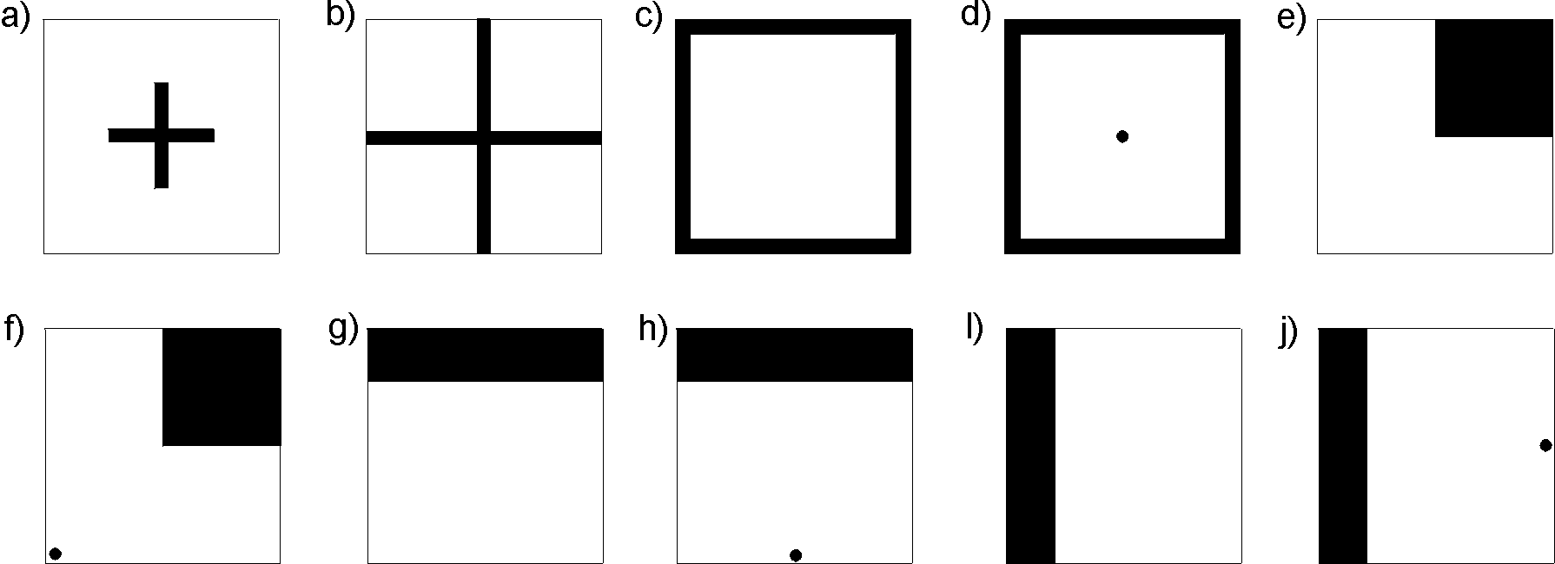
Figure 7. GCP distribution cases in area of QuickBird image (16x16km)

Black regions on graphs represent areas where GCPs were placed, white regions represent GCP free areas. Analyzed cases represented:
- GCPs were concentrated in the middle of the image, not closer than 4km from scene edge.
- GCPs grid was formed approximately in cross shape with its end on scene edges
- All GCPs were concentrated on edges of satellite scene
- GCPs were concentrated on edges of scene. One GCP point was placed in the middle of image.
- All GCPs were placed in one corner of image.
- Points were concentrated in one corner and single GCP was placed in opposite one.
- All points were placed in a strip on one (north) edge of image.
- GCPs were in strip on north edge of image. Single point was placed in the middle of south edge.
- All GCPs were concentrated in a strip on west edge of image.
- GCPs were concentrated in a strip on west edge of image. Single point was placed in the middle of east edge.

Comparison was made on results from the entire image received on ICPs, only. 13 GCPs were used always, independently of the analyzed case. Exactly the same 56 ICPs were used in each case. Obtained results are shown in table 3.

3.3. GCP SOURCES

The task was to evaluate the influence of GCP accuracy on ortho generation process. GCP coordinates were acquired from three sources:
- Collected from 1 : 10 000 scale topographic maps with accuracy to 3 – 5 m
- Measured hand-held GPS receiver Pathfinder with accuracy to 2 – 3 m
- Measured Differential GPS with accuracy 0,1 m

The number of GCPs was different in each method and depended on: type of collection, scene spacing, pixel size, economy factor and method of geometric correction. Because the large number of GCPs would enable reducing error propagation by using least-square adjustment method, more GCPs were collected from topographic maps.
In the first case, 27 GCPs were colleted from 1: 10 000 scale topographic maps. Points in places, which were least generalized were chosen as GCPs. These were mainly road intersections and fence corners. Points were acquired from topographic maps by diagonal scale with accuracy to 0,3 – 0,5 mm in map scale. In the two other cases, 10 points were measured using the global positioning system. Points taken were mainly contrast lines on ground, such like zebra crossing or parking lines, which could be identified with accuracy to about one-half of one pixel.
Quality was inspected using the same 59 checkpoints measured with highest accuracy to facilitate comparison. Additionally, ground control points were chosen in similar locations in all methods; thus deployment of points did not affect orthorectification. Deployment of rigorous method was particularly reasonable in this case, as it is more resistant to data error compared with the rational polynomial method, what is very important when GCPs of lower accuracy are used.

Table 4 shows results of bundle adjustment: number of GCPs and ICPs, RMS on GCP and ICP, for different methods of GCP collection.

4. RESULTS AND ANALYSIS

Point class | 01 | 02 | 03 | 04 | 05 | 06
Average RMS on ICPs [m] | 2,02 | 1,65 | 1,82 | 1,80 | 1,45 | 1,70
Increase in relative error | 39% | 14% | 26% | 24% | - | 17%

Table 2. GCP class comparison results

Analysis of results, concerning different GCP classes, shown in table 2 allows to formulate the following conclusions:
- Details (lines) that are similar to or smaller than pixel size (class 05) are the best type of objects for GCP points. Human eye interpretation of measured pixel and its surrounding allows very precise identification of a point on the image.
- Points based on edges of straight objects on the ground (class 02-03) or above ground (class 04) are very unequivocal. Using such type of points can be effective with optimal results of orthorectification.
- Street lamps and other point objects can be very useful for GCPs (class 06). These kinds of details are difficult for precise measurement in terrain and identification on image, but proper processing can minimize this problems. Work with this kind of GCPs is difficult but can bring good accuracy of results.
- Axes of wide lines (class 01) are very difficult for interpretation and equivocal. Usage of such type of details for GCP will lead to significant loss on results. It is strongly recommended to avoid this type of points.

Case of distribution | GCP / ICP | RMS ICP [m]
Case of distribution | GCP / ICP | X | Y | XY
a) | 13/56 | 8.64 | 7.24 | 11,27
b) | 13/56 | 2.00 | 1.16 | 2,31
c) | 13/56 | 1.00 | 0.54 | 1,14
d) | 13/56 | 0.78 | 0.53 | 0,94
e) | 13/56 | 2.20 | 6.54 | 6,90
f) | 13/56 | 1.70 | 1.39 | 2,20
g) | 13/56 | 11.51 | 4.54 | 12,37
h) | 13/56 | 0.94 | 1.18 | 1,51
i) | 13/56 | 1.59 | 1.53 | 2,21

Table 3. Orthorectification results with different GCPs distribution

Experiments concerning GCP distribution and its results (table 3) allow to formulate the following conclusions:
- Using GCPs that are lactated only in the middle of image prevent obtaining of correct results for the entire image. Expanding GCP grid to the edges of image will result in gaining accuracy not worse than 4 meters even in the corners of scene.
- Using GCPs located only on edges of image is sufficient for orthorectification. However adding a single point in the middle of image can improve results reasonably.
- It is strongly recommended not to use points only in one corner because of very serious errors appearing in remainder of the satellite scene. Adding one point on opposite corner will improve final accuracy significantly.
- GCPs located in strips only on one edge of the image will result in strong errors on the opposite edge. If the GCP strip is perpendicular to satellite orbit track (cases g, h), the situation is much more serious. Adding a single point on opposite edge of scene brings significant improvement of result accuracy.

GCP Method | GCP accuracy [m] | GCP / ICP | RMS GCP [m] |  | RMS ICP [m]
GCP Method | GCP accuracy [m] | GCP / ICP | X | Y | X | Y
GPS FastStatic | 0,1 | 10 / 59 | 0,56 | 0,25 | 0,94 | 0,65
GPS Pathfinder | 2 - 3 | 10 / 59 | 0,52 | 1,17 | 1,29 | 1,81
Topographic maps  1:10 000 | 3 - 5 | 27 / 59 | 3,61 | 2,07 | 1,31 | 1,50

Table 4: Comparison of RMS for different methods of GCP collection.

Analyzes of GCP sources sown in table 4 leads to the following conclusions:
- RMS error reflects the major sources of error, which depend on the GCP collecting method applied, such as plotting, map coordinates or GCP definition error. However, magnitude of the RMS error is not of the same order of magnitude as the input data error.
- The GPS FastStatic method should be used to achieve best ortho-adjustment accuracy. In order to increase planimetry accuracy, the predominant error of this method, which is pointing error, has to be reduced by choosing details (lines) that are similar or smaller than pixel size for GCPs.
- Hand-held GPS receiver collection method is useless for GCP collection. In this case, cartographic coordinate error is the predominating error. In result, the ICP error is almost the same as input accuracy (2 – 3 m) what can be achieved with other, cheaper GCP collection methods.
- Very good results for input accuracy were received with GCP collected from 1:10 000 scale topographic maps. The ICP error is over twice better than the predominant error, which here constitutes the graphic map accuracy (3 - 5 m). The main benefits from using this method of collection include the economy factor and easy accessibility of this source of data. In case of GCP collection from maps, the RMS error on ICPs is significantly lower than on GCPs, due to unbiased validation of positioning accuracy with ICPs measured using the FastStatic GPS method.

5. CONCLUSIONS

Several problems were analyzed during the experiment referring to different aspects of the GCP grid. Three experiments were examined for the purpose of estimating the impact of accuracy, distribution and types of GCPs on the orthorectification process. The same QuickBird image was tested with the same DEM – DTED Level 2 in each case. Received results show main sources of potential errors and aspects that should be considered with special caution. Final conclusions of this paper are as follows:
- Lines thinner than one pixel and crossings of edges or edges and axis are the best details for GCPs. These kinds of details are most equivocal in interpretation and measurement. Fence edges can be also useful for this purpose. Crossings of wide objects axis and street lamps should be avoided as GCPs because of possible accuracy loss.
- In GCP grid projecting it is very important to fill whole image with GCPs. Obeying of one edge or corner will result in significant loss of accuracy in that place. If it is impossible to project regular grid for whole image for some reason, at least single point should be measured on each edge/corner of scene.
- GCP grid can be differed from image parts. In this case it should be full on edges and wide in the middle. Using single point in the middle of image is fully sufficient for all purposes.
- It is necessary to use points measured with differential GPS techniques to obtain very precise orthoimages. When results accuracy of about 2 meters is required GCPs can be collected from traditional 1:10 000 scale topographic maps.

6. REFERENCES

[1]. Passini R., Jacobsen K., 2004, “Accuracy Analysis of Digital Orthophotos from Very High Resolution Imagery”, XX ISPRS Congress, 12-23 July 2004, Istanbul, Turkey

[2]. Toutin TH., R. Chénier, Y. Carbonneau and N. Alcade’de, 2002, “3D Models for High-resolution Images: Examples with EROS, IKONOS and QuickBird”, Int. Archives of ISPRS Symposium, Comm. IV, Ottawa, Ontario, Canada, July 8-12, Vol.34, Part 4, pp.547-551

[3]. Toutin TH., R. Chénier, 2004, “GCP Requirements for High-Resolution Satellite Mapping”, XX ISPRS Congress, 12-23 July 2004, Istanbul, Turkey

[4]. Wolniewicz W. 2004, “Assessment of Geometric Accuracy of VHR Satellite Images”, XX ISPRS Congress, 12-23 July 2004, Istanbul, Turkey

[5]. Wolniewicz W., Jaszczak P., 2004, „Orthorectification of Very High Resolution Satellite Images”, 25th ACRS meeting, 22-26 November 2004, Chiang Mai, Thailand

 Student of Faculty of Geodesy and Cartography, specialization Photogrammetry

