Forest Fire prediction. The GIS Simulation Model

Ahmed SAIDI, A. MISSOUMI, Chercheur en Géomatique,
Centre National des Techniques Spatiales, Division Géomatique,
B.p 13, 31200 Arzew, ALGERIE tél. : 041 47 22 17- 041 47 25 82 fax : 041 47 36 65
Email : ha_saidi@yahoo.fr

Keywords : Forest Fire – Modeling – Simulation - GIS

Summary :

The mastery of strategies of forests fire-fighting passes compulsorily by deep knowledge of forest fire phenomenon. One of the efficient means of apprehension of the forest fire, is to dispose of a tool that is capable to inform us about the behavior of fire before its apparition according to the given climatic conditions. In this context, the simulation remains an effective tool for the prediction of the fire behavior. It permits to determine with a relative confidence degree, susceptible zones to be ravaged by the fire during a determined period. The objective of this work is the study of mechanisms of forest fire progression by the elaboration of an automatic tool capable to pattern suitably a fire forest, its parameters, its propagation and its behavior in a given region. Through out this study, it will make conspicuous the considerable property (perhaps unavoidable) the Geographical information Systems (GIS), in combination with techniques of simulation in the apprehension of a problematical "fires forest". This resides in the power of the GIS to modeling all phenomenons presenting a geographical character. The interest that presents such a survey for operators in charge of the management of a forest fire (Fireman department, services of forests, local collectivities, etc.) is double. It permits to define to the long term a homogeneous and coherent politics of forest fire prevention, whereas the system permits to verify the adequacy of amenities and presents infrastructures of wrestling against the fire with the reality of a disaster [DAG 97]. It also allows to determine, in the perspective of the beginning of a fire, means to put in work for a coordination of intervention teams and a strategy that remains efficient, of wrestling against the fire progression.

1. Introduction :

A lot of countries confronted to problems of forest fire seized the interest to resort to modern techniques of science to control and to master the forest fire that is source of permanent danger for the nature, the environment and the man's security. Countries as Canada, USA, France, Germany, Austria, etc., have started during the years 70 the study and the development of relative computer systems to a thematic " forest fires ". In the panoply of developed tools, models of propagation represent an appreciable part. Indeed, to fight a forest fire efficiently, a fire passes compulsorily by the understanding of mechanisms governing its propagation. Among techniques used for the propagation phenomenon study, the simulation holds a preponderant place.

2. The simulation:

The simulation of a phenomenon is the operation that consists to study its behavior in situations generated by virtual data, to master it better in the real cases. The simulation permits to foresee the evolution of the phenomenon, once conditions of its manifestation are present. However, the simulation can never substitute itself for the reality, even though it permits to approach it. The process of simulation has for objective to reinforce the degree of confidence of the good working of the system put in place and no to validate it. In the case of a fire forest, the simulation is connected to the conception of an automatic process capable to inform us about the propagation of fire according to criteria's defining a given climatic and environmental state [LEN98]. Values of these criterias describe a virtual situation connected to a real experimentation condition. It is right to confront results obtained with confirmed statistics that are able to bring the necessary corrections for a good calibration of the process. The description of forest fire situation requires the collection of data land (relief, vegetation, dwelling, electric networks,) and the collection of climate data (wind, humidity, temperature,). We speak then of parameters of definition of forest fire.

3. Parameters of forest fire definition :

The forest fire integrates the ambient air and draw its fuel in the plantable setting. Wind constitutes its principal vector. The shape of the land where it appears, contributes to its development and extension. In this context, the main factors intervening in the evolution of a forest fire are according to SHERLIS [SHE96] and MISSOUMI [MIS97] strength and the direction of wind, the degree of inflammability of the plantable setting, the importance and the orientation of the slope and the starting point of fire.

3.1. wind:

It represents one of the fundamental factors (probably the main) in the process of evolution of fire. Its force, influences directly the fire propagation velocity and its direction determines the orientation of fire. The measurement of the wind is climatological information provided according to two data: speed in km/h and orientation in a cardinal direction.

3.2. Vegetable cover:

The vegetable species have a different sensitivity towards fire. Indeed, the "Alep Pine" differently burns (more or less quickly) than the "Oak cork" or the "the Eucalyptus". This sensitivity of the vegetable species with respect to fire is characterized by two indicators that are the degree of inflammability (DI) and the index of combustibility (IC). These indicators can be obtained, once the species of vegetation correctly specified. In our case, the identification of species is released by techniques of Remote Sensing from satellite images.

3.3. relief:

Fire acts differently on a ground according to whether it is flat or presenting very marked asperities (broken relief). A coherent process of simulation, must take into account the direction and the degree of the slope. The relief is generally represented by a Digital Terrain Model (DTM). Its generation rises from the altimetric data of ground such as the slope and the elevation.

3.4. the starting point of fire:

Lastly, any forest fire emanates from a starting point which is advisable to specify. The algorithms of calculation of the area devastated by fire in the process of simulation takes as initial point, the starting point of fire. The geographical co-ordinates of the starting point must be known.

4. Presentation of the study:

Our study, will initially presents a short overview of the existing models of propagation per simulation. It will note the contribution of a Geographical Information system (GIS) in the development of a model of forest fire simulation. The recourse to the GIS is justified by the geographical nature of the data relating to forest fire, such as data of ground, relief and ground occupation, and by the capacities of the GIS to integrate suitably all the parameters intervening in fire. Moreover, the tools of the graph theory and mathematical models necessary for simulation, are usual components in the GIS tools.

5. Model of simulation of propagation of forest fire:

A model of propagation of forest fire, if it wants to be rigorous and precise, must integrate all factors of definition of the fire. Several models exist throughout the world characterizing the propagation of forest fire. Nevertheless, three classes of models appear according to the level of integration of the factors of propagation of fire. These models are identified much more with the space forms generated by simulation. Thus we find the pseudo-conical models, concentric models, and the polygonal models.

5.1. Concentric Model [PAR90] :

In this type of model, the prevalent parameter is the force of the wind. In fact, the process of simulation takes into account only the factor forces wind associated with the starting point with fire. The result obtained by this type of model is a series of concentric circles representing an approximation of the zones touched by the fire and which extent is a function of the evolution in time. "FIRES" developed by the laboratory of bio-forestry of the UQAT (Université du Québec A Trois Rivières) [QUE 91], is undoubtedly the first prototype of this type of model. It was developed in Canada, for the account of Park-Canada, organization responsible for the forests and green parks of Canada. It was tested during several years in the province of the "Territory of North", where it gave mitigated results [GAU 93]. The model of simulation (Eq.1) is articulated around a simple approximation where the starting point of fire constitutes the center of the circle and the ray is determined by:
Eq.1
V_{f} : wind velocity.
T : Time.
α : Ponderation Coefficient.

$$R=α\text{.}V_{f}\text{.}T$$

We will test all the models on the forest of " KOUNTEIDAT " in the area of Sidi-Bel-Abbès, represented by an image of the satellite "SPOT", and the result of the simulation of the model will be underlined there.
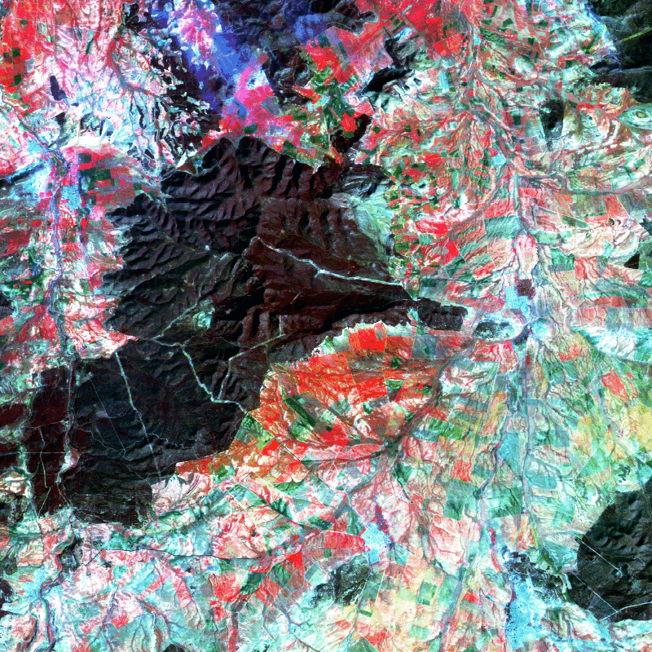
Fire propagation after
1 hour.
Fire propagation after
5 hours.

Wind speed = 30 Km/h

The circles obtained by this model contribute to define with very approximate accuracy the zones concerned with fire. These models make a global idea on the extent of these zones in the event of disaster. However, they cannot be used as an effective basis to determine with precision the means to work up the fire control. Indeed, the model is based on a rough approximation to claim to define the burnt zones. The propagation of fire never takes the shape of a circle. This is due to the important influence of the other factors of fire propagation not taken by this type of model (Eq.2). An improvement of the model is observed by the introduction of the degree of inflammability of vegetable cover in the form of a factor ξ, (0 < ξ < 1). The model would thus become:
Eq.2 $R=\text{ξα}\text{.}V_{f}\text{.}T$

This improvement adds a certain precision, particularly in the evolution of fire but remains still not very reliable. The approximation of the zones touched by fire through concentric circles reflects a great disparity compared to reality.

5.2. Pseudo-Conical Model :

The principal factors introduced into this case are not only the force of the wind, but also its direction. This type of model approaches much more reality. The evolution of a forest fire follows a direction which is strongly correlated with that of the wind. The calculated zones take the form of a flattened cone. The aperture of the cone varies appreciably from a model to another.
Fired land after 1 hour.

- Wind Speed = 30 Km/h.
- Wind Direction = N NO.
Fired land after 5 hour.

This type of model (in which the index of combustibility of vegetable cover are integrated) contributed to the development of efficient policies of forest fires prevention in Canada, in particular in the province of Manitoba. Nevertheless, the pseudo-conical form is very rigorous to correctly represent the zone devastated by fire. After the study of several disasters and comparison with results obtained by simulation, one notes sometimes important disparities between the effective zone and the zone calculated by the simulation model. This underlines the importance of the morphological factor of the ground expressed by its relief. The slope of the ground and its orientation strongly acts on the behavior and the evolution of forest fire. The contribution of the GIS in this field seems very indicated. The GIS suitably integrates the relief by means of the MNT. Taking as a starting point these models, our approach wants to be more realistic. Indeed, our system based on a GIS allows integration of the factor wind, the relief and the vegetation cover.

5.3. GIS propagation Model :

We propose in this case a model of simulation of propagation of forest fire, calculated through a GIS, integrating all the prevalent factors in the evolution of fire. The morphology of the ground is expressed through a digital model of ground (DTM). The factors speed and direction of the wind, are extracted from weather data. The combustibility index of vegetable cover can be determined when the species correctly identified by Remote sensing techniques. Once these parameters injected into the model, the zone obtained by simulation looks like the shape of a polygon which expresses in our view a better approximation of the zone to be devastated by the forest fire.

5.3.1.Geographical Information System :

An Information System is a whole of data and tools allowing the collection, the management and the analysis of these same data. A GIS intervenes when the nature of information to be managed is geographical. A GIS allows acquisition, management, and analyzes data localized on the surface of the ground. A roadmap is a GIS, an urban Database can be a GIS if the space dimension of information is present. The following definition of the SIG is generally allowed [BLO 94] : "An organized whole of computer equipment, geographical software, data and persons able to hold, store, update, handle, analyze and present all forms of geographically referred information".

5.3.2. From the real world to the GIS, Modeling :

As soon as the space dimension of information is allowed, this GIS is unavoidable. A Database is able to answer the interrogation "What is the population of the department ?". On the other hand This same Database is stripped to answer the request suitably "What are the most populated zones". The response to this request requires the analysis of the geographical distribution of townships according to their population (charts of the densities of population). The data-processing tool used must bring a space dimension to the data (coordinated, forms, topology, …), to answer spatial requests.
Abstraction and simplification
results
Actions
GIS tools
Data base
Modeling in GIS

The complexity of geographical information implies a simplification and a modeling of the real world. This model is introduced into a GIS concept This complexity is due mainly to the infinite variety of the relations which exist between the various components of a geographical model. Geographical information is defined by three components: a geometrical description (space), a thematic description (semantic) and a whole of spatial relations (topology). The development data-processing tools of GIS, integrate these components perfectly. The space aspect is managed by suitable modules which make it possible to handle geometrical, and graphic data and its viewing. A DBMS present in these tools is to manage the semantic aspect. For the topology, structures of modeling using graphs theory are introduced.

5.3.3. GIS and modeling the forest fires :

Within sight of the geographical nature of the factors intervening in the propagation of forest fire, the SIG seem very indicated for an effective representation of forest fire. The SIG, thanks to their capacities to integrate the mathematical tools, make it possible to develop automatic processes, likely to generate the zones of propagation of fire according to the developed model. In the context of our study, it is a question to represent the propagation of the forest fire by a GIS model. In the model suggested, the form calculated for the propagation of fire determines a polygon.
Fire starting point
GIS Model.
The propagation zone is assimilated to the polygone

In the model suggested, the main factors of definition of the forest fire are present. Indeed, this model offers the advantage of integrating not only the fire starting point, the force and the speed of the wind but also the relief of the ground and the vegetable cover (Eq.3). It makes it possible to determine a zone (comparable with a polygon) at a given time of propagation.
the coordinates of the vertex of the polygon are defined by:

$$\begin{aligned}x=\text{Xd}+R\text{cos}(θ) \\ y=\text{Yd}+R\text{sin}(θ) \\ R=\left(\text{Vf}∗t\right)∗F \\ F=\text{fct}(\text{Dv},\text{Ic},\text{Mt}) \\ F=α_{1}\text{Dv}+α_{2}\text{Ic}+α_{3}\text{Mt} \\ 0<α_{i}<1∧\sum_{i=1,3}{α_{i}=1}\end{aligned}$$
Xd, Yd : fire starting point.
Vf : Wind speed.
T : Propagation time.
Dv : Wind direction.
Ic : Index of combustibility.
Mt : Digital Terrain Model.
θ : Sampling Angle.
α : contribution coefficient.
Eq.3

In the presented model, the propagation is defined like a continuous movement on an interval of established time. This movement will be disturbed by the action of the various parameters taken into account the development of a forest fire.

6. Experimentation:

The model was tested on station DEC ALPHA STATION via software GIS Arc/Info 7. procedures of simulation were developed on PC by the software Arc/Info PC. The images used to extract vegetable cover are LANDSAT TM. The experimentation gave the following results:

Fire extent after 1 hour.
Fire extent after 4h.
Wind variation 2 (weak wind)
Direction N NE.

Fire extent after 1 hour
Fire extent after 4 hour.
Wind variation 3 (strong wind)
Direction N NE.

$F=0\text{.}5∗\text{Dv}+0\text{.}\text{25}∗\text{Ic}+0\text{.}\text{25}∗\text{Mt}$ $F=0\text{.}6∗\text{Dv}+0\text{.}2∗\text{Ic}+0\text{.}2∗\text{Mt}$

It remains imperative to quantify the degree of contribution of each parameter in the computation of the model. This leads us to affect weights (ai) to each parameter. However, the study shows that these weights cannot be uniform for each terrain and each case of fire. To determine possible correlations between the various parameters, the best way remains the calculation of the coefficient of correlation and to carry out statistical tests like Student or Fisher. This approach is conditioned by the availability of data (maps of evolution of fire with a high frequency (every hour for example, or less) representing the evolution of a forest fire on our zone of study. Much to our regret, no data of this kind exists at the services and operators in charge of the forests in our country.

7. CONCLUSION :

The forest fire study, in particular their propagation, showed the complexity of the phenomenon. The process of simulation can appear powerful when it is a question of informing about the extent and the potential risks of the fire. It remains in combination with the risk map, a considerable tool in the analysis of the adequacy of reality with the means of intervention and in the planning of policies of prevention. The introduction of the GIS makes it possible to deal with the problem of forest fire propagation with much rigour and better precision. The ability of these systems to integrate and modeling suitably the inherent factors in the forest fire, makes their use inevitable in an approach by simulation [DAG 96]. The contribution of the GIS as modern tools, as a new technique and a base of model is once more proven and confirmed. However, the system of simulation developed here, is not released to answer a strategy of intervention in real time. Its precision is still very approximate. This is not due to the adopted approach, but to the limits of the current tools to modeling the intervening factors in the manifestation of the forest fire. Indeed, The natural elements that are the wind, and vegetable cover are much more complex to be represented by simple indices and values. Science does not provide at present time other tools that the wind speed and its direction to modeling an air movement on a given period, and the index of combustibility for the vegetable species in interaction with fire. However, what does it occur when the wind direction changes constantly (whirling wind)? What is the behavior of fire at the time of a wind changing speed abruptly (wind in gusts)? Is the extent of fire less important after a rain? does a relation exist between the fire propagation and the humidity rate?. Alas these questions remain without answers. The wind force and direction are given through measurements which reflect an average towards a given relative long period (2h - 1day). To claim to compute exactly the extent of fire through a simulation, it needs a knowledge of speed and direction of the wind over periods much shorter, even instantaneous. It is seldom observed for a wind, the constancy speed and direction. The important influence of this last factor on the fire propagation phenomenon, can become aware of the extent of the error made in the prediction. Only a more rigorous mathematical model in its definition and modeling of the wind can mitigate the effect of disparity of the simulation model with the reality. The index of combustibility of a vegetable species is a measurement much too rigid to contribute in the model of propagation without too many errors. It allows in laboratory conditions to identify the interaction of a species with fire. The sensitivity of vegetable cover to the forest fire is strongly related to the climatic conditions. If fire occurs following a dryness, the extent of the zone devastated by fire is very disparate among that rising following conditions from strong rain. The propagation in this case is dependent on the factor climate, humidity, etc. This established fact shows the difficulty to modeling suitably the propagation of forest fire. Many systematisms which influence is considerable, are occulted in the current processes of simulation. This is a consequence of the inexistence of models governing their demonstration. Because of these difficulties, the developed model cannot be used as a tool for the operations requiring a particular precision such intervention of the teams in the fire. However the introduction of the GIS makes the tool effective and powerful for any assistance in the analysis of the current situation in terms of conformity of the means with the potential risks. It becomes inevitable in any planning of prevention policy, forest amenities and in the event of declared fire, an indicator of the ways to be borrowed for the teams of fire control and gives an acceptable estimate of the tools worked up.

8. References :

[CAR96] P.CARREGA et J.L.WYBO, Vers une évaluation du risque d'incendie de forêt.
[DAG94] A.DAGORNE, SIG, télédétection aérospatiale et gestion des espaces sensibles aux feux et/ou parcourus par eux...ou l'utilisation de la cartographie.
[DAG96] A.DAGORNE, Application d'un SIG pour l'évaluation de la vulnérabilité au feu et la prévention.
[DAG97] A.DAGORNE et J.Y.OTTAVI, Des données à l'information, ou l'utilité d'un SIG.
[ISH96] R. INSAK, Y. STARP, J.F. HOLBY Predominance of factor wind in the development of natural disaster effects.
[KNU85] L.J. KNUTH A principles of statistics and econometry Vol 2.
[LEN98] M.LENCO et B.KIENTZ, Etude par télédétection de la simulation du déroulement du feu de forêt du massif de Sainte Victoire.
[MIS97] A. MISSOUMI Caractérisation des zones forestières à risque d'incendie à l'aide d'un Système d'Informations Géographiques.
[PAR90] A. PARENT Un système automatique pour quantifier le feu de forêt. Cas de la forêt de chicoutimi.
[SHE96] A.J. SHERLIS An overview on the Main factors in forest degradation. The fire forest contribution.

