Data availability and use of GIS to support agroforestry policies in Europe

R de Filippi Y Reisner¹ F Herzog¹
(GIS-specialist) (Environmental researcher) (Head ecological measures group)
Summary
Silvoarable agroforestry (SAF) could mitigate negative environmental impacts of agricultural land use in Europe. A GIS (Geographic Information System) tool was developed to identify agroforestry target regions where productive growth of trees in SAF systems can be expected and where, at the same time, SAF systems could potentially reduce risk of soil erosion, contribute to groundwater protection and increase landscape diversity.

Keywords: Agroforestry; Geographic Information Systems (GIS); Environmental impact; European scale; European Dataset.

Introduction
Silvoarable agroforestry (SAF) (the intercropping of trees and arable crops) provides an opportunity for achieving policy goals of diversifying farm incomes, increasing tree planting and making marginal areas more attractive. In silvoarable systems, the trees are usually planted in rows with an arable crop in the alleys between.
In Europe today, agroforestry is not supported by subsidies, whereas agriculture and forestry receive government support in all countries. However, agroforestry in arable landscapes can mitigate negative environmental impacts such as soil erosion and nitrate leaching while enhancing landscape and biodiversity. In this study we aim at identifying the regions where such an affect is desirable and to localise the areas where SAF can actually contribute to resolve environmental problems caused by intensive agricultural management.

Material and methods
In this study we build a GIS toll for the identification of target areas for SAF systems for five tree species Pinus pinea, Juglans spp (hybrids), Populus ssp (hybrids), Quercus ilex and Prunus avium.
Free data sources were used, to keep the data search as simple as possible and to test the availability of European environmental datasets and the quality of the final result at a continental scale. The investigation covers the entire European continent. GIS were used to standardise, integrate and query data on soil, climate, relief, biodiversity and land cover.

Data sources
Data sources used in the data collection phase come mainly by free dataset found on the internet on web sites of the European Community Environmental Agency of the United States Geological Services (USGS) and of others projects commissioned by the European Union and through contact with expertise on this subject.
Dealing with free data at continental scale in Europe means that a compromise must be fount between availability of the data, data needed for this type of analysis, accuracy and quality of the data.
Target regions for SAF were defined overlaying continental dataset indicating (Figure [1]):
(i) Arable landscapes
(ii) Regions where productive tree growth in an agroforestry setting is possible. This is based on the following natural conditions, where the trees can grow productively:
- topography
- climate
- soil.
(iii) Regions where environmental problems exist which agroforestry can help to solve. This is based on an analysis of environmental problems:
- high risk for soil erosion
- high nitrate concentration in the groundwater
- low landscape diversity.
Europe
arable land
potential productive
tree growth
environmental risk
Target
regions

Figure 1 : Spatial definition of target regions

European Arable Land
The analysis of target regions for silvoarable agroforestry in Europe was restricted to arable landscapes as defined in the PELCOM land cover map (Mücher, 2000). PELCOM (Pan-European Land Cover Monitoring) is a European land cover database with a resolution of 1100x1100 metres. The map was developed using NOAA-AVHRR satellite data and by following a concise methodology which relied upon a regional and integrated approach.

The PELCOM map was used for calculating the area of arable land in Europe and for overlaying the environmental risk areas and the potential tree growth areas. The PELCOM-classes: “Rain fed arable land”, “Irrigated arable land” and “Permanent crops” were defined as arable land.
For the assessment of landscape diversity a map with a higher resolution than 1 sqkm was needed. Therefore the CORINE land cover map (CLC, 2000) with a resolution of 250x250 metres was used. On Level 3 of the CORINE map, arable land comprises the two classes: “Non-irrigated arable land” and “Permanently irrigated arable land”.

Potential productive tree growth areas
The selection of regions where productive tree growth in an agroforestry setting is possible was based on tree growth requirements. Using the Forestry Compendium (CABI, 2003) criteria were defined to describe optimal growth conditions for the five selected tree species. The information was supplemented by expert assessments. The criteria for potential productive tree growth considered for every species were:

Climatic variables
On a European scale, the most comprehensive high-resolution climate datasets available are the CRU TS1.2 (New et al., 2002) and the CRU CL2.0 (Mitchell et al., 2003). Both datasets have a resolution of 10’x10’ (approximately 16x16 km) and contain monthly values. The CRU CL2.0 dataset contains five variables (precipitation, daily mean temperature, diurnal temperature range, vapour pressure, and cloud cover) for the period 1901-2000. From this dataset annual precipitation, mean annual temperature, mean maximum temperature of the hottest month, and mean minimum temperature of the coldest month were derived for the 30 years period 1971–2000. Information about wind and frost stems from the CRU TS1.2 dataset (30-year-period from 1961 to 1990). The 10’x10’ climate data was subsequently re-sampled to a 1 sqkm grid by Mücher at al. (2003) using bilinear interpolation.
To define the tree growth areas the following climatic variables were used:
- Precipitation (mm/year)
- Mean annual temperature (°C)
- Mean maximum temperature of hottest month (August) (°C)
- Mean minimum temperature of coldest month (January) (°C)
- Wind (m/sec)
- Frost (days/year).

Soil variables
Soil information is essential to assess the suitability for potential agricultural use. The digital European soil map (ESB, 2002), based upon an internationally accepted classification, was used to derive the following soil characteristics:
- Soil texture
- Water regime
- Soil type
- Minimum depth available for root growth (m)
- Minimum soil water capacity (one metre top layer) (mm)
A MS-Access database was built in order to manage and standardise the query based on the large amount of data stored in the European soil database (ESB, 2002). Soil data are in vector format with information about the geometry of the soil mapping unit (SMU) and the correspondent attributes, stored in the soil type unit table (STU). MS-Access was used as the query database system for the ArcGis platform and its geodatabase system. After extracting the soil mapping units that fulfil the tree growth requirements the data was converted to raster format with a resolution of 1100x1100 metres.

Topographic variable
Data about topography were calculated from a DEM (digital elevation model) available at the United States Geological Survey (USGS, 2003). The dataset is called HYDRO1k and has a resolution of 1 sqkm. The main topographic feature considered in the model is:
- Altitude
believed to be the most influencing topographic variable at a continental scale.

Environmental risk areas
Environmental risk areas were defined as regions with a potential environmental problem due to agricultural land use. The environmental problems were classified as a high risk of soil erosion, nitrate vulnerable zones and low landscape diversity (uniform arable landscapes).

Soil erosion
The assessment of soil erosion was based on indicators and values produced by the PESERA project (Gobin and Govers, 2003). Erosion indicators were calculated using a model with a physical basis, applied to the regional scale. A preliminary map of the PESERA-project was reclassified to locate areas with more than 5 t/ha/year soil loss, which was defined as a high risk for soil erosion. The PESERA map was already in the correct resolution, but the projection had be adapted to the projection of the PELCOM land cover map.

Nitrate vulnerable zones
Based on the Council Directive 91/676/EEC (European Commission, 2002) EU member states have identified “Nitrate vulnerable zones” (NVZ) where there is a high risk of nitrate leaching. The NVZ map is originally a vector map, developed at the European Environmental Agency and the Joint Research Centre (Ispra, Italy). It was transformed to a Grid-map with a resolution of 1100 metres.

Landscape diversity
Uniform arable landscapes were selected from the two land cover-datasets CORINE (CLC, 2000) and PELCOM (Mücher, 2000). The CORINE land cover map has a resolution of 250x250 metres, but is not available for all European countries. For the missing countries (Albania, Great Britain, Scandinavia, and Switzerland) the PELCOM map was used by re-sampling the PELCOM map to a pixel-size of 250 metres. The re-sampled PELCOM map and the CORINE maps were merged. A moving window (focal majority command) was used to filter out those areas in this new 250 m land cover map, where in a 5x5 km area more then 50% is covered by arable land. These areas were then reclassified as low diversity landscapes.

Target regions for silvoarable agroforestry
Target regions for silvoarable agroforestry for the five investigated trees were defined where productive tree growth on existing arable land was potentially possible and where at least one environmental problem existed. The data model illustrated in (Figure [2]) was implemented and the data processed using ArcInfo Macro Programming Language (AML).
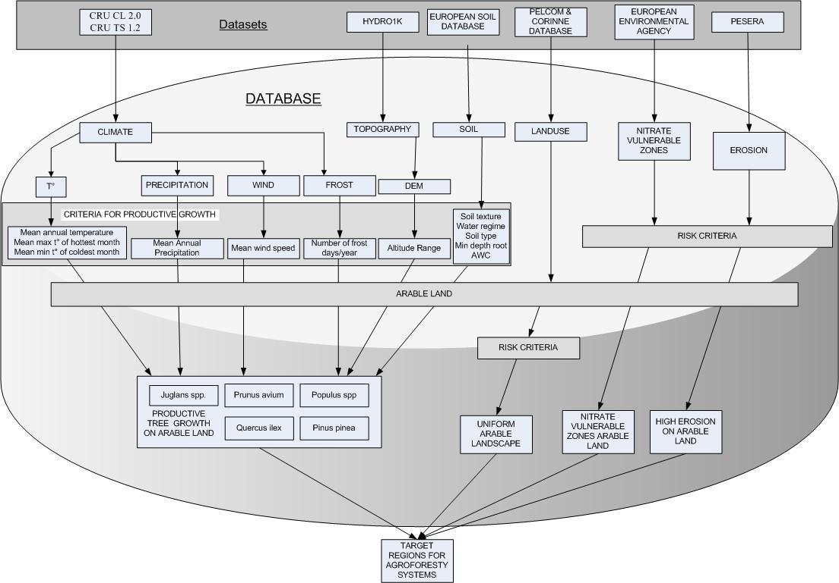
Figure 2 : Data Model

GIS (Geographic Information System ArcInfo) were used to standardise, integrate, query data on soil, climate, topography, and land cover and once all datasets had been converted in raster format, the data was overlaid (using simple additions) to identify the areas where all the criteria were met. These areas were then defined as target regions.

Result
Around 53% of the arable land in Europe was found to be suitable for at least one of the five tree species under investigation. Of this area,
- 5% were classified as being in danger of erosion with an erosion rate of more than 5 tonnes of soil per hectare per year;
- 30% were categorised as a nitrate vulnerable zone and;
- 68% had a uniform arable landscape.

On 80% of arable land at least one of these environmental risks existed.
Target regions covered 38% of European arable land and were located on 75% of the areas with a high risk of erosion, on 58 % of nitrate vulnerable zones and on 44% of those areas where a uniform arable landscape existed.
As an example, the area of arable land that would be suitable for the productive growth of the Prunus Avium (cherry) tree was calculated. The potential planting zone encompassed an area of around 278,000 km² which is equal to approximately 15% of the European arable land area. This area is mainly restricted to the temperate zones of Europe. Around 7% of the potential planting area had an elevated risk of soil erosion and approximately 30% was classified as a nitrate vulnerable regions (see Reisner et al., “submitted”).

Conclusion and outlook
Using free geographic data sources, means facing positive and negative aspects. Data are easily shared and accessible by anybody, on the other hand the data quality cannot be fully checked and the user cannot always get all the information he may need from the data producer. Another aspect is that European datasets depend on policy agreements between countries. In case not all countries participate (e.g. Corine land cover classification) the user has to deal with more then one research area, more then one classification and more then one spatial reference. When working with geometric features and thematic information, layers should share a standard coordinate system, the same resolution and a common classification system, which is often not the case. To gain a common spatial resolution and thematic information, geo-transformation and reclassification operations are needed. In most cases however this leads to a loss in accuracy. There is definitely a need for a common, standardised and trustworthy database at the European scale for environmental data. It should be made available by the European Union as easily as possible as it would facilitate the development of decisions supporting systems that work at a continental scale. This study has shown the usefulness of a general picture on specific environmental issues like the potential implementation of silvoarable agroforestry systems and the reduction of problems regarding soil erosion, nitrate leaching and arable landscape uniformity.

Acknowledgements
This research was carried out as part of the SAFE (Silvoarable Agroforestry for Europe) collaborative research project. SAFE is funded by the EU under its Quality of Life programme, contract number QLK5-CT-2001-00560, and the support is gratefully acknowledged. The Swiss Federal Ministry of Science and Technology (contract 00.0158) funded part of this study.

We would like to acknowledge the experts for the definition of the tree growth requirements: Christian Dupraz (INRA, France), Gerardo Moreno (Universidad de Extremadura, Spain), David Pilbeam (University of Leeds, UK), and André Gavaland (INRA, France).
Furthermore, we wish to thank João Palma for collecting climatic data.

Bibliography:
CABI, 2003. Forestry Compendium. CAB International, Wallingford, UK. http://www.cabi.org/compendia/fc/index.asp
CLC, 2000. CORINE land cover technical guide. European Environmental Agency ETC/LC, Copenhagen, 105 pp.
Daroussin, J. and D. King, 1999. Metadata: Pedotransfer rules database v.2.0 for environmental interpretations. The use of pedotransfer in soil hydrology research in Europe. Workshop proceedings. Orleans, France, 10-12 October 1996, 12 pp.
Ellis, E.A., Nair, P.K.R., Linehan, P.E., Beck, H.W. and C.A. Blanche, 2000. A GIS-based database management application for agroforestry planning and tree selection. Computers and Electronics in Agriculture, 27: 41-55.
ESB, 2002. European Soil Bureau. European soil database version 2.
ESRI, 2001. ESRI Data and Maps. Media Kit, Edition ArcInfo 8.1. CD-Rom.
European Commission, 2002. Implementation of Council Directive 91/676/EEC concerning the protection of waters against pollution caused by nitrates from agricultural sources. Synthesis from year 2000 Member States reports, Luxembourg, 51pp. http://europa.eu.int/ comm/ environment/ water/ water-nitrates/ 91_676_eec_en.pdf
Gobin, A. and G. Govers, 2003. PESERA: Pan-European Soil Erosion Risk Assessment. Third Annual Report, 143 pp.
Mitchell, T.D., Carter, T.R., Jones, P.D., Hulme, M. and M. New, 2003. A comprehensive set of high-resolution grids of monthly climate for Europe and the globe: the observed record (1901-2000) and 16 scenarios (2001-2100). Tyndall Centre Working Paper No. 55, 30 pp. http://www.tyndall.ac.uk/ publications/ working_papers/ wp55.pdf
Mücher, C.A. (Eds.), 2000. PELCOM project. Development of a consistent methodology to derive land cover information on a European scale from remote sensing for environmental modelling, Final report, 236 pp.
Mücher, C.A., Bunce, R.G.H., Jongman, R.H.G., Klijn, J.A., Koomen, A.J.M., Metzger, M.J. and D.M. Wascher, 2003. Identification and Characterisation of Environments and Landscapes in Europe. Alterra-rapport 832, Alterra, Wageningen, 119 pp.
New, M., Lister, D., Hulme, M. and I. Makin, 2002. A high-resolution data set of surface climate over global land areas. Climatic Research, 21: 1-25.
Richardson, D.M. and P.W. Rundel, 1998. Ecology and biogeography of Pinus: an introduction. In: D.M. Richardson (Eds.), Ecology and Biogeography of Pinus, Cambridge University Press, pp. 3-45.
Y. Reisner, R. de Filippi, F. Herzog, “submitted”.
Target Regions for Silvoarable Agroforestry in Europe. Ecological Engineering
Shakesby, R.A., Coelho, C.O.A., Schnabel, S., Keizer, J.J., Clarke, M.A., Contador, J.F.L., Walsh, R.P.D., Ferreira, A.J.D. and S.H. Doerr, 2002. A ranking methodology for assessing relative erosion risk and its application to dehesas and montados in Spain and Portugal. Land Degradation & Development, 13(2): 129-140.
USGS, 2003. U.S. Geological Survey, HYDRO 1K Europe, Elevation Derivative Database. http://edcdaac.usgs.gov/gtopo30/hydro/europe.asp

Agroscope FAL Reckenholz. Swiss Federal Research Station for Agroecology and Agriculture, Reckenholzstrasse 191, CH-8046 Zurich, Switzerland.. Email: riccardo.defilippi@fal.admin.ch

