Guide lines inside Map of Risk for georeferencing methodologies of
Cultural Heritage and Historical Centres

Raffaella BRUMANA
Professor
E-mail: brumanar@idra5.iar.polimi.it

Cristiana ACHILLE
Research Assegnist
E-mail: achillec@idra5.iar.polimi.it

Daniela ORENI
PHD first course year
E-mail: daniela.oreni@polimi.it

DIIAR - Department of Hydraulic, Environmental, Street Infrastructures and Survey Engineering
Survey Division - Polytechnic of Milan - ITALY
Laboratory of “Survey, Digital Mapping and GIS”
P.za Leonardo Da Vinci 32 - 20133 Milano - ITALY
tel. +39 2 2399 6533 fax +39 2 2399 6550

KEY: MAP OF RISK ARCHITECTONIC PATRIMONY; GEOREFERENCING; GIS FOR CULTURAL HERITAGE; ADVANCED 3D MODEL; PROGRAMMED MAINTEINANCE.

Summary
Here is reported the result of a research which has resulted in a guide to georeferencing cultural heritage inside Risk Map of Lombardy Region.
From some years in Italy there are multiple researches on possible methodologies of georeferentation, localization and valorization of cultural heritage, carried out in famous and minors historical centers. The interest in their conservation and valorization has this point of view: the attention to territorial scale of the historical-documentary-environmental stratified values. Many purposes: artistic heritage protection and rediscovery of identity and collective cultural roots, in the conviction that the building patrimony is not only an economic and social resource, but it can become one chance of improvement of the quality of ‘urban living’.
A collection and organic data management represent fundamental presupposing for one corrected political of integrated conservation of the cultural heritage, meant like situation in constant change; informative system (GIS), considered as open and updated shape, can become a support to the processes of city planning.
The georeferencing, as colletion of space-temporal data correlated to differentiates levels, and the correlation between historical and current cartographies can contribute to location of possible trasformation, in according to logical of sustainable development and active and partecipated protection.

Project of Risk Map of Lombardy Region
The experiments conducted in this field (still underway) have uncovered problems inherent to the research initiated, but at the same time, have shed new light on still other issues relating to aspects associated with protection, namely what is commonly known as the Risk Map. The main purpose of the Risk Map is to evaluate the risks to which cultural object is vulnerable in order to schedule conservation measures based on data and gauges used uniformly across the country. This risk is calculated through the combination of two indicators: the vulnerability indicator derives from analysis and processing the information on the state of decay of the building and the risk indicator that reveals the potential danger of environmental, anthropic and territorial factors. This study focuses mainly on environmental factors: the static and structural risk of natural phenomena that can influence the structural stability of buildings (sismic danger, overflows, landslides, instability, etc), while environmental-air risk (atmospheric pollution including erosion and surface blackening) and the anthropic risk (dwindling population, demographic and tourist pressures, theft, potential damage and which entails processing the respective indicators) is collateral to research, but appears in the organization of the GIS through conservative inventorying.

Introduction to the research
Georeferencing complex integrated models represents an avenue of research on the road toward pursuing the experiences conducted in the field of georeferencing the architectonic heritage as part of the recent research contracts (instruments for georeferencing the historic architectonic heritage of the Region of Lombardy, georeferencing historic centres, development of WEB GIS prototypes, interactive georeferencing-correlation-navigation of historic and contemporary cartographies, etc.).
Georeferencing, structuring and construction of a GIS to support the Risk Map of Architectonic Assets thus constitutes, starting with the graphic plotting required by the ICR (Central Restoration Institute) and the different cartographic bases and data (geographic and database), an unavoidable need.
This research, based on the experience gained and the study of analogous subjects on a national level (numerous but with a common denominator in the shared difficulties), proceeds in this direction. An orderly understanding of our heritage and its protection is essential.
In particular, with regard to the phase of identifying the historic architectonic objects on the available maps and their survey, when necessary or appropriate, the question remains how to link the cognitive phase with the construction process of the map as support for the decisions, starting out with a two-pronged approach: to shed light on information useful at all levels - the protection offices, public and private bodies, the owners of the objects, professionals and enterprise - and concurrently identify sources and methods for updating data. Only this integration can enable updating the GIS that underlies the system and as a result, its use over time. The analysis of the data based on the spatial properties is where the true potential of the GIS lie. Analysis, synthesis, and consulting of the systems have their roots in the spatial and temporal relations associated with sizes and relationships between the same entities.
Unlike the other protected cultural objects, the historic-architectonic legacy is used every day and is subject to changes in the use, rehabilitation, maintenance and restoration: the system must be organized to gather information related to the various types of intervention that involve this legacy and the context in which it is inserted.
A close integration between the rapidity of the cognitive part (identification of the object, survey of the object when necessary, georeferencing and insertion into the map) leads to construction of the Risk Map. Structured in a GIS, it can update information in real time, avoiding the paradox intrinsic to large systems, where information becomes obsolete between its collection and when it becomes available.
This paradox is overcome if you combine the highest technological skills available (rapid data scanning with laser scanners plus multi-scale survey, integration with 3D models and digital orthophoto) with development of on-line information systems.

The need for an Integrated System
To reach the definition of an integrated system that brings together a structure for georeferencing and the risk methods and indicators that are based on the risk map, you have to have a standardized methodology that includes specifications and clear standards to follow based on generation of the data. The progress made in the research that involves the object has emphasized how it is difficult to define, because the artistic expression that characterizes it as a subjective form is also amorphous, not only for itself but also for those who must evaluate its importance. We find ourselves working with a world and in a world that observes our clumsy attempts to impose rules, look for unequivocal and localised classification, a world that is typified by discrepancies of all kinds, that defy all methodological attempts to rationalize them, but that at the same time, provide an understanding that something must be done: namely, we have to find rules. Only by finding rules can we accept the unavoidable errors whose currently wide spread existence can be substantially limited.
The attempt to attain clear and valid standards for a high percentage of objects and the construction of maps of potential and expected risk requires a reasoned and thoughtful construction of guidelines that set standards and conduct for georeferencing, specific survey of objects, and their description and inventory, all of which lead to the construction of a GIS that cannot be reduced to the simple sum of the infinite parts of our heritage, but which clarifies structures, models, and relationships between data that conceive the risk map as part of the complex world of objects, protection policies, stakeholders, different purposes and institutions. Help comes in the form of standards, partly borrowed from other disciplines and component sectors (for example, cartography ...) and partly new. An important step in the right direction was taken by the Region of Lombardy, which created the Regional Office for the Risk Map within a framework programme of agreements with the Ministry of Cultural Heritage and Activities. This office has opened up interesting lines of interdisciplinary research and envisions an important line of research in formulating Guidelines for surveyors and risk map makers.
Moreover, the availability of new survey instruments and the great power of information systems provide high hopes in this direction, but also have many innovative aspects that must be investigated, experimented on the field, and resolved as this research project has set. These issues range from laser scanner survey to the problem of modelling complex objects and monuments to the issue of processing the scanned data using GPS palm top systems to the lines for georeferencing systems.

Steps of the research
The Risk Map of the cultural heritage is "an area of research that has been used for at least three decades as part of the Central Restoration Institute (ICR). It emphasizes the need to schedule conservation of cultural assets, especially through prevention of damage." In essence, it means putting together a theme map identifying and representing the risk that a work of art is subject to under normal environmental conditions that might threaten its conservation.
The tools used to construct a Risk Map include survey of the historic architectonic heritage identified on any available maps, survey techniques that are as "expeditious" as possible and at the same time, geo-referenced for the purpose of constructing an information base over a limited period of time. This base can be shared by the GIS present on a municipal, provincial or regional level and can be used by any number of players for the evaluation of the territorial danger, as well as for a more exact scheduling of future classification activities.

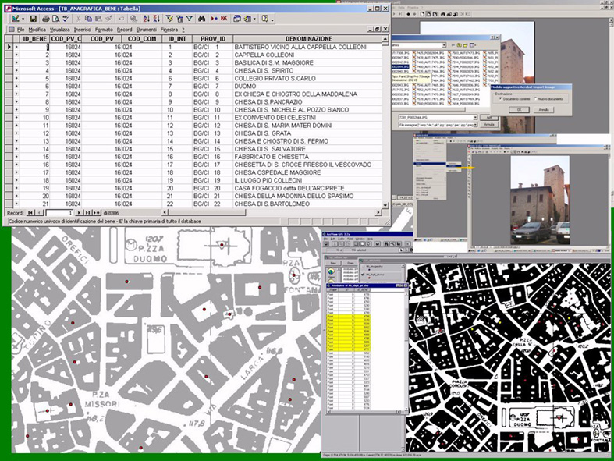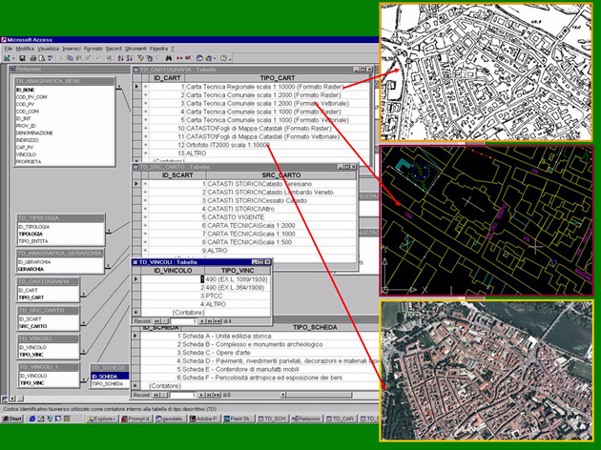
Fig. 1 From the inspection to the punctual georeferencing: different types of available and used cartography; tables with closed fields to guide the choice of.

Conservation and protection of the architectonic heritage hinge on the ability to obtain a high level of knowledge of the objects involved in the intervention, generated by the most advanced technological skills available today. Therefore, this research project can be considered preliminary and focuses on the production and integration of methods of advanced cognitive investigation such as laser scanners and the resulting modelling.

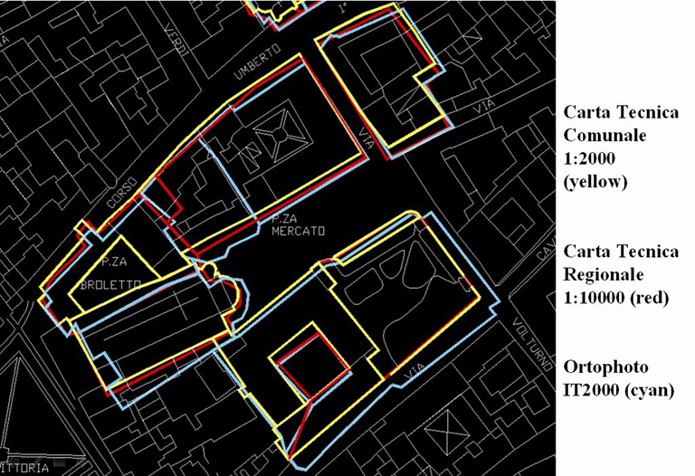
Fig. 2 Comparison digitalization beginning from three different cartographic bases.

Survey seems to be essentially limited to identifying the property on the available maps, determining its coordinates in a national reference system and citing these as part of an information system that gathers information relating to the factors of territory riskiness of the area in which it stands along with data of bibliographic sources and the conservational plot elaborated by the ICR. But it is not so because the objects can have variable complexity, different dimensions and stand in any range of contexts (either inserted in an urban area, isolated, or made up of several bodies assembled together but with different uses or with different historic and architectonic characteristics) and as a result the diversity of the methods with which they must be georeferenced. Added to this is the different scale of the maps in which they appear and as a result, their different representations. Generally used by digitalisation from the cartographic support, survey becomes part of the GIS through procedures that must follow a procedure as uniform as possible at the various bodies that handle the problem. With this intention and as part of a contract with the I.Re.R. of the Region of Lombardy, a research study was formulated that has emphasized the need for procedural regulations and a much broader vision than what point-based georeferencing can provide.
The diversity of the overall dimensions of the object make it possible for point -based digitalisation to provide only the localization while completely neglecting the geometric aspects that distinguish it and cannot be read on the ICR sheets. On the other hand, geometric representation on a plane or if possible, in elevation, gives a form of knowledge that goes far beyond what is revealed by a normal photographic shot and its importance seems clear not only for a better understanding of the object but also for risk factors related to the dimensions, especially in height, as well as its localization.
Today, an expeditious and fairly exhaustive representation can be obtained by integrating the laser scanner and digital cameras. Still, due to the numerous data revealed, this combination needs new software for accurate management and representation. This would enable a precise understanding of the object on an architectonic scale (1:50-1:100), on a municipal or cadastral map (1:500-1:2000), or on a regional scale (1:5000-1:10000). The processes of generalization allow the shift from "grand" representation to point-based, that resolves an important but non-exhaustive aspect, and does not enable the reverse.

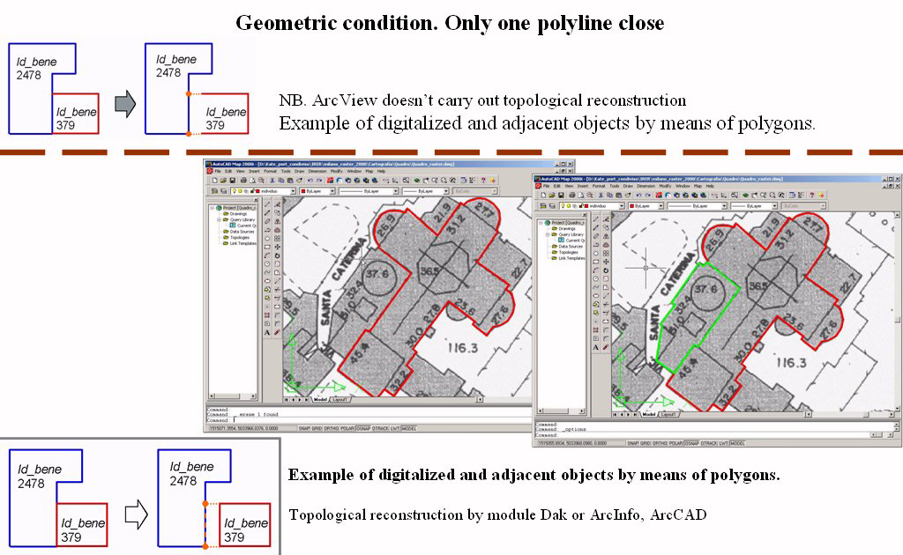
Fig. 3 Geometric condition
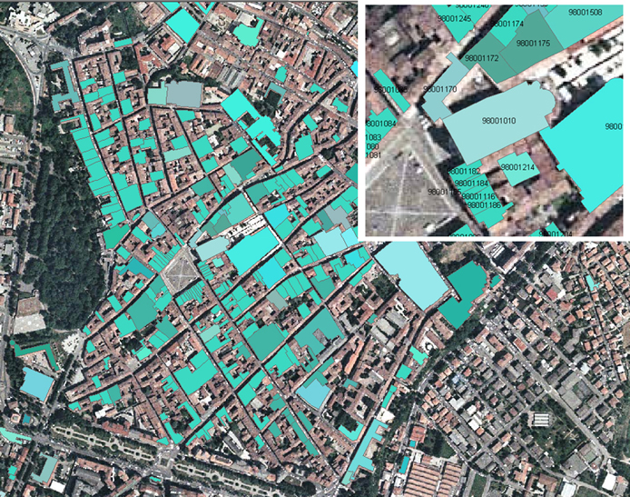
Fig. 4 Report of the first experimentation in the city of Lodi: imports in ArcGIS of the georeferenced objects of the province of Lodi. This phase has been carried out from the team of search on the base of what operators of the Province have supplied.
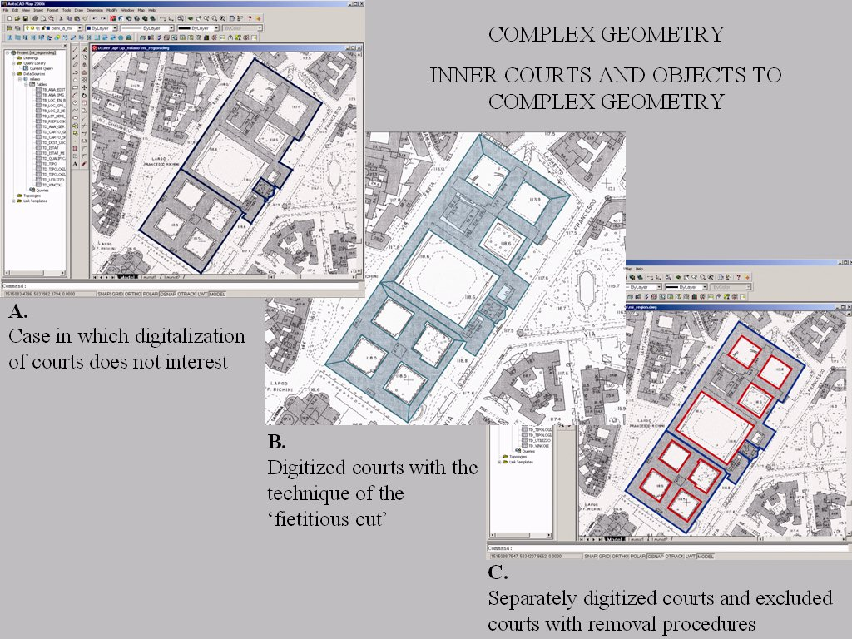
Fig. 5 Complex geometry

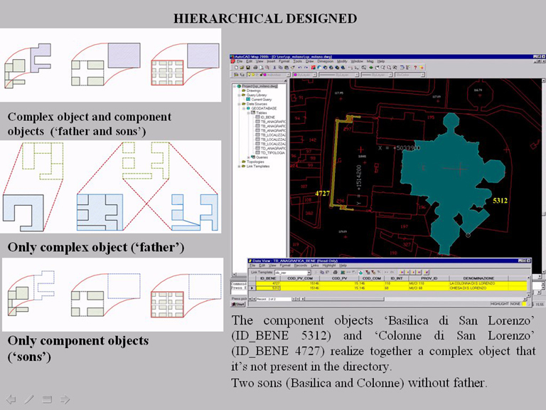

Fig.6 Hierarchical-logic structuring of the complex objects (father, son,…).

The possibility to work on virtual models of architectonic objects in the projects for understanding the potential risk represents a critical element in developing instruments to support the methodologies, monitoring the risks and planning the measures to take to prevent damage. From this perspective, one of the most complex problems is represented by the "virtualization" of the object surveyed. This problem is especially critical in the case of architectonic objects where the geometric irregularities and details of the surfaces cannot be surveyed by the scanning instruments currently on the market.
In this phase of the research, new advanced high resolution scanning techniques will be investigated and new tools for use of the laser data will be realized. The new advanced technology hardware and software can generate virtual models with high resolution characteristics.

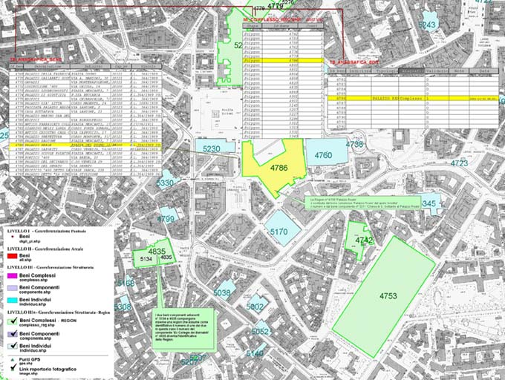
Fig. 7 Sampling of the objects in the Common of Milan. Layout about the level of the structured georeferencing (including Individual, Component and Complex object). The operating construction modalities of the Regions could be, in the future, change (considering that the functionalities of the SW GIS are in constant evolution): what it remains is the heart of the structure defined in the hierarchical-logical Phase. Besides the geographic layer of the REGION there are the geographic layers generated on the level BASE, in this case subdivided in substrates in function of the logical attribute of the single assets. The complex layer .shp exists only in the case of digitalization of the Complex object. Finaly, it will generate the complex layer complesso_reg.shp.

The lines of research clearly expressed in the title of the project have a distinct theoretical-methodological nature, a common need for experimentation on the field, and a strong application value aimed at finding feasible outlets for the proposed methodologies and their validation.
Also common is the need to clarify the essential terms of the problems by identifying several issues in the differences and methodological common bases in the extraordinary objective variety of the cultural heritage, making use of tests to confirm the methods identified.
Survey, georeferencing, multi-scale modelling, and monitoring are the lines identified a priori for the correct formulation of a risk map.

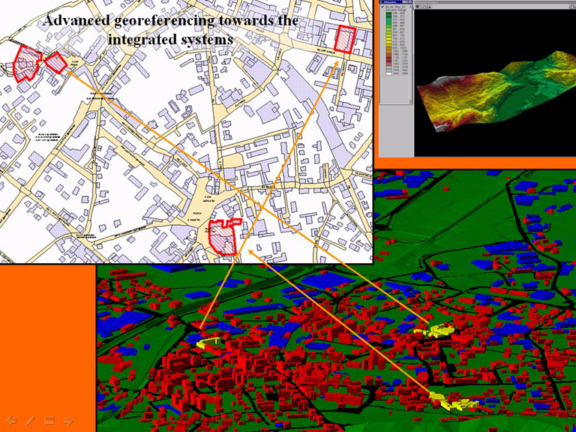
Fig. 8 Spatial definition of the information. In the concept of georeferencing, the positioning, i.e. the possibility to establish an entity with respect to a defined reference system (datum), is the foundation of the process; any data model devoid of localization becomes a product in itself, unusable in an analytical project that must interact with several areas. Georeferencing can construct a geographic structure of the data that define the model of complex reality which is projected on the macrostructure that are architectonic property or the environment.

Bibliographical references
Achille, C., Brumana, R., Fregonese, L., Savi, C., Integrated methodologies of survey (digital photogrammetry and 3D model laser scanning). The representation of the Piazza San Marco in Venice, in Atti CIPA, XVIII. International Symposium,Potsdam, September 2001

Achille, C., Brumana, R., Fregonese, L., Savi, C., Monti, G., Balletti, C., Auditore, G., Experimentation of a georeferencing methodology for the Cultural Heritage of Lombardia (Italy), Commission V Symposium, ISPRS WG V/4 – Close-range imaging, Long-range vision, Pag.429-433, Corfù Greece, September, 2-6, 2002

Achille, C., Brumana, R., Fregonese, L., Savi, C., 3D models generation from laser scanner data to support digital orthophoto 3D: the mosaic surface of the floor of S. Marcus Basilica in Venice, Commission V Symposium, Atti ISPRS WG V/4 – Close-range imaging, Long-range vision, Pag.423-428, Corfù Greece, September, 2-6, 2002

Achille, C., Brumana, R., Fregonese, L., Savi, C., Laser Scanner, GIS, modelli integrati per il rilievo, la gestione e la georeferenziazione dei Beni Culturali, V, Rivista dell'Agenzia del Dipartimento del Territorio, n. 3., R oma 2003, pagg. 23-43

Baehr, H. P., Documentation of Cultural Heritage Integradet in 3D Urban Information System, in Atti CIPA, XIX. International Symposium,Antalya, September_October 2003

Bur, D., Perrin, P., Fuchs, A., Germonprez, V., Laser Scanning as a Tool for Archaeological Recostitution: A Gallo-Roman Temple in Naix-aux-Forges, France in Atti CIPA, XIX. International Symposium,Antalya, September_October 2003

Brumana, R., Fregonese, L., Monti, C., GIS and multimedia network for cultural heritage: teaching experience, Atti Geo-Spatial Education, Hong Kong Convention and Exibition Centre, Hong Kong 6-8 luglio 2000

Burrough, P., McDonnel, A., Principles of Geographical Information Systems, Oxford University Press, Oxford, 1998

LI Deren, The Integrated Spatial DataBases in 3D visualization GIS, Atti ISPRS, International Workshop on "Dynamic and Multi-Dimensional GIS (DMGIS), Beijing, China, 1999

Karsli, F., Ayhan, E., Tunc, E., Building 3d Photo-Texture Model Integrated whit GIS For Architectural Heritage Conservation, in Atti CIPA, XIX. International Symposium,Antalya, September_October 2003

Kunze, Thomas., From 3D-Laser-Scanning to Electronically Controlled Reproduction of scultures in Natural Stone-A New Service for a More Efficient Monument Restoration, in Atti CIPA, XVIII. International Symposium,Potsdam, September 2001

Monti, C., Brumana, R., Achille, C., Fregonese, Savi, C., Agile services distribution: architectures to support WEB GIS, Atti ISPRS, International Workshop on "Dynamic and Multi-Dimensional GIS (DMGIS), Beijing, China, 1999

Sechidis, L., Tsioukas, V., Patias, P., Geo-Referenced 3D Video as Visualization and Measurement Tool for Cultural Heritage, in Atti CIPA, XVIII. International Symposium,Potsdam, September 2001

Research contract (pursuant to Law 1089/39) with the IRER (Lombardy Regional Institute of Economic Research) on the issue of inventorying and georeferencing protected cultural objects sited in Lombardy. There are 10,000 such protected objects and another ten times as many buildings of historic and architectonic interest outside the protection. This research study emphasized the correctness of the themes studied by the Cofin02 and at the same time, emphasized other very different problems, ranging from the ample space dedicated to survey procedures, digitalisation, georeferencing, classification, and the need to apply new instrumental survey technologies, in addition to applicability of appropriate existing maps to prepare the so-called Risk Map by inserting georeferenced objects.

