THE APPLICATION OF THE GIS FOR THE ADEQUATE CHOICE OF GARBAGE DUMP
B.CHORFA
Engineer
National Center of Space Techniques
boualem_chorfa@yahoo.fr
CNTS, Oran – Algeria (0031200)

Key words : Spatial Analyses, GIS, Thematic Cartography, Planning of Territory, Garbage Management.

Summary

According to specialists, the ground will become a large dustbin in the ten centuries to come. The biodegradable natural substances are replaced more and more often by aluminium, the plastic and other relatively new substances. Today, the existing discharges arrive at saturation because of the produced enormous quantities. However, the majority of the governments continue to worry more about storage reduction of garbages.
In this context, and an aim of contributing to find solutions to this problem, one calls upon the techniques of GIS by the application of this approach which is based on a grid of multi-criteria analysis:
- Proximity of the dwellings and the residents.
- Sensitivity of the landscapes and the natural environments.
- Sensitivity of subsoil waters.
- Sensitivity of surface water.
- Cut discharge.
- Age of the discharge.
- The transport of waste.
The establishment of this approach is made on the commune of Aïn el Aouda, the choice of this commune is due to its geographical situation (commutes insulated) on the one hand, and of its characteristics on the other hand (small surface, data relatively available). In this work, one used the software Arc view like integrator, it constitutes a platform adaptable to our problems and the data available. This project also implements the techniques of the training and those of the networks of neurons, for the validation of the weighting coefficients on the rules of choice of the sites of the dumps starting from examples available to Morocco.

1. Problematic

The more one consumes and the more one produces garbage , today, the average production per capita in the world is about 450 kg of domestic garbage per year, that is to say 1,2kg/day [ www 1 ] (in Morocco it is of the order 0,61 kg/day [ 1 ]).During the 25 last years, the quantity of domestic garbage received by the collective installations has triplet. According to this estimate, the quantity of garbage in the world, is in continuous increase [ www 1 ].

The refuse is responsible for very important damage which threatens at the same time the human life, the possessions and the environment. They are responsible for degradation, of the cleanliness of the cities and the beauty of the landscapes. This garbage is also factors of risks for the soils, water and the air.

Therefore, the reduction of production of garbage , selection of the adequate sites for the garbage dumps, and the elimination of those which are inadequate, are essential and that is the business of all: public authority, local communities, industrial, individuals, etc...

In this context, and to combat the risks caused by garbage , an approach of feasibility, presented by this study, should make it possible to sit a strategy of prevention centered on the contribution of the modern techniques of observation and analysis of space such as the remote sensing and the Geographical Information Systems (GIS).

More specifically, and in order to achieve this goal, an installation of a computerized decision-making system for the adequate selection of the sites of deposit of garbage , is aimed by the means of this project.

2. Methodological Approach

A computerized decision-making system for the selection of the sites of deposits of garbage is the prime objective of this methodological approach. This one called upon the development of rules of choice of the sites by combining the various techniques of the multi-criteria and space analysis available in a geographical information tool.

This approach makes it possible to the user (decision maker) to ensure the transparency of the elements having led to the choice of the sites through an interactive system. It is a question of finding in an explicit way the technical parameters (geological, hydrogeologic, hydrographic...), environmental (protected zone, conditions of road traffic, proximity of the suppliers of garbage , visual exposure) and social (special interest groups, sensitivity of the population) having allowed the selection of the sites and being able to compare them with sites not selected.

In this approach, we try, starting from an integration in a GIS the data coming from multiple sources (cartographic data, statistical data, derived data and auxiliary data) to chart the adequate site for a garbage dump, by exploiting the various functionalities of crossing of information and analysis of this tool.

The choice of a site of the garbage dump must meet the laws and standards in force. It depends on the following parameters:

- Direction of the dominant winds: it gives an idea on the place where it it dump can be installed, so that the agglomeration is protected from the odors and biogases from the refuse.

- The nature of ground of the site: this information is available by the availability of the geological maps of the zone. From the latter, one can draw the type of adequate ground for a dump, in order to protect the underground tablecloths located in the zone and according to laws' from installation of a dump. The ground must be impermeable, in general of type argillaceous or rock.

- The land statute of the site: the from an economic standpoint, and to minimize the cost of the installation of a garbage dump, it is preferable to choose the domanial sites and to avoid to the maximum all that is private.

- Natural cover: the knowledge of the nature of soil occupation permits to avoid all agricultural and forest earths as well as the appreciable zones (rivers, coasts…). Also, one must take all measures of struggle against the pollution of soils of a quoted, and resources in water (superficial aquatic surfaces and the underground tablecloths) by the deposit of garbage of the other quoted. Therefore, it is necessary to take account of all geological data, hydrogéologique and hydrographic of the zone.

- The visual exposure: in order to preserve the esthetics of the city and to preserve the beauty of the landscapes, it is necessary that the garbage dump is far away from the special interest groups (agglomeration). This distance of distance of garbage dump is described by the laws of the installation of territory. It is fixed according to the contact with the various agencies of environmental protection between 5 and 10 km.

- The slope of the ground: in order to facility the discharge of the refuse on the dump itself on the one hand, and to weigh down the flow of the lixiviats¹ in the seasons of strong pluviometry on the other hand, the slope of the ground for a dump is fixed at 5% to the maximum.

- Surface of the site: it is proportional to the number of inhabitants and the volume of production of garbage by inhab/day. Also the growth rate of the population of the area must be taken into account in order to estimate the capacity and the age of activity of a garbage dump.

- Transport: it is necessary to choose the shortest way to win the time and to minimize the cost of transport of the refuse to the dump in question.

¹ the lixiviat, sometimes called washed, percolat or ' juice of dépotoir' designates the aqueous liquid descended of residues of their biodegradation and the percolation of waters through garbage [7].

3. Bibliographic research and investigation on the terrain

This study requires an intense research bibliography on the zone, and the reinforcement of the latter by an inventory of the natural environment, plus an investigation on the terrain, this enables us to estimate the surface, the capacity, the age and the forecast of the adequate place for a garbage dump; all that is according to:

- The number of inhabitants and their ways of life.
- Method of garbage collection (van, cart...).
- Existing infrastructures (markets, restaurants, stations road...).
- The volume of garbage produce.
- Characterization of garbage.
- Existing road infrastructures.

3.1 Estimate of the garbage production

In order to estimate the surface, the capacity and the age of a garbage dump for an agglomeration, it is necessary to evaluate the weight and the volume of the garbage produced by this agglomeration. In the general case, the volume of garbage produced by an inhabitant per day in the world is different between the developed countries and the countries of the Third World, this daily volume are fixed on average at 1.2 kg per capita [ www 1 ]. For Morocco it is about 0.61 kg/inhab/day [ 1 ].

Therefore, to evaluate the volume of domestic garbage for an agglomeration, it is sufficient to multiply daily volume by personne/day by the population (the most recent census) and by 365 days.

3.2 Estimate of the surface reserved for the domestic garbage

According to my research in the framework of this study and the various contacts with the specialists in the field of the environment, the surface reserved for domestic garbage produce by an inhabitant and per year is 1m². In order to avoid the problems caused by the saturation of the dump, it is necessary to fix for this last one duration of maximum activity, this duration is fixed according to specialists' in the environment at 40ans.

Therefore, the surface of a garbage dump (S) for an agglomeration of population (P) with a growth rate (T) is:

S = P(1+T)⁴⁰

4. Methodology (scenario)

This stage consists in checking the conditions of the installation of a garbage dump, analyzing each data available and combining all the data, according to the criteria which meet the laws and standards of installation of a dump, in order to achieve the final goal of this approach.

  - The direction of the dominant wind

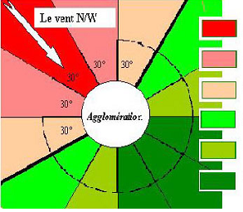

To protect the city against the odors and biogas from garbage , it is necessary to hold account of the dominant winds in the area, this wind presents the principal factor of propagation of the harmful odors at the inhabitants of the agglomeration. Therefore, the knowledge of the dominant winds makes it possible to indicate the sector where one must deposit the garbage dump. As is indicated by the diagram below: the dominant winds come from the North-West.
Acceptable sector
Unacceptable sector
Figure 1 : The dominant wind factor.

  - The remoteness of the city

After the determination of the adequate sectors for a dump according to the direction of the dominant wind, one passes to the remoteness compared to the agglomeration. This distance of the remoteness is given in accordance with the standards of regional planning. As already specified, this distance is fixed between 5 at 10km.

GIS Operation

- Creation of two buffer zones on the last result:
- Buffer of 5km.
- Buffer of 10km.
- The geometrical subtraction of the two buffer zones.
- Creation of a layer for the result obtained, layer " remoteness".

In this manner, one specifies exactly a part of the zone which presents sector favorable (sector of ring with a width of 5km) for a dump, on which one applies the different previous criterias.

Remark: From that point, and to create the Digital Terrain Model (DTM) and the other layers derivatives, the digitalisation of level curves, the quoted points etc…, will only make himself on the favorable sector determined by the two previous criterias and this in order to win the time and to give a rhythm accelerated for the gait of the project, because it is useless to take in consideration all the zone.

  - Identification of the acceptable zones

To find the adequate soil for a dump, it should be shown that there is no vegetable, aquatic resource (superficial or underground) or faunistic on the ground. In addition, no archaeological or patrimonial resource was identified on the terrain. In the contrary case, it is necessary to create buffer zones around these resources.

  - Land statute

according to the laws of regional planning which stipulate that the installation of a garbage dump is preferably on a domanial ground and that is a free ground of construction with a surface (S) such as:

S = P(1+T) ⁴⁰ with: S: surface of the dump.
P: population of the agglomeration.
T: the growth rate of the population per year.

  - The hydrographic network

to protect natural cover from the zone in particular aquatic surfaces such as the rivers, the lakes and everything that constitutes the hydrographic network against the lixiviat generated by garbage, , one will create buffer zones around watery surfaces available in the area. According to the protective agencies of the environment, any installation must be distant at least from 500m of aquatic mass.

  - The type of the ground for a garbage dump

the choice of dump must also take into account the impact on the underground tablecloths, as it is necessary to base on the premise, than this dump can attenuate and manage in a constant way and control the infiltrations generated by garbage which will be deposited there in the future.
From the geological data on the ground one makes a total selection of all the impermeable grounds of types argillaceous and rock, not to infect the underground tablecloths.

  - The nature of surface for a garbage dump

afterwards the knowledge of the soil types for a garbage dump of the preceding stage, it is necessary for us to know their nature of surface such as their slope. The GIS tool gives the possibility of generating this information starting from a Digital Terrain Model (DTM). This last presents the layer of information showing the morphology of the ground and is considered like one of most important in the setting up of a GIS [3].
In this approach, the generation of this layer by a GIS is done by the digitalization of the level lines and the points, and the use in general of the structure of network of irregular triangles (Triangular Irregular Network). The structural elements of the model (faults, lines of changes of incline, zones plane) will be taken into account.

In order to facilitate the movement of the vehicles of discharges on the zone of the dump, it is necessary to take into account the optimal slope for a truck charged with refuse and which is considered lower or equalizes to 5%.

Obtaining the DTM will make it possible to derive from them the useful layers of information for the choice from an adequate garbage dump, such as the layer of the slopes. Therefore, on the latter and thanks to the functions of GIS one makes a filtering of all the slopes superior than 5%.

  - Transport

At the end the application of the different previous criterias and thanks to the GIS tool one gets separated several sites in general and that verify all conditions, for it one puts a last criteria on the transportation in order to finaliser on only one adequate site..

This criteria is going to help concretely to minimize the time and the cost of garbage transportation, therefore it is necessary to choose the shortest path.

5. Case Study (The Township of Aïn El Aouda)
  - The geographical situation

In order to validate our approach one chose the zone of Aïn el Aouda like a zone of application, this zone is delimited by the parallels 33° 45' and 33° 50' Northern in latitude and the meridian lines 6° 45' and 6° western 50' in longitude. It is limited to north by the township s of Youssoufia, Yacoub El Mansour and Temara, with the south and the west by the province of Benslimane and with the east by the province of Kemisset.

  - The Township of Aïn El Aouda

The township of Aïn el Aouda located at less than 25 km of Rabat with a surface of 175 ha a population of about 20000 inhabitants [ monographic card of the township ] and a growth rate of 1.6% per year.
The majority of the inhabitants of Aïn el Aouda have various economic activities, with a standard of living in general average.

According to the visits which were made on this township ; the architecture of Aïn el Aouda is of type `` houses séparées`` with a simple division represented in some districts lengthened according to the road which connects Rabat, Rommani.

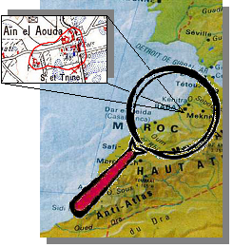
Existing infrastructures in this township represented in two administrative infrastructures (the seat of the commune and an appendix of civil protection), only one educational infrastructure (official primary school) and a small open market (Souq At Tnine).
Figure 2: Geographical situation of the township of Aïn el Aouda.

  - Estimate of the production of garbage

In order to value the weight and the volume of garbage products, one received some official data on the township of Aïn Aouda el (card monographique), but in order to have some concrete numbers one to extrapolated in continuation these data on the basis of the experience acquired at the time of the visit instead and while doing reference to the bibliographic existing scientist.

The commune of Aïn el Aouda doesn't possess a balance to measure the quantities of garbage deposited in the discharge. In absence of the exact statistical methods for the evaluation of garbage produced, we made an evaluation per capita on the basis of a daily production hypothesis.

Let us announce that is impossible to quantify quantities of different infrastructure garbage separately notably the administrative infrastructures of domestic garbage. Seen the number reduces these infrastructures in this township, the quantity of garbage produced by these last is sent with the domestic garbage.An evaluation of the quantity of domestic garbage produced to been done there by introverted data extrapolation and on the theoretical knowledge basis.

One to mentioned already, that the middle quantity of domestic garbage for Morocco is the order of 0. 61kg/inhab/day [1]. One kept this middle quantity for our application and one extrapolated this daily quantity for the totality of population of the township of Aïn el Aouda.Therefore, the total production in solid garbage for this township of population 20000 inhabitants (census 1994) is estimated at 12.20 tons/day.

For the 40 years to come the quantity from garbage of this township will be: Q = P ₄₀ * 0.61*365.

The population in the 40 years to come is: P ₄₀ = P(1+T) ⁴⁰ = 20000 (1+1.6%) ⁴⁰ ≈ 37738 inhabitants.

Q = 37738*0.61*365 ≈ 8402366 kg = 8402.366 tons.

Surface reserved for this quantity: as already mentioned, the surface reserved for the quantity of garbage produced by an inhabitant is 1 m ² , thus the surface reserved for the quantity of garbage in the 40 years to come is about 37738 m ² ≈ 4 ha.

  - the setting in discharge

The township of Aïn el Aouda uses the municipal discharge of Oued Akrech currently, this deposit of garbage it been put in place since several years without taking in consideration of measures and the scientific criterias. Currently, this dump represents really a source of harmful effect for the agglomerations bordering, because of insufficiency of its capacity and its seniority. In this optics, and like a solution to this problem, one will reduce the pressure on this dump by the creation of a new dump for the township of Aïn el Aouda, which meets the standards and of the criteria study scientifically and in bases itself for that on the GIS techniques.

In order to validate the adopted approach, the application will be led under the Arcview® environment, this software GIS makes it possible to adapt with our problems and to the data available.

The existing maps are the sources essential with the construction of our GIS, and the creation of the various layers. The geometrical unit is built starting from the digitalization of various information being reproduced on these maps and which appearing to be useful for our application.

Before their final storage and their use for purposes of analysis, the space data underwent preprocessings: creation of topology, conversion of structure of the data, unification of the system of projection [ 3 ].

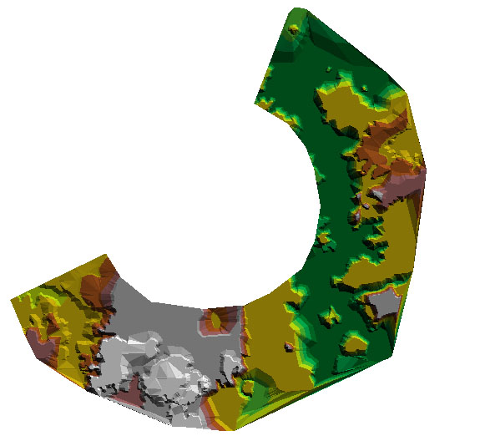
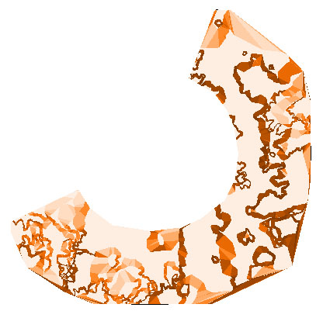
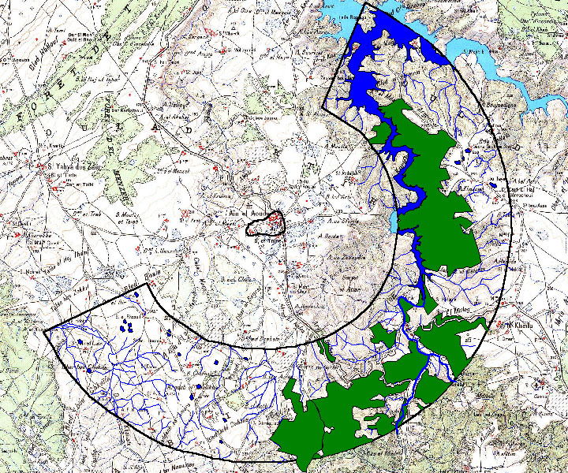
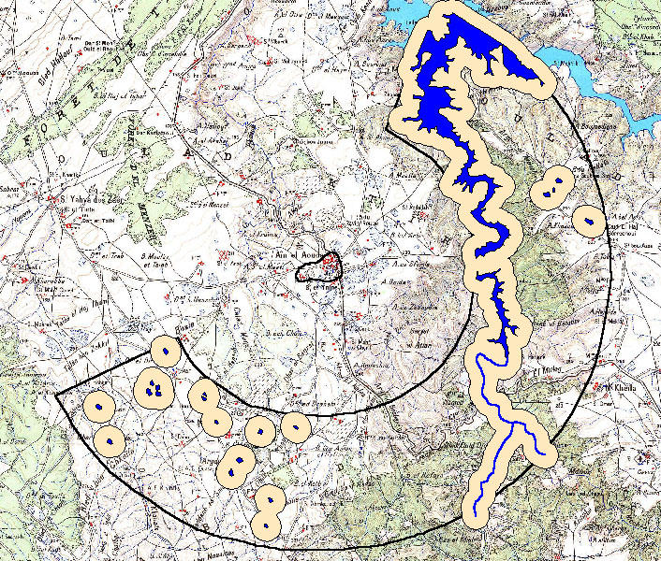
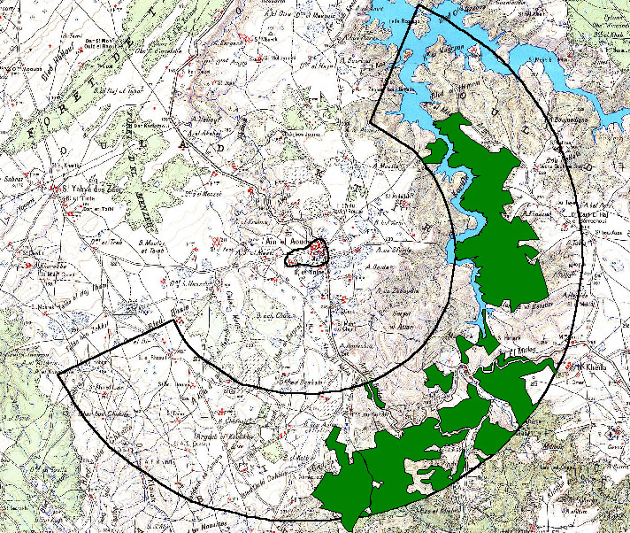
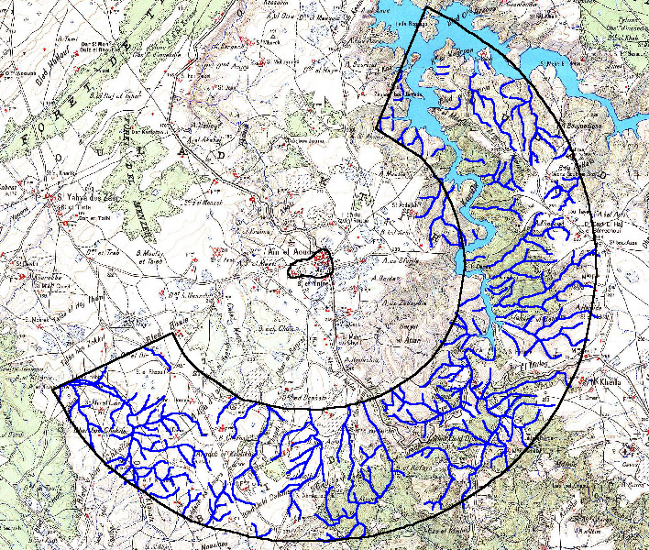
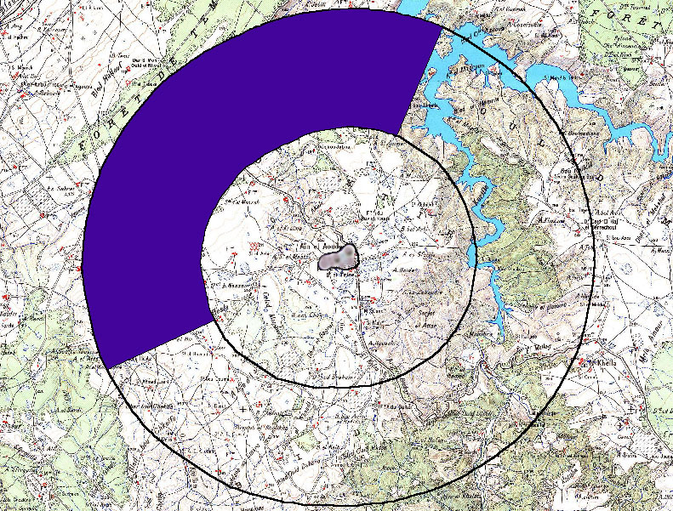
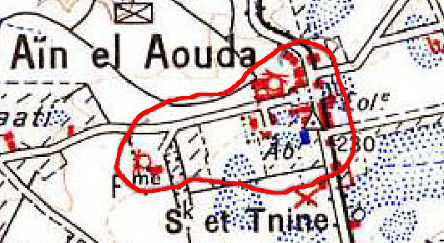
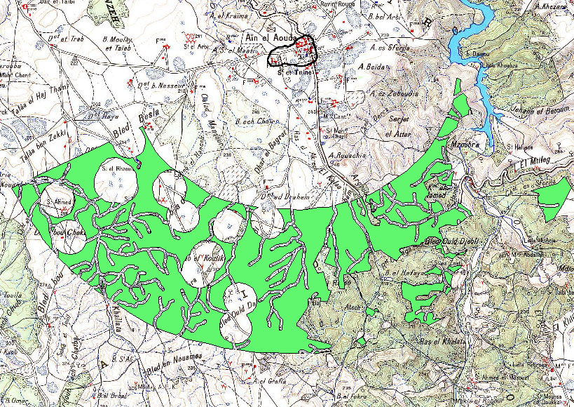
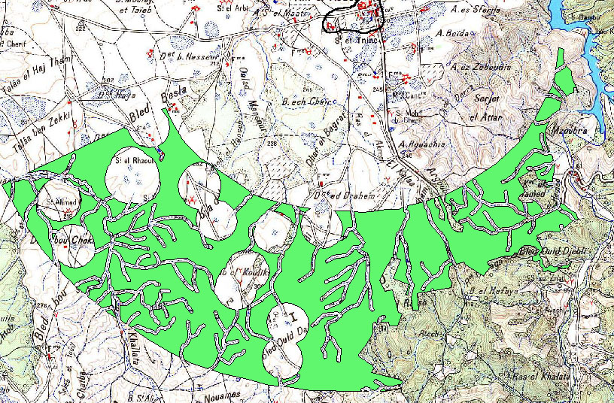
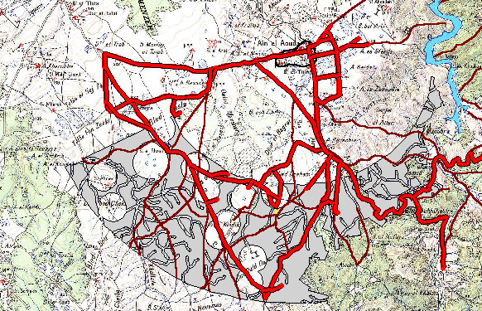
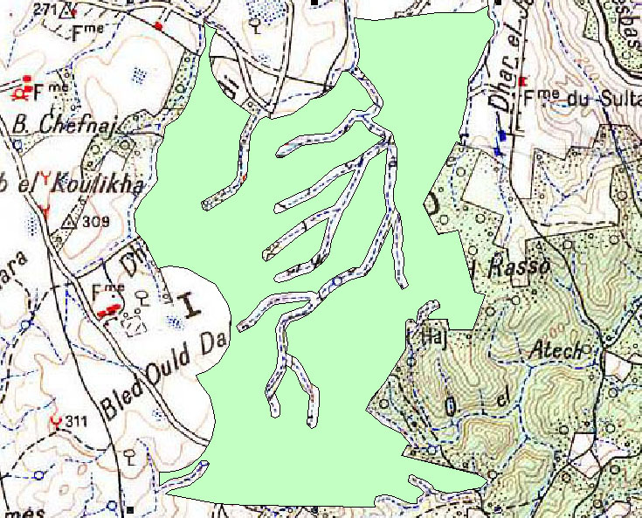
Delimitation of Appreciable zone :
Forest
Dam
wadi
Affluents
DTM
Slopes Map
Création of the buffers.
The crossing of:
Buffer of the water surfaces.
Layer of forest
Layer of slopes < 5%

Slope<5%
The elimination of the zone infected by wind dominating N/W
Topographic Map Digitalization
P.C.C de Lambert .1/100.000
Delimitation of the agglomeration
Buf de 10 km

-
Buf de 5 km
Crossing
The Map Synthesis
R1 :4 ha.<= The Surface < 5ha
The Shortest Path
REQUEST : R1
Extraction of Road Network
Figure 3: The Cartographic Model
Digitalization:Curves of level, Points, Hydrographic network, Road network, Network of affluents

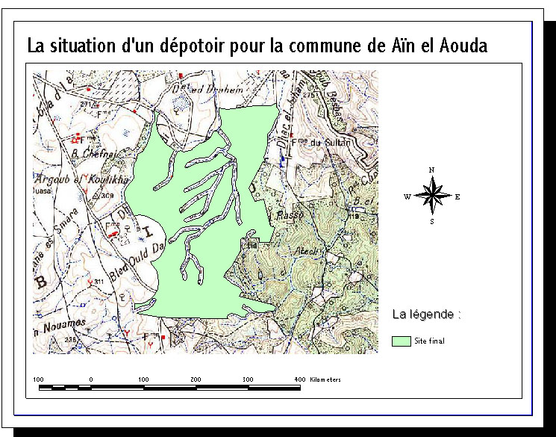
Figure 4: The final result.
The Garbage Dump situation for the township of Aïn El Aouda

Conclusion

The paramount objective of this study is to identify an adequate site for the installation of a garbage dump, by the use one of the modern techniques of the space analysis [ Geographical Information system (GIS) ], following criteria and studied scientific bases.
Certainly, this methodological approach will help the decision makers and the planners of the regional planning to make the good decisions, in order to initially preserve the health of the inhabitants and all what is natural in second place.
In this context, the decision of adequate choice for a dump, remains in the first time insufficient to protect our environment.
In the second time, it appears more convenient to reinforce this decision by all the predispositions of the population and the municipalities to combat this risk which threatens the human life and the environment. The principal predispositions suggested to with dimensions of this approach are:
- Training schemes of the population.
- The adaptation of regulation.
- The activation of the control systems.
- The application of the sanctions.

Bibliographic references

[1] Annuaire statistique du Maroc, Direction de la statistique, pp 691-694, 2001.
[2] Audit environnement de la ville de TETOUN, RESING, version provisoire, pp 75-81, Jan /1997.
[3] Bulletin Géo-Observateur N°11, CRTS, Nov / 2001.
[4] Conduire un projet de gestion des déchets municipaux, Agence De l'Envi_onnement et la Maîtrise de l'Energie (ADEME), France 2000.
[5] Déchets municipaux, Agence De l'Environnement et le Maîtrise de l'Energie (ADEME), France 2000.
[6] ESRI, Using ArcView GIS, the Géographic Information System For EveryoneTM, AC, USA,1996.
[7] Guide d’évaluation des incendies sur la sente, pp200.
[8] MARIUS THERIAULT, Système d'information géographique / concepts fondamentaux, 2^{éme} édition, Département de géographie ( Université Laval, Québec), Jan /1996.

Internet sites

[www 1] :http://www.panda.org/resources/publications/sustainability/choice_fr /page1.htm#contents
[www 1] :http://www.emse.fr/environnement/fiches/framlingk.html
[www 2] :http://www.globenet.org/preceup/pages/fr/chapitre/capitali/cas/recy_b.htm
[www 3] :http://www.ademe.fr/collectivites/Dechets-new/Politique-planif/default.htm
[www 4] :http://ecolu-info.unige.ch/~haurie/GEAT/cours6/#Evaluation du volume de déchets ménagers par commune
[www 5] :http://www.unesco.org/csi/csiinf.htm
[www 6] :http://www2.ville.montreal.qc.ca/biodome/bdm.htm

