Spatial analysis and GIS to identify the spatial concentration of the road accidents – Application to the RN11 (Western Algeria)
*Abdelkader Mendas, Samir Hamdoun
*Laboratoire de géomatique
CNTS, BP 13 Arzew 31200, Oran, Algérie
mendask@yahoo.fr

Summary

The cartography requires the use of adequate statistical methods to the risk to establish bad diagnoses. The improvement of security conditions of people using the road every day needs to know several factors, mainly the road infrastructure.
To avoid damages of accidents and to assure the comfort of passengers, it is necessary to know the real reasons provoking accidents of the road then to take the best decisions. The main objective of this study is to identify places of spatial concentration of the road accidents in black zones and to show the contribution of geographical information systems for their cartography. The use of a spatial analysis method based on the local measures of spatial autocorrelation permits the localization of these black zones.
The relevance and the efficiency of this method are taken in consideration and an interpretation of results is proposed. Geographical information systems (GIS) are used to put in place tools of follow-up and local management of the road security. Endowed of modules relative to the dynamic segmentation to study the road destinations (events) of networks, they appeared necessary for the cartography and the representation of black zones. They are powerful tools for the spatial analysis to help to the management and the decision making.
The application of the method to a section of the National Road RN11 shows its adequacy and its application to the problem of the black zones localization.

Key Words : Road accidents; Spatial analysis; Spatial statistics; GIS.

The road traffic is an essential practice to the human beings its advantages on the individuals and the community. The increase in the vehicles number related to the needs for the people displacement and the economic exchanges development involved an acceleration without precedent of the traffic, this is why road infrastructures were conceived and necessary means to their maintenance must be set up.
In parallel of the car advantages, we will find true socio-economic problems, in all the world countries, which are the road accidents. To solve these problems, in the road infrastructure level, it is first of all necessary to identify the dangerous places of the road network.
This identification is usually done by the use of the black spots approach. According to Flahaut B. (1999), the black spots are road segments (a 100 meters length) which enter at least three accidents with lesions during one year. This process does not take account of the accidents migration in the time and the identification is only prompt. For a more satisfactory identification, the places of the road accidents spatial concentration can be represented in black zones form.
Thus, the network is broken up into one hectometer length units (assimilated to a prompt entity) ; it is the smallest space unit for which the accidents data are available. The black zones are constituted of several hectometers and defined as road sections characterized by a high concentration of accidents.
The objective of this study is to propose a danger zones definition (black zones) which is based on statistical elements using the spatial autocorrelation method to show where and when a zone is it statistically more dangerous than another, to determine which length must we allot to each zone and finally, to map the black zones by the use of GIS.
Thus, are the possibilities of statistical and spatial analysis, for the spatial concentrations identification of the road accidents, which will be explored. The GIS will be exploited for the road networks management and, particulary, for the black zones representation and mapping.

Causes of road accidents in Algeria

The explanation of the road accidents number and victims is a very difficult, even impossible. The accidents result from a pluri-factorial causal process which utilizes factors relating to the implied people (conducting, pedestrian, etc), to the vehicles, to the road and its environment (road infrastructure) and to the circulation system functional characteristics. These factors are generally interdependent and combine to generate accidents. Thus, the road accidents result mainly from three fundamental elements interaction to knowing the vehicle, the driver and the road infrastructure. The table below gives, in Algeria, the number of accidents related to various causes.

Causes | Accidents Nbre | Percentage
related to the drivers | 6554 | 59,83
Related to the pedestrians imprudence | 2866 | 26,16
Related to the road state and its environment | 486 | 4,43
Related to the vehicles state | 1048 | 9,56
Total | 10954 | 100
Table I : Serious accidents annual balance sheet at the national level.
(Source: National state police (Gendarmerie) command)

The accidents data analysis shows that, in a small number of cases only, the maintenance bad condition of the vehicle appears as the principal factor. Often, the combination of vehicle dynamic behavior and the driver capacity to control the critical situation produce the accident.

Causes | 1999 | 2000 | 2001 | 2002
Related to vehicles | 40 | 61 | 62 | 32
Table II: Accidents balance related to the vehicles in Oran department
(Source: National state police road safety squadron - Oran)

The behavior of the driver can be influenced by many factors which can contribute to distort the perception of the risks or to make accept excessive risks. These latter are variable from a user to another and, for the same user, from a moment to another.
Certainley the relation between speed and the accidents is very complex but speed is an essential question in the road safety. It is considered that two laws of physics apply in this case (Maycock, 1995). The first law is that the stopping distance is proportional to the speed square. Consequently, high speeds give a strong probability to be implied in an accident. The second law say the kinetic energy is proportional to the vehicle speed square, which means that accident at high speed will imply more material and body damages. On the basis of these assumption, we deduct that if we reduce the mean speeds by 1 km/h, we will then reduce in average the wounds and the accidents to 3 % approximately (Finch and Al, 1994). An increase of 1 km/h involves an increase of 3 %. What means that minor changes in speed give considerable consequences.

Cause | 1999 | 2000 | 2001 | 2002
Dangerous overtaking | 66 | 73 | 69 | 105
Dangerous stop | 14 | 0 | 12 | 10
Excess speed | 141 | 193 | 266 | 115
Driven in drunkenness state | 36 | 43 | 69 | 28
Not respect of the highway code | 6 | 0 | 1 | 11
Give way refusal | 78 | 43 | 19 | 44
Other | 109 | 93 | 51 | 164

Table III: Serious accidents assessment related to the driver in Oran department.
(Source: National state police road safety squadron - Oran )

The driver must adapt its operations according to the road configurations variation. Indeed, all the road sections are not equivalent. The accidents concentration can sometimes find a simple explanation:
- roadway abnormally slipping, causing the vehicle control loss at the rain period,
- tree plantation meadows of the verges, which worsen the consequences of a roadway exit out,
- curve (turn) badly poured which leads the driver to lose his vehicle control.

It is thus essential that the infrastructures and their environment are conceived in order to not impose to the users excessive difficulties and to enable them to clearly perceive the requirements to which they must adapt their control, by preventing that the road does not have any misleading appearance and does not constitute in no case a trap to which the user lets himself take (Hamzaoui O, 1996). One of the road qualities will be its legibility, the facility to perceive the real risk level associated at such speed or such operation.
Of course, indication plays a significant role within this environment to supplement and specify, by its conventional signs, the situations to which the driver must be prepared. The following tables illustrate the accidents causes related to the road infrastructure.

Cause | Accidents Nbre | Percentage
Deficient roadways | 38 | 1,84
Slipping roadways | 390 | 3,56
Indication defect | 0 | 0
Animals divagation | 42 | 0,38
Bad atmospheric conditions | 10 | 0,14
Table IV: Serious accidents average annual assessment related to the roadway at the national level.
(Source: National state police command)

Cause | 1999 | 2000 | 2001 | 2002
Defective roadways | 4 | 0 | 3 | 5
Defect of indication | 1 | 0 | 0 | 0
Divagation of animals | 4 | 0 | 0 | 2
Bad atmospheric conditions | 10 | 25 | 20 | 14
Other | 10 | 2 | 4 | 14
Table V: Assessment of accidents related to the roadway on the level of the wilaya of Oran.
(Source: National state police road safety squadron - Oran)

Method and material

The best way of carrying out a long-term approach, on scientific bases, for a system implementation of basically surer road traffic, is to attack the causes which are at the accidents origin, by eliminating the conflict zones or making them controllable by the road users.
With this intention, we have several approaches. Most traditional is the accidents analysis on their sites (black spots, black routes and black zones): we seek similarities between the accidents characteristics. It should then found how to improve the road design in order to eliminate these accidents.
According to (Slop, 1993) the approach known as the "black spot" and recently the "black zones" are very effective. He recommends highly the latter estimating that it can reduce up to 50 % of the deadly accidents number and wounded.
The danger zones definition (black zones) is based on statistical elements. It is to determine, statistically, the dangerosity degree, to define the length to be allotted to each zone and to see whether it is single or variable from one zone to another.
With this intention, we uses the dangerosity measurements based on the spatial autocorrelation whose indices permit to measure the spatial dependence/association between values xi catches by the same variable X in places characterized by a certain spatial proximity.

Spatial analysis

The expression "spatial analysis" covers some theories and research methods which must be rather precisely defined and which overflow the geography limits. We distinguishe considerable spatial analysis, among which those bearing on the spatial localizations, on the spatial relations and finally on the spatial structures. It studies the distribution and the organization of objects which are localisables.
This localization is done by a géoréférence, a géocodage, which is an operation permitting to assign without ambiguity a localization with an object in a precise geographical reference system, or with an objects whole in a common system.
The spatial analysis permits, in particular, to locate the place in space where a phenomenon will occur, to study the space dimension and the localization of several phenomena at the same time and to compare the various attributes of the places studied between them, insofar as these places are comparable and finally to decide and envisage starting from the built models and of simulations permitting to test comparative qualities of the various scenarios.

Spatial statistics

Taken in its broadest methodological direction, this term indicates any analysis using the statistical tool and having a spatial dimension which concerns the tool itself, the analyzed object or the variables used like descriptor of this object. Various combinations are possible:
- Only the object is spatial;
- Localised objects and spatial variables;
- Localised objects and spatial statistical tools.

For the road accidentology study, the first stage consists in studying the road accidents spatial concentration, more precisely to identify the accidents spatial concentration zones, or black zones (danger zones). It is an exploratory study, no assumption is not still posed as for a possible explanation of the road accidents spatial distribution.
Among the most used methods, the spatial autocorrelation. It utilizes the localised objects and the spatial statistical tools.

Sspatial autocorrelation method

Space autocorrelation measurements are based on the assumption that what occurs in a given geographical place depends on what occurs in the close places. They take into account the places relative position the some in relation to the other (two close places resemble each other more than two distant?).
The space autocorrelation indices permit to measure the spatial dependence/association between values xi taken by the same variable X in places characterized by a spatial proximity. Variable X considered here is the accidents number per road hectometer. This methodology of spatial autocorrelation permits to take explicitly the distance in its formulation (a neighbors number considered as near) and to choose the length of most appropriate to reality zone (Flahaut B., 1999). The choice length is a significant aspect to take into account, Thomas (1996) showed that the road sections length choice has a strong influence to the statistical measures related on the accidents number and density. The method also permits to be adapted to the space structure observed locally, by spatial autocorrelation local measurements.

Spatial autocorrelation method choice

At the time of the spatial data observation, values xi taken by the same variable X in various places i present relations between close observations in space. According to Tobler (1970): “everything is related to everything else, goal near things distant are more related than things”.
If the xi are interdependent in space, we say data are spatially autocorrelated (Cliff & Ord, 1981). Spatial autocorrelation measurements permit to consider the spatial association/dependence/correlation between the same variable values in various space places, more or less near each other. The relation between the spatial interaction and the spatial autocorrelation was shown by Getis (Ord & Getis, 1995).
The space autocorrelation indices permit to define places wich present relations compared to two simultaneous criteria:
- spactial proximity,
- resemblance or opposition enters between same variable values in various places of the study area.

For the black zones identification on a road network, knowing that the hectometer constitutes the smallest space unit to which the accidents are located.
Thus, a road sections dangerosity indice, based to a sptiale autocorrelation measure, will be measured. The zones length (it depends on the neighbors number taken into account in the index calculation) and the zone dangerous character intensity (it depends of the index value) can be indicated .

Spatial autocorrelation indices

To permit to estimate if the set of places belonging to the study area presents spatial autocorrelation, two indices are mainly used, that of Moran and that of Geary. According to Upton & Fingleton (1985), the Moran indice is often preferred than Geary indice because there is a larger general stability.
The Moran coefficient I uses, in numerator, a covariance term weighted between contiguous observations, null covariance in spatial autocorrelation absence of, positive in the positive autocorrelation case, and negative in the negative autocorrelation; the denominator is constituted of observations variance measurement.
⎟
⎠
⎞
⎜
⎝
⎛
⎟
⎠
⎞
⎜
⎝
⎛
=
∑
∑
∑
Z²
z
z
W
S Bad atmospheric conditions ¶
i
j
i
ij
i
j
n
I
0
(1)

Where Wij: are weightings reflecting the proximity relations.
∑
∑
=
i
j
W_{ij}
S₀
(2)

x
x_{i}
z_{i}
__
−
=
(3)

x
x_{j}
z_{j}
__
−
=
(4)

Xi = variable X value in place i
Xj = variable X value in place j
$\overset{\text{__}}{x}$= Xi average value
N = place number
In the indice construction, observations average value X constitutes the reference value, it permit to determine high or low values xi. To a positive zi corresponds a high xi value, while to a negative zj corresponds a low xi value.
If the indice is negative, it translates a negative spatial autocorrelation which corresponds to a values association opposed to the item I, to which the index is measured, and to its vicinity (produced from a negative value for one and a positive value for the other, or conversely).
If on the other hand the indice is positive, it translates a positive spatial autocorrelation which corresponds to a similar values association.
For this application, of which the goal is to identify the black zones, only the last case (produced of two positive values) is interesting, since a black zone constitutes a near hectometers association whose general tendency is to present a high accidents number. Consequently, they are only the positive local indices resulting from the two positive values product which are retained like dangerosity indices for the black zones identification and the the intensity evaluation of their dangerous nature.

Weighting

Space autocorrelation measurements are always to put in relation with the corresponding space structure which was selected. Different measurements can be obtained considering different weightings matrices, and the fact of arriving at a spatial autocorrelation presence or absence conclusion for a particular structure does not mean that it will be the same for others.
Two considerations intervene in the weighting coefficients evaluation : the neighbors number of each place (i.e. the distance from vicinity, or the adjacency level) and the weights value allotted to each one of them.
Neighbors number: as we cannot choose a priori an neighbors optimal number, we will do for each hectometer i of each road a systematic and exploratory analysis to highlight the data spatial structure, i.e. to evaluate the most suitable neighbors number. To this end, zones lengths varying between 300 and 2100 meters of 200 meters (either a neighbors number varying from 2 to 20, divided in a symmetrical way on the central hectometer both sides i), are successively used to calculate a space autocorrelation local indice Ii (Flahaut B, 1999). These indices values are compared, and the neighbors optimal number is that for which the spatial autocorrelation local indice value is maximum, thus representing the best association of the variable high values between one hectometer and its neighbors (i.e. the product of two positive values). This step is repeated for each hectometer of each road, in order to determine for each one an indice value related to a neighbors number adapted to the local spatial structure.
Weightings value : with regard to the weightings value, many possibilities also exist (see in particular Cliff and Ord, 1973 and 1981, Haining, 1990). We consider weights which are a function of the distance to the considered place. Among four functions of weightings decrease with the distance (function of dij0, dij ⁻¹, dij ^{-1.5}, or dij ⁻²), we choose that which maximizes the local space autocorrelation average indice : dij ⁻². It translates kind strongest association between the accidents numbers observed in the black zones (center and vicinity). This observation is in coherence with the literature relating to the spatial interaction which generally considers that the spatial relations between places are decreasing with the reverse of the distance square, (Flahaut B, 1999).

Data processing and results

The data taken into account concern only the accidents with body lesions which took place on the road network level managed in a regional way. Indeed, this accidents type is in theory always indexed since it requires the intervention of the state polices services the farming environment and the police force in the urban environment.
This accidents type corresponds, in Oran, to approximately 465 accidents per year on average with an observed decrease in time, 1859 accidents over 3 years and half during the period from September 1999 to February 2003 according to the road safety squadron of the Oran regional state police.
On the 4430 hectometers of the RN11, only 630 are retained (availability of data). During a period of 3 years and half, 252 accidents were recorded. The accidents average number per hectometer (x_{mean}) is thus 0.4.
The road network must be numbered to facilitate the accident localization in relation to the nearest kilometric boundary-mark (kilometer point), with a 100 meters accuracy in order to be able to assign an accidents number to each road hectometer.
The road network concerned in this study makes party of Oran department, exactly on the national road RN11 which connects Oran and Mostaganem towns (see figure 1).
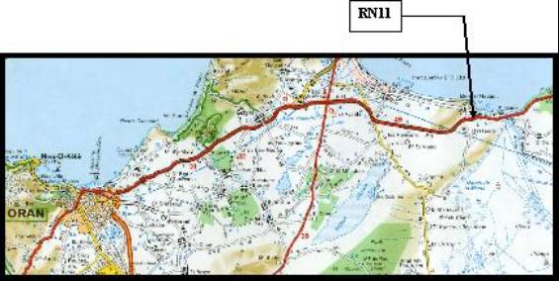

Figure 1: Study zone situation

During this study, a program called ICSAR was achieved (Road Accidents Space Concentrations Identification) calculate the autocorrelation spatial indice, the dangerosity indice and to identify the road accidents space concentration. Its application requires data on the accidents, the study zone length, the neighbor number which can be translated by a length and the exhibitor for the decrease functions.
Figure 1: plan of situation of the RN11 (1/200000)

The figure 2 shows that the dangerosity indice presents a high positive correlation with the accidents average number per hectometer and that the relation between these two variables is not linear but rather exponential. However, to evaluate the association degree between two variables, we done a transformation of the variable "index of autocorrelation" by taking his logarithm.
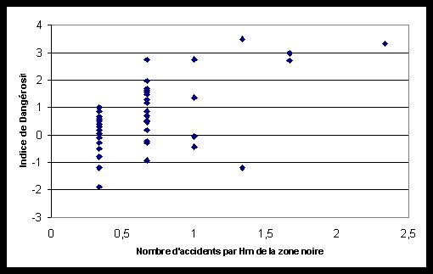

Figure 2 : Relation between the log (local AC index) and the average number accidents per hectometer of the black zone

Figure 3 represents the total autocorrelation indice according to the weight function exhibitor dij for each black zone length.
The accidents number association between an hectometer i and its neighbors is very often more intense with its immediate neighbors or those closest. It is noticed that the global indice decrease is more significant with a dij exhibitor nearer to zero and it is noted that the global indice gathers between 0.2 and 0.3 for a weak exhibitor who is -2 (see figure 3).
On this graph the spatial autocorrelation variation total indice according to the black zones length appears clearly.
In the same way, it is noticed that, for a neighbors given number, the total indice increases when the dij exhibitor decreases, and that this growth is more marked when the neighbors number is large.
Figure 4 shows that each time the black zone length increases, the autocorrelation global indice decreases.
The length choice adapted to the local spatial structure and the weightings decrease function influence with dij on the black zones determination are studied.

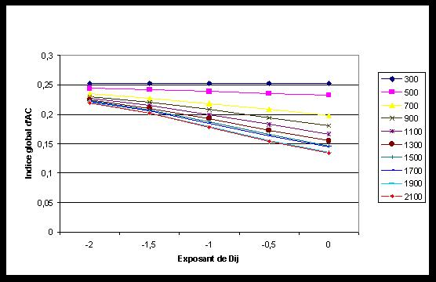
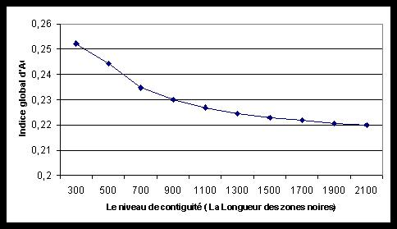
Figure 3 : Variation of the total index with the level of adjacency for various functions of decrease of weightings with Dij (zones of 300 - 2100 m)
Figure 4 : Variation of the total index of space autocorrelation according to the level of adjacency (Dij = -2)

Choosing increasingly small dij exhibitors, we can observe a reduction in the identified black zones number (see figure 5) and a reduction of their average length (see figure 6).
Since we use exhibitor equal -2, black zones identified are thus fewer than with exhibitor more large (they are longest which are not identified), their length is on average smaller and they have a high dangerosity indice. As for the space autocorrelation local indice average value (proportional to the global indice of the black zones set), it increases when the distance exhibitor decreases.

In fact the least significant black zones are not identified by decreasing the dij exhibitor.

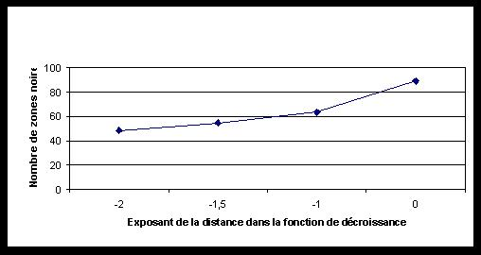
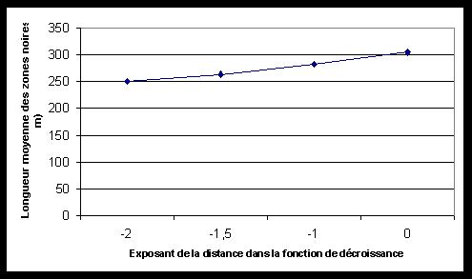
Figure 5 : Variation of the number of the black zones according to the function of decrease of weighting.
Figure 6 : Variation in the average length of the black zones according to the function of decrease of weighting .

The geographical information systems, by the module Network Analyst means of the ArcView PC software version 3.2 of ESRI used for the spatial analysis functions exploration, facilitated the black zones cartography of RN11.
In comparison with our work problems, it appears that one of the fundamental criteria of suitable GIS tool choice must be the spatial analysis operations richness which it can allow.
The Network Analyst module offers to the users the functionalities of linear networks analysis. It permits to solve many problems related to linear size data in various fields. It is equipped with a segmentation dynamic function which allowed the black zones representation on the road network.
The dangerous zones are identified with proportional weightings to dij ⁻² and classified in 3 categories (arbitrary choice). We specify that all the identified black zones do not require an inevitably installation since their dangerous nature intensity is not always sufficiently high ; 25 % of the black zones (the least dangerous) are not represented on the chart in order to better visualize the most dangerous black zones. The places set for which spatial autocorrelation local measurements are taken is constituted of the hectometers characterized by at least one accident. The hectometers without accident do not intervene in measurements.

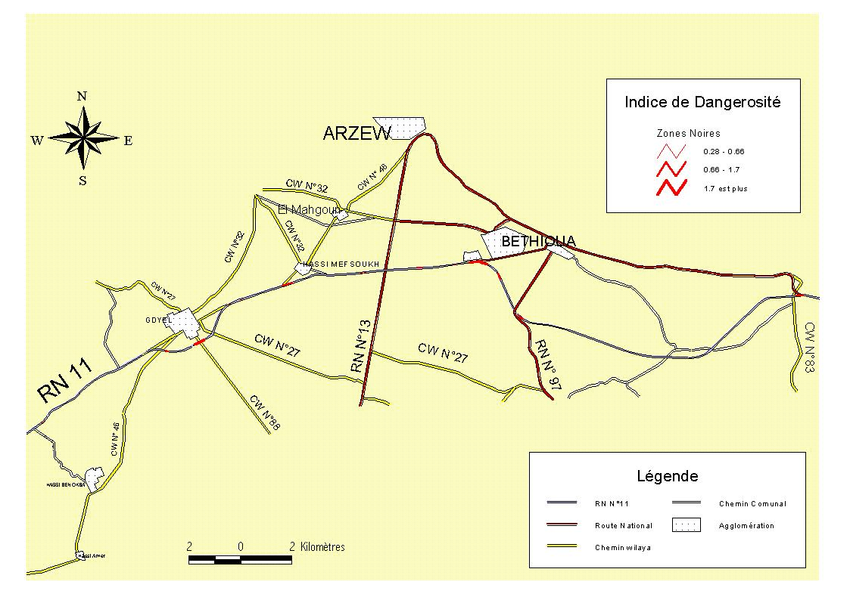

Figure 7 : Black zones representation

Conclusion

The dangerosity indice determination, calculated according to of spatial autocorrelation indices, permitted the dangerous zones identification on the national road RN11.
These indices are proportional to the accidents mean number by hectometer of every zone. A weak exhibitor choice (function of pondérations decrease with the distance) permitted to limit the identified black zone number and length.
The black zones classification according to their dangerosity indices permits to know most dangerous in order to be interested in their planning.
The ISCAR program made during this study facilitated us a lot the autocorrelation indices calculation and danger.osity indice. It is easy to manipulate and give satisfactory results.
Considering the country large surface and consequently the national road network in relation to the treated zone and identified black zones numbers (part of 63 km of the RN11 in Oran deprtement , 16 black zones), imagine the black zones number on the road network whole.
The geographical information systems, by their spatial analysis power, appear s necessary tools for a road network rational management and an assistance means to the decision-making. In this direction, the use of the dynamic segmentation available in Network Analyst module, dedicated mainly to the networks management, gave full satisfaction.
At the end, once black zones are delimited, the competent organizations, can even must concentrate on the first black zones classified more dangerous to treat them and arrange them.

References

- ANSELIN L., 1995. Local Indicators of Spatial Association - LISA, Geographical Analysis : 93 - 115.
- CLIFF A.D. and ORD J.K., 1981. Spatial processes. Models and applications, London - Pion; 266 p.
- ESRI, 1996. ArcView GIS, The Geographic Information System for Everyone, GIS by ESRI, Using ArcView. Environmental Systems Research Institute, Inc. ; 349 p.
- ESRI, 1996. ArcView Spatial Analyst, Advanced Spatial Analysis Using Raster and Vector Data,GIS by ESRI, Using ArcView. Environmental Systems Research Institute ; 147 p.
- FINCH D.J., KOMPFNER P., LOCKWOOD C.R. & MAYCOCK G., 1994. Speed, speed limits and accidents : Project report, Transport Research Centre, Crow Thorne ; 58 p.
- FLAHAUT B., 1999. Influence de l’aménagement du territoire sur la sécurité routière durable. Analyse de la situation belge. Rapport de recherche inédit, Louvain la neuve ; 54 p.
- HAINING R., 1990. Spatial data analysis in the social and environmental sciences, Cambridge, University press ; 409 p.
- HAMZAOUI O., 1996. Réalité de la prévention et de la sécurité routier en Algérie. 2^{éme} Congre Algérien de la Route : 156 - 163.
- MAYCOCK G., 1995. The effect on accidents and injuries of excess and inappropriate speed. Contribution to the ETSC-symposium: Reducing speed-related casualties. The role of the European Union, ETSC, Brussels.
- ORD J.K. & GETIS A., 1995. Local spatial autocorrelation statistics: distributional issues and applications, Geographical analysis : 286-306.
- SLOP M., 1993. Low-cost engineering measures to improve road safety in Central and Eastern European Countries, A-93-25. SWOV, Leidschendam.
- THOMAS I., 1996. Spatial data aggregation: exploratory analysis of road accidents, Accident Analysis and Prevention: 251-264.
- TOBLER W.R., 1970. A computer movie simulating urban growth in the Detroit region, Economic Geography, Supplement : 234-240.
- UPTON G. & FINGLENTON B., 1985. Spatial data analysis by example, New York, Wiley.

