Quantitative Estimation and Modelling of GPS
Carrier Phase Multipath Signals

K. K. Fan and X. L. Ding

Department of Land Surveying and Geo-Informatics, The Hong Kong Polytechnic University,
Hong Kong

Key words: GPS, carrier phase, multipath, Electromagnetic Modeling

ABSTRACT
The Global Positioning System (GPS) has been shown to be capable of supporting a wide variety of exciting applications. However, multipath is a dominant error source in the widespread use of GPS in real-time operations for general surveying and monitoring applications.

Objective of this project is observing effects of carrier phase multipath in urban environment. GPS multipath signal propagation model is presented. Visualization and the generation of multipath errors in urban environment are provided. Estimated multipath error results are presented and further analyzed with the field test data. By estimating and modeling of carrier phase multipath, a better understanding of the characteristic of the multipath can be achieved.

In this project, Electromagnetic Modeling technique is described and used as the mathematical basis for quantifying and modeling carrier phase multipath error parameters, where the characteristics of the different multipath signals are handled separately. Wireless Insite and MATLAB software will be used for modelling and processing the data respectively. Static multipath modelling studies in roof environment of The Hong Kong Polytechnic University will be carried out. Selected measured and estimated multipath error results will be presented and compared.

1 INTRODUCTION
The Global Positioning System (GPS) has been shown to be capable of supporting a wide variety of exciting applications. However, multipath is a dominant error source in the widespread use of GPS in real-time operations for general surveying and monitoring applications.

Multipath is the phenomenon in which a signal arrives at an antenna via several paths due to signal reflection and diffraction. GPS carrier phase measurements are affected by multipath signals that can significantly affect the quality of data used for static and kinematic positioning applications. In the receiver, multipath is characterized by four parameters, all of which are relative to the direct signal. They are amplitude of the reflected signal relative to direct signal, path delay, phase of the reflected signal relative to direct signal and phase rate [5].

Researchers have done a number of investigations on GPS carrier phase multipath effects based on hardware technique. Multipath Estimating Delay Lock Loop (MEDLL) technique [25] has been developed for estimating multipath signals to mitigate both code and carrier phase errors. [16] developed Multiple Signal Classification (MUSIC) technique with multiple antennas to mitigate code multipath and with a MEDLL receiver . [7] simulated multipath error by Advanced Strobe Correlator. [20] derived spatial correlation of the multipath error between multiple closely-spaced antennas. [4] developed a method for the absolute field calibration of multipath by decorrelating the multipath through controlled motion of a robot.

Some researchers used data processing technique to identify multipath errors. Multipath was identified by looking at the difference between L1 and L2 phase observations [8]. [1, 2, 24] used Signal-to-noise (SNR) information to estimate multipath. [5, 26] analyzed carrier lock loop behaviour in the presence of multipath. [14] developed phase and amplitude multipath error maps for a modeled antenna and environment based on geometric diffraction theory methods. [10, 27] have used parabolic equation method for propagation modelling of GPS signals and multipath. [11] used semi-parametric models and the penalized least square method to model the multipath. [22, 29] have used wavelet algorithm to reduce multipath. [12] modelled modernized GPS signals to mitigate the multipath which are from nearby reflective objects mainly.
Modelling of carrier phase multipath signal using Electromagnetic Modeling technique appears to be another good approach especially in urban environment. GPS multipath signal propagation model can be visualized in an urban 3D model. Parameters used for characterizing multipath can also be estimated using EM technique.

2 REVIEW OF GPS SIGNAL
The carrier phase is a measure of the phase of the received satellite signal relative to the carrier phase generated by the receiver at the reception time. The measurement is made by shifting the receiver-generated phase to track the received phase. Measuring the carrier phase is to measure the fractional phase and to keep track of changes in the cycles.

In units of cycles the equation for the carrier phase L1 is
(1)
where
Geometric vacuum distance that is computed from the receiver coordinates and satellite coordinates
Integer ambiguity
Ionospheric L1 carrier phase advance
Tropospheric delay
Receiver hardware delay
Multipath delay
Satellite hardware delay
L1 phase measurement noise (< 0.01 cycles)

In units of lengths, the above equation for the carrier phase L1 is multiplying with and becomes:
(2)
If two receivers k and m observe two satellites p and q at the same nominal time, the double-difference phase observable is
(3)
where

Relative positioning is very useful in surveying since most of the errors can be cancelled. In double-difference observation, receiver clock errors, satellite clock errors, receiver hardware delays and satellite hardware delays are cancelled. Ionosphere and troposphere are highly correlated over short distances, most of their delays are common to both stations. However, multipath does not cancel in the double-difference observable since it is geometry dependant.

3 MULTIPATH EFFECTS ON CARRIER PHASE
Carrier phase-based precise positioning is widely used in attitude and orbit determination, geodesy, deformation monitoring, survey applications, Real-Time Kinematics (RTK) positioning for machine guidance, and other high-accuracy applications [12]. The influence of multipath signals on carrier phase measurements is one of the limitations to achieve high accuracy positions. The effect of multipath on carrier phase signal can be depicted in phasor diagram as shown in Figure 1.

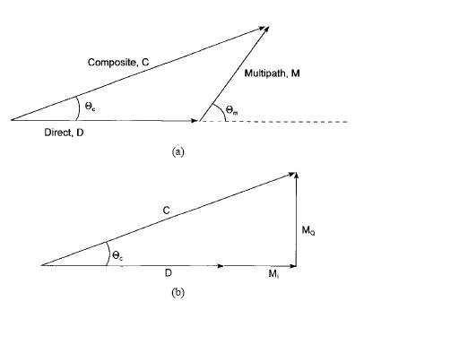
Figure 1: Relationship of direct signal and multipath signal in phasor diagram [6]
The magnitudes of the direct and multipath phasors are given by
(4)
(5)
where
is the prn code autocorrelation function as a function of lag
is the multipath delay relative to the direct signal
is the ratio of multipath signal strength to direct signal strength

is the relative phase between the direct signal and multipath signal. is the phase difference between the direct signal and composite signal. In order to determine an upper bound, relative phase rate between the direct signal and multipath signal is assumed to be zero. Multipath phasor is then decomposed into its in-phase and quadrature components, as shown in figure, for the purpose of deriving the equation for the arctangent of .

(6)
which can be written into another form
(7)
By dividing the numerator and denominator of the equation (7) by and describing as , the equation results:
(8)
Carrier phase multipath error due to n multipath signals can then be described as a function of the excess signal path (multipath delay), the ratio of direct signal amplitude to indirect signal amplitude (damping factor) and the carrier wavelength. By assuming negligible the multipath relative Doppler, the expression for the error in the carrier phase due to n specular multipath signals is [16]:
(9)
with
- damping factor (ratio of the multipath amplitude to the constant part of the direct signal)
- multipath delay [m]
- carrier wavelength [m]
, where is the amplitude of the reflected signal and is the amplitude of the direct signal
is the multipath phase shift of the ith multipath
The reflected signals are always delayed relative to the direct signal as they travel longer paths in environments. The maximum possible multipath errors on carrier phase observations can reach 0.25, i.e. 4.7 cm or 6.1 cm for L1 or L2 respectively [26]. For linear combinations of L1 and L2, multipath errors can be correspondingly smaller or even larger. In static observation, satellite is moving although the antenna and reflector remain unchanged, the multipath effect in carrier phases shows a cyclic behaviour. Typical periods are between 15 and 30 minutes, depending on local reflectors [23].

4 MODELLING OF GPS CARRIER PHASE MULTIPATH
Computational electromagnetic modelling technique is powerful to solve electromagnetic problem as they calculate the solution to a problem based on a full-wave analysis. Modelling can be used to study the propagation of GPS signals as well. The size of domain of one of the important factors for modelling of GPS signals. Special attention about its domain size should then be paid before applying the EM modelling technique.

Geometrical Theory of Diffraction (GTD)/ Uniform Theory of Diffraction (UTD) is one of the EM modelling techniques. The GTD technique provides a high frequency approximation solution of the Maxwell’s equations to the electromagnetic fields including direct, reflected and diffracted signals [15]. This method is suitable for the case when the dimensions of objects being analysed are large relative to the wavelength of the field. Detailed geometry information is required before giving out the solution. Difference between Geometrical Theory of Diffraction (GTD) and Uniform Theory of Diffraction (UTD) is that the later method implements the improvements to the diffraction coefficients of the former method.

Although different EM modelling technique can be used to study the GPS propagation theoretically, as I mentioned before, the size of domain is one of the important factors. Because of the size of the buildings compared to the wavelength at wireless frequencies, direct numerical solvers of Maxwell’s equations, such as the finite element and finite difference methods, involve too many unknowns to be feasible at this time. From the practical point of view, the high-frequency techniques like GTD/UTD and the parabolic equation method are more suitable for modelling GPS signal propagation. Some research on propagation modelling of GPS signals using parabolic equation method can be found in [10, 27].

In this project, GTD/UTD technique is used for modelling of GPS multipath. This high-frequency method is suitable to apply when the structures are larger than the wavelength. Characterizing GPS multipath effects in a pre-defined simply multipath scenario based on the use of GTD technique in signal propagation model can be found in [17]. For the GPS L1 frequency and L2 frequency, the wavelength is about 0.19 cm and 0.24 cm respectively which are much smaller than the building structure in urban environment. Since terrain information is required for determining appropriate diffraction coefficients, 3D building model is established in this project.

The ray tracing method represents the most commonly used approach in the calculation of propagation models for terrestrial and urban environments. Several software packages are available [3, 13, 19], and some research efforts keep going to increase the efficiency and accuracy. Some research activities were found at CSELT in Italy and KDD Research and Development Laboratories in Japan. Propagation ray model in this project is processed based on the Uniform Theory of Diffraction. Shooting and Bouncing Ray method (SBR) is acquired in the propagation model.

5 EXPERIMENT AND ANALYSIS
Tests were carried out on the roof of the DE core at The Hong Kong Polytechnic University in September 2004. Two receivers, both of which are Leica System 530 model, 02 and 03 were used for the experiment. The antennas assemblies, both of which are AT 502 model, were placed on concrete pillars which are about 1.270 m in height as shown in Figure 2A. Distance between two receivers is about 3.020 m. Since the distance between two receivers is short, almost all GPS errors but multipath and noise are eliminated. Double difference residuals calculated consists of carrier phase noise and multipath error mainly. Figure 2B shows another side of view of the test area.

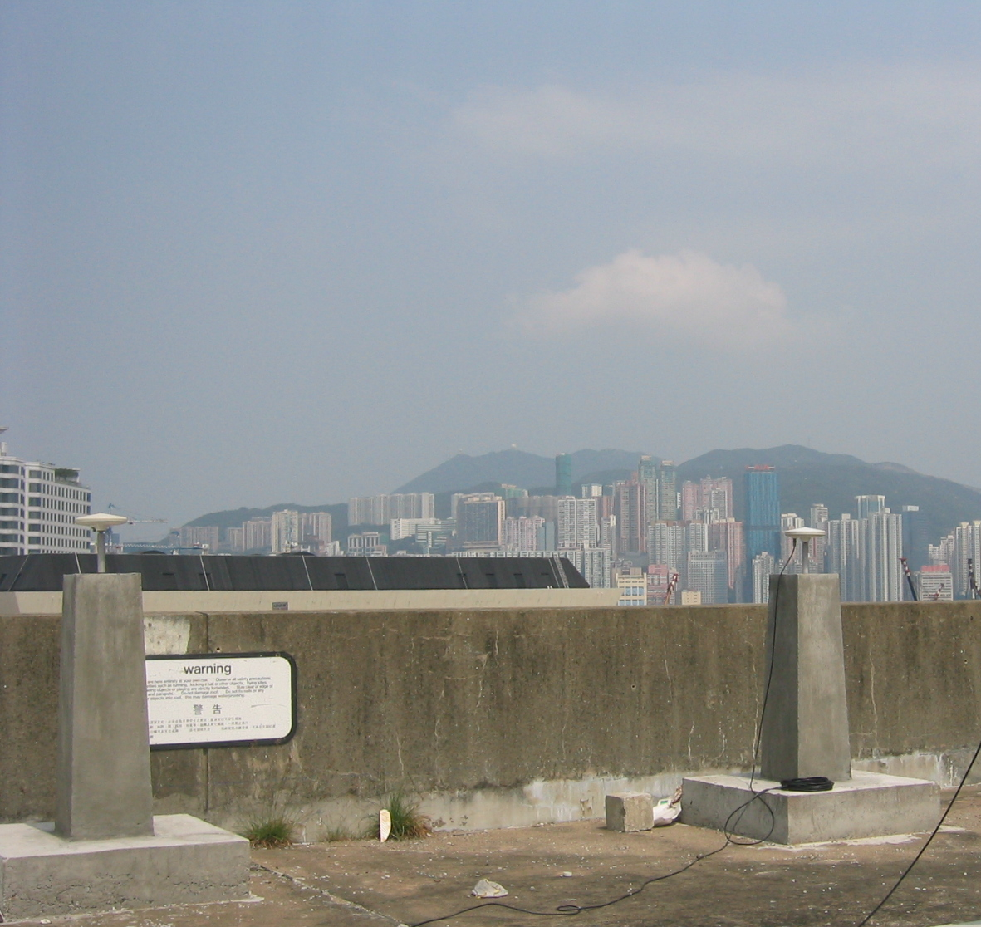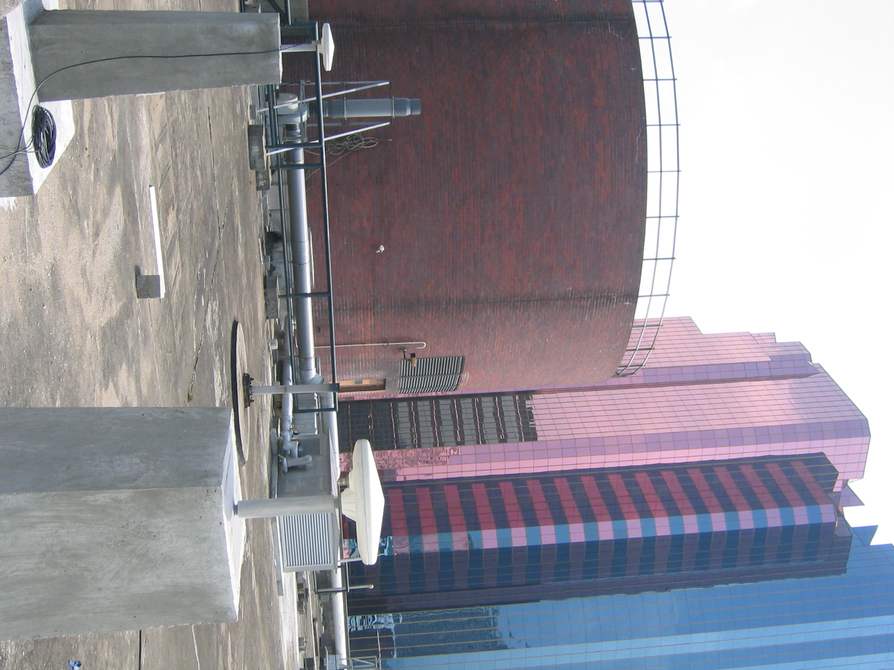
Receiver 02
Receiver 03
Receiver 02
Receiver 03
A. B.
Figure 2: Test Area

Signal propagation model is used for accounting the characteristics of different multipath signals. An urban environment digital model, which is generated by CAD and Wireless Insite software, is required for modelling the multipath environment. The structure is usually decomposed into flat faces because of its simpler reflection and diffraction geometrical relationship. The footprints of the buildings covering an area of about 0.5 square kilometers are shown in Figure 3A, together with two receivers, which are indicated by squares. Three-dimensional view of the study area is shown in Figure 3B.
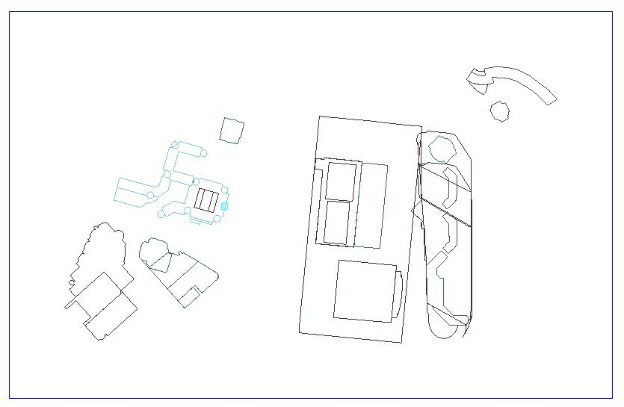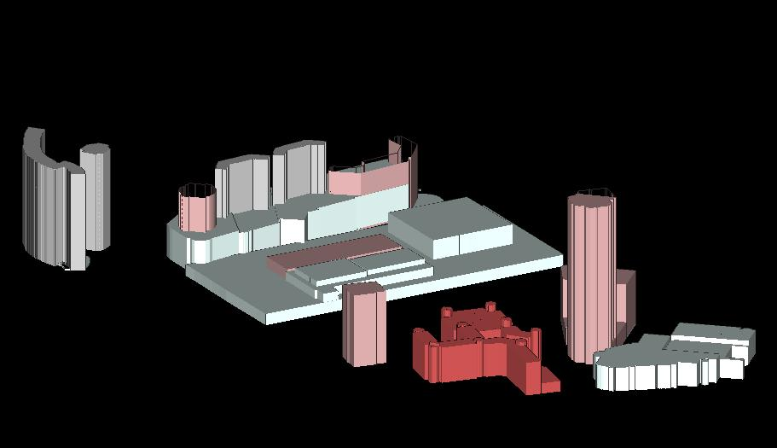
A B
Figure 3A: 2D view of the study area; 3B: 3D view of the study area
Real world models of buildings are then established. Actual materials of building surface are applied in the study area. Note that since propagation characteristics may sensitive to the building environment, the measurements in one city may not apply to another. Figure 4 shows the typical propagation paths from different satellites of the study area in one particular epoch. Information given in electromagnetic field (direct, reflected and diffracted) is computed for the multipath measurements.
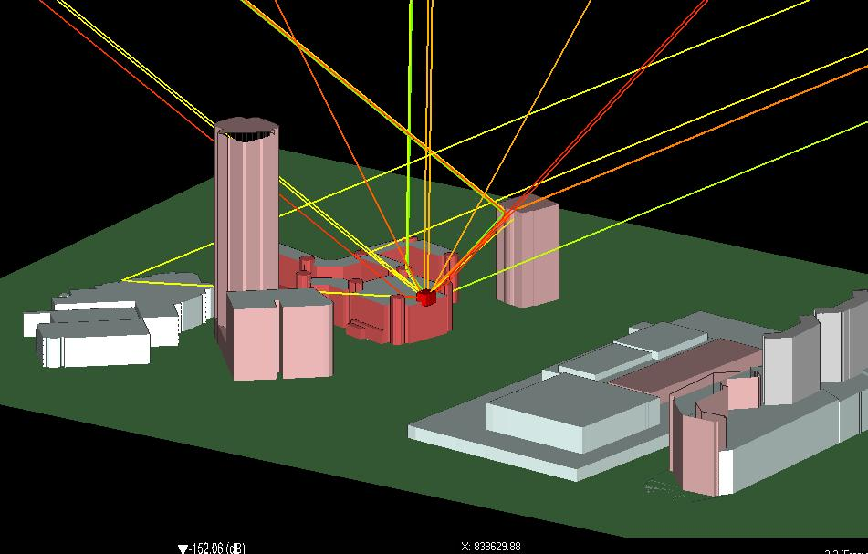
Figure 4: Propagation paths from satellites
Carrier phase noise is random in nature, while the multipath error is oscillatory where the amplitude depends upon the material and surface structure of the reflector as well as the distance between the reflector and antenna [20]. Parameters such as time delay, path delay and damping factor are required for computing the phase multipath error. Those parameters are produced by GTD/UTD technique and output in ASCII text format for further processing by MatLAB. In this project, the modelling results are based on L1 GPS frequency which is 1.575 GHz. Estimated carrier phase multipath errors for satellite 20, satellite 19 and reference satellite 1 on two receivers are then calculated. Double difference carrier phase multipath errors for satellite 20 and satellite 19 are shown in the Figure 5A and Figure 5B respectively. Data collected on the following day in almost the same period (4 minutes earlier than the previous day) shows the similar trend (Figure 6A and 6B). This indicates the DD residuals which are due to multipath mainly. Table 1 shows the results of carrier phase errors before and after applying multipath mitigation.
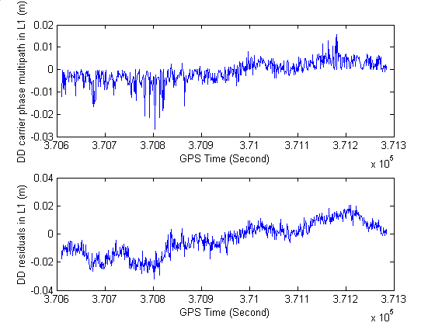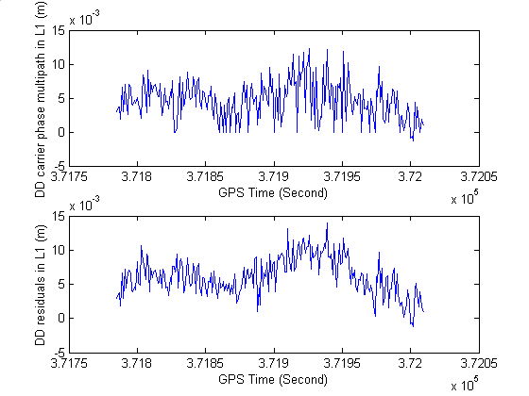
A B
Figure 5A: Double difference carrier phase multipath errors for SV 20;
5B: Double difference carrier phase multipath errors for SV 19

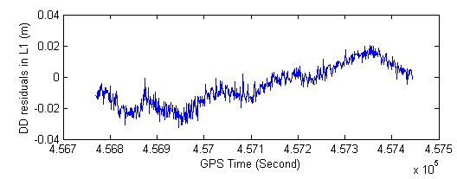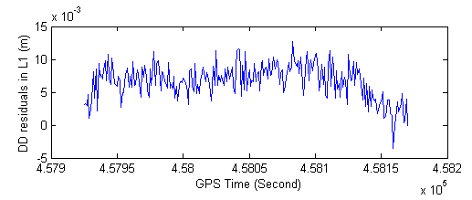
A B
Figure 6A: Double difference residuals in the following day for SV 20;
6B: Double difference residuals in the following day for SV 19

Satellite Number | Before correction |  | After correction |  | Improvement (%)
Satellite Number | Mean (m) | RMS (m) | Mean (m) | RMS (m) | Improvement (%)
19 | 0.0061 | 0.0067 | 0.0015 | 0.0030 | 55.2
20 | -0.0038 | 0.0121 | -0.0028 | 0.0088 | 27.3
Table 1: Carrier phase errors before and after multipath mitigation
From the above table, we can see that there is about 27% improvement of carrier phase errors for Satellite 20 after multipath mitigation. Over half (55%) improvement of carrier phase errors can even be obtained for Satellite 19. Note that the reference satellite used during this section of epoch is Satellite 01 mainly, although Satellite 03 is used in a small section of period. The elevation angle of the reference Satellite 01 is between 70 degrees and 80 degrees. We have found that mulitpath error is existing in receiver 03 from the reference Satellite 01 as well. Figure 7 shows that Receiver 03 suffers multipath errors which is within 5mm from the reference Satellite 01, while receiver 02 suffers nearly no multipath error.
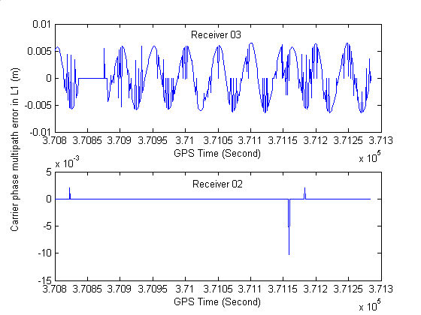
Figure 7: Carrier phase multipath errors for SV 01 on two receivers
One of the functions of GPSSM, which is developed by our department, is used for investigating the position accuracy based on double difference solution after mitigate the carrier phase multipath. Phase observation is determined. The impact of multipath mitigation on deviation of coordinates between the GPS time 370598 and 372321 at 1 second epoch is being studied. Deviations of coordinates before multipath mitigation and after multipath mitigation are shown in Figure 8A and 8B.
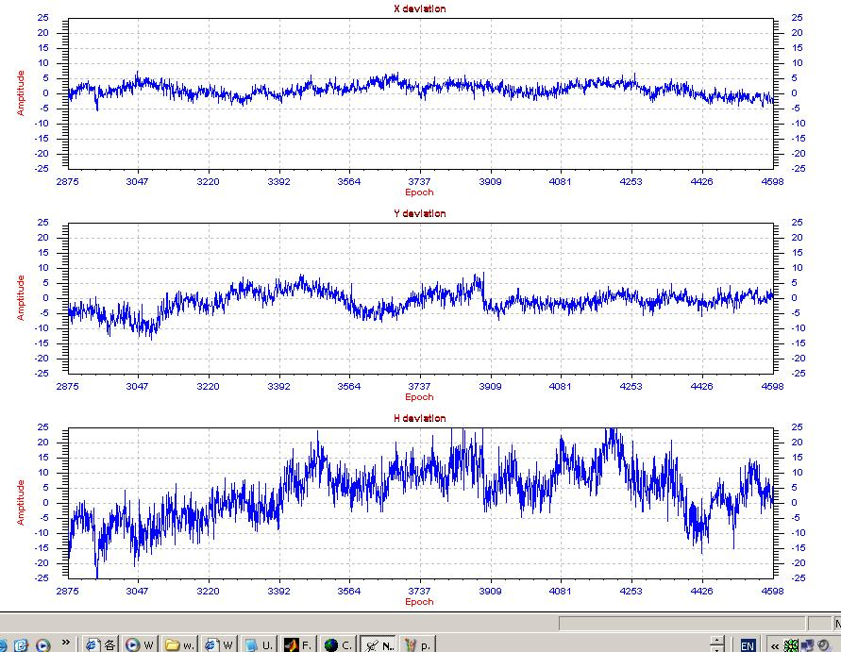
Figure 8A: Deviation of coordinates before multipath mitigation

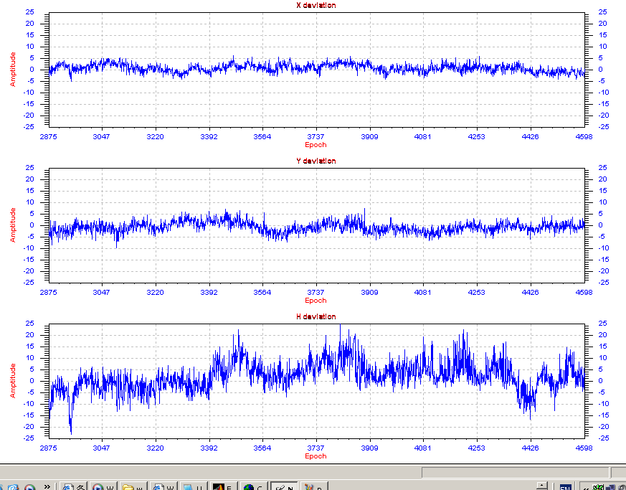
Figure 8B: Deviation of coordinates after multipath mitigation;
From the above figure, we can see that there is a slight improvement in x-coordinate deviation. Better and more apparent improvements are obtained in y-coordinate and z-coordinate deviations. Table 2 gives the statistics results of the standard deviation of positioning errors before and after multipath mitigation.
 | Standard deviation (m)
 | x-coordinate deviation | y-coordinate deviation | z-coordinate deviation | 3D error
Before correction | 0.0020 | 0.0035 | 0.0088 | 0.0097
After correction | 0.0017 | 0.0022 | 0.0062 | 0.0068
% improvement | 15.0 | 37.1 | 29.5 | 30.0
Table 2: Statistics results of positioning errors before and after multipath mitigation

6 FUTURE WORK
Further investigation will be focused on the dynamic mode. Carrier phase multipath in kinematic application is our main interest. Extended research will be carried out to see the possibility of modelling carrier phase multipath in kinematic mode using EM technique. The estimator used in the 3D model also needs to be further tuned for better multipath mitigation performance.

7 CONCLUSIONS
GPS carrier phase multipath is modeled in the 3D urban model environment. Parameters used for characterizing the multipath relative to the direct signal are estimated by EM technique. Tests were carried out on the roof of the DE core at The Hong Kong Polytechnic University. Two receivers were used for determining the double difference carrier phase multipath error.
Initial results demonstrate that 27.3% and 55.2% improvement of carrier phase errors can be obtained for SV 20 and SV 19 respectively. Some multipath errors are also found for the reference satellite in certain section of period. For the positioning accuracy, about 30% improvement of 3D positioning errors in static mode can be achieved. Further investigation will be focused on the carrier phase multipath in kinematic mode. The estimator used in the signal propagation model will also be tuned for better multipath mitigation performance.

REFERENCES
[1]. Axelrad, P., Comp, C. J. and MacDoran, P. F. (1994), Use of Signal-To-Noise Ratio for Multipath Error Correction in GPS Differential Phase Measurements: Methodology and Experimental Results, Proceedings of ION GPS-94, Salt Lake City, September 20-23, pp. 655-666
[2]. Axelrad, P., Comp, C. J. and MacDoran, P. F. (1996), SNR-Based Multipath Error Correction for GPS Differential Phase, IEEE Transactions on Aerospace and Electronic Systems, Vol. 32, No. 2, pp. 650-660, 1996
[3]. Bertoni, H. L. (2000), Radio Propagation for Modern Wireless Systems, Prentice Hall PTR, pp.217-221, 2000.
[4]. Böder, V., Menge, F., Seeber, G., Wübbena, G. and Schmitz, M. (2001). How to Deal With Station Dependent Errors – New Developments of the Absolute Field Calibration of PCV and Phase-Multipath With a Precise Robot. 14th International Technical Meeting of the Satellite Division of the Institute of Navigation, ION GPS-2001, Salt Lake City, Utah, USA, September 11-14, 2001
[5]. Braasch, M. S. (1996). Multipath Effects. Global Positioning System: Theory and Applications. Edited by Parkinson, B. W. and Spilker, J. J., Vol. 1. AIAA.
[6]. Braasch, M. S. and A. J. Van Dierendonck (1999). GPS receiver architectures and measurements. Proceedings of the IEEE, Vol. 87, No.1, Janurary, pp. 48-64.
[7]. Garin, L. and J. Rousseau (1997). Enhanced strobe correlator multipath rejection for code and carrier. Proceedings of ION GPS-97, Kansas City, Missouri, September 16-19, pp. 559-568
[8]. Georgiadou, Y., Kleusberg, A. (1988). On carrier signal multipath effects in relative GPS positioning. Man. Geod. 13: pp.172-179
[9]. Georgiadou, Y., Kleusberg, A. (1990). Multipath effects in static and kinematic GPS surveying In: Bock, Leppard (eds.) c1990, pp. 82-89
[10]. Hannah, B., Walker, R., Kubik, K. (1998). Towards a Complete Virtual Multipath Analysis Tool. 11th International Technical Meeting of the Satellite Division of the Institute of Navigation, ION GPS-1998, Nashville, September 15-18, 1998
[11]. Jia, M., Tsakiri, M., Stewart, M. (2000) Mitigation multipath errors using semi-parametric models for high precision static positioning. IAG symposia. Geodesy beyond 2000 – The challenges of the first decade, vol 121, pp. 393-398
[12]. Lau, L. and Cross, P. A. (2003). Impact of GPS Modernization on Precise Carrier Phase-Based Positioning in the Presence of Multipath. Proceedings of ION GPS 2003, September 9-12, 2003
[13]. Liang, G. and H. L. Bertoni (1998). A new approach to 3-D ray tracing for propagation prediction in cities. IEEE Trans. Antennas and Propagation 46: pp. 853-863.
[14]. Lippincott, W. L., Milligan, T. and Igli, D. (1996), Method for Calculating Multipath Environment and Impact on GPS Receiver Solution Accuracy. Proceedings of the National Technical Meeting of ION 1996, Santa Monica, CA, January, 1996
[15]. McNamara, D. A., Pistorius, C. W. I. and Malherbe, J. A. G. (1990), Introduction to the Uniform Geometrical Theory of Diffraction, Boston: Artech House, 1990
[16]. Moelker, D. (1997). Multiple Antennas for Advanced GNSS Multiple Mitigation and Multipath Direction Finding. Proceedings of ION GPS-97, September 16-19, Kansas City, pp. 541-550, 1997
[17]. Mora-Castro, E.J., Carrascosa-Sanz, C. and Ortega, G. (1998). Characterisation of the Multipath Effects on the GPS Pseudorange and Carrier Phase Measurements. Proceedings of ION GPS-98, September 15-18, 1998
[18]. Park, K., Davis, J. L., Jarlemark, P. O. J., Elosegui, P., Normandeau, J. E., Corey, B. E., Niell, A. E., Meertens, C. M., Andreatta, V. (2002). Multipath Characteristics of GPS signals as determined from the Antenna and Multipath Calibration System (AMCS). Proceedings of ION GPS Meeting, Portland OR, September 24-27, 2002, 2103-2110
[19]. Rappaport, T. S., Hawbaker, D. A. (1992). A ray tracing technique to predict path loss and delay spread inside buildings. Proceedings of IEEE GLOBCOM'92 Dec: 649-653.
[20]. Ray, J. K., Cannon, M. E., Fenton, P. (1998). Mitigation of Static Carrier Phase Multipath Effects Using Multiple Closely-Spaced Antennas. Proceedings of ION GPS 1998, Nashville, September 15-18
[21]. Ray, J. K., Cannon, M. E., Fenton, P. (1999). Characterization of GPS Carrier Phase Multipath. Proceedings of ION NTM 1999, San Diego, Janurary 25-27
[22]. Satirapod, C., Khoonphool, R., Rizos, C. (2003). Multipath mitigation of permanent GPS stations using wavelets. International symposium on GPS/GNSS, Tokyo
[23]. Seeber, G. (1993). The Global Positioning System (GPS). Satellite geodesy: foundations, methods, and applications, Berlin ; New York : W. de Gruyter, 1993, pp. 289-312
[24]. Sleewaegen, J. (1997). Multipath Mitigation, Benefits from using the Signal-to-Noise Ratio. Proceedings of ION GPS-97, Kansas City, September 16-19, pp. 531-540.
[25]. Townsend, B., Fenton, P.C. and Van Dierendonck, K. (1995). L1 Carrier Phase Multipath Error Reduction Using MEDLL Technology. Proceedings of ION GPS-95, Palm Springs, CA, September, 1995
[26]. Van Nee, R. D. J (1994). The Multipath Estimating Delay Lock Loop: Approaching Theoretical Accuracy Limits, Proceedings of IEEE PLANS, Las Vegas, April 11-15, pp. 246-251.
[27]. Walker, R. A., Kubik, K. (1996). Numerical Modeling of GPS Signal Propagation. Proceedings of International Technical Meeting of the Satellite Division of the Institute of Navigation, Kansas City, MI, September 1996, Part 1 pp. 709-717
[28]. Wanninger, L. and May, M. (2000). Carrier Phase Multipath Calibration of GPS Reference Stations. Proceedings of ION GPS 2000, Salt Lake City UT, September 19-22, 2000, pp. 132-144.
[29]. Xia, L. (2001). Approach for multipath reduction using wavelet algorithm. Proceedings of International Technical Meeting of the Satellite Division of the Institute of Navigation, Kansas City, September 11-14, 2001, pp. 2134-2143

