A TEST OF A GNSS/INS INTEGRATED NAVIGATION SYSTEM FOR REMOTE SERVICES IN TERRESTRIAL VEHICLES

Rafael Toledo Moreo
Automation and Electronics Engineer
Researcher at the University of Murcia

Benito Úbeda Miñarro
Telecommunications Engineer
Assistance Professor at the University of Murcia.

Universidad de Murcia, Facultad de Informática
Departmento de Ingeniería de la Información y las Comunicaciones
Campus de Espinardo 30071, Murcia, Spain.

Key words: Intelligent Transport Systems, Navigation, GNSS, Inertial Systems, Road Applications,

Summary

Nowadays, one of the most important applications of the navigation systems are the remote services. Applications such as the electronic-fee-collection, truck fleet control or antitheft devices imply millions of users through the roads of the whole world. Particularly in Europe, the development of the GALILEO system and the efforts of the European Parliament in prioritizing the toll collecting systems based on GNSS and cellular networks (GNSS/CN), enlarge highly the European market of potential users. In that million users market, no particular exceptions can be treated by a realistic solution. Most of the actual navigation systems rely mainly on the satellite navigation. Problems such as the deficit of precision, the lack of coverage or the service interruptions due to disturbances on the satellite network arouse the implementation of a more reliable solution combining GNSS and autonomous navigation systems. This paper is to present how a GNSS/INS integrated system offers the accuracy and quality assurance required in remote services. Both practical and theoretical researches about the possibilities of a single GPS receiver, the EGNOS-SISNeT/SBAS position correction improvements, the incoming GALILEO-GPS constellation and the use of a multisensor GNSS/INS integrated solution as a reliable navigation system for remote services applications are presented.

1. Introduction

Many of the current remote services for land vehicles such as traveler information, route guidance, automatic emergency calls, freight management or advanced driver assistance require a road side equipment (RSE) capable to offer a high available accurate position with low price. A wide communication availability is essential regarding most of the Localization Based Services (LSB). Specifically, in applications where people security is involved, high integrity monitored positioning is absolutely required. With this purpose in mind, developers had been focusing their efforts on the combination of Global Navigation Satellite System and Cellular Networks (GNSS/CN). This solution allows low-cost positioning system, the possibility of increasing the accuracy and integrity by using the Satellite Based Augmentation Systems, (SBAS) and bidirectional communication between the vehicle and the service provider. However, today the GNSS systems do not provide the availability, accuracy and integrity necessary and some other technologies must be used. Main features the future on-board unit (OBU) of a vehicle must comply are:
- Low cost including easy installation, maintenance, etc.
- Capacity for computing vehicle parameter like vehicle dimensions, truck class, weight, etc.
- Capacity for logging the trajectories, speed, time, etc, and management of geographical Information Systems (GIS), compute distance traveled along some ways, etc.
- Integrate wireless communication for tasks such as e-pay, e-maintenance, etc.
- Interoperability with other systems.
- Anticheating enforcement (difficulty to manipulate the OBU by a not allowed person).

For example, just in the case of the electronic-fee-collection systems (EFC) in Europe, the aim of a common compatible solution seems to be a fairy tale. Despite of the efforts of the EU for a technical standardization, harmonization of national projects, and negotiations between operators, the reality is the next: A charging system is implemented in Switzerland (LSVA-RPLP) using DSRC microwave 5.8 GHz. Germany planned other approach based on GNSS/GPRS. In Italy, haulers may use the Telepass technology (a different DSRC microwave, technology not compatible with the Austrian one). In France and Spain, the possibility of a solution based on DSRC and compatible with the Austrian one “LIBER T” is attended. United Kingdom, Belgium, Netherlands and Czech Republic are interested in the deployment of a GNSS/GPRS solution [1]-[5]. That is, too many different not compatible onboard equipment in the vehicles behind the windscreen.

According to the actual bibliography, the most reliable solution to the problem of terrestrial vehicle localization implements a positioning system based on the integration of a GNSS and another autonomous positioning system. Different approaches are being studied in order to guarantee the proper quality of positioning for remote applications. All of them rely on an accurate GNSS position, either as the leading positioning information input, or as an assistance system, to determine vehicle movements along roads. In [6], a GPS receiver is complemented with odometry information and an electronic compass to estimate the position of an autonomous vehicle. In that work, some assumptions concerning GPS availability and velocity limits are done. It is worth mentioning the different versions of the NabLab positioning systems equipped by a GPS receiver, odometry and supported with a vision system and a laser range scanner for avoiding collisions [7]. In [8], a GPS receiver and inertial units are used. In Europe, the European Space Agency (ESA) is encouraging the use of the EGNOS/SISNeT position corrections while private companies as BMW offer their localization systems based on a single GPS receiver.

2. The State of the Art of the GNSS

Two different scenarios should be distinguished regarding the road ITS applications. Despite the fact objectives and technologies are the same, the different problems a GNSS sensor has to deal with in urban environments and wide open environments encourage us to study them from different points of view.

In urban environments the signal availability, and its accuracy when available are the main problems. If there is a possible GNSS error or malfunction, it is likely it will appear in urban areas. Among all of them, the multipath propagation is winning the palm due to their unpredictability and high value. In wide open environments, such as motorways and freeways, even though the availability is much better than in cities, sometimes it does not seem to be good enough to guarantee a warranty solution for critical services.

During the last years, one of the most ambitious project connected with the GNSS technology is the implementation of a unique, reliable, high integrity toll collect system for road vehicles. The European Commission is kindly encouraging the use of the GNSS as the leading technology of the ITS applications, probably to arouse the acceptance of the incoming GALILEO system. Nowadays, most of the services available along the european roadways are based on the GPS/EGNOS-SISNeT system, the european SBASs system.

There is also one more satellite constellation in the actual stage. The russian GLONASS constellation is becoming more and more obsolete, and the confidence of the scientific community on this system is poor. However, it can be used as a good way to estimate the possibilities that a double number of satellites in view will bring.

3. The Navigation Systems Tests

In order to study the performance of a multisensor navigation system, different tests have been done. Selected results of GNSS and GNSS/INS integrated solution are presented in this section.

3.1. The GNSS solution

One of the main interests of this research is the use of satellite positioning systems to provide an enhanced positioning. An EGNOS prototype that provides a broadcast Signal in Space (SIS) is offered since February of the year 2000 as an EGNOS System Test Bed (ESTB). This prototype is used to support and test the development of the EGNOS system, to present EGNOS to potential users, to prepare the market to the EGNOS entrance and to test the possibility of expanding this system outside Europe. The ESTB provides users with a GPS-augmentation signal system a few meters accuracy positioning. A further aim of the European Commission is to increase the number of potential users of the GALILEO system in transport applications.

The poor coverage in built-up areas and tunnels and the undesirable propagation of the signal in many dispersed navigation trajectories are the main problems observed (both in the case of GPS and geo-stationary satellites). In order to minimize the problem of the poor visibility of the AOR-E satellite, corrections are sent by 2.5G and 3G mobile phone networks as a part of the ESA SISNeT project. The results of testing these corrections in our vehicle are also shown in this paper. SISNeT can replace the geo-stationary augmentation signal, but it is not a solution for the lack of GPS coverage. A solution based on sensor fusion to maintain the integrity of the vehicle position is proposed. The EGNOS/SISNeT signal and an Inertial Navigation System (INS) are fused by an Extended Kalman Filter. Our test vehicle is shown in figure 1. Next section shows the results of the GNSS experiments.

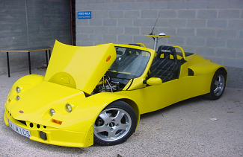

Figure 1. SATANT. The SatAnt prototype, our test vehicle.

The GNSS trials

Selected results of the tests performed by using a High End GPS/GLONASS Thales GG24 sensor both in urban and open environments are shown.

An application developed at the University of Murcia, shows the current position of the vehicle superimposed on a GIS map (figure 2). In this application the position is referenced to a GIS map, offering the current distance of the vehicle to the center of the road definition to the user. GNSS attitude information, the name of the roads available on the database and the status of the GNSS signal are also shown.

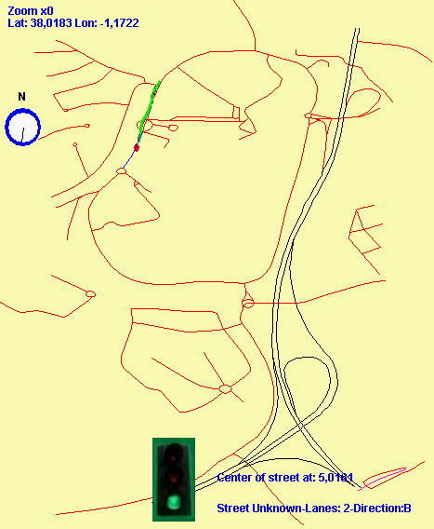

Figure 2. The Positioning Application.

The tests realized in the city of Murcia, Spain and through the A7 spanish freeway between Murcia and Lorca are focused on the issues of availability and GNSS sensor parameters to determine the quality of the GNSS position. The performance of a double constellation sensor regarding these topics is shown.

Urban environments

According to our investigations, assuming a HDOP = 3, the availability achieved remains between the 70 and the 84 %. Too low for accuracy demanding services. The use of a double constellation sensor do not offer a significant improvement compared to the single constellation ones in city environments and assistance positioning is highly recommended. As a conclusion of our tests, the use of the SISNeT signal can not support the GNSS solution in urban environments.

a) GNSS outages in an urban area sample. | b) The z axis represents the HDOP over the trajectory.

Figure 3. Urban trajectory details. Figure a) shows a typical urban situation where GNSS coverage is totally missed along whole streets. Figure b) shows the HDOP parameter obtained during a trajectory. The value of the HDOP factor is being increased in specially difficult environments.

Open environments

The comparison between the HDOP parameter obtained in both urban and open areas is shown in figure 4. While availabilities in the first case are not much higher than 80 % in the best case, values around 95 % are normal along the open motorways. The application requirements will decided if it is enough or not. Applications such as road pricing systems require better performances to avoid daily malfunctions.

a) HDOP in the city. | b) HDOP through the motorway.

Figure 4. The HDOP feature in both urban and open environments.

These tests were performed using the GG24 sensor previously commented. According to our tests, the main reasons for outages in motorways are crossing motorways, tunnels, and often trucks and high vehicles surrounding our test vehicle. These results were obtained along 200 km. trajectories along the A7 spanish freeway.

3.2. The INS support

The lack of GNSS coverage in some environments (even when SISNeT signal is used) is a real problem that cannot be solved with a global positioning system. A reliable solution for these periods without GPS signal is absolutely required to guarantee the system success. Both odometry and inertial measurements have been studied to determine the best way to fulfill the system requirements. The nature of the inertial measurements (accelerations and rates of turn in the three coordinated axes of the body frame) complements perfectly the deficiencies of localization systems based on the GPS solution. However, the need of a double integration process to obtain the position from the acceleration measures is the principal source of error in an INS/GPS integrated system. Often updates should be taken to zero the solution drift. The odometry option avoids the double integration, but new problems such as glides, uncertainty of the effective wheelbase, unequal wheel diameters, etc are presented.

In this paper, how the INS unit support the GNSS/CN positioning is presented. These results invited us to implement an GNSS/INS integrated navigation system. For the test presented, a medium cost vertical gyro has been used. In that way, no compensation models further from the its own filtering are required. Kinematic errors are defined as variables in the Kalman filter (see 9 for details). Next, how the GNSS/INS integrated system improve the quality of the solution is shown.

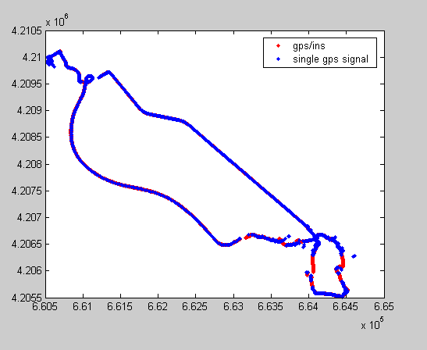
east (m)
north (m)

Fig. 5. Trajectory through Murcia A typical situation where the GNSS/INS solution is highly recommendable.

Fig. 5 shows the results obtained by a single High End GNSS sensor in a combined environment. In this test performed in realistic traffic conditions, during approximately 36 minutes of trajectory, no GNSS position was recorded on the order of 6 minutes. That is too long even for non critical applications, not mentioning life applications.

However, the GNSS outages are not the only (maybe not even the main) problem in city environments. In built-up areas, spurious GNSS data resulting from the multipath signal are extremely usual. This problem gives this noisy aspect to the real time solution, impossible to remove via map matching (usual solution for wide open areas when multipath is due to trucks, etc.). In order to improve this undesired behaviour, a Nyquist validation filter has been implemented. High improvements are achieved, but further investigations on this topic, and the GNSS parameters applicable for this purpose, will be realized soon.

One of the main disadvantages of working with INS technology, its price, makes the practical application of the inertial technology not affordable for average vehicles. However, the fast development of the MEM’s devices (based on microelectromechanical technology), with real low cost price units (few dollars the set of inertial sensors), encourage us to believe that the future on-board-units for toll-collecting systems will implement inertial technology in the main aiding positioning system of the GNSS.

4. The Communication System

The presented navigation system has been tested out using the SatAnt test vehicle. The SatAnt vehicle is a platform equipped with a hardware architecture that provides the communication infrastructure required in our test (figure 6).

The hardware architecture consists of two blocks. The main CPU is in charge of sensor fusion, high-level applications and user interface. A second CPU with less computational requirements is in charge of communications into the vehicle and with the base station. Both CPUs are connected with an Ethernet bus. The main CPU is a standard single board computer based on a 32bit Pentium processor. For the second CPU it has been used an 8bit microcontroller in order to increase the I/O features of the whole system and to append more peripherals.
Communications out of the vehicle are carried out with GPRS wireless connection. This link is used to connect the vehicle with the base station and any other remote system. Inside the vehicle, a Blue-Tooth wireless link can be used to connect the vehicle with a laptop (or other mobile device such as PDAs, etc.). Additionally, a WLAN connection is available through the PCMCIA slot of the main CPU, bringing the possibility of communication with vehicles close to SatAnt.

Communications with the sensor system of the SatAnt vehicle are carried out through a CAN bus interface. Different control and sensor units are distributed along the vehicle, and all of them are connected through a CAN bus with the communication CPU.

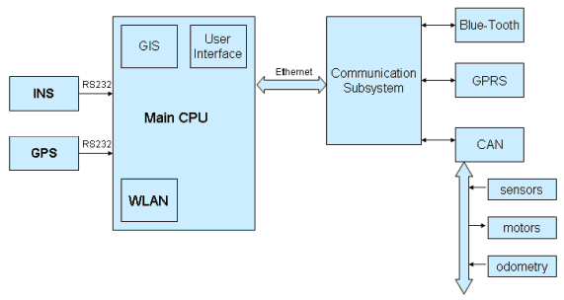
Figure 6. The Communication Infrastructure.

5. Conclusions

According to our test, actual GNSS/CN solutions can not guarantee high integrity positioning. Many of the most demanded remote applications, required a better performance of the positioning system. In this paper, we presented some results of using a double constellation sensor. In the test performed with a GLONASS/GPS sensor, no significant improvements of the solution were achieved. These results do not presage a good future for a possible GPS/GALILEO sensor, but we have to bear in mind that the current state of the GLONASS system is not comparable with the warranty of the incoming European system.

Our GNSS/INS integrated system has been presented as a reliable solution in hostile environments, such as built-up areas, tunnels, crossing roads, etc. However, problems such as multipath errors must be removed in a most efficient way. These problems are partially solved by using a validation algorithm based on the Nyquist inequation. However, further improvements of the solution must be achieved. Investigations regarding different types of antennas, their location and the study of the GNSS parameters to model the multipath error are yet to come.

There are two problems not directly connected with the GNSS technology but critical for the reliability of a single GNSS/CN solution as on board unit of a positioning system: fraud and price. The problem of the fraud detection must be carefully consider when the user is responsible of the maintenance and performance of the unit. If it is not easy to achieve a reliable solution assuming the most friendly of the users, the situation becomes much more difficult when the user does not want the system to succeed. Further from legal policies, a technical enforcement is recommended to guarantee the proper performance of the system. For example, in many of the actual toll collection systems, enforcement is implemented via video control, detecting number-plates and checking out this number with the database register. These video systems raise the price significantly, getting further and further from the low cost solution planned. With this low cost purpose on mind, enforcements implemented in the on-board-unit are recommended. In terrestrial vehicles, both inertial sensors and odometry have been tested in out test vehicle. Selected results of the inertial solution are shown. Taking into account that High End GNSS receivers and medium cost inertial units were used in our tests, a GNSS/INS integrated solution can reduce the price of the sensors significantly, not being necessary high quality single units, thanks to the redundant information coming from the different sensors. Despite the fact the price of an on-board-unit integrating GNSS/CN and INS is still far from the wide market, the development of the inertial technology, improvements on GNSS receivers, and the possibility of a serial production for the on-board-units would reduce significantly the final price of the product.

6. Acknowledgements

The Authors would like to thank the Spanish Fundación Séneca, Agencia de Ciencia y Tecnología de la Región de Murcia, for founding this work under the grants PI-78/00833/FS/01 and FPI02-00001/EFPI/04 and the Spanish Ministerio de Fomento for sponsoring the research activities.

7. References

[1]. DSRC Electronics implementation for Transportation and Automotive applications, DELTA. http://www.ertico.com/links/delta.htm
[2]. Juan G. Jordán et al. “A comparison of different technologies for EFC and other ITS applications”. IEEE Intelligent Transportation System Conference Proceedings. 2001.
[3]. European Space Agency. Feature on Navigation Satellite Applications. http://www.esa.int/export/esaSA/navigation.html
[4]. CEN TC278 Road Transport and Traffic Telematics (RTTT) – “Application requirements for Electronic Fee Collection (EFC) Systems based on GNSS/CN”.
[5]. Swedish National Road Administration. “Basic Requirements Specification for Interoperable EFC-DSRC Systems in Sweden”. A Specification for Implementation of PISTA and CARDME. Version 1.0. 2003.
[6]. A.G. Skarmeta, H. Martínez, M.A. Zamora, B. Úbeda, F.C. Gómez and L.M. Tomás, “MIMICS: Exploiting Satellite Technology for an Autonomous Convoy,” IEEE Intelligent System. N IV. V. vol. 17, pp. 85–89.
[7]. U. Ozguner and others. The OSU DEMO’97 Vehicle. Procs. Of the 1997 IEEE Int. Conf. on Intelligent Transportation System. Detroit, Michigan, USA, September 1995.
[8]. California PATH Home Page. http://www.path.berkeley.edu, 2003.
[9]. Angus P. Andrews, Mohinder S. Grewal, Lawrence R. Weill. Global Positioning Systems, Inertial Navigation and Integration. John Wiley, 2001.

