.
IMPROVING SAFETY AND SECURITY ON TRANSPORTATION OF HAZARDOUS GOODS ON
EUROPEAN WATERS.
Dr. Jordi Corbera (1), Dra Marina Martinez (1), Mr. Jean Marechal (2),Mr Stefano Scarda (3)
1-Spanish Institute of Navigation
2-Centre Nationale d’Estudes Espatials
3-Galileo Joint Undertaking
1.Introduction


In Europe and particularly along the Atlantic coastline, there have been a number of disastrous accidents involving oil tankers (Torrey Canyon, Amoco Cadiz, Tanio, Braer, Aegean Sea, Erika and Prestige) causing catastrophic economic consequences. In addition, regular operational pollution increases the damage to the environment and the local economy.
Because of the volume of traffic and the high risks to shipping in European waters, ship routing systems have been introduced. These systems, which have been approved by IMO, have helped to limit the risk of collision. But the existing systems are of limited geographical scope and concentrate on the main areas of traffic convergence without properly covering events, which could occur outside the scope of Radar or AIS.
In December 2002, the IMO introduced the ISPS code, as an amendment to the SOLAS convention, and recommended that measures should be introduced, at the earliest opportunity, to provide Long Range Identification and Tracking of SOLAS vessels. The code, which becomes effective from 1st July 2004, aims to provide defined procedures for maritime security at the ship / port facility interface. Long Range Identification and Tracking of incoming is therefore an important factor in the assessment of risk and the definition of appropriate security procedures.
In this context, the NAUPLIOS demonstration project was launched to evaluate new long range maritime surveillance services that could benefit from the implementation of Galileo services. NAUPLIOS is a project of the 5th RTD framework programme of the European Commission (EC) and has been followed by the Galileo Joint Undertaking (GJU).

2. NAUPLIOS objectives
NAUPLIOS set out to demonstrate new services that would improve maritime surveillance and search & rescue. A six month demonstration period was included to allow a thorough evaluation of the system by operational teams. For the project team, this demonstration period allowed them to implement a measure of fine tuning to the system in accordance with the operators recommendations and to configure test scenarios to fully exercise the functionality of the system in accordance with normal operating procedures.
Six different vessel types were involved in the demonstration to evaluate the new services in various situations: an HSC ferry (high speed craft), a tanker, a fishing vessel, a container carrier, a ferry and a French patrol vessel (see details alongside). During the demonstration, these vessels continued their normal activity and travelled as usual. Moreover, the system was able to add hundreds of simulated vessels in order to represent a variety of traffic situations.
3. Architecture
To address these needs, the system architecture has the three following main design characteristics:
- A satellite communication link allowing flexible message exchanges provides the necessary shore to ship data transfer. This link is able to handle short or long messages (from 64 to 640 bytes). In NAUPLIOS demonstration, Inmarsat C has been used.
- A unique management centre is in charge of collecting all data and disseminating them between users.
- The on board terminal is based on the existing AIS standard (automatic identification system), modified to allow new services and satellite communications. For simplification reasons, the VHF AIS system was not used.

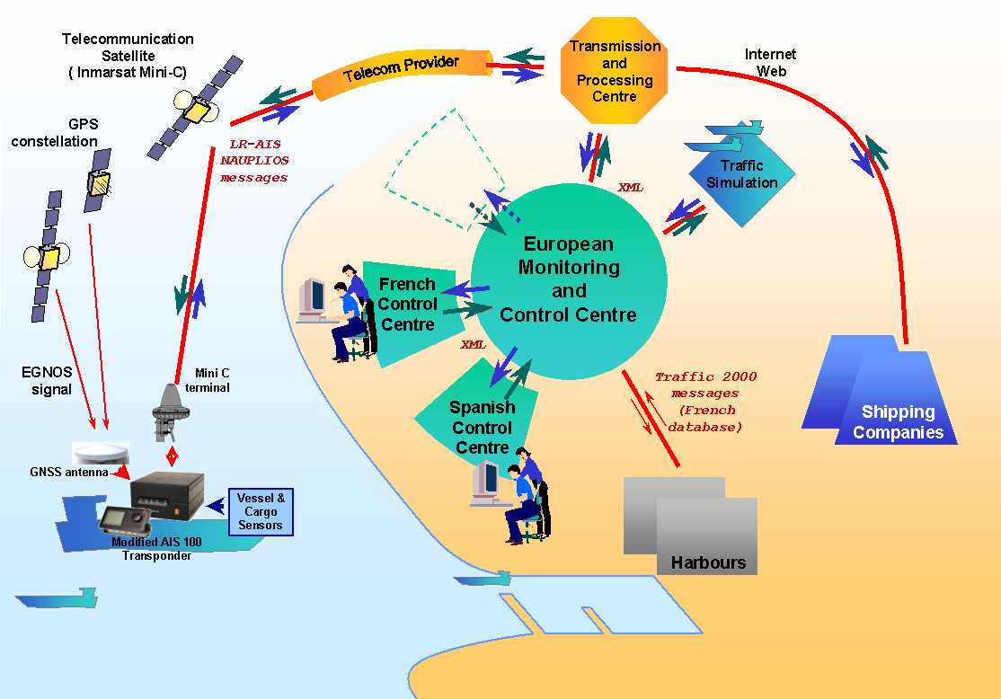
Figures 1 and 2 present the NAUPLIOS architecture and associated devices evaluated during the demonstration: each vessel computes its navigation data using a GNSS receiver (GPS augmented with EGNOS –European SBAS– signals and data. During the demonstration the EGNOS System Test Bed was used). An AIS terminal handles these data, adds to them vessel, voyage and cargo data and sends them to the NAUPLIOS Transmission and Processing Centre (NTPC). NTPC main roles are to insure interface between the satellite communication world and the maritime authorities one, and to provide NAUPLIOS services to private maritime companies through the Novacom web site. After the NTPC, the management centre works as a provider, including necessary gateways with existing external systems. Its principal customers are the maritime surveillance centres. In NAUPLIOS demonstration, there were two operational surveillance centres involved: one is Jobourg MRCC (DAMGM, Fr) on the English Channel, the other is TARIFA MRCC (SASEMAR, Sp) on the Gibraltar strait. In a future system, several centres might be connected to the management centre. Reports from vessels are directly transmitted to the final surveillance centres, without filtering according to the areas where vessels are located: as soon as a vessel enters the NAUPLIOS global zone, all European authorities are able to have access to the information. However, it was agreed that surveillance specific requests could be issued only by the centre in charge of the area where the vessel is operating. In NAUPLIOS, the global area was split in two, following a parallel for simplification reasons and doesn't match the real maritime boundaries between Spain and France.

Telecommunication Satellite
( Inmarsat )
Transmission
and
Processing
Centre
Telecom Provider
Shipping Companies
Internet Web
GPS constellation
EGNOS signal
Harbours
European Monitoring
and
Control Centre
Spanish
Control
Centre
French
Control
Centre
LR-AIS
NAUPLIOS
messages
XML
XML
Traffic 2000 messages (French database)
Traffic
Simulation
Figure 1: NAUPLIOS architecture for traffic surveillance

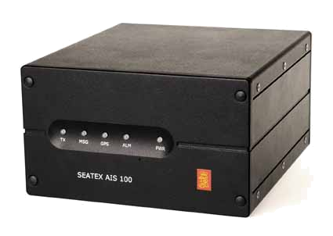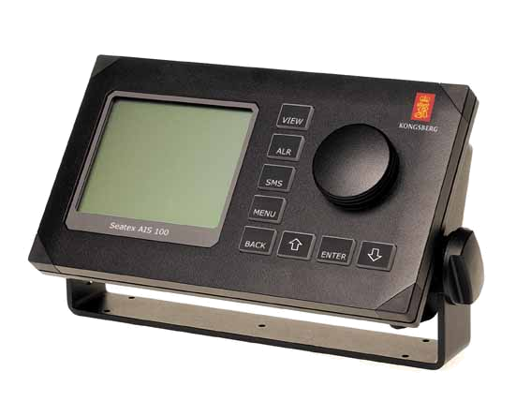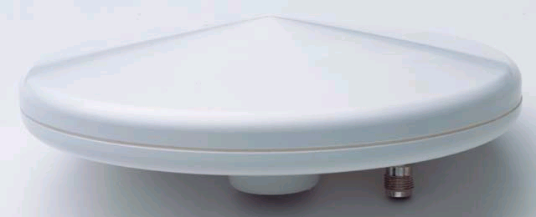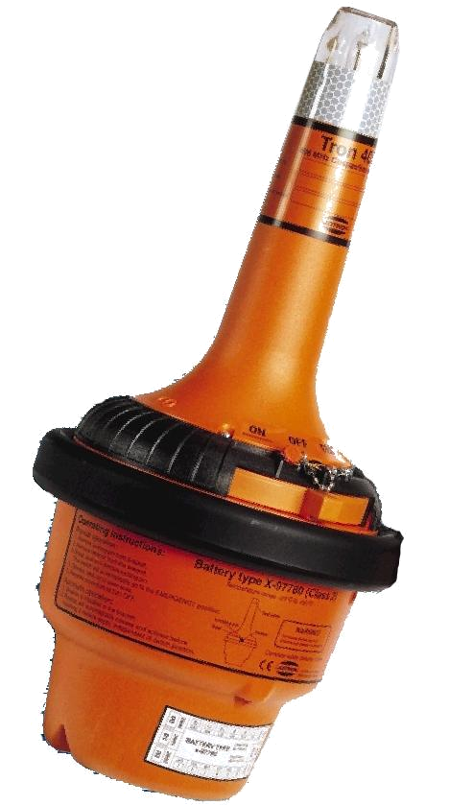
Modified AIS 100 Transponder
Telecommunication Satellite
( Inmarsat )
GNSS antenna
GPS constellation
EGNOS signal
Vessel
Sensors
Cargo
Sensors
SAR Beacon

(remotely
switched on/off)
Mini C
terminal
COSPAS
SARSAT
Satellite
Figure 2: NAUPLIOS architecture-on board equipment
As soon as the watch officer of a surveillance centre triggers a specific surveillance process, a message exchange occurs between the centre and the vessels involved. Other surveillance centres are fully informed of the exchange, receiving all messages, even if they are not the principle actors in the process.
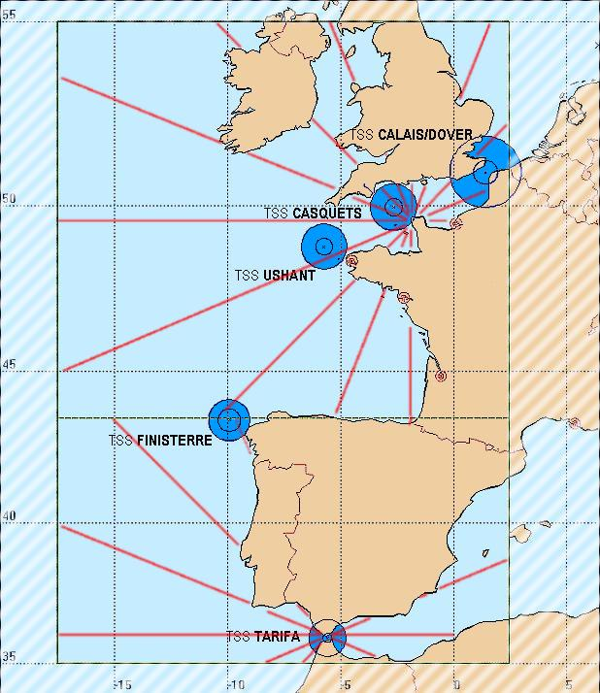
The management centre also insures the exchanges with the existing European databases. In the demonstration, a bi-directional link was established with the “Traffic2000” system, which is the first version of the French database to be connected to the European SafeSeaNet network. Harbours have access to this database and take benefit of the vessel, voyage and cargo data provided by NAUPLIOS. As well, surveillance centres get harbours information on vessel entrances and exits, completing and updating the information received from the satellite link. Le Havre harbour (Fr) was involved in the demonstration.
Finally, the management centre is connected to the NAUPLIOS traffic simulator, which is able to populate the sea with many fictive vessels and react as if these fictive vessels were equipped with a NAUPLIOS AIS terminal.
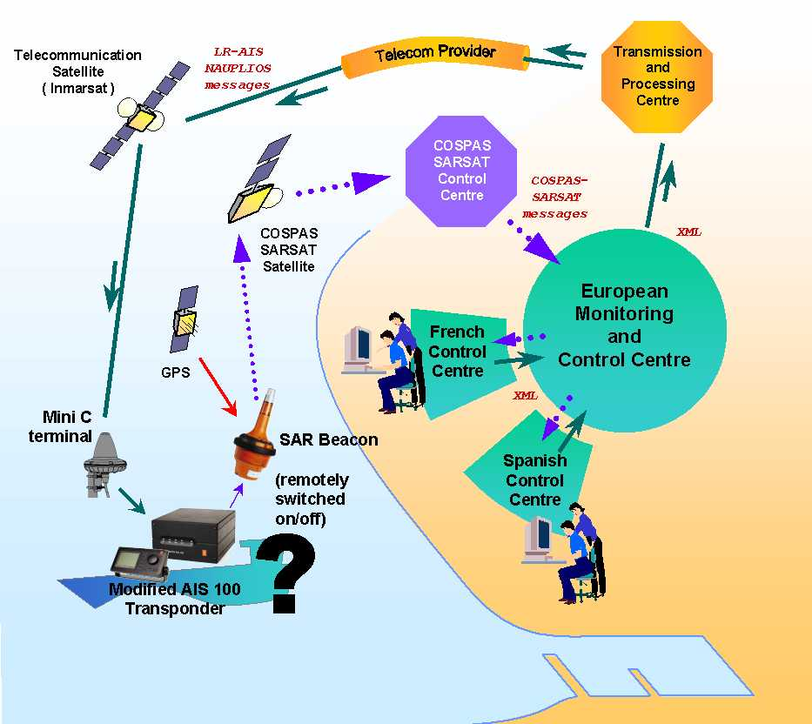
SAR needs are addressed by integrating existing SAR systems into the NAUPLIOS architecture. Distress messages from NAUPLIOS test SAR beacons are re-routed from the normal management process to be directly forwarded to the management centre and then to the surveillance centres. There, the SAR alert is displayed on the same screen that is used for surveillance information. The return link to be implemented by the future Galileo system is handled in the demonstration by the satellite communication link already used for surveillance purpose. This choice doesn’t reflect what should be a future system where SAR return message might be enclosed in GNSS navigation messages, preserving beacon autonomy from additional communication link.
Insert (picture): NAUPLIOS SAR Architecture

3.1 Partnership
The NAUPLIOS partnership, co-ordinated by CNES (French Space Agency), is constituted of the French maritime authorities (DAMGM) who were in charge of surveillance and SAR needs definition and of the operational tests; INAVE (Spanish Navigation Institute) addresses the commercial needs of maritime companies; CNES designs the architecture and integrate the system. BlueFinger (UK), CLS (Fr) and SEATEX (No) companies are in charge of providing the operational demonstrator. CETEMAR Company (Sp) manages the participation of Spanish authorities, which comes in complement to the demonstration in France. ECORYS company (Nl), providing the necessary external look, evaluates the system and obtained results. It performs also the cost benefit analysis of the future deployment of such system on European waters.

3.2 Data flow
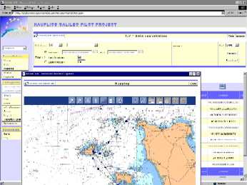
The architecture described above provides automatic identification of a vessel as soon as it enters the NAUPLIOS global area: the NAUPLIOS on board terminal, knowing the area boundaries, transmits a report on entry and exit. The system automatically performs the necessary registration or deregistration process. After registration, vessel and cargo information is made available to the surveillance centres. While operating on the high seas within the NAUPLIOS area, all vessels will be required to transmit their position every four hours. This tracking process can be adapted to different tracking requirements when the vessel crosses other zone boundaries inside the NAUPLIOUS Global Area. When entering an internal zone, the NAUPLIOUS terminal automatically transmits a report to the surveillance centre. On reception of this report, the surveillance process set for this zone is triggered for the vessel: a specific warning message is sent with a new reporting rate (every 10 minutes for instance), if applicable. The warning message is made available to the crew through the NAUPLIOS terminal user interface and the specific reporting rate is automatically applied by the NAUPLIOS terminal. This process applied on specific zones could also be used on any vessel inside the global area for active surveillance purposes: on demand, watch officers of surveillance centres may transmit a dedicated message and remotely trigger a specific reporting rate to any vessel. In the same way, crew of a vessel, (for instance, under emergency circumstances), may write and transmit messages to surveillance authorities or may set a specific reporting rate on demand.

3.3 Search and Rescue
The DAMGM patrol vessel “IRIS” is equipped with a test SARSAT beacon, including a GPS receiver that could be remotely activated or deactivated on demand (model used is Jotron 40 GPS). The GPS receiver inside the beacon allows rapid and accurate localisation of the distress signal (the position is transmitted inside the 406MHz distress message). Several scenarios have been run and services were as scheduled. The accurate precision and the short delay to get the alert (5 to 10 minutes) are confirmed by RCC authorities as the key information in alert qualification and particularly in confirmation of false alerts.
Another conclusion came on the acknowledgement message to be sent to the beacon. Authorities have considered this message as an acknowledgement to be used in case of real distress and that may include a description of the rescue status.
The remote activation of a beacon has been proven during tests and is expected to actively contribute to the search for missing vessels. An observation from users was that, if this service should become reality, the remote SAR activation should be the last means to be used to locate the vessel after all the other available means of communication have failed to produce a response. However, two organisational issues should be considered to make such services feasible: firstly, the reference of the SAR beacon should be obtained through knowing the identification of the missing vessel. However, it is important to remember that, in many cases, databases already exist providing such information but not all databases use the same beacon identification formatand many databases are not updated on every beacon replacement. Secondly, the distress message should include a flag indicating that the beacon is emitting due to a remote activation. This flag is necessary to the centre that will handle such distress message: such centre may not be aware of the initial request for remote activation and it should handle the message as a research process and not as a recognised distress.

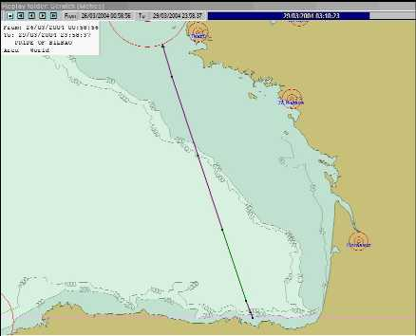
A common point of all these new services is that they largely involve the RCC team. Feeding the return link with RCC data is however questionable: in practice, the current delay observed for RCCs to launch rescue operations takes, on average, several hours. Although RCCs have a legal responsibility to launch rescue operations, the uncertainty on the delay of rescue is linked to the various operational capabilities of the different RCCs and the location and type of the distress call.
Another implementation, not tested in NAUPLIOS demonstration, would allow confirming distress management quicker and to provide a service not depending on the RCC status. This solution consists of transmitting an automatic confirmation at MCC level as soon as the distress message has been forwarded to the appropriate RCC.

4. Demonstration analysis

In NAUPLIOS information was collected from each vessel in addition to the normal vessel identifier and navigation data (ID, position, course and speed). This simple tracking data constitutes the basic information required to perform surveillance on large areas.
Insert (picture): Specific reporting frequency on zones

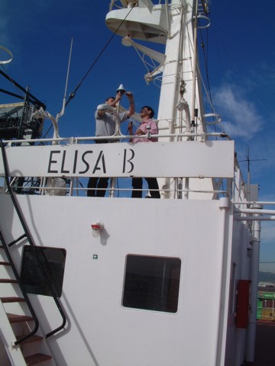

Figure 3: Personnel from CLS and SEATEX, assisted by INAVE is going to install NAUPLIOS architecture onboard of ELISA-B vessel.

4.1 Surveillance area
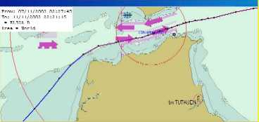
The area under which surveillance is performed was a topic of intense discussion during demonstration evaluation. The 400nm (740km / 460miles) used in the demonstration was considered to be a useful area as it equated to approximately 24 hours sailing time at approximately 16 knots and is equal to twice the typical EEZ limits of a maritime state. A smaller continued surveillance area (without gap) was also considered as acceptable with a lower limit at 200nm (typical EEZ limit). Interests of the larger area (more than 400NM) appear to be limited.
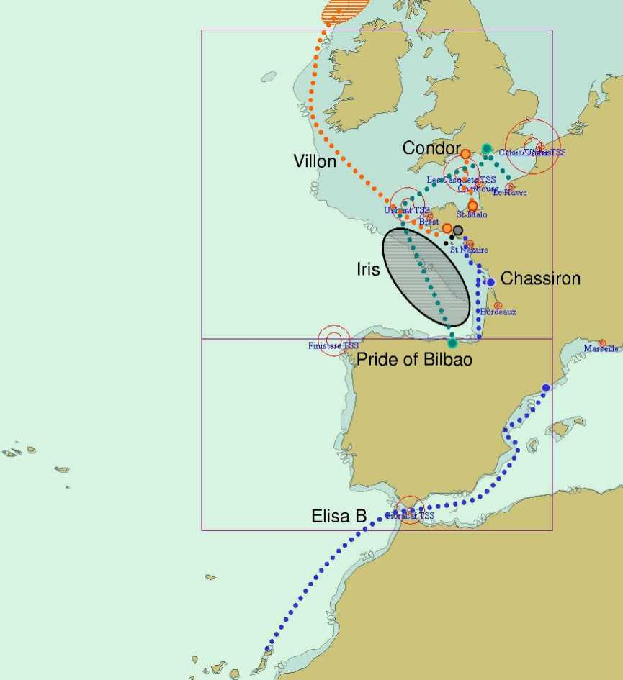
Figure 4: Surveillance area an vessels involved on NAUPLIOS demonstration Phase

4.2 Fixed reporting frequency
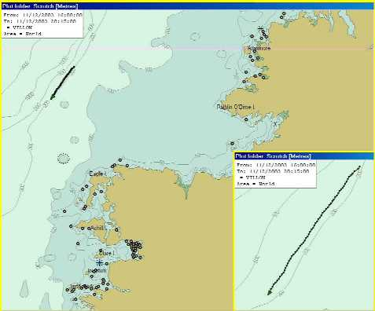
Still discussing long range tracking conclusions, it was concluded that the fixed reporting frequency of 4 hours that is used in the demonstration is sufficient for vessel tracking on the high seas. It is added that this frequency could be lower if main changes in vessel course and vessel speed are automatically transmitted. This function may easily be integrated inside the onboard terminal and will help to early detect abnormal situations (speed/heading change, stop, etc.)
Insert (picture): Specific reporting frequency on identified vessels

4.3 Specific reporting frequency on zones
In the demonstration the specific reporting frequency that is triggered according to specific surveillance areas applies inside TSS areas (Traffic Separation Scheme) and harbours. In a future system, VHF AIS and satellite AIS will work together and such areas close to the coast and under close surveillance will be covered by AIS VHF. However, outside AIS VHF coverage, it should be possible to define dynamic zones where closer surveillance on open sea could be performed at any time: vessels in these areas will automatically report more frequently.

4.4 Specific reporting frequency on identified vessels
In NAUPLIOS demonstration, it is possible to define a specific reporting frequency for any vessel under surveillance. This very useful service will be fully available in VHF AIS coverage (30 to 60NM) and outside VHF AIS, this service is needed in many unusual situations. Such a service would be very important in crisis management. For instance, the management of several tanker incidents could have ended differently if accurate position reports had been received from the vessel in real time (as opposed to the inaccurate positions that were manually transmitted under emergency conditions).
A solution based on travel history, not present in demonstration, may be analysed: The storage onboard of positional information (every 5 minutes for instance) will enable such data transfer of this historical information on authorised demand for specific surveillance processes or accident investigation (after a major event for instance). Even if this solution does not allow a real time management, it may contribute to reduce illegal behaviours (see hazardous goods below). Such a service is like a black box, remotely available for consultation on demand.

4.5 More information on vessels
Insert (picture): Vessel details window
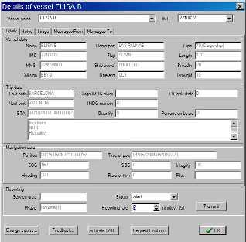
Further to the basic long-range tracking, more information on vessel, voyage, cargo and navigation are available in NAUPLIOS demonstration for each vessel.
Additional vessel data are [Name, IMO, MMSI, Call sign, Home port, Flag, Owner, Operator, Vessel type, Length, Breadth]. Additional voyage data are [Last port, Next port, ETA (estimated time of arrival), persons on board, a free field for voyage remarks, (also hazardous goods info which are presented below)]. Additional navigation data are [Heading (to be obtained onboard from compass), rate of turn, integrity of position, presence of a pilot on board, a free field for alert message]
The additional vessel and voyage data obviously increase the quality of the surveillance and facilitate the earlier detection of abnormal situations. In crisis management, all these data are actively searched, sometimes with difficulty, because the vessel is arriving for the first time inside the surveillance area.
However, the quality of the additional information to be updated regularly (voyage data essentially) is in questions. During demonstration, because onboard terminals were considered as test devices, they were not allowed to have access to operational onboard computers and systems to collect the additional data. Thus, these data were updated manually by the crew after each call, using the NAUPLIOS terminal user interface. In a future system, such manual entry of data is source of mistakes and negligence and automatic collection from onboard systems showed several difficulties: Vessel systems should be recent enough, interface standards should be defined and applied, onboard operational computers (certified) should be accessible.

4.6 Long range exchanges with vessels
In NAUPLIOS demonstration, diffusion of safety messages is tested on a long-range basis: a warning message could be transferred to any vessel entering a specific zone. The surveillance centre is able to set and update messages according to the zones. Again, it appears to be a very useful service in several situations: weather, unusual situation in TSS, wreck, etc. (message length expected to be 100 characters or more).
Even in open sea, the surveillance centre is able to transfer a message to any vessel and get an answer from the vessel, this service however requires crew involvement, which is never guaranteed.

4.7 Hazardous goods information
Data regarding hazardous goods available in the demonstration were considered too limited: the unique IMDG code and associated quantity in tons, used in demonstration, will preferably be replaced by the quantities of hazardous goods listed according to the ten IMO codes list. Of course this service, which is an extension of a declaration already mandatory inside a TSS, faces the same difficulty as seen above regarding the quality of information set in the onboard terminal by the crew.

4.8 Reduction of pollution
Because NAUPLIOS has nothing to do with an anti-collision system, the number of collisions won’t decrease with such a system widely deployed. Nevertheless, earlier and better knowledge of the real situation will clearly improve management of large crisis.
Concerning the illegal oil spill, the system may participate actively to investigations after oil detection, allowing a rapid identification of potential responsible vessels. The system will constitute a good complement of existing means: planes & tanker (oil) analysis.

In addition, the collection, in real time, of quantities of grey waters in ballast will be a good tool to perform a close follow up of suspicious vessels discharging. (Again, nevertheless, serious doubts are emitted about the integrity of such onboard sensors and the possibility to falsify the information).

5. NAUPLIOS: an extended AIS system
VHF AIS was not implemented in NAUPLIOS demonstration, and the satellite link was used for both open sea and coastal surveillance. However, onboard terminals are VHF AIS modified (including new services, new messages, satellite link, etc.) and all NAUPLIOS messages are defined within the AIS standard: existing long-range AIS messages are used and additional proprietary messages have been defined.
An essential conclusion is that a system like NAUPLIOS, based on satellite communications, should be considered as an improved long range AIS, complementing the VHF AIS coverage. Satellite and VHF could be associated to provide similar services on short range and long range basis. Yet, distance is not the only criteria to compare VHF and satellite. Satellite communications, in comparison with VHF will always faces two main drawbacks, which are costs and time delivery delays, but also provide the main advantage of confidentiality in data exchanges. Thus, under VHF AIS coverage, interest of satellite is limited but may however be used for redundancy and specific services not present in AIS standard but necessary in crisis management.
A remark is performed on the fact that AIS format is too verbose. Its direct use on the satellite communication links is therefore not recommended due to transmission costs: a “compressed AIS” format should be used (identical header, unchanged information is repeated in all messages, etc.).

5.1 An European vessel traffic centre
One objective of the NAUPLIOS project was to demonstrate the feasibility of implementing a European centre in charge of the management of such data. That issue has not really been studied in regard with the establishment of a European Maritime Safety Agency and the possibility for this Agency to be involved, in the future, in the management of an operational centre.

5.2 Sharing data with maritime companies
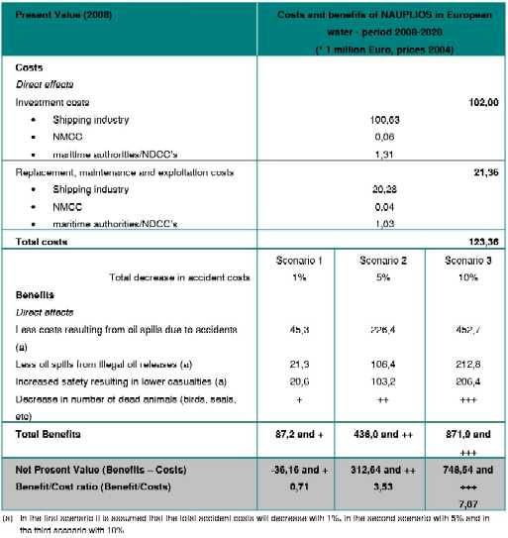
The sharing of data with maritime companies was fully operational in the demonstration thanks to the Novacom web server (www.novacom-services.com). However, evaluation of benefits is unclear: the number of consultations on the web site did not produce convincing results that suggest that maritime companies need to get more information on their vessels and we should conclude that commercial needs, different from the surveillance one, expect less information and are reluctant to pay for it. For instance, one or two positions per day appear to be sufficient for fleet management when maritime authorities is looking forward to active surveillance mechanisms. On the opposite, commercial needs are important when a vessel is approaching its port of call: several data exchanges with many partners occur at this time addressing commercial and administrative issues. In this case, the information need is larger than what could be provided by a surveillance system. Furthermore, the NAUPLIOS system comes in addition to existing commercial systems dedicated to the commercial need. As mentioned before, the main commercial advantage of NAUPLIOS system is the guaranteed confidentiality on exchanges.
Insert (picture): Tableau CBA

5.3 GNSS
A major GPS breakdown on one satellite has occurred on the first of January 2004 (a damaged atomic clock has been at the origin of wrong information transmission during more than a couple of hours by one satellite). This event has allowed having a clear return off GNSS dependency for the vessels that where under surveillance inside Casquets TSS that day.

According to the Jobourg MRCC surveillance team who logged all vessel VHF reports during this breakdown, the following has been observed: some receivers were not able to provide a position for approximately one hour, some receivers transmit position reports with very large errors (about 1 NM) during various periods of time, and finally some receivers, thanks to embedded anomaly detection processes, were able to discard the information coming from the wrong satellite quickly and provide good positions. In addition to this direct conclusion, it appears that training of crews to face such situation seems to be clearly insufficient. Therefore, in emergency situation, the usage of classical navigation because of GNSS unavailability will increase the risk of accident.
This event showed the need for at least two main services provided by augmentation systems (EGNOS for SBAS over Europe) and future GNSS system (Galileo European system): integrity and availability.

5.4 Satellite communications
For flexibility reasons, the Inmarsat C system has been used during the demonstration: it enabled the design several types of services, implementing bi-directional exchanges with various size message. However, what is efficient to build a demonstration may have drawbacks for system largely used with fixed and simpler characteristics. The Inmarsat C messaging system does guarantee neither the transmission delay nor the integrity (proof of delivery or non-delivery). During the demonstration, a good part of messages (more than 90% of received messages) were transmitted and received within 10 minutes from vessels to the shore. However, the other 10% could produce very significant delays.
Regarding the integrity, no statistic is produced by the project on lost messages but the evidence is given that messages are lost for unknown reasons. Another point has been noticed regarding the access to the link, that means the ability to transmit even if the system or the terminal is loaded: during demonstration, it was often very difficult to reach a terminal which has been asked to emit a position every 5 minutes. Sometimes it was even impossible and in this case, thanks to a timer inside the NAUPLIOS terminal, the terminal should exit itself this specific mode after some hours. Addressing priority levels, the system used a classical low priority during all the demonstration, whatever the content of the exchanges were. The need of several priority levels, guaranteeing accessibility and integrity in specific situations (crisis) is clearly a priority.
Although, the satellite communication link should be chosen according to the services expected in such future surveillance system: if the need to be addressed is a simple long range tracking, without active surveillance services, the target should be simple systems with small messages and could be one way systems. If on demand surveillance functionality is added, the link should allow two way exchanges. Frequent reporting will require good access management. Crisis management requires good availability and priority levels.
Finally, whatever the expected services are, a good accessibility to the satellite communications service is essential, taking into account the very large number of mobiles under surveillance and the mobiles concentration that may be important in certain regions.

6. Conclusions
Following the tragic events related to acts of terrorism, IMO has adopted the International Ship and Port Security Code (ISPS) and modified the SOLAS convention by integrating a new chapter XI-2 related to Special measures to enhance maritime security. At the last Maritime Safety Committee (MSC77) it was proposed to add a new regulation for the Long Range Identification and Tracking of Ships. The decision is still pending, and should be discussed again by the IMO partners.
In this framework, NAUPLIOS demonstrates that using a satellite communication system coupled together with an existing standardised system for identification like AIS, should provide a efficient service for both maritime safety and security application. The satellite is able to perform a global service with a worldwide coverage, to collect the data with a high level of security. The process for the collection and distribution of data should be automated, without any overload for seafarer or VTS officers. The data should be distributed in accordance with user requirements through existing ground system like SafeSeaNet. The implementation of such a system, specifically designed for this service, should permit interactive action from the shore, giving to the maritime authorities the possibility to adapt the tracking of ship according to specific situations or status.

Bibliography:
Corbera J, et al “NAUPLIOS: improving the monitoring of maritime traffic and search & rescue services using Galileo. IAIN-Smart Navigation Systems 2003

Knappen B, "Utilisation de GNSS pour la securité de la navigation des ngv", Revue Navigation, Vol 49, nº 195 (2001).

Kopacz Z et al "The maritime safety system. its main components and elements"-The Journal of Navigation, Vol 54, nº 2, (2001).

I.M.O. resolutions a.860 (20), a.741 (18)
European Commission document 2001/c 221/07)
European Maritime Radionavigation Forum-doc EMRF 5/10/3 and EMRF 6/10/01
Januszewsky J, "Why does maritime navigation need gnss?", Proceedings of GNSS99. (1999).

Maritime Rescue Co-ordination Centre. Jobourg MRCC is close to Cherbourg (Fr).
Rescue Co-ordination Centre
Defined by UNCLOS (United Nations Convention on the Law of the Sea)
International Maritime Organisation code
Maritime Mobile Service Identity number
International Maritime Dangerous Goods
www.schriever.af.mil/GpsSupportCenter/archive/Frontpage/frontpage_archive.htm
"Les Casquets" TSS is located in the middle of the Channel, under Jobourg MRCC surveillance.

