Spatial Rubber Sheeting of DTMs

Yaron Katzil, Yerach Doytsher

Department of Transportation and Geo-Information Engineering
Faculty of Civil and Environmental Engineering
Technion - Israel Institute of Technology
Haifa, Israel, 32000

Keywords: Digital Terrain Model (DTM), DEM, Conflation, Rubber Sheeting.

Abstract
DTMs describing the terrain relief constitute a central component of mapping and GIS in general and photogrammetric mapping in particular. DTMs are used in various applications - all requiring that no gaps or discontinuities are included in the DTM. In practice however, the same area may be covered by several overlapping terrain databases collected from diverse sources, differing in their densities or accuracy. The goal in these cases is to merge all databases in order to achieve a complete and continuous representation of the terrain, with the continuity expressed both in terms of continuous height representation and continuous topological representation (morphological structures). Algorithms currently used to merge overlapping terrain databases offer a partial solution only regarding the completeness and continuity requirements, as they address only the issue of height representation of the terrain, but not its characteristics.

A new conflation algorithm is proposed for merging the overlap region ("rubber band" region) of two adjacent DTMs. While merging the two separate overlapping terrain datasets (DTMs), the algorithm is aimed at achieving a continuous topological representation and "correct" morphological structures of the terrain. Based on homologous 3D polylines within the two adjacent DTMs, a seam line of the rubber bands is defined and thus a spatial 3D transformation for merging the rubber bands can be applied. Contrasting with the current relatively inaccurate methods, the proposed algorithm facilitates an accurate 3D conflation and merging process of different DTMs into a unified DTM, taking into account both the completeness and the continuity requirements.

- Introduction
GIS and computerized mapping systems developed in recent decades led to the establishment of geospatial databases of the terrain – altimetry and planimetry – for various mapping and planning purposes. Although most planimetric data are discrete in nature, terrain relief is a three-dimensional continuous entity describing the terrain. Since terrain reality is continuous, the digital description of the relief is expressed by discrete data (discrete points and/or typical break-lines) known as DTM (digital terrain model) or DEM (digital elevation model).

DTMs describing the terrain relief constitute a central component of mapping and GIS in general and photogrammetric mapping in particular. DTMs are used in various applications, all requiring that no gaps or discontinuities are included in the DTM. In practice, however, the limitations of photogrammetric and other measurement methods for collecting the relief information may cause discontinuities and gaps in the database.

A related problem is the data fusion or conflation of multiple layers of terrain data. The same area may be covered by several overlapping terrain databases collected from different sources, differing in their densities or accuracy. The goal in these cases is to merge all databases in order to achieve a complete, contiguous and continuous representation of the terrain, with the continuity expressed both in terms of continuous height representation and continuous topological representation (morphological structures). Conflation in general and map conflation in particular is discussed in [6], [8], [9], and in [11]. The problem of conflating DTM datasets however, is rarely addressed.

Algorithms currently used to merge overlapping terrain databases allow a partial solution only to the completeness and continuity requirements, as they address only the issue of height representation of the terrain, and not its characteristics [7]. In practice, two types of algorithms are used, one being an expansion of the other:
“Cut and paste”
The less accurate (usually lower density) database is replaced with the more accurate (usually higher density) database in the overlapping zones.
“Height smoothing”
Heights of the merged database in the edge zones between the two databases are calculated using a weighted average of heights from both databases, with weighting defined as a function of the different database accuracy levels.

The “cut and paste” method defines a process that preserves the height differences (or elevation and planimetric datum differences) between the databases. Thus, the result is a merged database of the area covered by the two databases that is usually neither continuous nor complete. While the “height smoothing” method is an improved method from the height continuity standpoint, it still suffers from topological discontinuities. Datum differences in both planimetry and altimetry are also a cause of topological discontinuities that produce height differences. In the “height smoothing” case, a point in the merged database can, for example, be a mathematical average of a point along a ridge in the first database and a point along a valley in the second database. Thus, the nature of the terrain is not preserved. From the topological standpoint, applications using the merged database may even create a product of lower accuracy than when using one of the original databases.

In order to avoid these complications when merging terrain databases, an alternative approach and a new algorithm is proposed. This algorithm deals with the overlapping region of the two databases assuming the existence of a seam line constructed by using a set of homologous point pairs between the two DTMs. The set of homologous point pairs is calculated by methods of registering two DTMs, which are not part of the current research. Methods registering two adjacent DTM datasets and calculating the set of homologous point pairs are described in [1], [2], [3], [5], [10] and in [12].

- Proposed rubber band fusion algorithm
  - General description
The proposed fusion algorithm consists of the following steps:
- Global geometric correction of one of the adjacent DTMs by a three-dimensional affine transformation calculated using a given set of homologous point pairs.
- Seam line construction based on the given set of homologous point pairs.
- Rubber band construction around the seam line.
- Local geometric correction by morphing the rubber band of each of the adjacent DTMs to the seam line on the merged DTM.

  - Global geometric correction
Using a given set of pairs of homologous points $\left\{L_{i},R_{i}\right\}$, a three-dimensional affine transformation, described in Equation 1, is calculated and applied to the less accurate of the two adjacent DTMs, as well as to its corresponding points in the set of homologous point pairs. The source grid coordinate system of transformation is the less accurate DTM and its target grid is the more accurate DTM.
$$X^{'}=R+\text{mM}\left(X−C\right)+C$$
Where:
- | $$X={\left(\begin{matrix}x & y & z\end{matrix}\right)}^{T}$$ | - | A point in the source grid coordinate system.
- | $$X^{'}={\left(\begin{matrix}x^{'} & y^{'} & z^{'}\end{matrix}\right)}^{T}$$ | - | A point in the target grid coordinate system.
- | $$R={\left(\begin{matrix}x_{0} & y_{0} & z_{0}\end{matrix}\right)}^{T}$$ | - | Coordinate system shift.
- | $$C={\left(\begin{matrix}x_{c} & y_{c} & z_{c}\end{matrix}\right)}^{T}$$ | - | Center of rotation.
- | $$m=\left(\begin{matrix}m_{x} & 0 & 0 \\ 0 & m_{y} & 0 \\ 0 & 0 & m_{z}\end{matrix}\right)$$ | - | Scale matrix.
- | $$M=\left(\begin{matrix}m_{\text{11}} & m_{\text{12}} & m_{\text{13}} \\ m_{\text{21}} & m_{\text{22}} & m_{\text{23}} \\ m_{\text{31}} & m_{\text{32}} & m_{\text{33}}\end{matrix}\right)$$ | - | Rotation matrix.

  - Seam line construction
The seam line $S$ of the two adjacent DTM datasets is constructed using a given set of homologous point pairs $\left\{L_{i},R_{i}\right\}$ registering the two adjacent DTM datasets. The seam line is a polyline whose vertices $S_{i}$ are a weighted (or unweighted) arithmetic average of each homologous point pair $\left\{L_{i},R_{i}\right\}$, as shown in Equation 2 for the unweighted arithmetic average. In addition to the seam line, two other polylines are defined. The first, $S^{L}$, is the polyline whose vertices are the points $L_{i}$ of the homologous point pairs of the first DTM, with the other polyline $S^{R}$, defined by the vertices$R_{i}$ on the second DTM. Seam line construction is shown in Figure 1:
$$S_{i}=\left(\begin{matrix}S_{i} \\ S_{i} \\ S_{i}\end{matrix}\right)=\frac{1}{2}\left(L_{i}+R_{i}\right)=\frac{1}{2}\left[\left(\begin{matrix}L_{i} \\ L_{i} \\ L_{i}\end{matrix}\right)+\left(\begin{matrix}R_{i} \\ R_{i} \\ R_{i}\end{matrix}\right)\right]$$

  - Rubber band construction
A rubber band is defined by a parallel polyline to the right or left of the seam line at a given distance $D$ and the seam line itself. The distance $D$ is the selected width for the spatial morphing, which is calculated as a function of DTM density. In the case of fusing two adjacent DTMs, two rubber bands $R^{L}$ and $R^{R}$ are defined. Rubber band $R^{L}$ is defined by the polyline $B^{L}$ parallel to the left of seam line $S^{L}$ at the given distance$D$, and $R^{R}$ is defined by the polyline $B^{R}$ parallel to the right of seam line $S^{R}$ at distance$D$. Figure 2 shows the seam line and rubber band of both DTMs. In this figure, polylines ($B_{1}^{L}$,$B_{2}^{L}$,$B_{3}^{L}$,$B_{4}^{L}$,$B_{5}^{L}$,$B_{6}^{L}$,$B_{7}^{L}$,$B_{8}^{L}$,$B_{9}^{L}$) and ($L_{1}$,$L_{2}$,$L_{3}$,$L_{4}$,$L_{5}$) are parallel and define rubber band $R^{L}$. Similarly, polylines ($B_{1}^{R}$,$B_{2}^{R}$,$B_{3}^{R}$,$B_{4}^{R}$,$B_{5}^{R}$,$B_{6}^{R}$,$B_{7}^{R}$) and ($R_{1}$,$R_{2}$,$R_{3}$,$R_{4}$,$R_{5}$) are parallel and define rubber band $R^{R}$. The rubber band width, when constructed as above, is not constant and varies around vertices where the polyline direction changes by more than 180⁰.

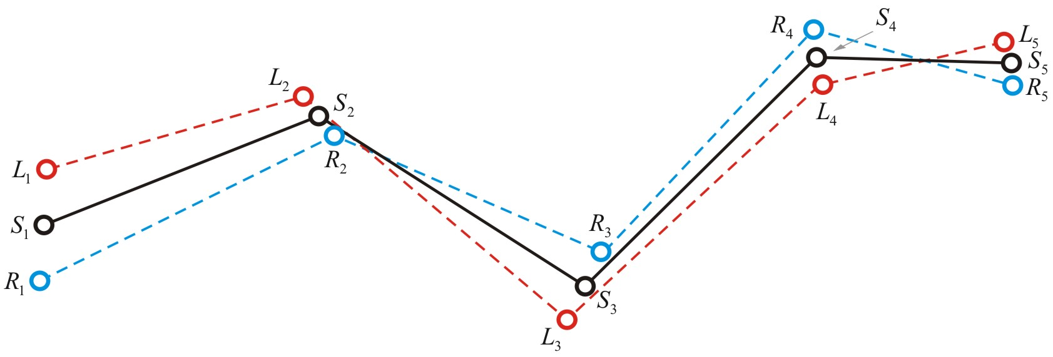
Figure 1: Seam line construction

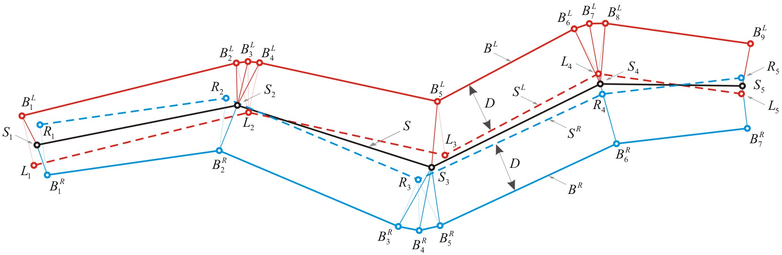
Figure 2: Rubber band construction

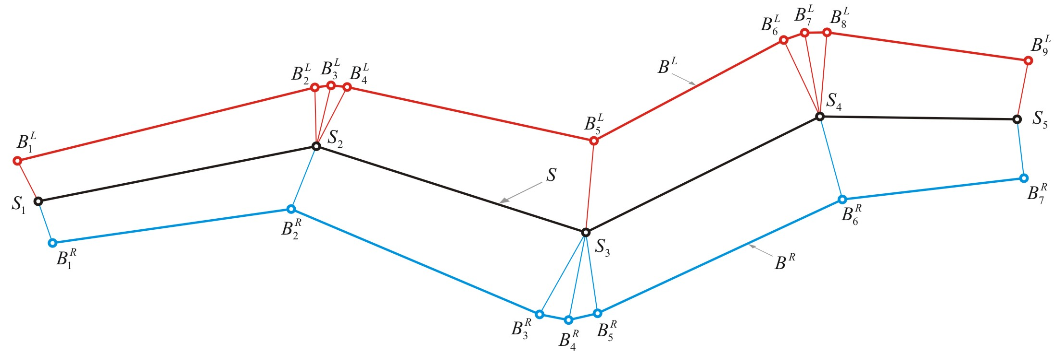
Figure 3: Rubber band quadrilateral grid

  - Local geometric correction
Local geometric corrections are performed by spatial morphing of source rubber bands $R^{L}$ and$R^{R}$, constructed as described in 2.3 and shown in Figure 1, into target rubber bands $R_{L}^{'}$ and $R_{R}^{'}$ which share the same seam line - $S$. The spatial morphing of each rubber band is performed by splitting the rubber band into a set of quadrilateral and triangle components whose vertices are those of the rubber band, and by bilinear interpolation for calculating the correction of each DTM cell within the quadrilateral.

  - Quadrilateral bilinear interpolation
It is required that the geometry of the quadrilateral bilinear interpolation preserves linearity of the quadrilateral edges in order to construct a continuous quadrilateral grid. This means that the interpolation of a point on an edge of two adjacent quadrilaterals yields the same value in each of these two quadrilaterals. The above requirements are fulfilled by using isoparametric quadrilateral representation as shown in Figure 4. A point $P$ within the quadrilateral is located at the intersection of two lines, which bisects opposite sides of the quadrilateral in equal proportions. The natural coordinates are normalized such that the line joining node $P_{1}$ to node$P_{2}$ has the normalized coordinate$t=−1$; while the line joining node $P_{3}$ to node $P_{4}$ is $t\text{=+}1$. Similarly the line joining node $P_{1}$ to node$P_{4}$ is $s=−1$ and the line joining node $P_{2}$ to node$P_{3}$, is $s\text{=+}1$. In this system the intersection of the bisectors of opposite sides of the quadrilateral is the point (0, 0), while the corners are (-1, -1), (-1, 1), (1, 1), (1, -1) respectively. When this grid system is adopted, the shape functions presented in Equations 3 and 4 are used to represent the quadrilateral using its four corner nodes.
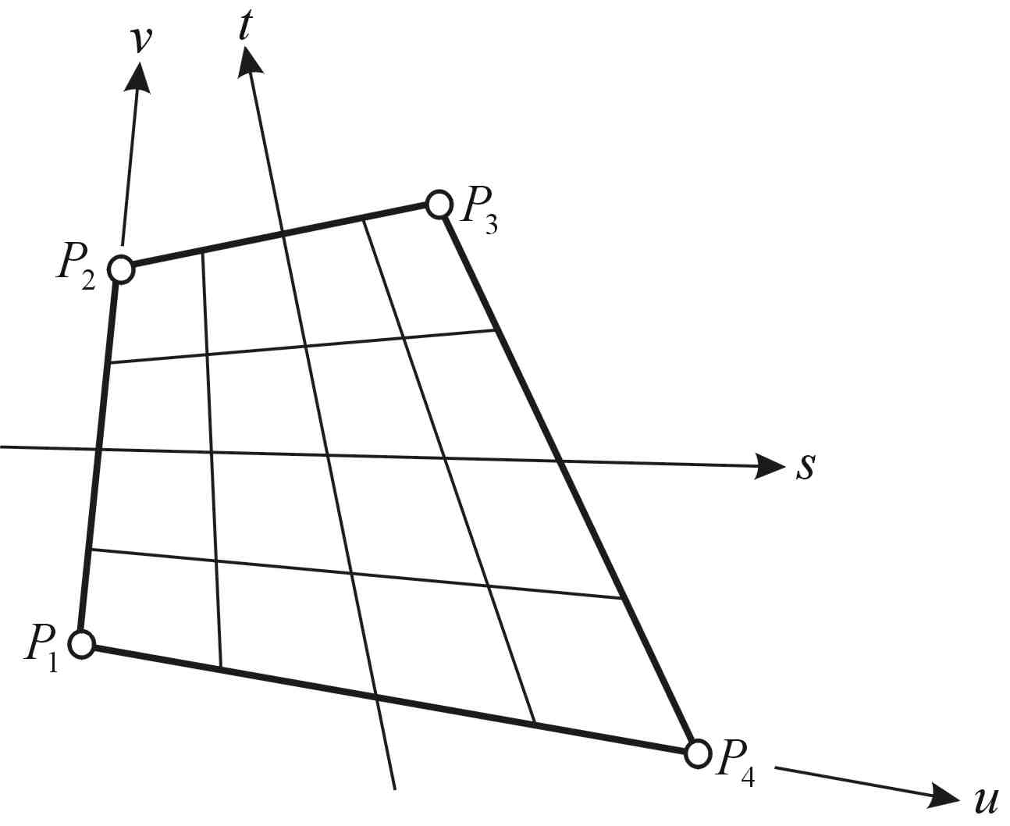
Figure 4: Quadrilateral coordinate system

 | $$\left(\begin{matrix}x \\ y\end{matrix}\right)=\left(\begin{matrix}x_{1} & x_{2} & x_{3} & x_{4} \\ y_{1} & y_{2} & y_{3} & y_{4}\end{matrix}\right)\left(\begin{matrix}N_{1} \\ N_{2} \\ N_{3} \\ N_{4}\end{matrix}\right)$$
 | $$N_{i}=\frac{1}{4}\left(1+s_{i}s\right)\left(1+t_{i}t\right)$$
 |  | $$N_{2}=\frac{1}{4}\left(1−s\right)\left(1+t\right)$$ | $$N_{3}=\frac{1}{4}\left(1+s\right)\left(1+t\right)$$
 |  | $$N_{1}=\frac{1}{4}\left(1−s\right)\left(1−t\right)$$ | $$N_{4}=\frac{1}{4}\left(1+s\right)\left(1−t\right)$$

Where:
- | $${\left(\begin{matrix}x_{i}, & y_{i}\end{matrix}\right)}^{T}$$ | - | Quadrilateral corner node coordinates.
- | $${\left(\begin{matrix}x, & y\end{matrix}\right)}^{T}$$ | - | A point within the quadrilateral given in global coordinates.
- | $${\left(\begin{matrix}s_{i}, & t_{i}\end{matrix}\right)}^{T}$$ | - | Quadrilateral corner node in natural coordinates.
- | $${\left(\begin{matrix}s, & t\end{matrix}\right)}^{T}$$ | - | Quadrilateral natural coordinates.
- | $${\left(\begin{matrix}N_{1} & N_{2} & N_{3} & N_{4}\end{matrix}\right)}^{T}$$ | - | Shape functions.

Solving Equation 3 for $\left(s,t\right)$ yields a quadratic equation as shown in Appendix 1.
Another method for computing the natural quadrilateral coordinates is described in [4].

The bilinear interpolation, as described in Equation 6 below, uses quadrilateral coordinates $\left(u,v\right)$, which are parallel to $\left(s,t\right)$ in the means of the isoparametric field. Coordinates $\left(s,t\right)$ are given in the
closed range [-1, 1] while coordinates $\left(u,v\right)$ are given in range [0, 1]. Thus, linear mapping is used for converting $\left(s,t\right)$ to the $\left(u,v\right)$ coordinate system as described in Equation 5.
$$\left(\begin{matrix}u \\ v\end{matrix}\right)=\frac{1}{2}\left(\begin{matrix}s+1 \\ t+1\end{matrix}\right)$$
$$F_{\left(u,v\right)}=F_{1}+\left(F_{2}−F_{1}\right)⋅u+\left(F_{4}−F_{1}\right)⋅v+\left(F_{1}−F_{2}+F_{3}−F_{4}\right)⋅u⋅v$$

  - Piecewise rubber sheeting
Imagine stretching a DTM band as if it was made of rubber. This is done by stretching (spatial morphing) each of the quadrilateral and triangle components participating in the assembly of the rubber band into their target position. The target position of each component, as described in 2.5, is defined by replacing the edge lying on the seam line ($S^{L}$ or $S^{R}$) with the corresponding segment of the target seam line $S$. In this case the correction of the quadrilateral nodes used to transform the quadrilateral from its source to the target position is calculated as described in Equations 7 - 10.
The target seam line is constructed as described in 2.3. The correction,${ΔP}_{i}$, to each of the quadrilateral nodes lying on the seam line is defined by the correction to the node that would transform it to the corresponding vertex of the target seam line. The correction${ΔP}_{i}$ is a three dimensional entity, expressing both the topology and continuity requirements.
 |  | $$S_{i}=L_{i}+{ΔL}_{i}$$ | $$⇒$$ | $${ΔL}_{i}=S_{i}−L_{i}$$
 |  | $$S_{i}=R_{i}+{ΔR}_{i}$$ | $$⇒$$ | $${ΔR}_{i}=S_{i}−R_{i}$$
In the case of unweighted seam line construction, this becomes:
 |  | $${ΔL}_{i}=\frac{R_{i}−L_{i}}{2}$$ |  | $${ΔR}_{i}=\frac{L_{i}−R_{i}}{2}$$
For example, the correction${ΔP}_{i}$, to each of the quadrilateral components composing the left rubber band, where $P_{3},P_{4}$ are located on the seam line and $P_{1},P_{2}$ are on the parallel polyline, is as follows:
 |  | $${ΔP}_{2}≡0$$ | $${ΔP}_{3}={ΔL}_{i}$$
 |  | $${ΔP}_{1}≡0$$ | $${ΔP}_{4}={ΔL}_{i+1}$$
Computing the correction to a DTM grid node within the left rubber band is done by applying Equation 6 three times, the first by defining $F_{i}={ΔP}_{i}\left(x\right)$, the second by defining $F_{i}={ΔP}_{i}\left(y\right)$, and the third by defining $F_{i}={ΔP}_{i}\left(y\right)$. In all three cases the same point coordinates $\left(u,v\right)$ are used for calculating the bilinear interpolation coefficients.

- Tests and results
In order to present a quantitative as well as a qualitative analysis, a decision was made to use simulation data based on a real DTM. A DTM of mountainous terrain with 10 meters density was selected for the test area. The two adjacent DTMs derived from this DTM for the test were defined as follows: defining the left DTM to be the original data and the right DTM as a spatial transformation of the original DTM. In addition, a set of homologous point pairs was measured in the overlapping region of these adjacent test DTMs.

The adjacent test DTMs were merged into one seamless DTM using the proposed fusion algorithm. Figure 5 shows the two source DTMs and the merged DTM using two methods, the proposed algorithm and the “cut and paste” method. It is shown in Figure 5c, presenting the “cut and paste” method, that the seam line is in fact a line of discontinuity. On the other hand, Figure 5d, presenting the proposed algorithm, shows that the seam line used for the process of merging the two DTMs is hardly visible. A small area marked by a red ellipse at the bottom of Figures 5c and 5d demonstrates the distinctions between the two merging approaches. It is seen that the proposed fusion approach preserves a continuous topological representation and "correct" morphological structures of the terrain.

Table 1 presents a comparison between the two merged DTMs in the overlapping region. It particularly shows that even though the selected area is characterized by a mountainous terrain the maximal residual and the standard deviation of the proposed algorithm are improved compared with the “cut-and-paste” method.

Spatial Rubber Sheeting versus “Cut and Paste”
Number of Compared Points | 38032
Standard Deviation improvement | 15%
Maximal Residual improvement | 8%
Table 1: Comparison results of merging two adjacent DTMs using different approaches

- Summary
This paper suggests a new approach and an algorithm for fusing the overlap region of two adjacent DTMs. This algorithm is aimed at achieving a continuous topological representation and correct structures of the terrain as described by the merged DTM. The suggested approach and algorithm were tested and compared to currently used DTM merging methods. The new approach, which proved to be efficient in achieving a continuous topological representation of the terrain, is a step toward merging terrain data from diverse sources into a single, coherent DTM, creating a seamless DTM database.

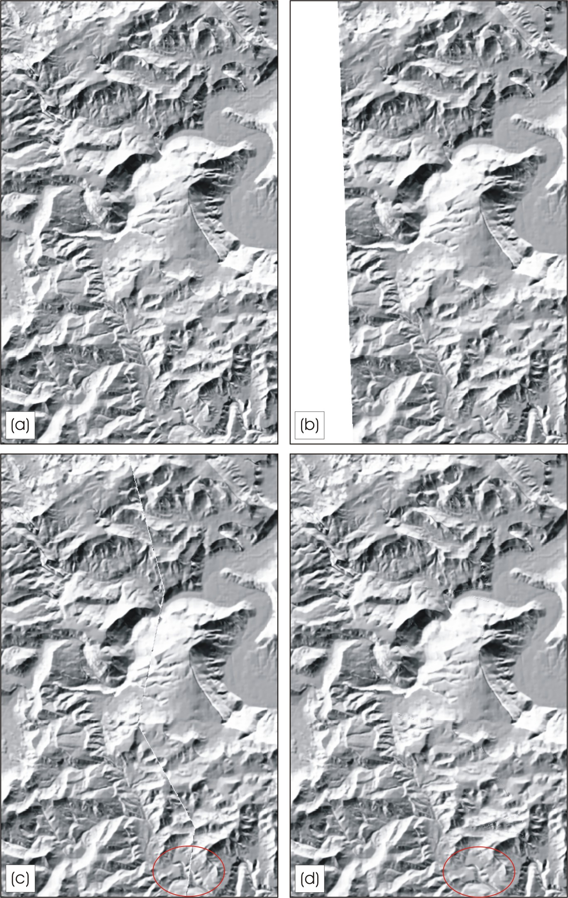
Figure 5: Merging two adjacent DTMs
- Left DTM.
- Right DTM.
- Merged DTM using cut-and-paste method.
- Merged DTM using suggested approach and algorithm.

References
- Afek Y., Brand A., 1998, Mosaicking of Orthorectified Aerial Images, Photogrammetric Engineering & Remote Sensing, Vol. 64, No. 2, pp. 115-125.
- Besl P.J., McKay N.D., 1992, A Method for Registration of 3-D Shapes, IEEE Transactions on Pattern Analysis and Machine Intelligence, Vol. 14, No. 2, pp. 239-256.
- Brookshire G., Nadler M., Lee C., 1990, Automated Stereophotogrammetry, Computer Vision, Graphics & Image Processing, Vol. 52, pp. 276-296.
- Doytsher Y., 2000, A Rubber Sheeting Algorithm for Non-Rectangular Maps, Computers & Geosciences, Vol. 26, No. 9/10, pp. 1001-1010.
- Feldmar J., Ayache N., 1994, Rigid, Affine and Locally Affine Registration of Free-Form Surfaces, International Journal of Computer Vision, Vol. 13, No. 2, pp. 99-119.
- Gillman W. D., 1985, Triangulations for Rubber Sheeting, Proceedings of 7th International Symposium on Computer Assisted Cartography (AutoCarto 7), pp. 191-199.
- Laurini R., 1998, Spatial Multi-Database Topological Continuity and Indexing: A Step Towards Seamless GIS Data Interoperability, International Journal of Geographical Information Science, Vol. 12, No. 4, pp. 373-402.
- Lupien A., Moreland W., 1987, A General Approach to Map Conflation, Proceedings of 8th International Symposium on Computer Assisted Cartography (AutoCarto 8), pp. 630-639.
- Saalfeld A., Fritsch D., 1988, Conflation - Automated Map Compilation, International Journal of Geographical Information Systems, Vol. 2, No. 3, pp. 217-228.
- Walter V., Fritsch D., 1999, Matching Spatial Datasets: A Statistical Approach, International Journal of Geographical Information Science, Vol. 13, No. 5, pp. 445-473.
- White M. S., Griffin P., 1985, Piecewise Linear Rubber Sheet Map Transformations, The American Cartographer, Vol. 12, No. 2, pp. 123-131.
- Zhang Z., 1994, Iterative Point Matching for Registration of Free-Form Curves and Surfaces, International Journal of Computer Vision, Vol. 13, No. 2, pp. 119-152.

Appendix 1: Solving Equation 3 for $\left(s,t\right)$
Solving $\left(\begin{matrix}x \\ y\end{matrix}\right)=\left(\begin{matrix}x_{1} & x_{2} & x_{3} & x_{4} \\ y_{1} & y_{2} & y_{3} & y_{4}\end{matrix}\right){\left(\begin{matrix}N_{1} & N_{2} & N_{3} & N_{4}\end{matrix}\right)}^{T}$ (Equation 3) for $\left(s,t\right)$ yields the following solution:
- Expanding ${\left(\begin{matrix}N_{1} & N_{2} & N_{3} & N_{4}\end{matrix}\right)}^{T}$, the relationship of $\left(x,y\right)$ and $\left(s,t\right)$ produces:
$$x=\frac{1}{4}\left[\left(1−s\right)\left(1−t\right)x_{1}+\left(1−s\right)\left(1+t\right)x_{2}+\left(1+s\right)\left(1+t\right)x_{3}+\left(1+s\right)\left(1−t\right)x_{4}\right]$$
$$y=\frac{1}{4}\left[\left(1−s\right)\left(1−t\right)y_{1}+\left(1−s\right)\left(1+t\right)y_{2}+\left(1+s\right)\left(1+t\right)y_{3}+\left(1+s\right)\left(1−t\right)y_{4}\right]$$
- Rearranging the expressions as functions of $\left(s,t\right)$ produces the following bilinear equation system:
$$\underset{a}{\underbrace{4x−\left(x_{1}+x_{2}+x_{3}+x_{4}\right)}}=\underset{b}{\underbrace{\left(−x_{1}+x_{4}+x_{3}−x_{2}\right)}}s+\underset{c}{\underbrace{\left(−x_{1}−x_{4}+x_{3}+x_{2}\right)}}t+\underset{d}{\underbrace{\left(x_{1}−x_{4}+x_{3}−x_{2}\right)}}\text{st}$$
$$\underset{e}{\underbrace{4y−\left(y_{1}+y_{2}+y_{3}+y_{4}\right)}}=\underset{f}{\underbrace{\left(−y_{1}+y_{4}+y_{3}−y_{2}\right)}}s+\underset{g}{\underbrace{\left(−y_{1}−y_{4}+y_{3}+y_{2}\right)}}t+\underset{h}{\underbrace{\left(y_{1}−y_{4}+y_{3}−y_{2}\right)}}\text{st}$$
$$a=b⋅s+c⋅t+d⋅s⋅t$$
$$e=f⋅s+g⋅t+h⋅s⋅t$$
- Solving the bilinear equation system for $s$ yields:
$$s=\frac{a−c⋅t}{b+d⋅t}$$
- By posting the above solution in the bilinear equation system, a quadratic equation of $t$ is obtained:
$$\underset{A}{\underbrace{\left(g⋅d−h⋅c\right)}}t^{2}+\underset{B}{\underbrace{\left(h⋅a+g⋅b−f⋅c−e⋅d\right)}}t+\underset{C}{\underbrace{\left(f⋅a−e⋅b\right)}}=0$$
$${\text{At}}^{2}+\text{Bt}+C=0$$
$$⇓$$
$$t=\frac{−B±\sqrt{B^{2}−4\text{AC}}}{2A}$$
- The value of $t$ is chosen as the positive solution of the quadratic equation.
- The coordinate $s$is calculated by using the value of $t$ in the solution of $s$ in the bilinear equation system:
$$s=\frac{a−c⋅t}{b+d⋅t}$$

- A special case, when points $P_{3}$ and $P_{4}$ coincide the quadrilateral becomes a triangle as shown
in Figure A1. In such a case, the solution of Equation 3 for $\left(s,t\right)$ is as follows:
$$c=−d=−x_{1}+x_{2}$$
$$g=−h=−y_{1}+y_{2}$$
$$a=b⋅s+c⋅t−c⋅s⋅t$$
$$e=f⋅s+g⋅t−g⋅s⋅t$$
$$s=\frac{e⋅c−a⋅g}{f⋅c−b⋅g}$$
$$t=−\frac{C}{B}=−\frac{f⋅a−e⋅b}{h⋅\left(a−b\right)+c⋅\left(e−f\right)}$$
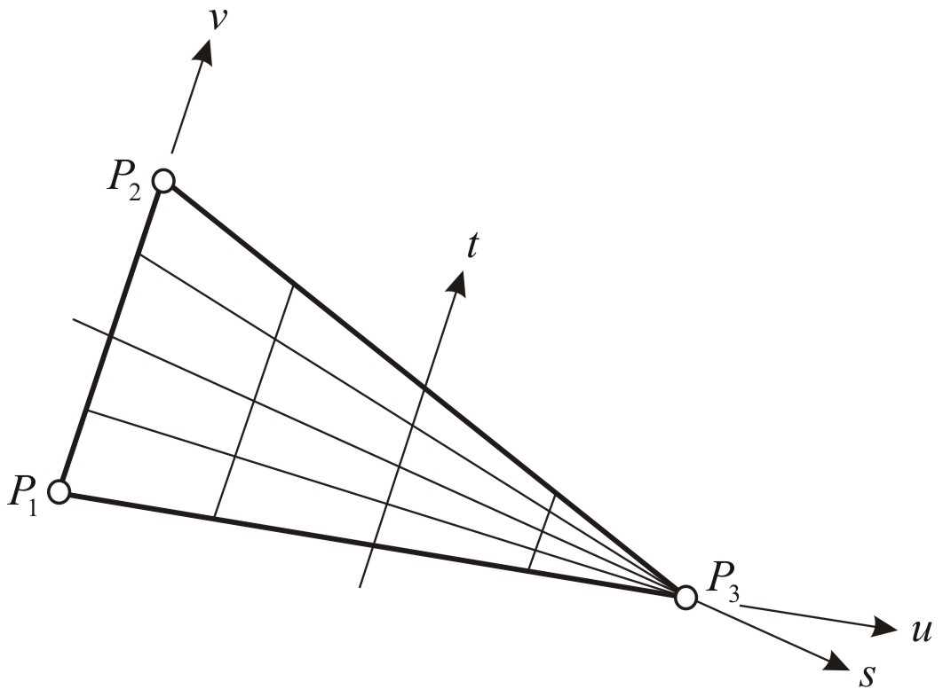
Figure A1: Quadrilateral coordinate system on a triangle

Yaron Katzil graduated from the Technion – Israel Institute of Technology in Geodetic Engineering in 1993, receiving his M.Sc in Geodetic Engineering from the Technion in 1998. He is currently engaged in PhD research in the DTM field. His main areas of interest are DTM, three-dimensional surface modeling, photogrammetry, and computer vision in geoscientific applications.
Prof. Yerach Doytsher graduated from the Technion - Israel Institute of Technology in Civil Engineering in 1967. He received his M.Sc (1972) and D.Sc. (1979) in Geodetic Engineering from the Technion. Until 1995 he was involved in geodetic and mapping projects and consulting in the private and public sectors in Israel. Since 1996 he has been a faculty staff member in Civil and Environmental Engineering at the Technion, and is currently Head of the Department of Transportation and Geo-Information Engineering. He also heads the Geodesy and Mapping Research Center at the Technion.

