APPLICATIONS OF THE AIRBORNE PHOTOS AND IMAGES ATTAINMENT SYSTEM (APIAS)
Eduardo Piovesan¹, Gustavo C. Silveira², José C.C.Gonçalves Junior²
¹Universidade de São Paulo - EESC Escola de Engenharia de São Carlos
Av. Trabalhador Sãocarlense, 400. Caixa Postal 359
13566-280 São Carlos – SP -Brasil

²Universidade Estadual Paulista-FCT Faculdade de Ciências e Tecnologia
Rua Roberto Simonsen, 305.
19060-900 Presidente Prudente - SP - Brasil

Key words: Radio-controlled aircraft, conventional photographs, photo-interpretation, and use of products.

Summary:

This article shows the use of images obtained by radio-controlled aircraft, equipped with a conventional camera

1. Introduction

Conventional photogrametry is a widely spread technique, applied in mapping. Its utility is beyond any discussion, and its methods are often in progress. Its quality is due to the use of high precision cameras and sophisticated eletronic and computering devices, operating along with precise set of lens. These equipment bear fidutial marks (that allow models orientation), constant focal distance, and 23cm x 23cm size negative, wich allows better trade between covered area and flight scale.
These cameras are generally positioned in aircraft and helicopters, and the taking of images of an area depends upon a set of factors, that must be considered in the phase of planning that precedes the flight. All these previous proceedings, plus the after-flight proceedings turn airphotogrametric setting up a very expensive technique, narrowing its application to large area projects.
When one is willing to analyse the characteristics of an isolated small area, one alternative is the use of an old flight images. However, depending upon the region, those images can be out of date, and maybe mismatching the needs of the users.
Another possibility is the use of orbital sensors digital images. The use of this kind of images is wide spreading, and its application, that until the last decade was limited to large areas of Earth surface, due to the little space resolution, is becoming more accurate and specialized due to improvements in satellite sensors, with high resolution capabilities.
IKONOS and QUICKBIRD images can lay detailed informations about Earth surface targets, with space resolutions close to 1 meter and in short time periods, wich allows constant up to date. This resolution allows several kinds of analysis in a given area, such as: rural planning, precision agriculture, and rural monitoring. The disadvantages of this kind of technique are its high cost, and the need to employ modern and sophisticated processing techniques and equipment.
Research developed since the 70ies, shows that to analyse the characteristics of surface areas, the photo-interpretation of images obtained through small frame conventional cameras (focal distance ranging from 35 to 80 mm) is enough and offers excellent results, thus dispensing the use of complex photogrametry set of instruments, and turning the process financially attractive, as long as the topographic detailing is not a target.
There are small frame cameras specific to airlifting that can be also used in mapping. To allow that, the big distortions inherent to this system had to be offset. This was reached in the decades of 70 and 80 through the development of new computing models and analytical methods.
So, the use of small frame pictures was limited to obtain a sinoptical vision of the area to be analized, what anyway, helps a lot the task of mapping, considerably reducing time and cost in the construction of the desired map by suppressing many field analysis. This allows the use of common small frame cameras, smaller and lighter than those specifically employed in airlifting, thus dispensing the use of conventional aircraft.
A practical, cheap and fast way of obtaining aerial pictures of a small area with common cameras is installing them in a radio-controlled aircraft (airmodel), then setting flight altitude, speed, exposure time, and kind of film to be used, according the field of interest, in order to achieve the best use of the final product. If properly taken, these pictures will bear quality enough to allow a proper photo-interpretation, from where interesting information can be obtained.

2.APIAS Project

2.1Prototype

The project APIAS (airborne photos and images attainment system) was born in 2001 with the development of a small radio-controlled aircraft, able to bear a camera and over-fly an testing area, started with the adapting of a standard model, that can be found at any modelism store, originally used to prepare beginners in the “art of airmodeling”, and able to perform a stable, low speed flight, with good altitude control, thus allowing clean, uniform and overmatching pictures to be taken. The standard model, with small wing range, performed a flight turbulent enough to interfere in picture quality, so harming the photo interpretation. To solve that problem, a new aircraft was used, keeping almost the same features of the precedent, except wing range (2,2 meters). This new model, besides greater load capacity, enough to bear even a video camera, has excellent quality. The new model is illustrated in images 1 and 2.
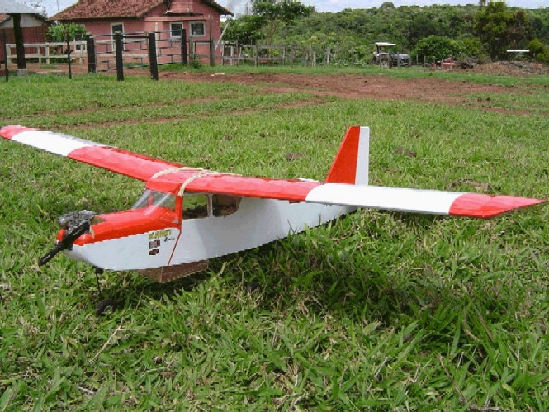
Image 1: Actually Air model Kit

Three models of the cameras were used to take the pictures (Olympus M-210, Kodak Dc-210 and Sony Cybershot DSC-P73) but any other device can be used (digital cameras, movie cameras, DV-Cam). Any camera model can be easily installed due to the wide enough aircraft body.

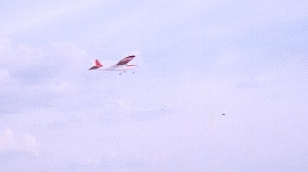

Image 2: Air model during the flight

As far as the shooting mechanism is concern, although electronic systems were available, a servomechanism was rather used, able to be mechanically operated by the radio transmission, so that the air model operator can be also the camera shooter.

2.2Cost

The cost of the project is described in table 1:

Material | Cost (Euros)
Model (material ) | 150
Model (assembly) | 60
Engine | 70
Radio – control | 200
Camera | 200
Total | 680
Table 1: Cost of the project

3.Images Acquisitions Tests

3.1 Airlifting Scheme

The airlifting scheme is described as follows:

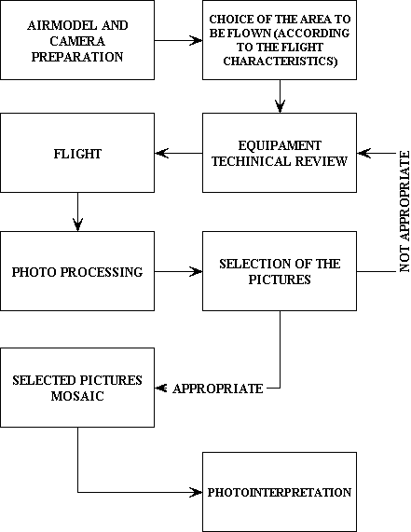

Image 3: Main Phases of airlifting

3.2 Testing Areas

For testing project viability on Terrain use and occupations recognizing, the chosen area, was located in the municipality of Alvares Machado, SP, where there is leisure club with a paved airmodeling runaway, who allows the aircraft operation. At The club borders there are rural production properties and an intermunicipal road, which offer a good base of aircraft operations and interesting elements for photo-interpretations. For that study, the premises along the airmodel runaway were selected as photo-interpretation targets.

In another study, at urban applications a flight was done to take images nearby urban zone of Presidente Prudente city.

The agriculture of precision and florets monitoring also was boarded, with images token over-flight experimental campus of the agronomics schools of Universidade Estadual Paulista UNESP in Botucatu- SP.

The purpose and localization of the tests is described in image 4:

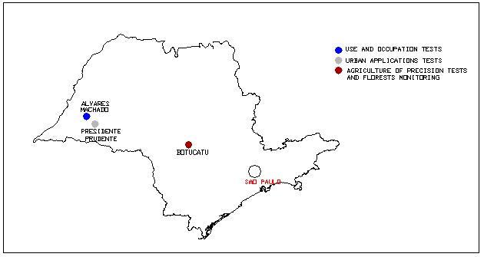
Image 4: Purpose and localization of the tests

3.3 Flight Cover

To ensure, total runaway cover, the aircraft flew approximately 70 m high and at 10 m/s speed.
The utilized camera has a 35mm focus range, and the shooting was made randomly, while the craft was over-flying the targets. The model bears a 250 ml fuel tank, with 25 minutes flight autonomy, what allows the target region pictures to be taken in a single flight.

4.Images Interpretation

4.1Image Selection

The processed pictures were analyzed, to determine wich of them were appropriate to the project and wich had to be put away. Sets of intuitives criteria were employed in this task, using elements as scale, brightness, color range, contrast and resolution.

Although showing good stability and control, the aircraft, influenced by climate elements, changed its altitude while taking some of the pictures, wich were put aside due to its not compatible scale. Pictures that were not accurate enough to allow the identification of the photographed targets, or exhibited scrolled images, were put aside.

To improve image quality, some of the camera parameters were modified, such as the time of exposure. In this case, this problem was solved by changing the flash system position, because this, when out of use, extends the time of exposure, causing image scrolling. As the available light was enough, and the camera had good features, the flash was set in the position “automatic”, where the light amount is measured by a sensor device installed in the own camera, thus controlling the exposure time. So, after that, the pictures dramatically improved, allowing a good photo interpretation.

4.2 Information Retrieval

The visual interpretation of images was originally conceived to retrieve data from air photographs, the process being called photo interpretation. The photo interpretation is directly related to the visual accuracy of the interpreter, along with his or her scientific knowledge, activity and degree of mastering of the image acquisition system. Thus, no matter what the photo interpretation purpose should be, a good conceptual background, application experiences and related areas knowledge are required, so that the aimed that should be criteriously retrieved.

The visual interpretation of image can be ordered into three related phases: photoreading, photo analysis, and photo interpretation itself. Photoreading consists mainly in identifying, or recognizing, the objects (faces) in the images. The photo analysis deals with examining the objects, trying to stablish the relations, associations and orders among them; and the photo interpretation deals with the definition of the objects and faces present in the scene, using inductive, deductive and comparative methods.

Visual interpretation requires training and the use of logic criteria to develop the process with the employment of visual data retrieval method.

4.3Interpretation Elements

The images represent the recording of the energy coming from the surface objects. Those images can be of several resolutions and scales, but beyond that, show some basic elements that allow the retrieval of information from the terrain. There is no consensus about wich elements should be considered in the visual analysis of images, however the most widely accepted are: colors, texture, shape, standard, shadow, localization, convergence of evidences, size and resolution (often considered as image characterizing element).

4.4Photointerpretation of the Object of Study

In the use and occupation tests, the pictures were taken from several points within the club, but just were selected those that targeted the object of study, that is the flight runaway. With the chosen images, an uncontrolled mosaic was set, because in that starting phase of the project, neither the aircraft altitude control mechanism, nor the spatial coordinates of the region were available.

In the images obtained at urban tests, the study was concerned in recognizing great targets as buildings, gardens, soccer field and other targets important for urban planning.

At rural applications the interested information are about contrasts caused because of ground deficiencies and plagues. On forests monitoring the images gives important data about deforestation, fire and affected area recover.

5. Results

5.1 Use and Occupation Test

In the mosaic (see Image 5), can be identified since the constructions and runway infrastructure details to the people and cars present in the scene.
Existing trees around the runaway, and the variations of the green cover of the soil opposed to the constructions in the runway, are other samples of interpretation obtained with the use of APIAS.
With the help of the topographic lifting, the region’s space coordinates can be determined and even use the images to sponsor mapping field visits.

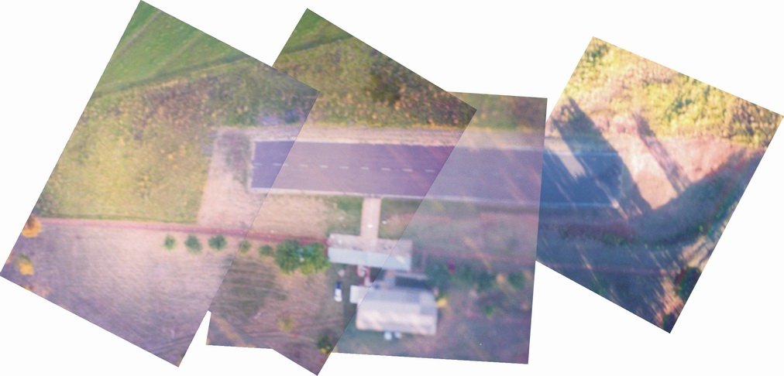

Image 5: Mosaic of the flight track

5.2 Urban Area

The results of urban flying is shown in images 6 and 7:

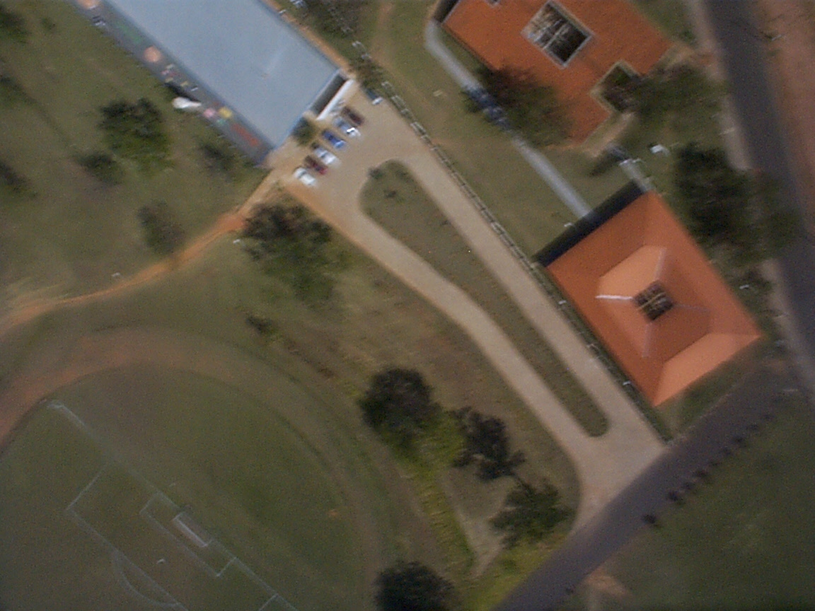
Image 6: Urban Image of Unesp University Campus

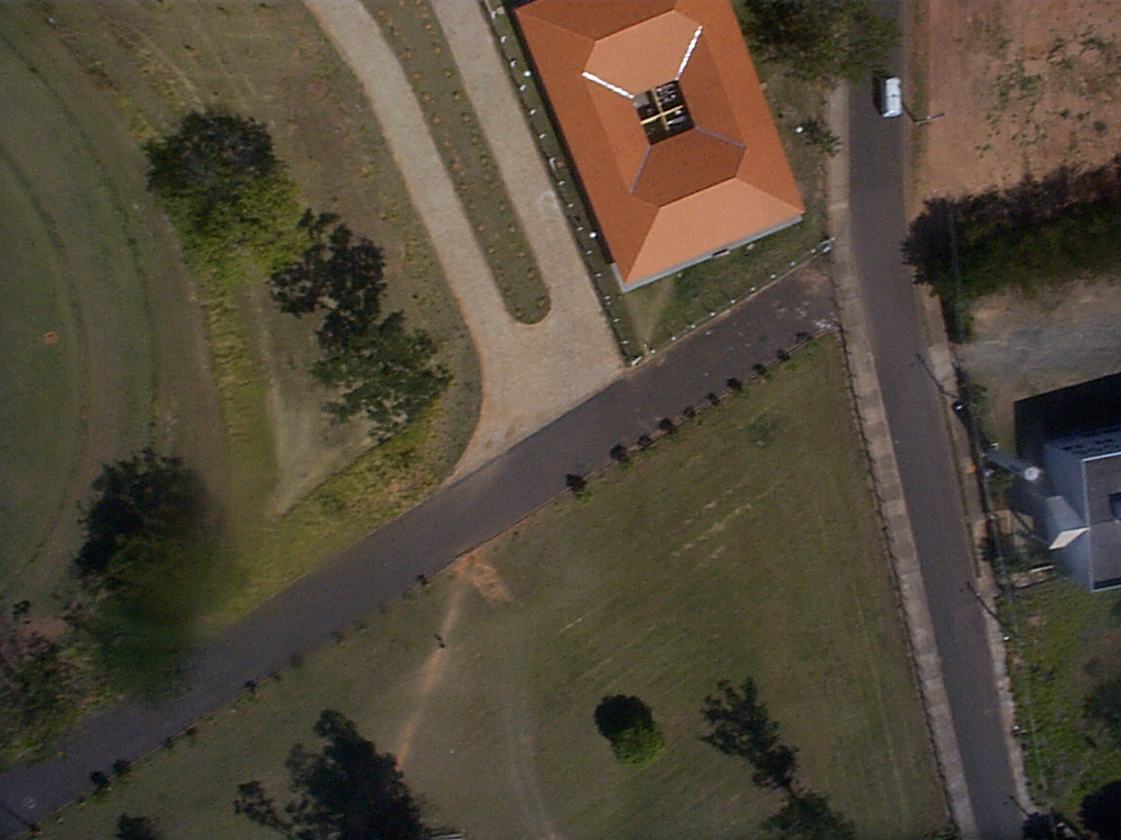

Image 7 : Urban Image of Unesp University Campus

5.3 Agriculture and Natural Resources

Agriculture should also benefits from the system, wich retrieved data should be used to optimize production.

The results of rural flying is shown in images 8 and 9:

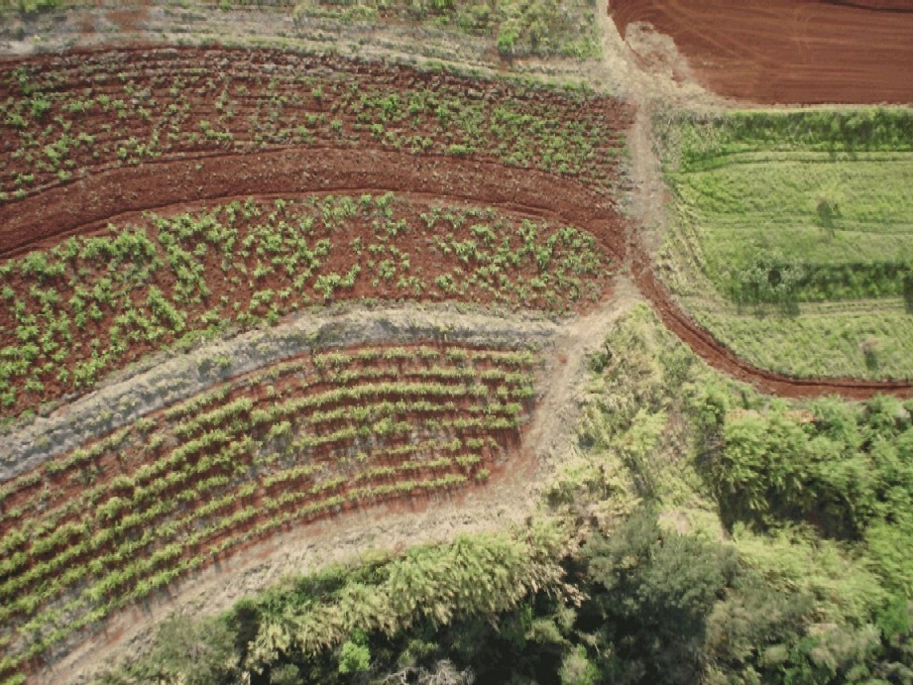
Image8: Agriculture use of Image
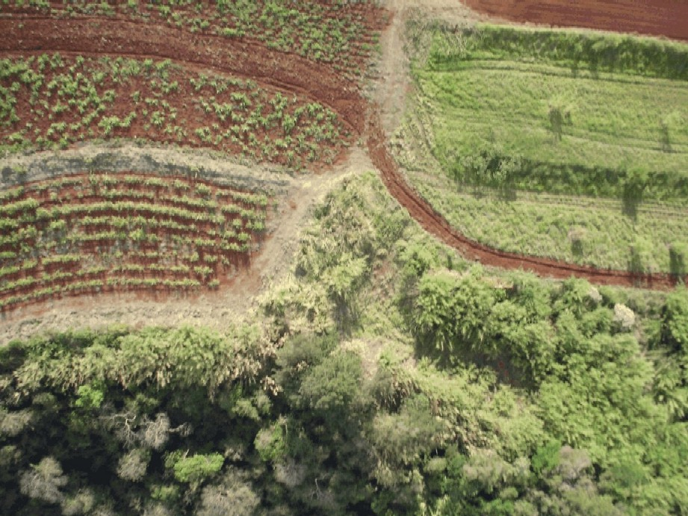
Image9: Agriculture use of Image

In forestall area, the result of flying is shown in images 10 and 11:

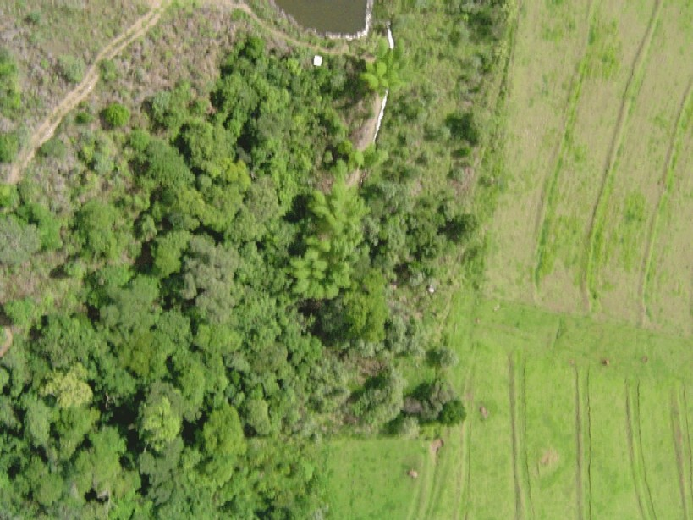
Image10: Natural Resources
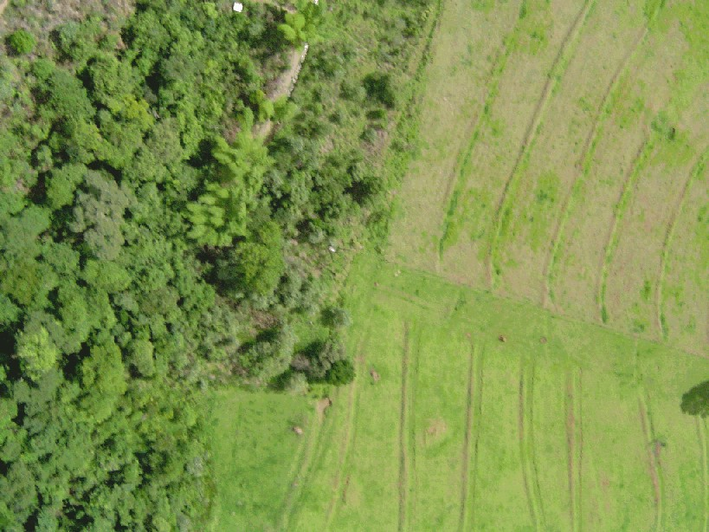
Image11: Natural Resources

5.4Future Expectations

A GPS receiver should be installed in the aircraft, and the positions of the images taking should be known, as well as the aircraft altitude and speed, allowing both the control on building mosaic and the measuring with topographic purposes with APIAS.

6.Conclusion

APIAS has proven efficiency and versatility on aerial pictures, and can be used to photo interpretation as described in this paper. In the future, other kind of lifting should be available, increasing the options of cartographic products or data for mapping purposes.

The low cost of the project, compared with the standard airphotogrametry is the main attraction of the AIPAS. The reduced employment of labor – only one or two persons are needed to execute the lifting – allows economy, besides the equipment saved costs.

7. References

[1]. Amorin, A, 1993.Utilização de câmaras de Pequeno Formato no Cadastro Técnico Urbano, Mestrado dissertação, 105p Florianópolis-SC.
[2]. Disperati, A. A., 1991. Obtenção e Uso de Fotografias Aéreas de Pequeno Formato, 290p, Curitiba-PR.

[3]. Galo, M. L. B. T., 2001. Interpretação Visual de Imagens, 14p, Presidente Prudente-SP.
[4]. Gonçalves Junior, J. C. C.; Piovesan, E. C.; Silveira, G. C, 2004. APIAS - Airborne Photos and Images Attainment System.GEOINFORMATICS 2004, Gävle, Sweden.
[5]. Gonçalves Junior, J. C. C.; Piovesan, E. C.; Silveira, G. C, 2003. SOFIA - Sistema de Obtenção de Fotos e Imagens com Aeromodelo. Congresso Brasileiro de Cartografia, Belo Horizonte – MG.

