Ofek-Multivision – Comprehensive Oblique Photogrammetric Software Solution

Ilan Friedlander

Vice President

OFEK Aerial Photography

New Industrial Zone, P.O. Box 8065

Netanya, Israel

Key words: Photogrammetry, oblique photo orientation, DTM, measurement tools

Summary

Ofek-Multivision (MV) is a program that enables the display and measurement of objects on the ground, from various angles and directions and provides a dynamic photogrammetric solution for oblique aerial photographs. The programs aim is to enable lateral viewing and measurement of objects, such as facades of buildings, antennae and poles. The development of Multivision was based on the premise that every user, regardless of his/her level of skillfulness, should be able to interpret, measure and understand occurrences on the ground, without necessarily being physically present on site.

General
Ofek-Multivision (MV) is a program that provides a dynamic photogrammetric solution for oblique aerial photographs. The program enables the display and measurement of objects on the ground, from various angles and directions, while a map or an orthophoto provide only a view from above and horizontal measuring on the surface of the ground. The aim of this program is to enable lateral viewing and measurement of objects, such as facades of buildings, antennae and poles. The program has multiple and diverse uses. The development of Multivision was based on the premise that every user, regardless of his/her level of skillfulness, should be able to interpret, measure and understand occurrences on the ground, without necessarily being physically present on site. The horizontal viewing which Multivision solves is the convenient angle, to which we are all accustomed.

The information required for setting up the data for MV are as follows:
- Aerial photography – mode of collecting data
- Photos’ processing – photogrammetric orientation of the photos
- User’s program – enables simultaneous movement and measurement of objects.

- Aerial Photography Data
- Aerial photographs are produced through various methods: photogrammetric cameras (film or digital)
- Digital metric cameras
- Other, non-metric cameras
The photographic method and the type of photography affects the quality of the solution. The closer the photography, the better the resolution obtained. However, this requires a greater number of photos and longer flight time. This applies to the quality of the solution as well.

Wide-format Photography using a photogrammetric camera may provide the best and most accurate solution, but each point would anyway have to be photographed from four directions.
Oblique photography, like vertical photogrammetric flight, is carried out following planning with flight planning systems, and by means of GPS.
For calculating the solution, the camera’s calibration report is required. In the absence of such report, the camera is either non-metric, or the quality of the solution and measurements is impaired.
Photos taken by an analog metric camera must be scanned with a calibrated photogrammetric scanner.

- Photo processing – photogrammetric orientation
The objective is to find the camera’s 6 parameters: Y, X, Z, Omega, Phi, Kappa.
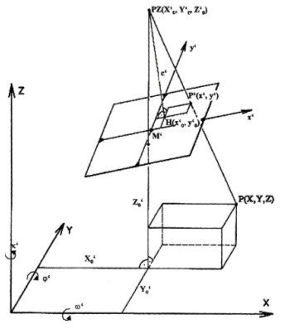
Figure 1: Exterior orientation: the point PZ is the position of the camera we seek
  - MV enables carrying out the orientation by sampling control points, like the method by which orientation is carried out for aerial photos that undergo rectification and orthophoto. The program displays an orthophoto and an oblique photo at the same time, so that control points can be sampled on both of them simultaneously. The solution program, MV-SPECIAL ONE, is designated to calculate these parameters efficiently, without requiring any further flight data. The solution is based on the collinearity equations :
$x_{p}=x_{0}−f\frac{m_{\text{11}}(\text{Xt}−X_{c})+m_{\text{12}}(\text{Yt}−Y_{c})+m_{\text{13}}(\text{Zt}−Z_{c})}{m_{\text{31}}(\text{Xt}−X_{c})+m_{\text{32}}(\text{Yt}−Y_{c})+m_{\text{33}}(\text{Zt}−Z_{c})}$ (1)

$y_{p}=y_{0}−f\frac{m_{\text{21}}(\text{Xt}−X_{c})+m_{\text{22}}(\text{Yt}−Y_{c})+m_{\text{23}}(\text{Zt}−Z_{c})}{m_{\text{31}}(\text{Xt}−X_{c})+m_{\text{32}}(\text{Yt}−Y_{c})+m_{\text{33}}(\text{Zt}−Z_{c})}$ (2)

$X_{p},Y_{p}$ is photo coordinate, $\text{Xt},\text{Yt}$ is object coordinate in world space
$x_{0},y_{0}$ is taken from camera calibration report , or can be calculated by fiducial coordinates.

Control points can be taken from photogrammetric maps, or from any other accurate source. Accuracy of the sampled points will determine the accuracy of the solution. Orientation of analog aerial photos requires internal orientation, such as input of fiducial marks.
  - The solution of oblique aerial photos can be carried out using the INS system, and airborne GPS. While this solution would spare the need to sample control points, the option of using these systems and their support incurs additional costs, and somewhat complicates the photographic work.
Conclusion: MV enables a photogrammetric solution for any type of photo/camera. The type of photographic system and solution will ultimately determine the accuracy and resolution of the solution.

- MV – The User’s Program
The program enables each user to dynamically view several aerial photos, all at the same time, and measure certain objects with very high accuracy.

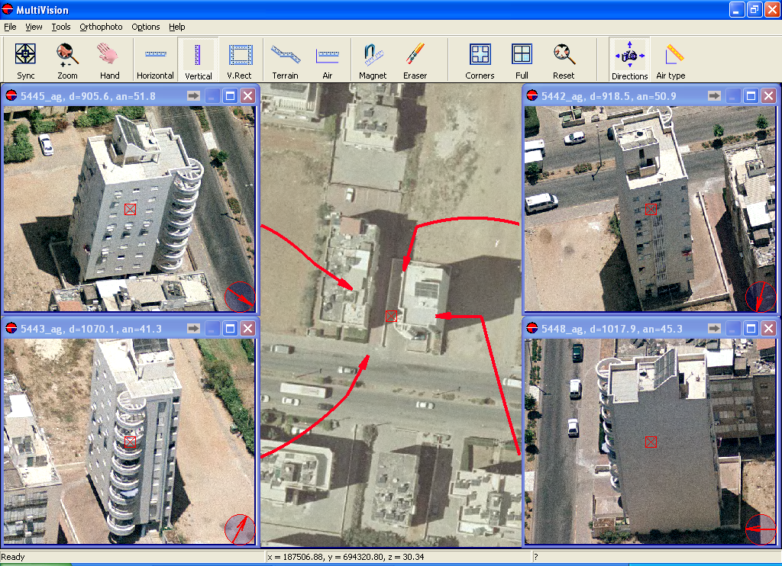
NORTH
WEST
EAST
SOUTH
Figure 2: Multivision Main Screen
The main features of the program are as follows:
- Geo-referencing
- The program operates in DTM environment, thus enabling to make various calculations for locating the user’s relevant oblique photos.
- An orientation map can be an orthophoto, a photogrammetric map or any other vector or raster map.
- The program incorporates the collection of all photos relevant to any specific tile.
- While moving on the map or the orthophoto, 4 oblique photos are in motion, one from each direction: North, South, East, West. The four oblique photos displayed on the screen are the four that are nearest to the camera lens, one from each direction.
Their simultaneous motion is fast, which is enabled by the speedy calculations made by the program.
In case the photo collection contains more than four photos (for instance, when aerial photography coverage includes dozens or hundreds of photos), the system will select, as mentioned above, the four that are nearest to the lens, by calculating their exact location.
- Zoom in/out - While designing this program, efficiency and working speed on the computer screen were taken into consideration. Thus, focusing on a specific point, enlarging it and making it small are fast and convenient.
- Moving a single photo: each photo can be moved on the screen separately. Each movement is achieved by making the necessary calculations of distances, angles, etc., as mentioned above.
  - The program’s main feature – a measuring tool
MV enables making all principal measurements:
- Measurement of objects above ground such as buildings, poles, facades, trees, etc.
- Measurement of ground surface objects such as distances, areas (polygons) and the like.

- Measurement of objects above ground
MV enables the measurement of horizontal and vertical objects only. Therefore, the program starts out by calculating the vertical line seen on the screen. This calculated line, and its positioning before measuring any object, is the key to accurate measurements. The line is calculated based on the solution of each photo separately.

Horizontal measurement
This is a relative measurement, which enables measuring horizontal objects situated on the surface of the ground or elevated high above ground surface. For example, measuring the length of a balcony on the 50th floor of a high-rise. Such measurement can achieve ~10 cm accuracy. However, accuracy is conditioned on several factors: accuracy of the solution, accuracy in identifying the measured objects, and measurement should be only horizontal.
Method of measurement: the vertical line is to be positioned on ground surface, under the object that is being measured. Measuring starts on the vertical line, horizontally, and along the measured object.

Measuring elevations
Similar to the way horizontal measuring is performed. Measurement is to be carried out only along the vertical line. MV enables the measurement of segments along the vertical line.

Façade area measurement
MV enables measuring the area of facades, such as of buildings, windows, doors, signs, etc. Area measurements combine the measurement of elevations and horizontal measuring.

Polygon measurement
As in horizontal measurement, polylines and polygons can be measured, thus enabling calculation of an elevated area, such as the area of a roof, a balcony, etc.

Measurement of “cubes” – 3D modeling
Combining elevation measurement of the “cube” (for example: a structure) and measurement of its elevated area (the structure’s roof) enables the creation of a 3D model, carried out by MV on a one-dimensional photo.

The combination of all of these features enables a quasi-photogrammetric measurement based on a single oblique photo.

b. Measurement of objects on the ground:
This is actually accomplished on the DTM. The photogrammetric solution of each photo and the DTM data are integrated in this measurement. This measurement is similar to measuring on a map or orthophoto. The advantage of measuring on an oblique photo is that it enables the user to better understand the measured objects and the topographic nature of the terrain (in vertical orthophotos, the capability to understand the terrain topography is meager).

Measuring on the Terrain
This type of measurement enables to position the measuring line in between two points – A, B – with the line itself – ab – positioned on the ground.
Calculating the length of line ab, is based on the DTM.

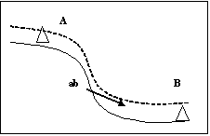
Figure 3: Terrain Measurement

Horizontal measurement
This measurement is carried out in between two points – A, B – and calculates the distance between a and b, including the slope.

Measuring an aerial line
Measuring distance between two points: A, B₁, enables the measurement of an aerial line ab₁, like measurements taken on a map or orthophoto.

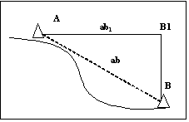
Figure 4: Aerial Line Measurement

Polygon measurement
This is enabled through the measurement of aerial lines. The area of the polygon is equal to the area of a polygon measured on a map or orthophoto.

  - Additional features of Multivision:
In order to provide the end user with maximum convenience in operating the program, some additional tools are available. Using them improves the user’s capability to make utmost use of the program.
- Color balance – possibility of controlling colors through the tools of Brightness, Contrast, RGB.
- Changing the nature of the measurement lines: color and thickness of each line can be changed.
- Changing size and color of text: each text can be changed in terms of size and form, including numbers.
- Numerals can be made bold.
- Transparency – polygons may be changed or colored as selected.
- Objects such as lines, text, etc., can be displayed or hidden, as selected.
- Each photo can be viewed in B/W or negative form.
- Any selected feature may be saved by “Save as default.”

Multivision operates in correspondence with GIS (for example, ArcView). The GIS operator can make geographic queries; once a datum from the GIS is displayed (such as an address, coordinate, polygon, etc.) – four oblique aerial photos for the specific coordinate, will appear on screen. It is possible to go back and forth between Multivision and the GIS.

