Mapping and Modeling of Urban Environmental Quality in Hong Kong

Janet Nichol¹ and Man Sing Wong
The Department of Land Surveying and Geo-Informatics
The Hong Kong Polytechnic University
Hung Hom, Kowloon
Hong Kong
e-mail: lsjanet@polyu.edu.hk
e-mail: ls.charles@polyu.edu.hk
Telephone: 852-27665952
Fax: 852-23302994

Abstract

This paper demonstrates the application and usage of current remote sensing techniques for estimating and depicting Urban Environmental Quality at detailed level from satellite images. Temperature data derived from Landsat ETM+, Vegetation Index derived from high resolution IKONOS multispectral images, digitized data of the city urban infrastructure and 3-D virtual reality models were integrated in this study to assess Urban Environmental Quality in Kowloon Peninsula and Hong Kong Island in Hong Kong. A vegetation index image from IKONOS multispectral imagery was fused with the thermal waveband from Landsat ETM+, to obtain more spatially detailed information on surface temperature. These data are combined with image-derived biomass indices for evaluating UEQ in densely built high rise areas of Hong Kong. The structure and spatial location of buildings as well as the evaluation of the terrain are also modeled to permit visualization of urban morphology. The roof surface temperature and the facet temperatures are determined from analysis of the relationship between horizontal ‘seen’ surfaces and ground truth data. This model not only gives an accurate representation of the urban thermal environment, but it also indicates: 1. the presence of natural fresh air corridors into urban areas along mountain valleys and ridges, 2. the key buildings or city blocks which restrict air flow, 3. the effectiveness of biomass in conjunction with building height and orientation in moderating urban temperature, 4. the importance of small patches of greenery in the city, 5. overall strategies for moderating the Urban Heat Island in Hong Kong.

Keywords: Urban Environmental Quality; Urban Heat Island; Remote sensing; Visualization; Biomass; Image fusion

1. Introduction

After the SARS epidemic, Hong Kong is evaluating its policies on urban environment and quality. In this study, Urban Environmental Quality is evaluated by integrating the causative factors including the Urban Heat Island, the distribution of greenery, building density and geometry, and air quality. Currently, although satellite sensors can detect and identify objects at meter-level, it is still not possible to capture all this complexity due to spatial and spectral inadequacies. However, the close positive relationship between these parameters and the Urban Heat Island [4,5,7], and its inverse relationship with biomass [6] are well documented. A highly detailed surface temperature image can be derived from fusing the thermal satellite images to fine resolution sensors. It is noted that the urban heat islands effect can be derived and estimated through surface temperature [8,13]. And, the detailed land cover, biomass estimation [12] can be derived from fine resolution sensors such as IKONOS. Whereas some satellite-based studies have demonstrated strong relationships between the Urban Heat Island, thermal image data and biomass [6] these have been at a generalized level. The present study is unique in its utilisation of both the satellite-derived parameters, temperature and biomass, as independent indicators of environmental quality and their application to urban structures at micro-scale.

2. Study area

Hong Kong, a city in southeast China, has similar weather to many hot tropical cities. The temperature is ranging from 10 to 35 degree and most days have high humidity, creating thermal discomfort for several months of the year. Recently, due to rapid industrial development in Shenzhen, in the southern China adjacent to Hong Kong, aersols and ashes produced by coal burning are carried by monsoon wind to Hong Kong (Figure 1). A combination of mountainous terrain and dense building structures, causes the pollutants to be trapped among the high rise buildings and street canyons of the flat coastal plain. Also, the dispersion is blocked by steep mountain slopes. This phenomenon causes the air pollution indices to be “high” at this time, especially in Mongkok and Causeway Bay (Table 1), which have the most dense concentrations of high rise buildings in Hong Kong [4]. These areas are devoid of trees and grassy areas due to lack of space and high land price, so, congestion, noise and high temperatures occur within these areas.
Janet Nichol¹ Associate Professor,
The Department of Land Surveying and Geo-Informatics,
The Hong Kong Polytechnic University, Hong Kong.

3. Thermal image data

Traditionally, thermal satellite sensors are of low resolution, such as 60m for Landsat ETM+, 90m for ASTER sensor and 1km for the AVHRR sensor. In this study, the Landsat ETM+ thermal band with 60m pixel size was corrected for emissivity differences in the conversion of the data to surface temperature, while simultaneously increasing the pixel size. [8] (Equation 1). This image fusion technique is called “classification image fusion approach” and its rationale is to use the coarse thermal waveband fused with a biomass image devised from fine resolution IKONOS imagery while correcting the differences in emissivity between the vegetated and non-vegetated areas. Since emissivity differences would be the main source of error in the derivation of surface temperature from thermal images, the correction is necessary. The correction, using Planck’s constant (Equation 1) [1] effectively fuses the thermal image with the 4m resolution IKONOS image which has been classified into vegetated and non-vegetated areas. The 4m pixels in this binary mask image are then allocated emissivity values according to whether they represent vegetation or non-vegetation. The production of the vegetation mask image will be illustrated in section 4.

Ts = Tb / [1 + (λT / α) ln ε] (Equation 1)

where:

Ts = Surface Temperature (°K)
Tb = Black Body Temperature (°K)
λ = wavelength of emitted radiance,
α = hc/K (1.438 × 10⁻² mK),
h = Planck's constant (6.626 × 10⁻³⁴ Js),
c = velocity of light (2.998 × 10⁸ m/sec),
K = Boltzman Constant (1.38 × 10⁻³ J/K).

A double row of street trees which can be seen in the colour air photo (Figure 2a), is not detectable on the uncorrected thermal image (Figure 2b), but is visible as a cool corridor on the corrected image (Figure 2c) after the emissivity correction. The temperature of these street trees is approximately 5ºC cooler than an untreed street. Significant temperature differences were observed between urban infrastructures and treed areas, similar to findings of a (2ºC) difference between the tree canopy and the open ground area, in Singapore [9]. Thus, the corrected thermal data with fine resolution are detailed enough for representing the surfaces temperatures of urban infrastructures including even individual buildings and single trees.

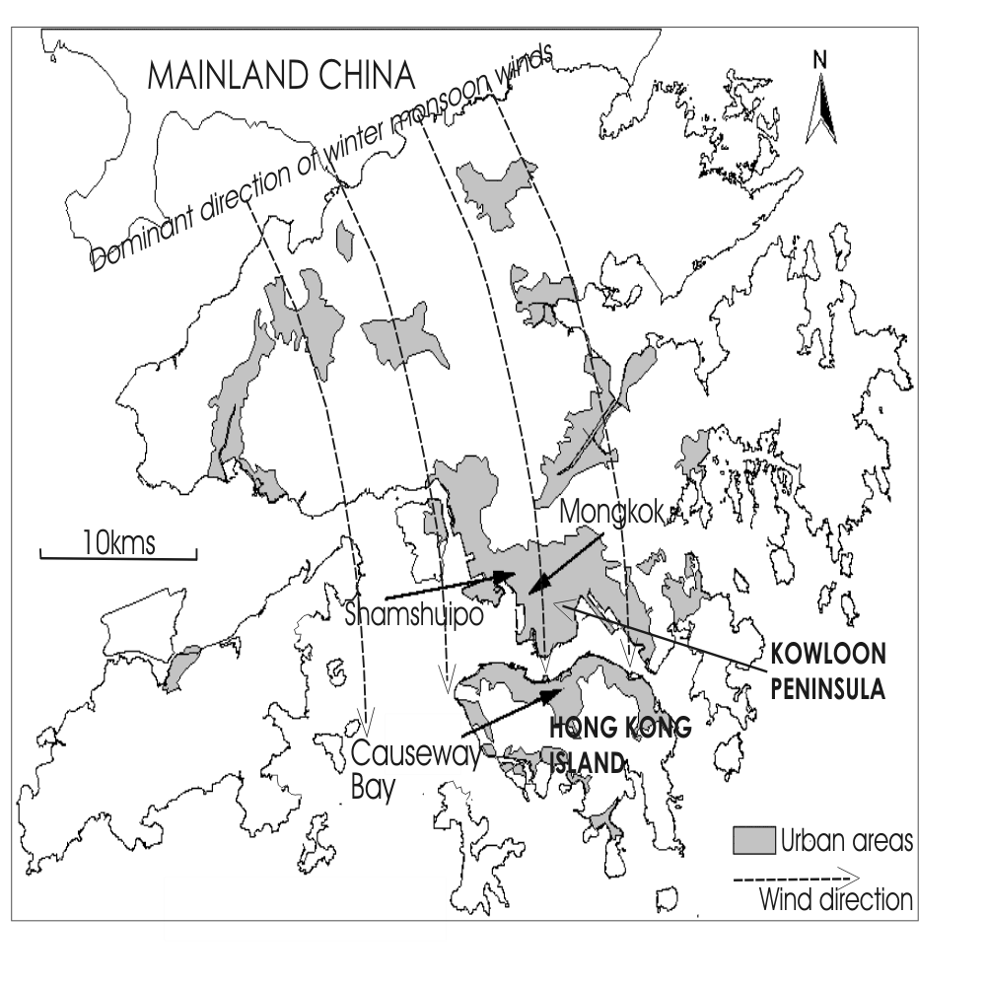

Figure 1: Moonsoon wind direction and the urban areas in Hong Kong

Station | Distribution of Hourly API (Number of Hours)
Station | Low  (0-25) | Medium  (26-50) | High  (51-100) | Very High  (101-200) | Severe  (201-500)
Causeway Bay | 0 | 857 | 1301 | 50 | 0
Central | 0 | 1092 | 895 | 220 | 0
Mong Kok | 0 | 1095 | 823 | 269 | 0
Eastern | 623 | 952 | 540 | 0 | 0
Kwai Chung | 453 | 994 | 740 | 20 | 0
Kwun Tong | 604 | 939 | 608 | 22 | 0
Sha Tin | 812 | 715 | 655 | 10 | 0
Sham Shui Po | 446 | 1058 | 693 | 2 | 0
Tai Po | 0 | 0 | 0 | 0 | 0
Tap Mun | 1025 | 474 | 499 | 3 | 0
Tsuen Wan | 436 | 1065 | 699 | 8 | 0
Tung Chung | 962 | 464 | 695 | 44 | 1
Yuen Long | 445 | 896 | 824 | 5 | 0

Table 1: Frequency of Air pollution Index in various levels in third quarter of 2004 [4]

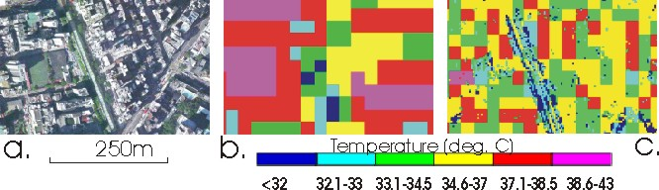

Figure 2: (a). Digital orthophoto; (b). Thermal data (60m); (c). Corrected thermal data (4m)

4. Biomass vegetation mapping

Vegetation is an important factor for estimating Environmental Quality, including the aesthetic considerations, temperature control due to evapotranspiration and shading, the filtering and recycling of pollutants [16] and as urban wildlife habitats [5]. On a paved area without vegetation, heat energy will be maximum since the evapotranspiration may be zero. Even individual street trees and small grassy parks have a cooling effect on the surroundings. The vegetation map for this study was devised from fine resolution IKONOS imagery using the chlorophyll index [12]. Forty one sample ground quadrats representing Vegetation Density were regressed against the image data (Equation 2) and a R² value of 0.8 was obtained [12].

Vegetation Density = 1.6*1000*sqrt(g/r)-404.4*(g/r)+34.8 (Equation 2)

where g = the IKONOS 0.52-0.6 µm waveband
r = the IKONOS 0.63-0.69 µm waveband

A strong negative relationship is observed between vegetation density and surface temperature due to evapotranspiration and shadow effects from the tree canopy (R² = 0.82). In order to construct a map of Urban Environmental Quality from the surface temperature and vegetation density maps, conditional statements may be applied to these two quantifiable parameters for depicting the variable levels of Urban Environmental Quality. Three such queries are:

- warm and unvegetated
- warm but vegetated
- cool but unvegetated

For example Vegetation Density >1.5 SDs below mean, and Surface Temperature >1.5 SDs below mean returns pixels of type (iii). These robust and logical statements show that even a small patch of greenery surrounded by densely built urban areas, remain both vegetated and cool. The result of this robust conditional vegetation mapping is illustrated in Figure 2. This detailed biomass and temperature mapping can be further enhanced using 3-D representations to promote a better understanding of environmental relationships and processes.

5. Modeling

5.1. Horizontal surface

Remote sensing data is mainly two-dimensional, therefore only the temperature of the horizontal ’seen’ surface can be measured. This is considerably smaller than the complete surface [10,15,17]. However, all urban surfaces contribute to the UHI in providing shade, and as barriers and funnels for fresh rural air. It is obvious that vertical facets are mostly cooler when they face away from the sun, but this issue is especially true in tropical cities such as in Hong Kong due to the high sun angle. Thus the 3-D model is constructed to provide a method for compensating for the systematic error of anisotropy associated with nadir viewing of an incomplete urban surface at city scale. In high rise areas of Hong Kong, at Causeway Bay, for example, where building density is 45% and the average building height is 50m, the active radiating surface is 2.67 times the planimetric surface ‘seen’ by the satellite. This constitutes an image error of +1.5ºC for the satellite ‘seen’ surface in Causeway Bay.

5.2. Vertical Building facets

Vector data of building outlines and roads were acquired from the Hong Kong Lands Department, and corresponding attribute data such as number of floors were used for constructing the 3-D buildings. ArcGIS and ArcView were used for handling the spatial vector data and 3D Studio Max software was used for model construction, texture attachment and rendering. For the colour attachment on the horizontal facets, the temperatures were directly derived by overlaying the image data with building outlines after the method of [7]. The temperature of the ‘seen’ roof surface was derived by averaging the temperature of pixels intersecting each building. Colour rendering of the vertical facets should consider the neighbouring urbanized features, as well as the effect of sun angle and azimuth at the image time. A further step would be a 4-D model for rendering facets according to diurnal and seasonal changes of temperature. However, the temperatures of vertical facets were determined according to relationships between horizontal and vertical surfaces from fieldwork conducted in September 2002 at the same season and time of day as the image. A total of 82 paired readings of horizontal and vertical surfaces were obtained in differently oriented street canyons in urban Hong Kong. Thus the temperature adjustments as a departure from horizontal ground temperatures, for vertical surfaces are -2.5ºC for shaded and -1ºC for sunny surfaces respectively. These amendments were applied on the image data with particular sun angle and image time.

5.3. Analysis of the Urban Environment

This 3-D model illustrates two main findings related to the structure of urbanized features and the distribution of vegetation. First, this model shows that where vegetation is absent, the local factors including the topography, building geometry and structure in relation with the sun angle and sun azimuth appear to be the greatest influence of temperature control. Figure 3, shows Shamshuipo and Mongkok area:- a densely built residential areas with the 1950’s urban design. They are devoid of vegetation except for a very few street trees and small parks, and most of the streets and buildings are oriented NW-SE; parallel to the direction of sunlight (solar azimuth is 127º). Thus this area appears 6ºC warmer at the image time, 9.30am, than Mongkok whose streets run roughly north-south. The solar azimuth would change to more southerly toward midday, and approaching noon Shamshuipo streets would become shadowed and Mongkok streets would experience a period of direct solar illumination. The model in its present form cannot represent these dynamic changes.

Figure 4 illustrates the 3-D model for Causeway Bay commercial and business district on Hong Kong Island, adjacent to Victorial Habour. It is shown that the temperature of Causeway Bay in 9.30 am at the image time is cooler than the residential area in Shamshuipo and Mongkok. This may due to, 1. the taller buildings in Causeway Bay creating deep shady street canyons in the early morning; 2. the high albedo of the reflective glass and tile surfaces of Causeway Bay’s modern office buildings (albedo=0.6), compared with concrete (albedo= 0.1-0.3) in the older mixed residential and commercial district of Mongkok and Shamshuipo in Kowloon. However, these two factors may operate interactively to create what appears to be a ‘heat sink’ in Causeway Bay at the image time. Actually, the dominant factor cannot be confirmed since, although the phenomenon of a daytime heat sink has been noted for a temperate zone city in the USA [3] and a tropical city in Nigeria [11], there is no research on the influence of reflective building surfaces on heat island magnitude at city scale.

The 3-D model shows the key buildings or city blocks which restrict air flow (A and B on Figure 4) and trap the polluted air at the mountain foot by temperature inversions, as well as blocking fresh air corridors to and from vegetated mountain valleys. These are building A and B, having 70 and 50 floors respectively. Thus the model facilitates visualization of the regional temperature differences and even particular buildings which appear to block potential air flow corridors preventing dispersion of the urban pollution plume.

Figure 5 shows the importance of small patches of green areas in the city. The small park is surrounded with residential and commercial urbanized features and it illustrates the cooling effect of vegetation. This park is approximately 6ºC cooler than the neighboring sun-facing facets and it demonstrates the importance of these sparsely distributed small parks. Rooftop garden is the choice for combating the Urban Heat Island effect without taking up extra space that is often scare in a city (Figure 6) [14]. The present study suggests that since space is at premium in Hong Kong, rooftop garden are the choice for improvement on urban environmental quality both on urban temperature, air quality and even noise pollutants.

6. Conclusion

This study demonstrates a combination of remote sensing and GIS techniques for modeling and analyzing Urban Environmental Quality. Since Urban Environmental Quality is an abstract and conceptual ideal and there is no scientific Urban Environmental Quality Index devised for international cities. This would consist of five related parameters: Building density, Air pollution, Temperature, Biomass and Noise pollution. This study illustrates the integration of temperature, biomass and building geometry for evaluating regional environmental quality. The biomass image was first derived from IKONOS image with fine resolution, and fused with Landsat ETM+ thermal waveband for enhancing its spatial resolution. Thus, the resulting finely detailed temperature image was overlaid with a 3-D virtual reality model for visualization and analysis of the urban environment in Hong Kong residential, commercial and business areas. The results show the influence and importance of biomass, strategies for moderating the Urban Heat Island, and associated aspects of urban pollution plume in Hong Kong.

To take advantage of improvements in temporal, spatial and spectral resolution of satellite platforms, there is a need for improvements in data analysis techniques especially in data storage structures, in order to utilize the full dimensionality of data available from remote sensing platforms in the context of visualization. The objective is to permit automated interpolation of multitemporal satellite data into three dimensional models, allowing for the variable sun angle and azimuth according to seasonal and diurnal cycles eg. linkages of database facets to image patches [2]. Such linkages were created semi-manually in this model following the method of [10] which used ArcCad. The relationships between topography, the Urban Heat Island, biomass and air pollution within the urban boundary layer are complex and dynamic and only superficially understood. Improved Object-Oriented storage structures which facilitate 3-D visualization in the context of each city’s unique topographic setting would improve this understanding.

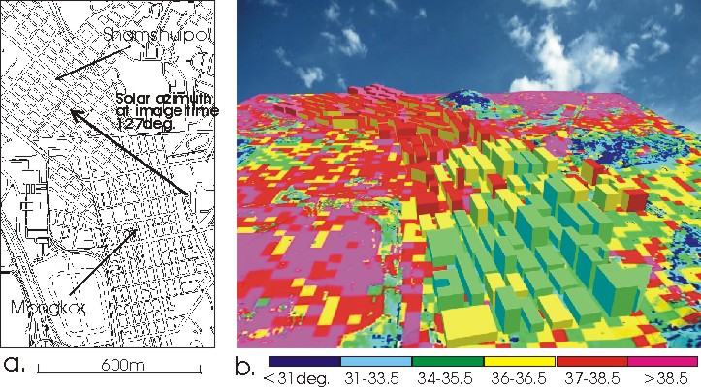

Figure 3: (a) Spatial geometry and sun angle of Shamshuipo and Mongkok area; (b) 3-D model with temperature data

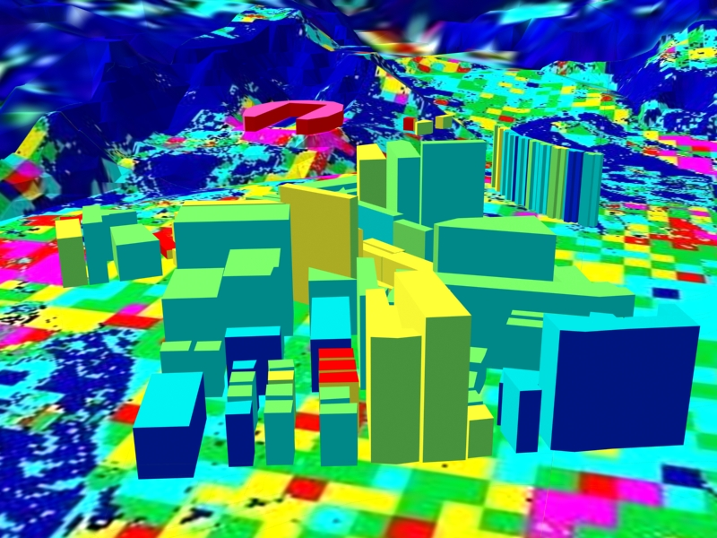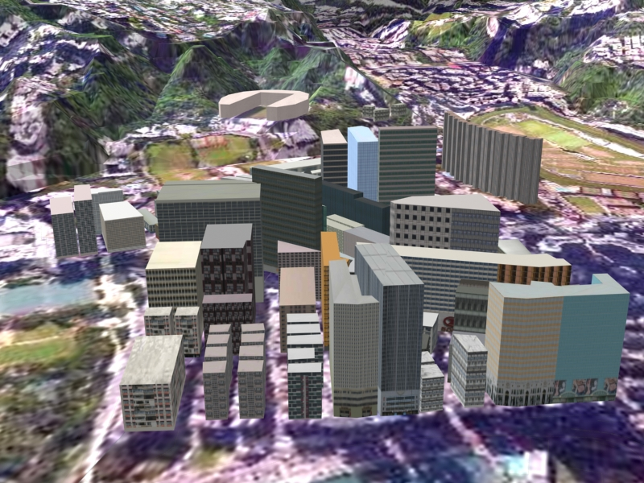
A
B
A
B

Figure 4. Left: 3-D model with temperature rendering for Causeway Bay; Right: 3-D model with real texture rendering

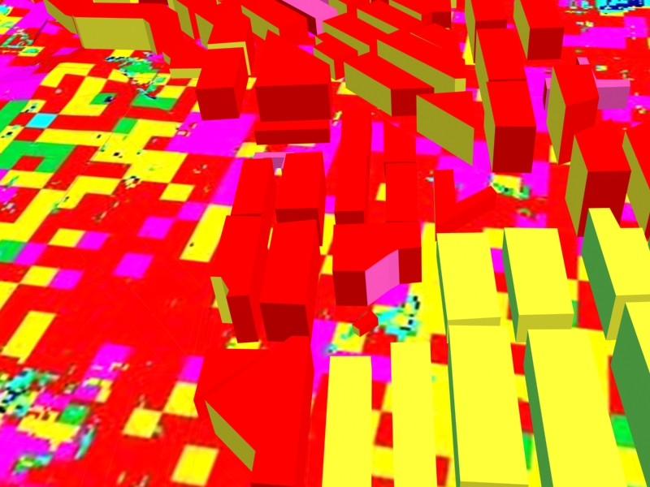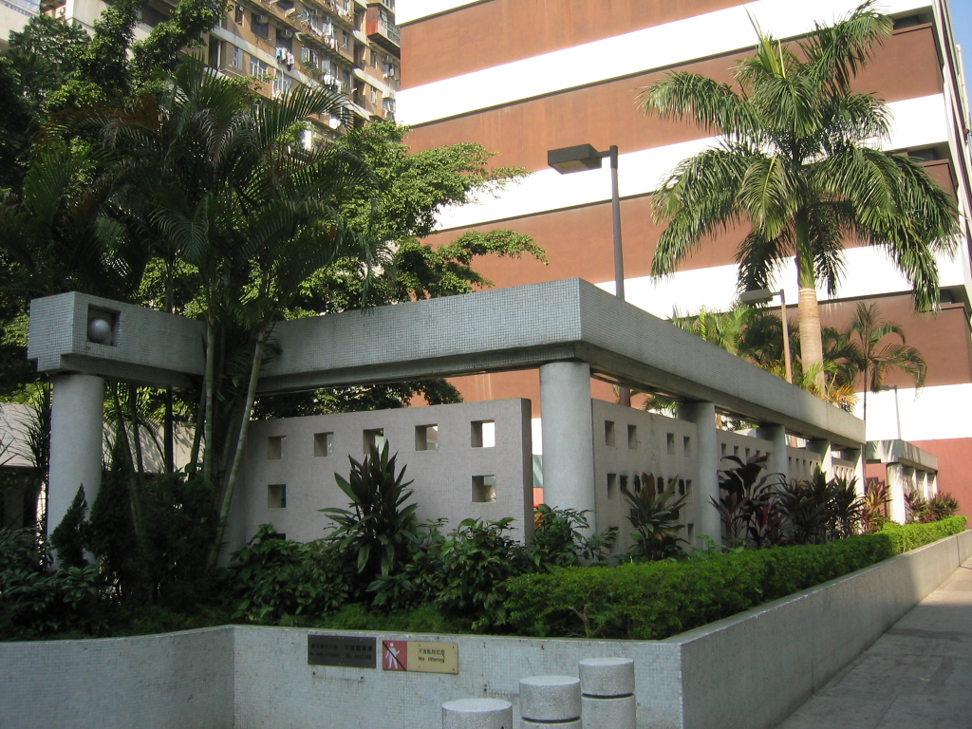

Figure 5. Left: Thermal 3-D model of small urban park in Mongkok; Right: Field photo of same vegetated park

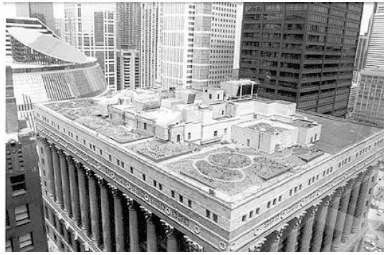

Figure 6. City Hall Roof top garden in Chicago [14]

Reference:

[1] Artis, D.A., Carnahan, W.H., 1982. Survey od emissivity variability in thermography of urban areas. Rem. Sens. Environ. 12, 313-329.
[2] Baltsavias, E.P., Gruen, A., 2003. Resolution convergence: a comparison of aerial photographs, LIDAR and IKONOS for monitoring cities. In: V. Mesev (Ed.) Remotely Sensed Cities, Taylor and Francis, London, pp.474-482.
[3] Carnahan, W.H. and Larson, C.H., 1990. An analysis of a heat sink. Rem. Sens. Environ., 33, 65-71.
[4] Environmental Protection Department, 2001. Air quality in Hong Kong 2001 The Government of Hong Kong 22p.
[5] Dwyer, J. F., MacPherson, G. E., Schroeder, H. W., Rowntree, R. A., 1992. Assessing the benefits and costs of the urban forest. J. Arboricult. 18(5), 227-234.
[6] Gallo, K.P., McNab, A.L., Karl, T.R., Brown, J.F., Hood, J.J., Tarpley, J.D., 1993. The use of NOAA AVHRR data for assessment of the urban heat island effect. J. App. Meteorol. 32, 5, 899-908.
[7] Klaus, D., Jauregui, E., Poth, A., Stein, G., Voss, M., 1999. Regular circulation structures in the tropical basin of Mexico City as a consequence of the heat island effect. Erdkunde, 53, 231-243.
[8] Nichol, J.E., 1994. A GIS-based approach to microclimate monitoring in Singapore’s high rise housing estates. Photogramm. Eng. Rem. Sens., 60, 1225-1232.
[9] Nichol, J.E., 1996. High resolution surface temperature patterns related to urban morphology in a tropical city: a satellite-based study. J. App. Meteorol., U.S.A., 35(1), 135-146.
[10] Nichol, J.E., 1998. Visualisation of urban surface temperatures derived from satellite images. Int. J. Remote Sens., 19(9), 1639-1649.
[11] Nichol, J.E., 2003. Heat island studies in third world cities using GIS and remote sensing. In: V. Mesev (Ed.).Remotely Sensed Cities, Taylor and Francis, London, pp.243-264.
[12] Nichol, J.E., Lee, M.H., (in press). Urban vegetation monitoring in Hong Kong using high resolution multispectral images. Int. J. Remote Sens.
[13] Roth M., Oke, T.R., Emery, W.J., 1989. Satellite derived urban heat islands from three coastal cities and the utilisation of such data in urban climatology. Int. J. Remote Sens., 10(11), 1699-1720.
[14] Roof top Garden, 2004. Rooftop Garden in City of Chicago organization. http://www.ci.chi.il.us/Environment/html/RooftopGarden.html
[15] Voogt, J.A., T.R. Oke, T.R., 1996. Complete surface temperatures. Proceedings of the 12th Conference on Biometeorology and Aerobiology (Atlanta: American Meteorological Society), pp. 438-441.
[16] Wagrowski, D. M., & Hites, R. A., 1997. Polycyclic aromatic hydrocarbon accumulation in urban, suburban and rural vegetation. Environ. Sci. Technol., 31, 279-282.
[17] Weng, Q., 2001. A remote sensing-GIS evaluation of urban expansion and its impact on surface temperature in the Zhujiang Delta, China. Int. J. Remote Sens. 22(10), 1999-2014.

