EVALUATION OF VHR SATELLITE IMAGES FOR IACS CONTROLS
IN POLISH AGRICULTURE

Jerzy Chmiel, Joanna Kossakowska, Krystyna Lady-Drużycka,
Katarzyna Osińska-Skotak, Wieslaw Wolniewicz
Warsaw University of Technology
pl. Politechniki 1,
00-661 Warsaw, Poland

Key words: remote sensing, classification, CAPI, VHR image, IACS, CwRS, agriculture

Summary

Very high resolution (VHR) satellite images were used in Control with Remote Sensing for Integrated Control and Administration System (IACS, in the frame of Common Agricultural Policy) first time in 2003 year in few of EU countries. The priority related to VHR satellite images in that campaign concerned mainly the geometric quality aspects of orthorectified products based on them. Beside already confirmed accepted geometric quality the VHR images are also considered as a good source of thematic information, especially the products based on multispectral images. Thus the above mentioned process of control can be supported by this kind of imagery products.
Poland as member of EU is also obliged to apply controls for IACS. The spatial agricultural structure is quite complex and it is very interesting in this scenario how far the VHR satellite images can be useable for the IACS purpose.
The paper presents the preliminary results of the research Project ongoing at Warsaw University of Technology with cooperation with the Institutions involved in IACS activity. The main aim is to evaluate the VHR thematic information content useable for land cover and crop identification. Different approaches and methods adaptable to the VHR image processing complexity for Polish specific conditions are subject of consideration.

1. Introduction
VHR images have already confirmed their usability in many mapping oriented application areas. The parameters (image resolution, repeat cycle, etc.) of VHR sensors combined with metric image properties have strong potential for creation of Land Parcel Identification System (LPIS) as well as for Control with Remote Sensing (CwRS). CwRS is one of the methods for verification of EU Common Agricultural Policy (CAP) aid applications by farms in Europe. In the context of control such images can be used for determination of the area and land use of declared agricultural parcels. To be applicable for this purpose the images have to meet first certain requirements defined in relevant guidelines stipulated by European Commission [2]. One of the important criteria is the orthoimage geometric accuracy at least 2.5m as RMSE_{1D} measured on a set of independent check points.
Due to a number of geometric distortions the inherent geometric accuracy of images and their approximate georeferencing (computed for some product levels from the source satellite orbital position and imaging geometry) needs to be improved for IACS applications by applying 3D geometric rectification (orthorectification), to be able to achieve the 2.5m RMSE accuracy [5]. The theoretical basis for orthorectification methods of VHR satellite imagery, as well as some research based results, are well documented in the literature although the VHR technology is still relatively new [10, 15].
In general, the satellite images can be applied in the frame of IACS control in two different ways:
- Classic method of CwRS, which concerns the land cover (land use) and crop identification based on the images, traditionally uses the multitemporal set of high resolution satellite multispectral images (from Landsat, Spot or IRS satellites). The identification process can be done either entirely by CAPI (computer aided photointerpretation), or by a combination of automatic classification followed by CAPI [2]. The usefulness of traditional satellite images (e.g. SPOT XS or IRS) for above purpose in agricultural areas with complex spatial structures, presents a certain level of limitations due to image spatial resolution.
- In so called rapid field visit method which assumes the land use (crop) recognition during the field visit (with the hard copy of the orthophotomap at hand) and after return back from the field. The digital orthophotomap is used for area measurement of agricultural parcel.
The choice of the control method in the given country depends on the certain tradition in the remote sensing area as well as on a defined and obligatory payment scheme (system). There are some countries in EU in which none of above mentioned methods was selected and the control is based on typical field inspection and measurements.
Poland has chosen for transitional period the payment scheme based on two components:
- uniform area payment,
- supplementary payment to the area of certain crop (defined by regulations).
In first control campaign in Poland, i.e. in 2004, the rapid field visits method was chosen (with orthophotomaps produced basically from VHR satellite images) to control the minor part of farmers applications and direct field inspection (and measurements) to control the significant majority of applications selected for control sample.
Poland has a significant area where the agriculture space is composed of small and frequently elongated parcels [Fig. 1]. Due to these spatial characteristics two different accuracy standards of orthophotomaps were defined for LPIS creation [Fig. 2]. In that point the VHR satellite multispectral imagery, instead of traditional high resolution ones, seems to be very promising type of data applicable for thematic analysis in heterogeneous (spatially and spectrally) terrain with small and narrow fields (parcels).

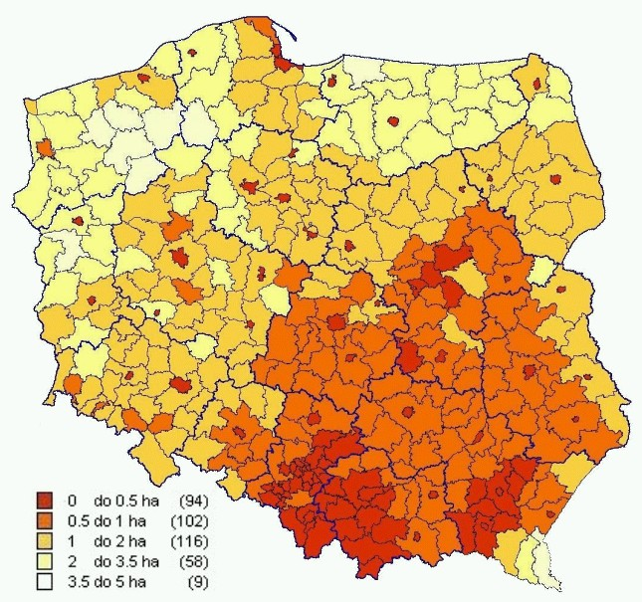
Figure 1. Mean area of parcels in Poland

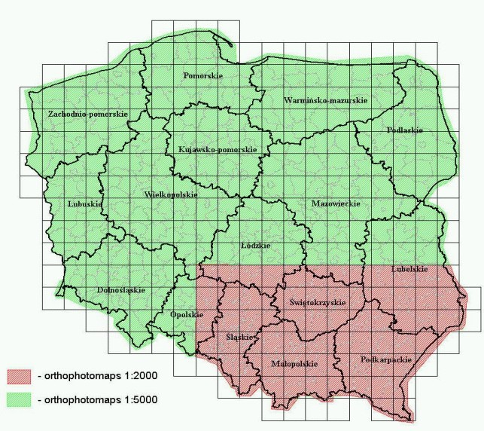
Figure 2. Standards of orthophotomaps in Poland

There is a need to test different scenario of using of VHR satellite images in the control process as well as to investigate and improve various processing methods which could make the VHR images more usable for this area of applications. The work is started in the research project (to which the paper is related) with one of the most important goals to evaluate the usability of VHR satellite images for the identification of land cover elements and crops what is directly related to the IACS control needs.
With regard to the subject and planned to be achieved results, the Project is carrying on with the cooperation with the Agency of Restructuring and Modernisation of Agriculture (ARMA, as a Paying Agency) to which the final results will be also transferred.
The project underlines two main aspects of evaluation of usability of very high resolution satellite images (IKONOS, Quick-Bird, and SPOT5) in IACS implementation for Polish conditions:
- geometric accuracy of orthorectified images and accuracy of area measurements (on digital orthophotomap) of agricultural parcels,
- thematic information content (and consequently improving of digital methods for accurate identification of land cover).
The geometric and thematic components should be investigated for test areas with different levels of size and spatial complexity of parcels taking into consideration adequate JRC/IACS technical specifications.
The achieved research results and conclusions will give answer to the important question about the potential usability of VHR satellite images for IACS purposes as well as for other aspects of CAP in Poland. All experiences will be used for preparing recommendations and detailed description of technological procedures.
From the research point of view it was assumed to use basically VHR satellite images applied by ARMA in control campaign ‘2004’ together with field and reference data collected for the purpose of the control creating a very useful set of data for different analysis and evaluation tests.
Due to the time schedule of the control and necessary awaiting time for the field and reference data from ‘2004’ campaign, the research work started first with the analysis related to two additional test sites for which the data was available from years: 2002 and 2003. The next sections of the paper consider the preliminary results linked to this part of the research.

2. The scope of the research presented in the paper
For testing methods of processing and image analysis the different satellite images were used. On this stage of work following images were available: IKONOS (2003) for Nieborów area and Spot5 with resolution 2.5m for Wyszków area (2002).
In practical part, works were mostly concentrated on:
- overview and analysis of the practical experiences in usage of satellite images similar to IACS control needs,
- evaluation of metric values after orthorectification for these images,
- testing of usability of different kind of processing for visual identification of land cover forms together with crop elements,
- analysis of usability of “pansharpened” process based on different algorithms,
- carrying pilot studies with usage of available satellite VHR data from 2003 year for land use forms identification in using two methods: visual interpretation and digital classification.
The results will be used for more efficient passing research works foreseen in next phase of the project on the basic set of VHR images together with field data which were used in 2004 campaign.

The study area and data

3.1. ‘Wyszków’ test site 1, with SPOT5
Usefulness of SPOT5 images for IACS was tested on Wyszków area. This is typical rural community with one bigger town (Wyszków). This site characterizes quite big differentiation of farm size and crops types. There are many typical farms with regard to size and shape but also there are very narrow and long farms characteristic for polish rural landscape.
Wyszków area is situated on the Mazovia Lowland in Bug River Valley. The community is dominated with rural area with great part of forests and meadows. Test area is laid down on the flat terrain with slight undulation on the 100 meters below a sea level.
Scene of SPOT5 was registered on 12th of September 2002 as a one of first images for Poland. Two kinds of mode were used: multispectral image (XS) with ten meters resolution and panchromatic image with 2.5 meters resolution (Super mode). The result of panchromatic and multispectral images merging using different methods was the object of further analysis.

3.2. ‘Nieborów’ test site 2, with IKONOS
It is a part of ‘Nieborów’ VHR site with an area about 14 km², situated in the central part of Poland. This is an agricultural region with size of farm near to statistical average for the country. The structure of crops is very diversified. There are most types of crops that occurred in Poland. Additionally, the meadows and orchards are present in the site area. Due to the fact that image was acquired very late some crops are already harvested but the site has quite complex spatial agriculture structure with narrow and elongated parcels and that is why it was finally selected.
IKONOS image has been acquired on 06-08-03 with off nadir view angle 14.15º and GSD equal with 1m for panchromatic and GSD equal with 4m for multispectral mode. Geo ortho kit product level was delivered. The descriptive information about the crops in selected cadastral parcels was obtained based on field reconnaissance done in the frame of CwRS pilot project managed by ARMA (Agency of Restructuring and Modernisation of Agriculture, Poland) in year 2003.

4. Results and analysis

4.1. SPOT5 for ‘Wyszków’ test site
Geometrical quality evaluation
The results obtained from SPOT5 geometric correction and control based on GPS control points indicate high geometrical quality of images. Especially this concerns panchromatic image registered in super mode with 2.5 meters pixel size. It is obvious that the flat landscape and also correctly selected points for rectification has essential influence on this result. But none the less, such low values of differentiations between imaging and GPS coordinates of points testify to high geometrical consistence of image. In case of super mode image (2.5×2.5 m) the obtained accuracies are included in allowed limits for mentioned above reference scale 1:10000, it means RMSE_{1d} less then 2.5 m.
The coincidence between cadastral borders and processing images from SPOT5 are recommended for special attention [fig. 3, fig. 4]. Particularly good result in this case was obtained for images with 2.5 m resolution. This is additional confirmation of the high geometrical quality of analysing image in that resolution. The similar effect of such high coincidence is evident for build-up area. Probably this image could be a source for updating of cadastral database.

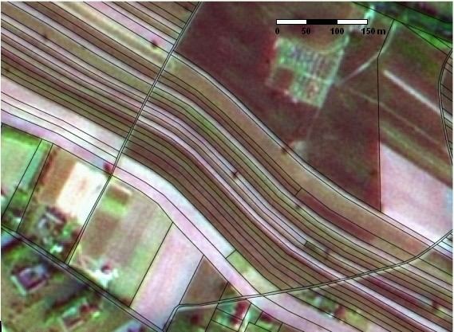
Figure 3. Colour composition SPOT5 (2.5m) with cadastral parcels.
Composition is based on bands after applying merging with multiplicative method for Spot P and XS.

Interpretation values
Mostly helpful for visual interpretation are colour compositions made from fusion of panchromatic and multispectral images. Images processed in this way underline high interpretation quality of SPOT5 data. The result of merging panchromatic and multispectral data allow to obtain coloured image with higher spatial resolution (than raw multispectral mode) and also with wider information (than raw panchromatic mode). Thanks to that, such products of fusion could be useful for updating of land use border lines. Cadastral data putting on fusion images confirmed their high geometrical fitting. Also they are good for distinguishing particular parcels, though initially there were anxieties with regards to very small parcels.
The high interpretation advantages of SPOT5 images allow to suppose that for crumbling agriculture structure they could be helpful interpretation materials for different goals of control system IACS.

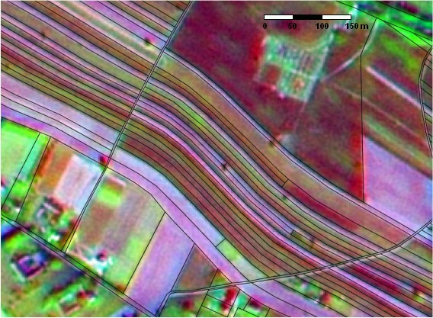
Figure 4. Colour composition SPOT5 (2.5m) with cadastral parcels. Composition is based on bands
after applying merging with PCA transformation method for Spot P and Spot XS.

4.2. IKONOS for ‘Nieborów’ test site
Geometrical accuracy of orthophotomap
Orthorectification with RPC model was done based on DTM with nominal vertical accuracy about 3m and set of ground control points (GCPs) measured by GPS. For accuracy check the independent set of GPS measured GCPs was used and achieved RMSE_{1D} for X and Y on the level of 1m (in case of orthorectification with two GCPs).
Visual interpretation potential
Visual interpretation (CAPI) of IKONOS data taken on the test area “Nieborów” let to form the conclusions:
- Multispectral data without merging with panchromatic data could be useful only for interpretation of meadow or such crop like potatoes or beets. In case of the other land use forms: orchards, cereals, corns or pastures, such images are not sufficient for right identification. Merging two types of IKONOS data panchromatic and multispectral (P+XS) enrich interpretational material about crop structure (texture). The visibility of this structure is necessary to conduct interpretation rightly.
- Usage of single image from one date could be sufficient for orchard’s identification or for pasture on the terrain where orchards have been before. In this case, all of acquiring dates proposed by CTS are suitable for CAPI. For right identification of other kind of crops i.e. corns could be sufficient, but the image has to be taken in a particular moment of growing, when plants give a shadow and are higher than other crops.
- In most cases (except orchards, part of pastures and corns) it is necessary to use multitemporal images, at least from two periods: spring and early autumn.
- For fallows even multitemporal images from two periods could not be sufficient for good interpretation.

The digital image classification
The unsupervised and supervised approaches were used for classification. The tests were carried out for standard multispectral sets of images, as well as for pan-sharpened bands (multispectral channels merged with panchromatic information of a higher spatial resolution).
The preliminary stage of analysis began with forming of thematic classes list and their definitions. First, the initial set of classes was defined based on analysis of: delivered ancillary data, prepared colour compositions and different levels of image clustering (with isodata algorithm) results. Next, the training areas were selected (based on prepared images and ancillary data) and necessary analysis done to verify separability and representativity of the training sets. This allowed for necessary redefinition of some classes especially with very low separability (divergence values). Additional verification of prepared training sets was done by applying initial maximum likelihood classification and checking the results on training areas (using confusion matrix). Finally, the supervised classification with maximum likelihood algorithm was done. The confusion matrix generated for the independent test areas is presented in table 1.

Group of classes | meadows | cereals | after crops | trees | buildings | water | others
meadows | 96,75% | 0,00% | 0,00% | 3,23% | 0,00% | 0,00% | 0,02%
cereals | 0,00% | 100,00% | 0,00% | 0,00% | 0,00% | 0,00% | 0,00%
after crops | 5,71% | 0,00% | 92,95% | 0,00% | 0,00% | 0,00% | 1,33%
trees | 8,77% | 0,00% | 0,00% | 90,89% | 0,00% | 0,00% | 0,35%
buildings | 0,00% | 12,01% | 0,00% | 6,39% | 73,33% | 1,87% | 6,39%
water | 0,00% | 0,57% | 0,00% | 0,00% | 0,15% | 85,13% | 14,16%
Table 1. Error matrix for supervised maximum likelihood classification

Table 1 presents the results of comparison of testing samples (vertical) with classification results (horizontal). For instance values from first line (meadows) mean that 96.75% of pixels (of testing samples meadows) were correctly classified and 3.23% of pixels (the rest of pixels of testing samples meadows) were classified to class trees. This result is obviously because these classes have very similar spectral characteristics. As a result of this similarity, single pixels representing class meadows could be classified as trees. The group of classes cereals has 100% correctness. The reason of this situation is significant distinction of this group from other and also very high number of classes in this group. This helps to increase classification accuracy for cereals. The group of classes after crops was classified with high accuracy. A few percent error (in meadows classes) is connected with spectral similarity of these classes. These parts of parcel with after crops could have different state than rest of parcel (without flowering) and were classified as meadows. In classes trees, a great part of pixels were classified as meadows. This results from above mentioned similarity of these type of land cover. Especially, the light part of trees may have similar spectral characteristics like meadows have.
Buildings were classified with the lowest accuracy between chosen group of classes. The great part of pixels was classified as cereals. This is connected with similar characteristics for build-up area and bare soil, especially with the fresh ploughed soil. Also many pixels were classified to class trees. Since class trees includes also coniferous trees, their spectral characteristics could be similar to spectral characteristics of dark roof (i.e. with plants such moss).
Classification result for water group mostly is correct but a small part of pixels were classified to group others. In fact this group means shadows. In both cases of water and shadow there is poor infrared reflection. Again the reason of classification errors is similarity of spectral characteristics.

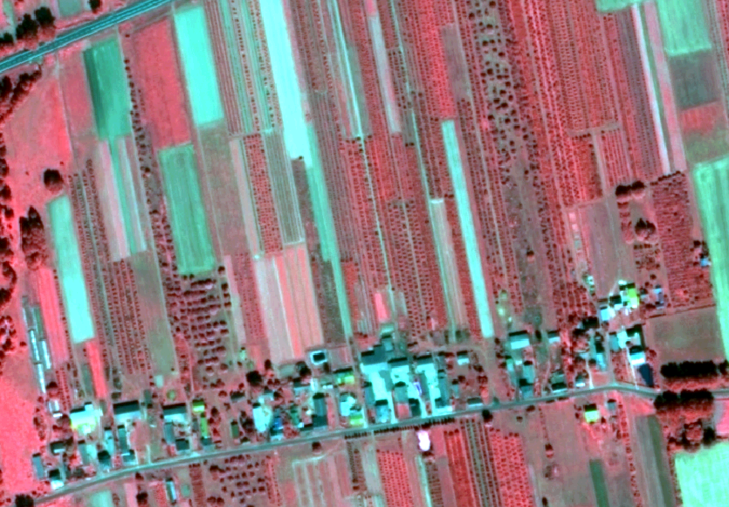
Figure 4. Ikonos pan-sharpened colour composition for part of ‘Nieborow’ test site

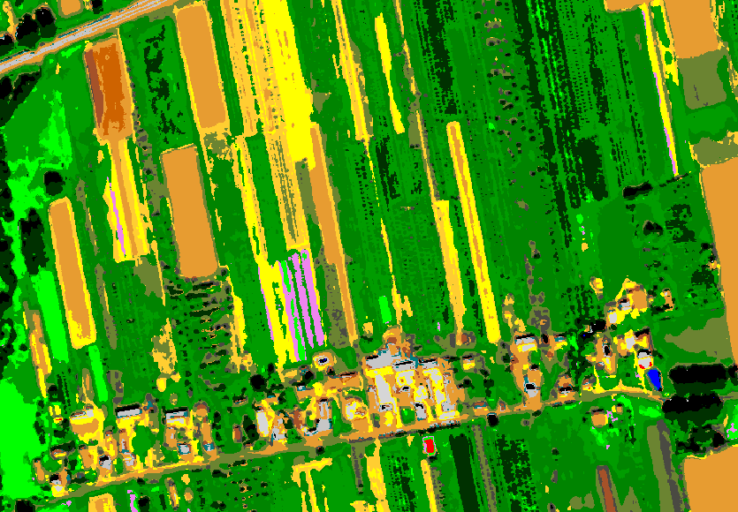
Figure 5. Land cover classification based on IKONOS data for part of ‘Nieborow’ test site

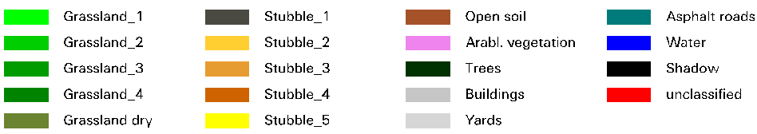

The fig. 5 presents the colour composition for part of the test site and fig. 6 presents the result of classification corresponding to the selected area. Taking it all, classification gives good result but with generalized classes. Also the date of image registration decreased the possibility of spectral distinguishing for classified objects.

5. Conclusions
The exploration taken in first faze of Project on two testing sites pointed on the high usability of different processing methods, especially image fusion based on multispectral and panchromatic data from SPOT5 and IKONOS. But there are a few disadvantages for VHR data which should be examined in next steps of Project. One of these is date of acquiring satellite images. The date has sufficient influence on the results from computer-aided photointerpretation and from spectral classification and should be dependant on weather but also on plants growing and their conditions. So, usage of multispectral images from different period in the same year is necessary for comparison of temporal changes in vegetation.

References

- “Common Technical Specifications for the 2004 campaign of Remote-Sensing Control Of Arable and Forage Land Area-Based Subsidies”, European Commission, Directorate General JRC, Institute of the Protection and Security of the Citizen, MARS, Ispra 4-12-2003, http://mars.jrc.it/marspac/CwRS/default.htm
- “Technical recommendations for the 2004 campaign of Remote-Sensing Control Of Arable and Forage Land Area-Based Subsidies” Part 2: Pre-processing of data and CAPI, European Commission, Directorate General JRC, Institute of the Protection and Security of the Citizen, MARS, Ispra http://mars.jrc.it/marspac/CwRS/default.htm
- Cheng P. Toutin Th. Zhang Y. Wood M. “QuickBird – geometric correction, path and block processing and data fusion” EOM Vol. 12 No 3, May 2003 pp. 24-30
- Chmiel J. Osińska-Skotak K. “Ocena przydatności zdjęć satelitarnych SPOT5 na potrzeby IACS”, XVII Sesja Naukowo-Techniczna z cyklu „Aktualne zagadnienia w geodezji” pod hasłem „Polski IACS”, Nowy Sącz 2003
- Chmiel J.Kay S. Spruyt P. “Orthorectification and geometric quality assessment of very high spatial resolution satellite imagery for common agricultural policy purposes” ISPRS 2004 (1019), Geo-Imagery Bridging Continents, XXth ISPRS Congress, 12-23 July 2004 Istanbul, Turkey
- Dial G. Grodecki J. “Applications of IKONOS imagery”, ASPRS 2003 Annual Conference Proceedings, may 2003, Anchorage, Alaska
- European Commission, 2003, Guidelines for Quality Checking of Ortho Imagery, http://mars.jrc.it/marspac/CwRS/default.htm
- Fraser C. “High-resolution satellite imagery: A review of metric aspects”, Int. Archives of Photogrammetry and Remote Sensing. Vol. XXXIII, part B7. Amsterdam 2000
- Goblirsch W. 1997 “The exact solution of the imaging equations for crosstrack interferometry” Proceedings of the IEEE, IGARSS I, pp. 439–441
- Grodecki J., Dial G., 2001. “IKONOS Geometric Accuracy.” Proceedings of Joint Workshop of ISPRS Working Groups I/2, I/5 and IV/7 on High Resolution Mapping from Space 2001, University of Hanover, Germany, 19-21 Sept 2001
- Kay S. Spruyt P. Kyriacos A. K. “Geometric quality assessment of orthorectified VHR space image data” PE&RS 05.2003
- Kurczyński Z. Wolniewicz W. „Korekcja geometryczna wysokorozdzielczych obrazów satelitarnych”, GEODETA Magazyn Geoinformacyjny nr 11 (90) listopad 2002, http://www.atomnet.pl/~geodeta/
- Orlińska J. Wasilewska Z. “System identyfikacji działek rolnych” XVII Sesja Naukowo-Techniczna z cyklu „Aktualne zagadnienia w geodezji” pod hasłem „Polski IACS”, Nowy Sącz 05.2003
- Toutin T. “Multisource data fusion with an integrated and unified geometric modelelling” EARSeL Advances in Remote Sensing 4(2) pp. 118-129, 1995. (http://www.ccrs.nrcan.gc.ca/ccrs/rd/sci_pub/bibpdf/1223.pdf )
- Toutin T. Chenier R. Carbonneau Y. “3D models for high resolution images: examples with QuickBird, IKONOS and Eros” Int. Archives of ISPRS Symposium, Comm. IV, Ottawa. Canada, 8-12 July 2002, vol. 43, part 4, 547-551
- Toutin Th. “Error tracking in IKONOS geometric processing using a 3D parametric model. Photogrammetric Engineering & Remote Sensing, 68(11):9. 2002
- Toutin Th. “Geometric Correction of Remotely Sensed Images; Remote Sensing of Forest Environments: Concepts and Case Studies” (Chapter 6), edited by: Wulder, Franklin, Kluwer Academic Publishers 2003, pp. 143-180

