REMOTE SENSING AND GIS, TWO MAJOR TOOLS FOR THE ENVIRONMENT MANAGEMENT AND PROTECTION CASE OF THE CARTOGRAPHY OF THE NATURAL DISASTERS

A. MISSOUMI¹ – M. CHIKH² – L. TIDJANI³
^{1,2,3} Researcher
National center of spatial techniques
1, Palestine avenue
31200 ARZEW - ALGERIA
Email : missoumi@cnts.dz
Tel. : +21341472217 - Fax : +21341473665

Abstract
As all over the world Algeria is affected by natural disasters and only the intensity varies depending on the place of the globe. We therefore can notice that our country is exposed to two categories of natural events, some of meteorological and others of terrestrial origins. Depending on the vulnerability of the sectors where the phenomena are taking place, the corresponding risks are more or less important and we therefore must take their effects into account.
To better apprehend and manage the different components of the risks, the production, the consultation and exploitation of cartographic data are necessary, to study/visualise the phenomena and to try to diminish its impact on the vulnerable zones. Thus the use of geographical information is so important as it brings details to different actors interested with environmental risks.
This paper neither can be very exhaustive nor developing all the aspects included in the subject. In this context we will focus essentially on “fire risks” for which we have tempted to show using two experiences led in the West part of the country that GIS combined with data from Algerian satellite Alsat-1 are efficient tools and in a continuous evolution. The aim of this feasibility study is to test the operationality of these tools to characterise the forest zones with fire risk so that to emphasise to the decision makers the role of geographic information in the environmental policy.
We will try to bring up that handing over precise and updated data can show all the difference between an excepted result and a weak result even with drawbacks and the access to precise data is necessary to the decision taking process.

Keywords : Environmental Risks- Forest Fires – GIS – Remote Sensing

Introduction
As all the countries of the world Algeria is subjected to the effects of natural risks, whose only intensity varies according to points' of the sphere. Certain risks are well-known to population, such as floods, turning into a desert, forests fires, collapses, landslides or earthquakes. One can then note that our country is exposed to two categories of natural event, the ones of weather origin and the others of terrestrial origin. According to the vulnerability of the sectors where these phenomena occur, the corresponding risks are more or less important and one must fear their effects. It is consequently necessary to try to identify them. Initially, it is a question of knowing where the natural phenomena can occur. Whatever the quality of our inspection networks, it should be known where to locate them so that their effectiveness is the best. This leads in locating the zones at risks. This knowledge of the zones at risk conditions at the same time the establishment of the networks, the control of the occupation of the grounds and the localization of the works of protection, provided that the cartography is the reflection at the same time of the knowledge of the risk, phenomenologic and historical.
To well apprehend and manage the various components of the risk, the production, the consultation or the exploitation of cartographic data are of primary importance, as well for to study/visualize the risk as to try to decrease the impact of it on the vulnerable zones. Thus the recourse to geographical information proves to be essential while bringing information to the various actors who intervene around the problems of the environmental risks. This paper claims neither with exhaustiveness, nor at the development of all the concepts present in the problems of a subject of such a scale. In this context, we will limit ourselves to the risk " of forests fires " for which we tried to show through two experiments (west of Algeria) undertaken on the forest of Msila (Oran) and the domanial forest of kounteidat (Sidi Bel Abbès) that the Geographical Information systems (GIS) compounds with the data of the Algerian micro satellite of earth observation ALSAT1, are effective management tools and constant evolution. The objective of this feasibility study is thus to test the functionality of these tools to characterize the forest belts with fire hazard in order to sensitize our decision makers on the important role played by geographical information in the development and the implementation of the environmental policies.
We will also try to show that the provision of convenient, precise and useful information can make all the difference between a desirable result and a poor result, even prejudicial and that the access to convenient information and specifies is essential with decisional logic.
1. Concept of natural risk
First, the apprehension of the concept of natural risk appears complex. Indeed, the study of the natural risks calls upon certain explanations and preliminary definitions. The natural risk is an event which originates in a "natural" phenomenon, in opposition to an event caused by a human action. It is thus an event with a non null probability which has its source and develops initially in a natural environment. The natural risk, itself, is a detrimental event, equipped with a certain probability, consequence of a natural risk occurring in a vulnerable medium. The risk results, therefore, of the conjunction of the risk and a stake, the vulnerability being the measurement of the damage of all kinds reported to the intensity of the risks. Must be associated this technical standard of the risk, the concept of acceptability to integrate its social component. This definition of the natural risks includes events of very diverse importance, great phenomena being able to involve very great catastrophes, but also much more frequent phenomena, not very destroying and whose consequences all are not negative.

2. Cartography of natural risks
The cartography of natural risks aims at delimiting the zones exposed at the natural risks, then to enact protection measures with respect to these risks. One thus has:
- a first technical phase, which makes it possible to estimate the probability of supervening of a given phenomenon in a given place, probability called risk;
- the second phase, lawful, which is posed more in terms of installation, determines which are the best answers to be brought to the problems highlighted by the first phase.
Generally, the establishment of cartography of natural risks presents several stages:
- an inventory of the last or visible phenomena concerning the commune or the sector of study, outcome to a chart of the natural phenomena,
- a futurology to establish a chart of the risks, taking into account the phenomena foreseeable and not only visible,
- a reflexion of installation, producing a lawful zoning on cadastral plane and an associated payment.
The first two stages constitute the technical phase, where the phenomena are considered; the third stage constitutes the lawful phase, where one considers the means of protection.

The chart of the natural phenomena
A first essential stage is to carry out a kind of inventory of the phenomena on the commune, at the same time by observations of ground and a survey, carried out near the inhabitants, municipality and services of the State.

The chart of the risks
A thought step of protection with respect to the natural risks could be based only on the phenomena last or present; it is necessary to take into account the probability of supervening of phenomena in the future, which corresponds to the concept of risk. It acts of a prospective step, which aims at analyzing the causes of the phenomena and the associated indices. One is thus often brought to classify in zone of risk of the zones where no phenomenon occurred up to date, because of apparent sensitivity of these grounds. The charts of Risk are not in they-even official documents, but are used to integrate in the land cover planning of the provisions of town planning with respect to the natural risks.

Lawful zoning
It now acts to find solutions with the problems arising from the risks. For a chart of the risks to be integrated in a land cover planning, the step is simple: to each risk a payment-type corresponds, and there is not thus a separate lawful chart; it is however carried out a pulling of the chart of risk on a cadastral plan, for a better transcription in the land cover planning.

3. GIS: from the geographic information to the general interest
Resulting from the technological progress made in the field of the management of the data banks and the computer aided cartography, the Geographical Information System (GIS) became today an ideal instrument of decision-making on territories as varied as a city, an agglomeration, an area or sometimes even the whole of a country. A GIS is, at the base, the obliged combination of three elements: software, a data base and a system.
- The software is articulated around a function of superposition of charts and management of edition of data.
- The data base is for its part made up of a whole of information having a geographical component and management tools of this information.
- With these two elements finally a system is added, which makes it possible to organize procedures of collection, management and diffusion of information.
The GIS assisted initially from the reasoning and the geographical analysis. It can indeed produce almost instantaneously charts on which will be repeated, crossed and quantified all the phenomena or topics possible and conceivable, since the data are available. But the difference of the traditional chart on paper makes it possible to follow the evolution of a phenomenon in time and to utilize successively several scales, according to the problem, and on the basis of totality of information available to the moment when the question is put forward. Information can indeed be gathered or permanently crossed with other data located, physical and socio-economic to extract useful information from it.
A second important factor in the field of the analysis is that the constrained GIS with a collective rigour in the collection, the processing and the use of information. And because this one becomes easy to archive and to diffuse independently of the people who are at the origin of information, the GIS leads finally to a shared and durable comprehension of a territory. While making it possible to gather information coming from any source and any structure, it obliges very diverse organizations indeed to work together for their mutual benefit whereas they often have neither the practice of it nor the will.
One thus adds a human and organisational dimension to the preceding vision, purely technological: if, at the beginning, the GIS supposes a software, a data base and a system, it cannot in fact of being created that on the basis of partnership increasingly wide. In third point, it constitutes a tool of assistance to the proposal by the technicians with respect to their political authorities, in order to optimize their decision-making process. The GIS is an optimal instrument of management of the territory, as it not only makes it possible to include/understand an urban environment or rural in all these aspects or its constraints, but especially because it makes it possible to better apprehend the best solution by offering all possible simulations of a situation, a project, or their alternatives. Its great added value lies indeed in the precision of localization which it provides, in complement facility of dialogue that it proposes (clear visualization of the data, synthetic vision of a problem made up of heterogeneous sources).
The current GIS can be classified in two types:
- the GIS vector and the GIS raster. The GIS vectors are the best known ones of the public. They manage the objects drawn in the charts while associating it to the informative data stored in a data base. The topological capacities of these tools make it possible to carry out analyses network, space crossings and statistical analyses spatialized on the informative data.
- The GIS, manage specific data attached to matrix "grids". These tools raster propose functions of satellite image processing or plane making it possible to extract in a more or less automated way the occupation of the ground and the topographic elements which will be then deferred like as many vectors objects. In addition to the image processing, they mainly make it possible to carry out sophisticated space analyses using several combined layers.

4. GIS and the management of forest fires
As for the other natural risks, the management of forests fires is traditionally broken up into three phases, prevention, crisis and post-crisis. The requirements in geographical information intervene in each one of these three phases in a distinct way :
- In the preventative phase, the cartographic data on the various scales are used to establish the plans of exposure to the risk, to delimit lawful zones, to define plans of intervention, to make the studies of vulnerability or to simulate impacts of potential events. The collection of data relative to former events is, in general, a need to establish the charts of exposure to the risks. The land occupation, the topographic and socio economic data, as well as information on the infrastructures or the population are thus gathered in the GIS to carry out analyses and to prepare the systems of assistance to the intervention. To integrate, to cross and analyze the various layers and localised information necessary, like producing specific charts, GIS tools can be used by various organizations implied in the questions of prevention (civil protection, local communities, administrations in charge of the equipment, the environment, agriculture and the forests...).
- In the crisis phase, where it acts of protecting/of reducing the impacts or to save human lives, the necessary information mainly of a tactical nature and is intended for civil protection. The GIS, as components of tools of decision-making aid, used by the technical cell of management of crisis, play a fundamental part to produce charts "with the flight", to diffuse them towards the ground teams, and to inform the authorities of the progress of the operations.
- Finally, in the post-crisis phase when comes the hour from the assessment, information is collected on the ground or using images taken by satellite or plane. Thus one will defer on charts the zones hit by fire. This information is as many data necessary to the economic evaluation of the damage, the analysis and the future improvement of the plans of prevention.

5. GIS and forest fires: the experience of SIDI BEL ABBES
The impact of a forest fire depends on the vulnerability with fire of the ecosystem, type of vegetation, fires former and subsequent potential threat of other natural events affecting the area. The effects of fire on the environment are less studied stricken. But it is undeniable that fire undermines the protective function of the forest. The high temperatures and ashes cause to seal the pores of the ground. This last is then less permeable with water, which accentuates the streaming and erosion in the event of strong rains. This effect is particularly marked in the areas saved by fire where the vegetation thus did not adapt consequently. The fires of forest are risks, for the prevention of which, nowadays, social delays are extreme. However, the phenomenon of forest fire is at the same time natural and essence for the forest ecosystem. The removal of all fires is neither physically possible, nor ecologically desirable (Conard and Latham, 2000).
The stakes are of three types: human, economical and environmental:
- Attacks with the people: victims, people wounded, burned, suffocated, homeless person, moved...
- Attacks with the goods: destruction, deteriorations, damage with the dwellings, the works, with the cattle, paralysis of the public services with damage or destruction of the networks.
- Attacks with the environment: damage, destruction of fauna, the flora, sterilization of the ground by impoverishment of the arable layer, rarefaction of vegetable cover worsening the dryness and turning into a desert.
We have the chance that many countries were concerned with fight against fires anthropic or natural under various conditions, so that they developed a relevant know-how by gathering many techniques and knowledge. Algeria is today in the ideal situation to profit and adapt them to its natural and socio-economic conditions.
In illustration of the reports which precede, we will try to present through this communication a concrete application which relates to the domanial forest of kounteidat located at 35 km in the south the city Sidi Bel Abbès. This forest covers an area of approximately 50 square km. It is characterized by a Mediterranean climate of semi type arid in cold winter. It is a mixed forest of pine of Alep, holm oak and thuja of approximately 50 years of age. It is presented in an unequal way in terms of height and density. The frequent type of vegetation gathers all the layers, herbaceous, bushy, under-shrubby, shrubby and arborescent, which constitutes an unquestionable predisposition to the starting and the extension of the fires which have of matter and fuels at various vertical or horizontal levels. The use GIS as an instrument of characterization of the forest belts with fire hazard holds obviously an important place.

5.1 Methodological approach
Among the many indices raised in the references, we chose an index of risk which appeared with our opinion, adapted to the problem studied. This index of risk, strongly inspired by the model of index suggested by A. DAGORNE and Y. DUCHE [ 1990 ] which propose an index integrating three under-indices, such as described the following formula:
IR = 5IC + 2IH + IM where IC represent the index of vegetation, brought back to combustibility (considered to be sufficient), IH the index related to the human occupation and IM the topo morphological index.
This index is conceived according to a model affecting each parameter a weighting coefficient, function of its influence on the propagation of the fire. However, the index representing the component related to the human activities, potential sources of fire setting, was not taken into account in the model selected, the studied forest does not present attended zones, nor dwellings. In our case, we start from the integration of multi sources data, to map the sectors exposed to the fire hazard. This characterization is based on the space variability of the fire hazard evaluated primarily starting from physical parameters (slopes, exposure, topo morphology and vegetation).

5.2 Application and results
To validate the adopted approach, the application was led under Arc/info environment. This GIS with vocation general practitioner, makes it possible to adapt to the data and the problems of all the fields which require the handling of space information. The chart resulting from the various crossings resulting from the model applied was visualized using the functionalities of analysis of data and cartography of the GIS Arc/Info. It is represented in figure 1 which visualizes the sectors discriminated by the criterion of vulnerability to fire.

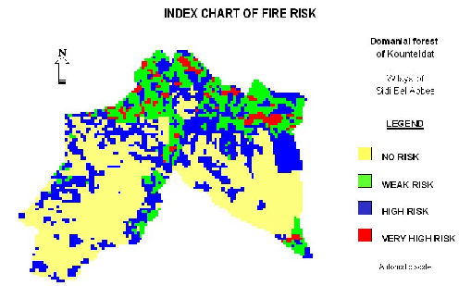
Figure 1 : Index chart of fire risk

The interpretation of the results obtained makes it possible to make the following analyses:
- A comparison between the synthetic chart of fire risk obtained, and that of the fires already recorded in the studied forest, made it possible to corroborate in the majority of the cases the results of this analysis. This comparison provides an element of appreciation of the limit of the IR index from which the pieces were ignited in the past.
- By superimposing this same chart with that of the forest infrastructures (figure 2), one could highlight the inadequacy of the distribution of the equipment of defence of the Forests against Fires (DFCI) in the most significant sectors. This chart will make it possible to define and better specify the zones to be protected. It must help the managers to better locate the sectors exposed to the fire hazard and thus to protect in priority. It could be used for the installation of new equipment, with the opening of new fire wall like for the establishment of new tracks.

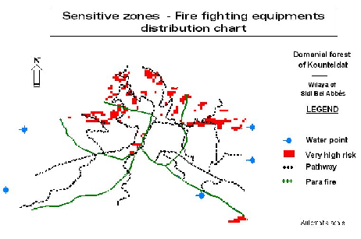
Figure 2 : Sensitive zones – Fire fighting equipments distribution chart

5.3 Impacts
This study, which could initially concern the sectors of the Forests and of Civil Protection would aim to : provide a cartography which constitutes an essential precondition to a policy reasoned as regards urbanization in forest and in contact with this one, and a policy reasoned as regards management of the territory. To help with better specifying the priorities of establishment or maintenance of the infrastructures, and thus a better definition of the maintenance and investment plans. Thanks to these charts, recommendations as regard town planning could be made in order to set up measurements of prevention, protection and safeguard which relate to installation, construction or the management of the grounds exposed at the risks which must be taken by the public bodies or the private individuals within the framework of their competences .

6. The satellites with the service of the environment
The protection of the forests requires the knowledge of the phenomena which threaten them. A durable management of the resources passes by the control of the risks and the natural and technological disasters, and by the design of installations respecting the forest. Thus the earth observation satellites bring a source of information privileged for the whole of the geographical satellite users of information, which has today a reliable and powerful tool for space management. The images satellitales have been used for several years for the study and the follow-up of the forests. They make it possible to reach the very precise knowledge of the land cover on a regional scale. Combined with other data bases in a Geographical Information system they bring essential information for a better management of the territory.
Very great repetitivity of satellite passes on the same zone, and the capacities of programming of the satellite ensure of the homogeneous imaging on very large territories. The information thus extracted from the satellite images will enrich the data bases considerably feeding the GIS, by limiting the long ones and expensive campaigns surveys of ground. To ensure a good prevention policy of forest fires, the follow-up in the time of the evolutions of the ground occupation makes it possible to include/understand and manage the environmental modifications. The satellite images bring lightings on the evaluation and the analysis of a finished fire:
- The cartography of the burned zones: the resumption of the vegetation after a fire, rather quickly masks the passage of the fires. It is thus essential to acquire images, as soon as the season of fires passed, on all the burned zones. This chart, combined with the chart of land occupation, will give very precise statistics on the zones stricken.
- A latter comprehension, of the dynamics of fire: the follow-up of the evolution of a fire of forest by men of ground can be studied according to the various parameters of the occupation of the ground. The models of propagation of fires will be refined, and consequently the actions of improved preventions. A representation of the satellite images for 3d facilitates the comprehension of the phenomena closely related to climatic and geographical parameters.
- The evaluation of push back vegetation is it also, an essential factor for a better management of the forest solid masses. The study of the consecutive ecological changes to a forest fire is highlighted by the comparison of two images acquired at the same period. Same manner the follow-up of brushwoods (embroussaillement) on the level of a solid mass is much more exhaustive, and thus reliable.
The capacity of the GIS to integrate multi-source data and in particular the images of remote sensing which conceal of a very important informative potential could be explored in this second experiment. Within the framework of this paper we focused our work primarily on the use of the imagery provided by micro satellite ALSAT1 for the cartography of the forest fires. In prospect, we plan to try out this imagery to show that it is possible to estimate the degree of in flammability of vegetable cover and to carry out cartography of the territory according to the level of risk of in flammability for better locating the zones at the risk.

7. Presentation of micro satellite ALSAT 1
The Algerian satellite Alsat-1 (figure 3) is the first experiment in orbit of Algeria. Launched on November 28, 2002 6h07 GMT by Russian launcher COSMOS-3M from the Cosmodrome of Plesetsk (800 km of Moscow), produced ALSAT1 of a partnership with Surrey Satellite Technology Limited (SSTL - United Kingdom) is a link of a constellation of micro satellites of 7 countries (Algeria, China, Nigeria, United Kingdom, Thailand, Turkey, Vietnam). It is within an international programme of observation of the ground for the prevention and the management of catastrophes (DMC - Disaster Monitoring Constellation). It is Algeria which had the privilege to launch first satellite ALSAT1, within the framework of this constellation which will allow the follow-up of certain natural phenomena and other risks major like the floods, the seisms and forest fires. The constellation once fully operational will make it possible to the members of consortium DMC to recover images of any point on the ground in 24 hours.
Launch date | November 28, 2002
Altitude | 680 km – 98° inclinaison.
Dimensions | 600 x 600 x 600 mm
Weight | 90 kgs
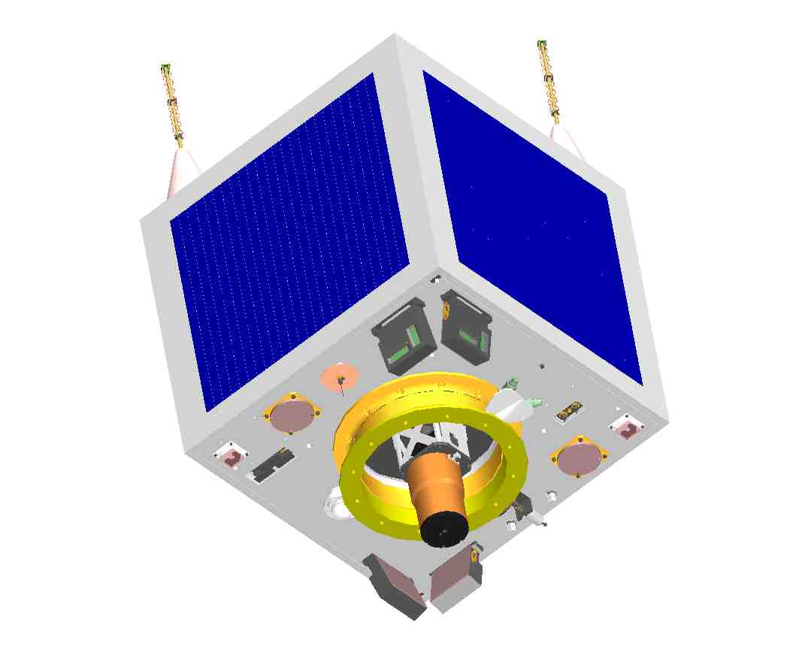  Algerian Micro satellite ALSAT 1  Imaging System | Imaging mode | Push broom
 | CCD Multispectral imager | 2 banks overlapping @ 5%.
 | Spectral band | (NIR, R, G)
 | Optics | 150 mm focal length.
 | Resolution / Swath width | 32 m / 600km
 | Number of pixel | 10000 pixels
Storage Capacity | 1Go byte
Spectral Bands | Bande 2 (Vert) 0.52 – 0.62μm
Spectral Bands | Bande 3 (Rouge) 0.63 – 0.69μm
Spectral Bands | Bande 4 (PIR) 0.76 – 0.90μm
Space Resolution | 32 m
Dimension of a scene | 600 x 560 km (max.)
Revisit Time | 5 days
Vocation | Earth Observation

8. Remote sensing and forest fires: the experience of ORAN.
This experiment was carried out on the domanial forest of M’sila, located in the wilaya of Oran. This forest is made up to 80% of vegetation formation of pine of Alep pure or mixed with oak cork. The pine of Alep or the oak cork is close to maturity, while the eucalypti have an age which varies between 30 and 40 years. The gasolines most represented are: mastic tree, oak cork, cistus, phyllirea and arbasier. The forest solid mass of Msila is composed of three types of vegetation formation: the forest, the matorral and the erme. The forest of M’sila presents a more or less broken relief. A class of slope of 3% covers more than half of the total area and is in the west of the forest. This softness of the slopes acts favourably with respect to the progressive evolution of the vegetation and its regeneration. The exposure factor has a particular importance since it orders the distribution of the vegetation.

9. Image processing Alsat
The images used within the framework of this application were taken by the Algerian micro satellite Alsat1, June 23rd 2003. They have been extracted starting from a scene from 600 km X 600 km. Their informative contents correspond to raw data, spoiled with some errors. These images are exploitable only after having undergone radiometric (development in progress) and geometric corrections. A coloured composition was realised starting from the combination of the three spectral bands of Alsat1
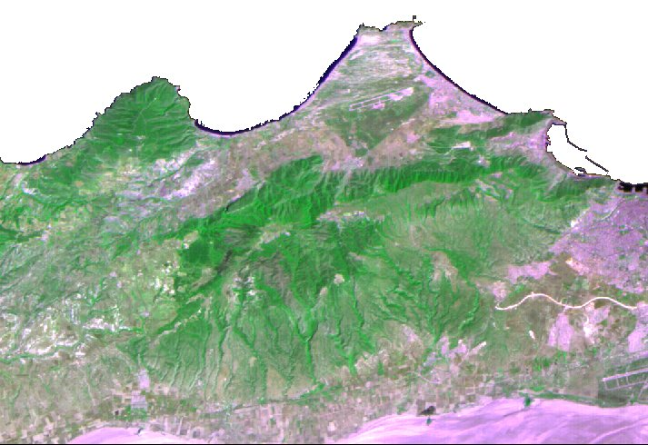
M’sila Forest
Figure 3 : Alsat-1 image on the M’sila forest

The rough digital image provided by Alsat1 presents geometrical distortions. This operation is necessary for the superposition of an image for a reference. It can be a question of another image or a chart. Various types of geometrical corrections are available, their goal is to make the remote sensing image super imposable to a geographical reference. The method we adopted is a polynomial correction. This type of correction uses a polynomial transformation of degrees N geometrically to fix the image with the system..

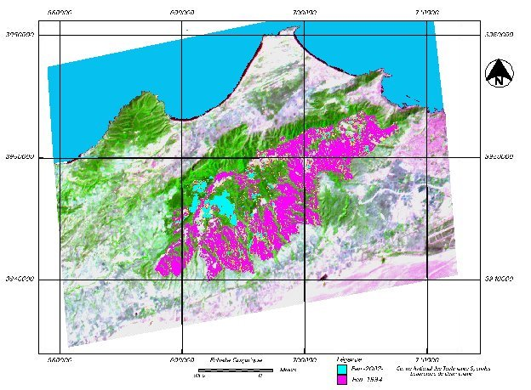
Figure 4 : Forest fires chart

The zone concerned with fire was extracted starting from the image corrected using a mask on the studied forest. This mask was carried out starting from a digitalization of the image on screen using the Erdas software. This last zone was classified in three (03) classes by the maximum method of probability: fire_1994, fire_2003 and other topics. The result of classification was smoothed by a median filter to reconstitute the contour of the classes and to remove the insulated pixels. This result was superimposed on the coloured composition corrected to carry out the cartography of fires of the zone of study (figure above). The method of classification used is the maximum of probability on the basis of two sample of truth ground (fire_1994 and fire_2003). The Alsat1 images can also bring lightings on the evaluation and the analysis after a fire: the cartography of the zones burned as well as very precise statistics on the most touched zones

Conclusion
Before all the GIS are built by men. They were initially specialists in particular in topographic services, before users such as the town planners, the persons in charge for the roads or the environmentalists do not adapt the tool to use it in a daily way within the framework of their trade. Become today of the convivial tools, the GIS reach the population for its information, and to even alert it in crisis. The concept of GIS is not thus limited more to the perimeter of that which manages it, but integrates on the contrary all the actors of the territory from the point of view of its sustainable development. The necessary multi-field approaches of the phenomena now force to confront analyses coming from different points of view, but which all meet on the same territory. It follows that the new generation of GIS will allow truly the sharing of information, modelling of the phenomena, their analysis, simulations, etc. GIS and remote sensing moreover will find in our country their applications in the field of the management and environmental protection. The fact of being interested in these techniques gives the opportunity to tackle questions in a more pressing and systematic way. It is certain that medium-term, these investments will generate profits which will result in a reduction of the damage caused by the fires of forest and a better protection of the natural resources.
These investments will generate profits which will result in a reduction of the damage caused by the fires of forest and a better protection of the natural resources. Let us recall in this context which financial means is more easily available to cure the damage than for their prevention. Moreover, to fight against the fires is an appreciable thing, to prevent them is more. Also, it is not enough to concede efforts and time against fires of forest, it is especially necessary to try to cure the evil with the source. To this end, the impacts of the public awareness campaigns are not to neglect.
Finally, if there are men for whom "the tree does not hide the forest", it is well those which are in charge of the management and the protection of this natural resource, in order to benefit from them best while preserving its longevity.

References
- DAGORNE Y. DUCHE et al. (1994) : Protection des forêts contre les incendies & Système d’information géographique : Application à la commune d'Auribeau sur Siagne (Alpes Maritimes). revue forêt méditerranéenne t. XV, n°4, octobre 1994.
- MISSOUMI, A. SAIDI, A. DJILLALI (1999) : Arc/Info et la protection des forêts contre les incendies. Conférence des utilisateurs 1999. ESRI France Paris 29 et 30 septembre 1999.
- MISSOUMI, A. SAIDI, A. DJILLALI (1999) : GIS et feux de forêts. Séminaire international sur les GIS ‘ALGIS 99’, Alger du 15 au 18 novembre 1999.
- A MISSOUMI, A SAIDI, A. DJILLALI (2001) « Apport des GIS dans la prévention et la lutte contre les incendies de forêts ». GEO OBSERVATEUR. Revue du Centre Royal de Télédétection Spatiale - Rabat - ISSN 113 - 4410 - MAROC . N°11 Novembre 2001.
- A MISSOUMI, K. MEDERBAL (2002) « GIS et feux de forêts en Algérie.». revue "forêt méditerranéenne". FRANCE. ISSN. 0245 - 484 x. FRANCE. t. XXIII, n° 1, juin 2002
- MISSOUMI, K. TADJEROUNI (2003) « GIS et imagerie alsat1 pour la cartographie du risque d’incendie de forêt. 2nd FIG Regional Conference Marrakech, Morocco, December 2-5, 2003.
- Types d’information et outils pour les GIS et la gestion des crues. Jean-Michel ROQUES, SCOT SA.

GIS : de l’information géographique à l’intérêt général. Jean Pierre DUFAY, Directeur international IAURIF.
- GIS et territoires. François SALGE, Secrétaire général du CNIG (Conseil National de l’Information Géographique) France.

Cf Marc LEMONNIER, Le regard infini des SIG, Diagonal, 116, dec 1995, pp.10-14 & 22-24

