QUALITY ASSESMENT OF DIGITAL ELEVATION MODEL PRODUCED FROM ASTER
IMAGES

Esra Ertenª , Nebiye Musaoğlu^{b}, A. Yucel Erbay^{c}
ª ITU, Institute of Informatics, 34469 Maslak Istanbul, TURKEY – ertenesra@hotmail.com
^{b} ITU, Civil Engineering Faculty, Remote Sensing Division, 34469 Maslak Istabul, TURKEY- nmusaoglu@ins.itu.edu.tr
^{c}NIK Construction Trade Co. Ortaklar Cad. No: 27/6 80290 Mecidiyekoy Istanbul

Key words: ASTER image, SRTM, topographic map, DEM, accuracy, mapping

ABSTRACT:

A Digital Elevation Model (DEM) is a representation of the terrain using point elevation information referenced to the nodes of a rather fine regular grid, and is a digital representation of the terrain features’ latitude, longitude and height. A Digital Elevation Model is the most effective way of a representation of part of the earth’s surface, terrain analysis, cell planning, environmental monitoring and constructing three dimensional geographical information system on a large scale. Although DEM can be generated from many methods, satellite images have many advantages including studying in large areas, acquiring image data periodically and naturally digital data. However, correctness of the generated DEM has importance in the studies that will be done. The most widespread and easiest way of the assessment of DEM quality is its comparison with the digitized map. This comparison is made by the help of ground control points (gcp). Ground control points that were used in this work were obtained via digitizing the topographic msp. In this work, we analyze the quality assessment of DEM which is produced from ASTER (Advanced Space Borne Thermal Emission and Reflection Radiometer) images. Because of its off-nadir sensor pointing capability, ASTER can collect the stereo pairs necessary to generate high resolution DEMS. The DEM was generated from 30m resolution ASTER satellite images. The DEM quality assessment was carried out by the help of the comparison with DEM produced from topographic map at a scale of 1/25 000. Experiments have been carried out to compare the DEM quality with conventional approaches. In addition, Shuttle Radar Topography Mapper (SRTM) DEM was used for an opinion about elevation information that is provided by a joint Department of Defence (DoD)/NASA interferometric SAR mission.

1. Introduction

Digital Elevation Model (DEM) is indispensable for many analyses such as topographic feature extraction, runoff analysis, and so on [5]. So, the importance of DEM’s accuracy is increasing depending on these analyses. Begining more than 25 years ago, efforts have been directed toward producing global elevation data in digital formats [3].There are many methods for generating DEM including a SAR interfrometry, a stereo matching from satellite image or air photo and surveying (GPS, levelling…). Each DEM has different properties, grid size and altitude accuracy. The DEM used is depended on application aim. We must know which accuracy is enough for any analysis. Therefore, searching a DEM accuracy is very important.

This paper shows the DEM accuracy derived from ASTER data via stereo matching. DEM extraction from ASTER image, the nadir and the backward looking channels are used. The extracted ASTER DEM for research area was compared with the DEM generated from 1:25000 contour line map and from the Shuttle Radar Topography Mission technique.

2. Data

The image of ASTER Level 1A, captured on the 2th of June 2003, was used for generating DEM. Besides the ASTER data, the topographic map was used on the purpose of evaluating the elevation information of ASTER DEM.

In addition, SRTM DEM was taken into account for the quality assessment of ASTER DEM. A global DEM of the land area of the earth produced from the SRTM data recorded in February 2000 and accurate to approximately ± 16 m will be completed by 2003 [3].

2.1 ASTER image

ASTER (Advanced Spaceborne Thermal Emission and Reflectance Radiometer) is an Imaging instrument on board Terra - the first Earth Observing System (EOS) satellite [6]. STER image is acquired in scenes of about 60x60 km and 64 seconds for stereo pair.

ASTER is separated into three subsystems which can be stated as follows: visible and near infrared radiometer (VNIR) subsystem, short wave infrared radiometer (SWIR) subsystem and thermal infrared radiometer (TIR) with the spatial resolution of 15 m, 30m and 90m.

The VNIR band of 3 includes two channels, a nadir looking channel (3N) and a backward looking channel (3B). These channels provide the stereoscopic capability in the along-track direction with a base to height ratio of 0.6 [6]. The stereo configuration of ASTER VNIR is shown in Figure 1 (Welch et al., 1998).

The angle which corresponds to B/H ratio (B=430m, H=705m) of 0.6 is 30⁰.96. However, the curvature of earth surface changes the angle to 27⁰.7. The backward looking channel has tilt angle on the degree from along-track direction. Nine seconds will be required to acquire a 60 60-km image and approximately 64 s for a stereo pair [7].

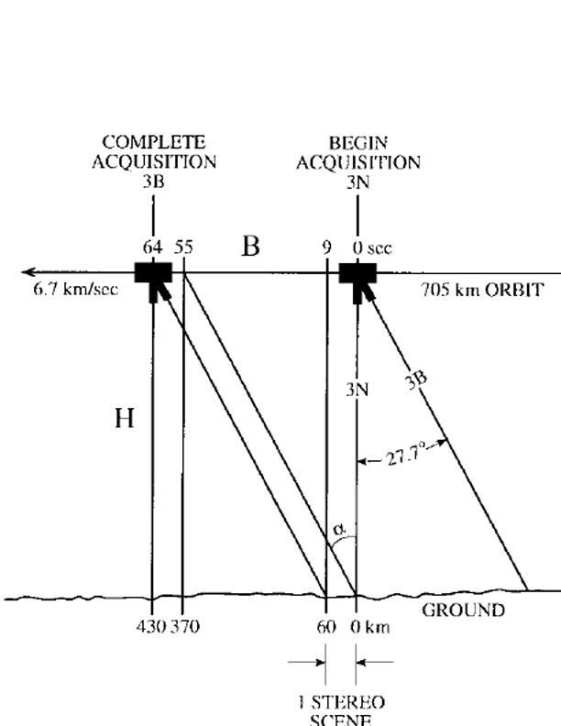

Figure 1. The stereo configuration of ASTER VNIR [7].

2.2 Research region

The study area, that is 4.079 ha, is located in the boundaries of the Gallipoli Peninsula Historical National Park in Eceabat in Canakkale. The area of research is located between the following coordinates: 40º 41' 32″ - 40º 22' 45″ northern parallels, and 26⁰ 12' 57″ - 26º 25' 23″ eastern meridians. Figure 2 is the location indication image of the Gallipoli Peninsula. The average altitude of the area varies from 100 m to 250 m. The highest point of the study area is Karaburun Peak which has a 400 m height. The historical peninsula has an uneven and rough land structure. Its structure is mountainous faulted and is consisted of slopes.
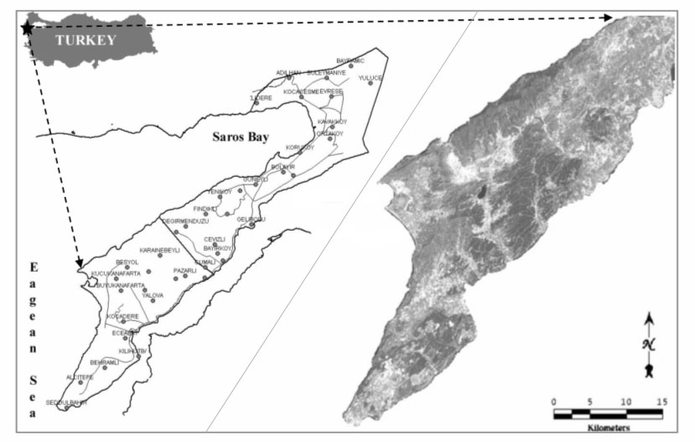

Figure 2. Location of research area

3. Methods

3.1 Generation of DEM

The generation of the DEM first requires the stereo pairs of images be registered to the same ground area. This aim is achieved by use of the standard topographic map at the scale of 1:25000. Using the PCI 9.0 software, DEMs can be generated automatically. The geometric model being used is a rigorous one; it reflects the physical reality of the complete viewing geometry and corrects distortions that occur in the imaging process due to platform, sensor, earth, and cartographic projection conditions [4]. Using rigorous models, epipolar image was generated from the 3N and 3B images. Epipolar images are stereo pairs that are reprojected so that the left and right images have a common orientation, and matching features between the images appear along a common x axis (PCI guide). The epipolar images include elevation information that is useful for automated DEM extraction. The result DEM, shown in Figure 3, is a raster presentation of the elevation of the ground objects with pixels values in the images.

In addition, the area of clouds and water were extracted using three data (visible and near infrared). Water and clouds area were extracted using threshold, variation in specific window and coarse DEM.

Another DEM used for comparison with ASTER DEM was produced from standard topographic maps. Ten standard topographic maps at a scale of 1:25 000 were digitized with a contour interval of 20 m and DEM was generated for the study area.
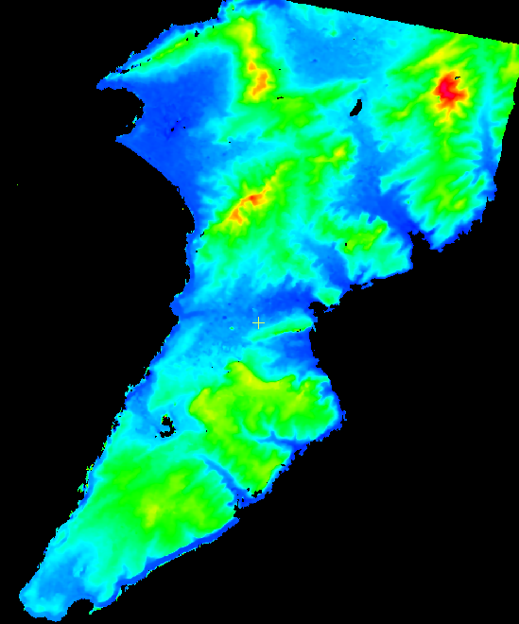
(a)
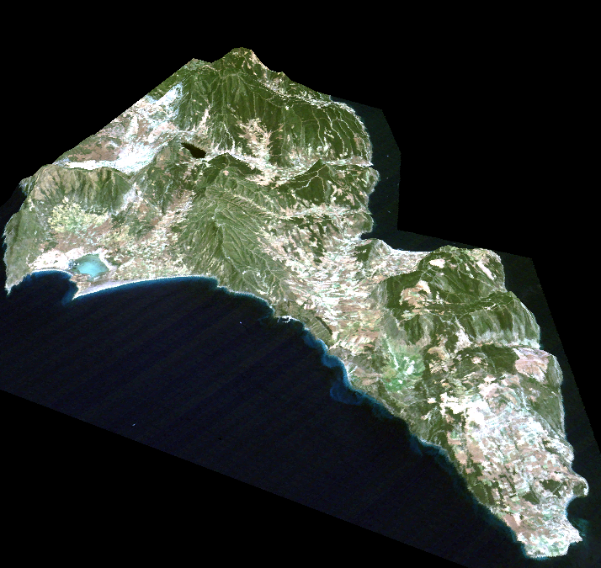
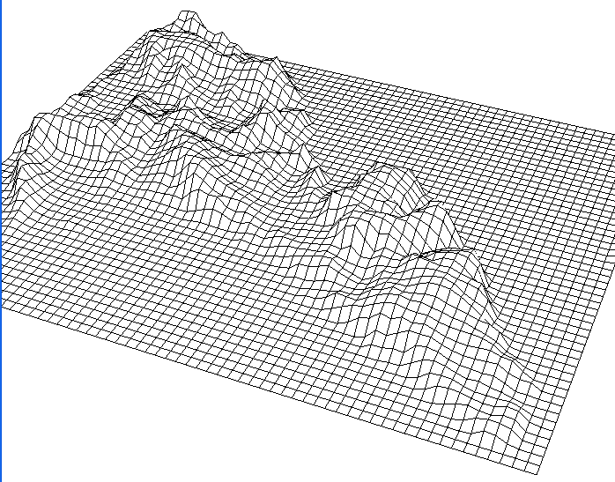
(b) (c)

Figure 3 (a) ASTER DEM from level 1A pseudo colour image of The Gallipolu Peninsula.
(b) Perspective view of DEM with a wire-frame representation.
(c) 3D Perspective view of DEM integrated with ASTER image.

3.2 DEM accuracy

There are many methods for validating the ASTER DEM and the possibilities for employing the DEM for mapping, geological studies and environmental assessment. In this paper, the vertical accuracy of ASTER DEM was checked with vector layers that were shown in orange colour in Figure 4a and fig. 5a for plotting elevation profiles. There were 10 random points chosen from each vector layer. One vector layer was lied from north to south direction and other was from east to west direction. These vector layers were merged with all three DEMs for setting elevation information through the lines.

The profile analysis through vector layer was carried out for each DEM. The results were shown via the chart of elevation (Figure 4b and Figure 5b) and elevation differences ( Figure 4c and Figure 5c)¹. According to these numerical information, there was a good agreement between ASTER DEM, topographic map at a scale of 1/ 25 000 and SRTM DEM. Although there was a good agreement among three DEMs, the chart of elevation differences showed that the elevation value from ASTER DEM was closer to that of topographic map than the elevation value of SRTM DEM.

¹ TM = Topographic ma
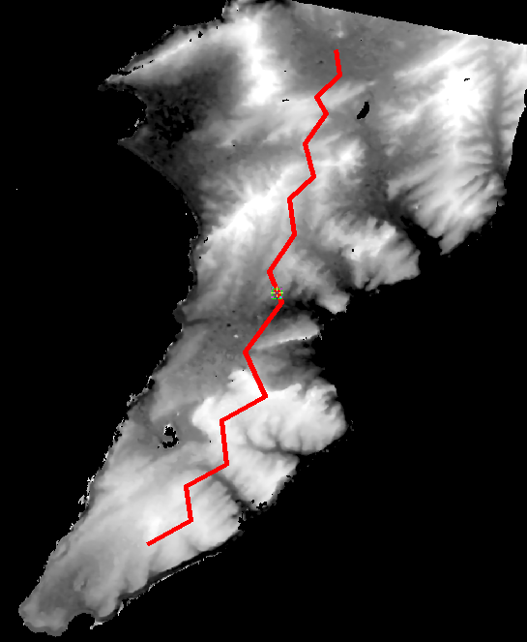

(a)
(b)

(c)

Figure 4 (a) ASTER DEM integrated with vector layer lied from north to south
(b) Profile differences image of ASTER DEM, SRTM DEM and Topographic DEM
(c) Elevation differences between topographic map and ASTER DEM and SRTM DEM

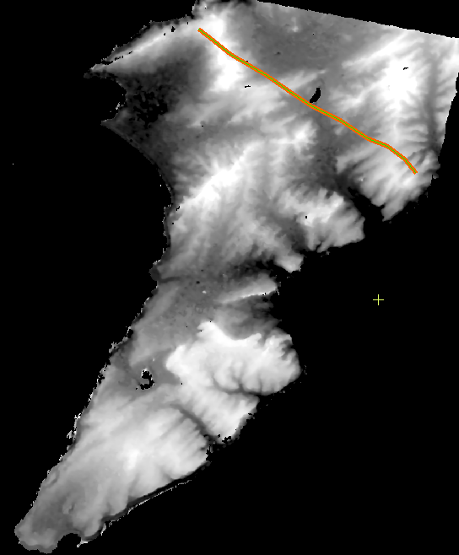

(a)

(b)

(c)

Figure 5 (a) ASTER DEM integrated with vector layer lied from east to west
(b) Profile differences image of ASTER DEM, SRTM DEM and Topographic DEM
(c) Elevation differences between topographic map and ASTER DEM and SRTM DEM

4. Results

The elevation of vertical accuracy resulting from automated digital streocorrelation indicates that ASTER DEM meets accuracy standards compatible with 1/50 000 scale map products. According to analyses, the maximum elevation difference between the topographic map and ASTER DEM is 16 m. Because of this, it is hard to say that DEM from ASTER data meets the accuracy of topographic map at a scale of 1/ 25 000.

ASTER DEM data meets expectations from topographic map at a scale of 1/50 000 to 1/ 100 000. In this situation, choosing GCP to use has an important role. A suitable distribution of GCP’s will yield elevations which are correct to within approximately ± 15 m to ± 25 m [7].

The results obtained from this study show that ASTER stereo image has a great advantage in extracting DEM in a mountainous area that is hard to survey. According to this study, DEM from ASTER stereo image is suitable for environmental mapping that requires elevation information such as volcanic activitiy, mapping of ice-sheet and flood …etc.

Further Work
Accuracy of ASTER DEM is highly dependent on the source of ground control points (GCP) used in automated digital streocorrelation technique. Because of this, for the aim of increasing the DEM accuracy, the ASTER DEM result will be compared to DEM measurement via differential GPS.

In addition, the number of study area will be increased based on the different kinds of topographic properties.

References

[1]. Eiumnoh, A., Shrestha, R.P., 2000. Application of DEM Data to Landsat Image Classification: Evaluation in a Tropical Wet-Dry Landscape of Thailand. Photogrammetric Engineering & Remote Sensing, Vol. 66, No. 3, pp. 297-304.
[2] Erten, E., Kurgun, V., Musaoglu N., 2004. Forest Fire Risk Zone Mapping From Satellite Imagery and GIS a Case Study. XXth ISPRS Congress, Istanbul, Turkey.
[3] Hirona, A., Welch, R., Lang, H., 2002. Mapping from ASTER Stereo Image Data: DEM Validation and Accuracy Assesment. ISPRS Journal of Photogrammetry & Remote Sensing, Vol. 57, pp. 356-370.
[4] Kamp, U., Bolch, T., Olsenholler, J., 2003. DEM Generation from ASTER Satellite Data for Geomorphometric Analysis of Cerro Sillajhuay, Chile, Bolivia. ASPRS 2003 Annual Conference Proceedings.
[5] Takagi, M., 1998. Accuracy of Digital Elevation Model According to Spatial Resolution. ISPRS Commission IV Symposium on GIS – Between Visions and Applications Stuttgart, Germany, Vol. 32,
No. 4
[6] Tokunaga, M., Hara, S., 1996. DEM Accuracy Derived from ASTER Data. http: //www.gisdevelopment
net/aars/acrs/1996/ts10/ts10007pf.htm (accessed on September 9, 2004).
[7] Welch, R., Jordan, T., Lang, H., Murakami, H., 1998. ASTER as a Source for Topographic Data in the Late 1990’s. IEEE Transactions on Geoscience and Remote Sensing, Vol. 36, No. 4, pp. 1282-1289.

