Contribution of the Alsat1 images to the geological cartography:
Case of the chain of Ougarta

Ahmed Zine Eddine SAAD
Algerian Space Agency
Center National Space Techniques
Division of remote sensing
01, avenue of Palestine 31200 Arzew, Oran, Algeria.
E-mail: a_z_saad@yahoo.fr
Fax: 041/473665

Key words: Geological cartography, Alsat1 images, Tele-analysis synthetic, Digital processings.

Abstract:
Since the first launching of the satellite and the acquisition of its numerical data, the imagery satellitale from all time have brought one more in the domain of geology in general. The latter marked of its print, the contribution which it can bring in the field of the geological cartography in fact the homogeneous geological units.
The study that we carried out returns within the framework of the program of cartography "Cga-500" of the geological service of ALGERIE. Its objective remains to widen and see the contribution of the Alsat1 images within the framework of the geological cartography of the mounts of Ougarta and this on the scale of the 1/500.000. The adopted approach is based on the tele-analysis synthetic. It consists in compiling all geological information available and that collected in the course of our own investigation (auxiliary data), in order to establish a place a model of the principal sedimentary and crystalline geological series of the mounts of Ougarta.
The numerical data of the area of study were extracted starting from a scene from satellite ALSAT1 which its dimension is 600km*600km. A geological analysis was established on the images of ALSAT1. The scale of these images is 1/80.000. This analysis will make it possible to make the synthesis on a small scale (1/500.000) of the objective posed beforehand. The final result is sanctioned by the establishment of the geological map of the area of Kerzaz with 1/500. 000ième. The tracing network is carried out by calling upon the adequate digital processings as for their characterization.

Résumé.
Depuis le premier lancement du satellite et l’acquisition de ses données numériques, l’imagerie satellitale a de tout temps apporté un plus dans le domaine de la géologie en général.
Un travail qui a comme objectif la réactualisation de la cartographie géologique par les données Landsat5 thematic mapper de la feuille de Bechar au 1/500.000 a été réalisé en commun collaboration entre le laboratoire de télédétection du centre national des techniques spatiales et l’office de recherche en géologie minière. Ce travail rentre dans le cadre du programme de cartographie “ CGA-500 ” du service géologique d’ALGERIE et où une convention de collaboration scientifique entre ces deux tutelles a été signée.
Dans ce contexte , l’objectif de notre étude reste d’élargir et de voir la contribution des données images Alsat1 dans le cadre de la cartographie géologique des monts de l’Ougarta et ceci à la même échelle. L’approche retenue est celle d’une télé-analyse synthétique. Elle consiste à compiler toute l’information géologique disponible et celle récoltée en cours de notre propre investigation (données exogènes), en vue d’établir un modèle de mise en place des principales séries géologiques sédimentaires et cristallines des monts de l’Ougarta.
Les données numériques de la région d’étude ont été extraites à partir d’une scène du satellite ALSAT1 d’une dimension de 600km*600km. Une analyse géologique a été établie sur la base des images d’ALSAT1 à 1/80000^{ième}. Cette analyse permettra de faire la synthèse à une échelle petite (1/500.000) de l’objectif posé préalablement. Le résultat final est sanctionné par l’établissement de la carte géologique de la région de Kerzaz à 1/500.000^{ième}. Le réseau linéamentaire est réalisé en faisant appel aux traitements numériques adéquats quant à leur caractérisation.

Mots clés : Cartographie géologique, Données images Alsat1, Traitements numériques, Base de données

I. Objective
The numerical data are used from the first micro Algerian satellite which was put into orbit on November 28, 2002 at 07h on morning. It has last is of a resolution on the ground of 32*32 meters and carrying three channels (03) which are respectively the infra-red close relation, the red and the green.
As for the objective of our work, it is double. It initially consists in using and testing the numerical imagery of the Alsat1 satellite in the field of the geological cartography. As for the second objective, is precisely a question of making a geological investigation on the chain of Ougarta, of delimiting the homogeneous provinces and of charting the aspect of the fracturing induced

II. Geographical Framework
The chain of Ougarta is a folded area (region creased) of the north-Western Saharan part. It is lengthened north-ouest_sud-is, over a length of 400 kms and 200 kms of width.
The whole of the chain is subdivided longitudinally in two beams, separated by Erg Raoui. We have in the North-East, the beam of Saoura, which constitutes the chain of Ougarta in a strict sense. As for south-west, the beam of Daoura, which comprises Kahal Tabelbala, and Djebel Ben Tadjine.

III. Position Geotectonics
The chain of Ougarta is in a joint position between two fields of different age. The first is the African Western Craton towards 2000 M.A. The second, it is the Touareg Shield. It is located on the tracing of a zone of joining continental, resulting from the collision between the passive margin of African Western Craton, and that activates of an Eastern continent connects to the operation of a zone of decked subduction towards the east (Black 1978 & Liegois 1988).

IV. Stratigraphy

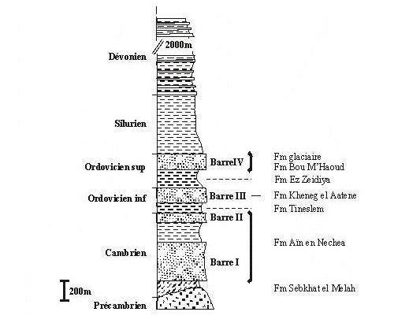
Figure 1. Figure 1. Stratigraphy column of the paleozoic formations of the chains of Ougarta
(consulted work: Donzeau, 1971a; Fabre, 1976)

The chain of Ougarta consists of a set of volcanic formations and volcanno-detrital, on which rests in discordance connect a powerful sedimentary cover of paleozoic age primarily Cambro-ordovicien presenting at its base a polygenic conglomerate with known element under the name of "conglomerate of Ben tadjine" (M, Chikhaoui and M, Donzeau. 1972). All the grounds of Pre-Cambrian ages appear in the form of buttonholes of erosion in the sedimentary cover, in the heart of the anticlines (Chikhaoui, 1974).

V. Methodology
According to the thematic problem of the themes posed, the approach adopted in a remote sensing campaign is different. Generally, the only data images are not sufficient and a study of teledetection requires as many data images as the contribution of other exogenic data. From where the methodological approach adopted with our study calls upon former geological work of the authors who worked on our zone of interest because the auxiliary support or data remains a fundamental contribution. the contribution of the data images of ALSAT1 to the geological investigation of the area offers information that is more significant. This numerical information once treated makes it possible to distinguish spectral and structural geological events complementary to order. The description of geological information, as well on the lithological plan and their limit, as in the field of the fracturing, obliges several adequate processings of these data. The cartography of the geological limits of the homogeneous units was made on the basis of analysis of the fundamental criteria of the photo-interpretation.
It is to noted that a satellite image requires before any digital processing, a geometrical correction. For a good geometrical correction, it is significant to have a sufficient number of points identified at the same time on the rough image and the topographic bottom taken as model of reference. These points must be distributed in a homogeneous way on all the image and located with a maximum of precision so that the residue is not significant.
In our study, the polynomial approach used is of order 2. The interpolation method used is "bilinear" insofar as the linear structural aspects in fact the features are well preserved, like those curvilinear ones (folds example)

Area  of study | Ground control points | Residual  Means | Type of projection  Cartographic | Method of interpolation
Mounts of  Ougarta | 20 | 0.834796 | U.T.M 30 (Transverse Universal MERCATOR) | Bilinear of order 2

Table 1Consequence of the geometrical correction

VI. Data processing images
There are several digital processings for an image. These processings are to make easier the data to interpretation. Figure 2 presents the various treatments necessary to the study with an aim of highlighting the principal geological units and the reactualization of the networks of the fracturing. It should be noted that we based ourselves on interpretation itself insofar as we called ourselves upon the geological data existing as for the study of the chain.

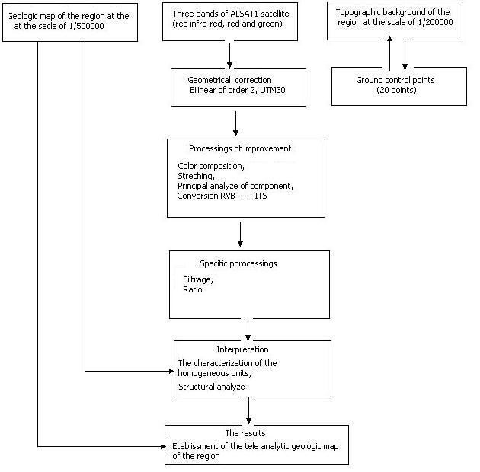
Figure 2. Principal consequent stages of the tele-analytical geological result of the area of the mounts of Ougarta

VI.1 Structural analysis of the fracturing of the mounts of Ougarta.

The structural analysis of the chain of Ougarta was made strating from the digital images of the microsatellite Alsat1 and are dated from February 16, 2003. The date of acquisition is significant because solar elevation is an important parameter in the illumination of geological surfaces as for their identification.
In our study, the approach was primarily based on the reconnaissance of form which is one of the fundamental elements of photo interpretation. The processings that we have realised, make possible to recognize and facilitate the cartography. It will thus be a question of interpreting the geological forms and in fact the geological features.

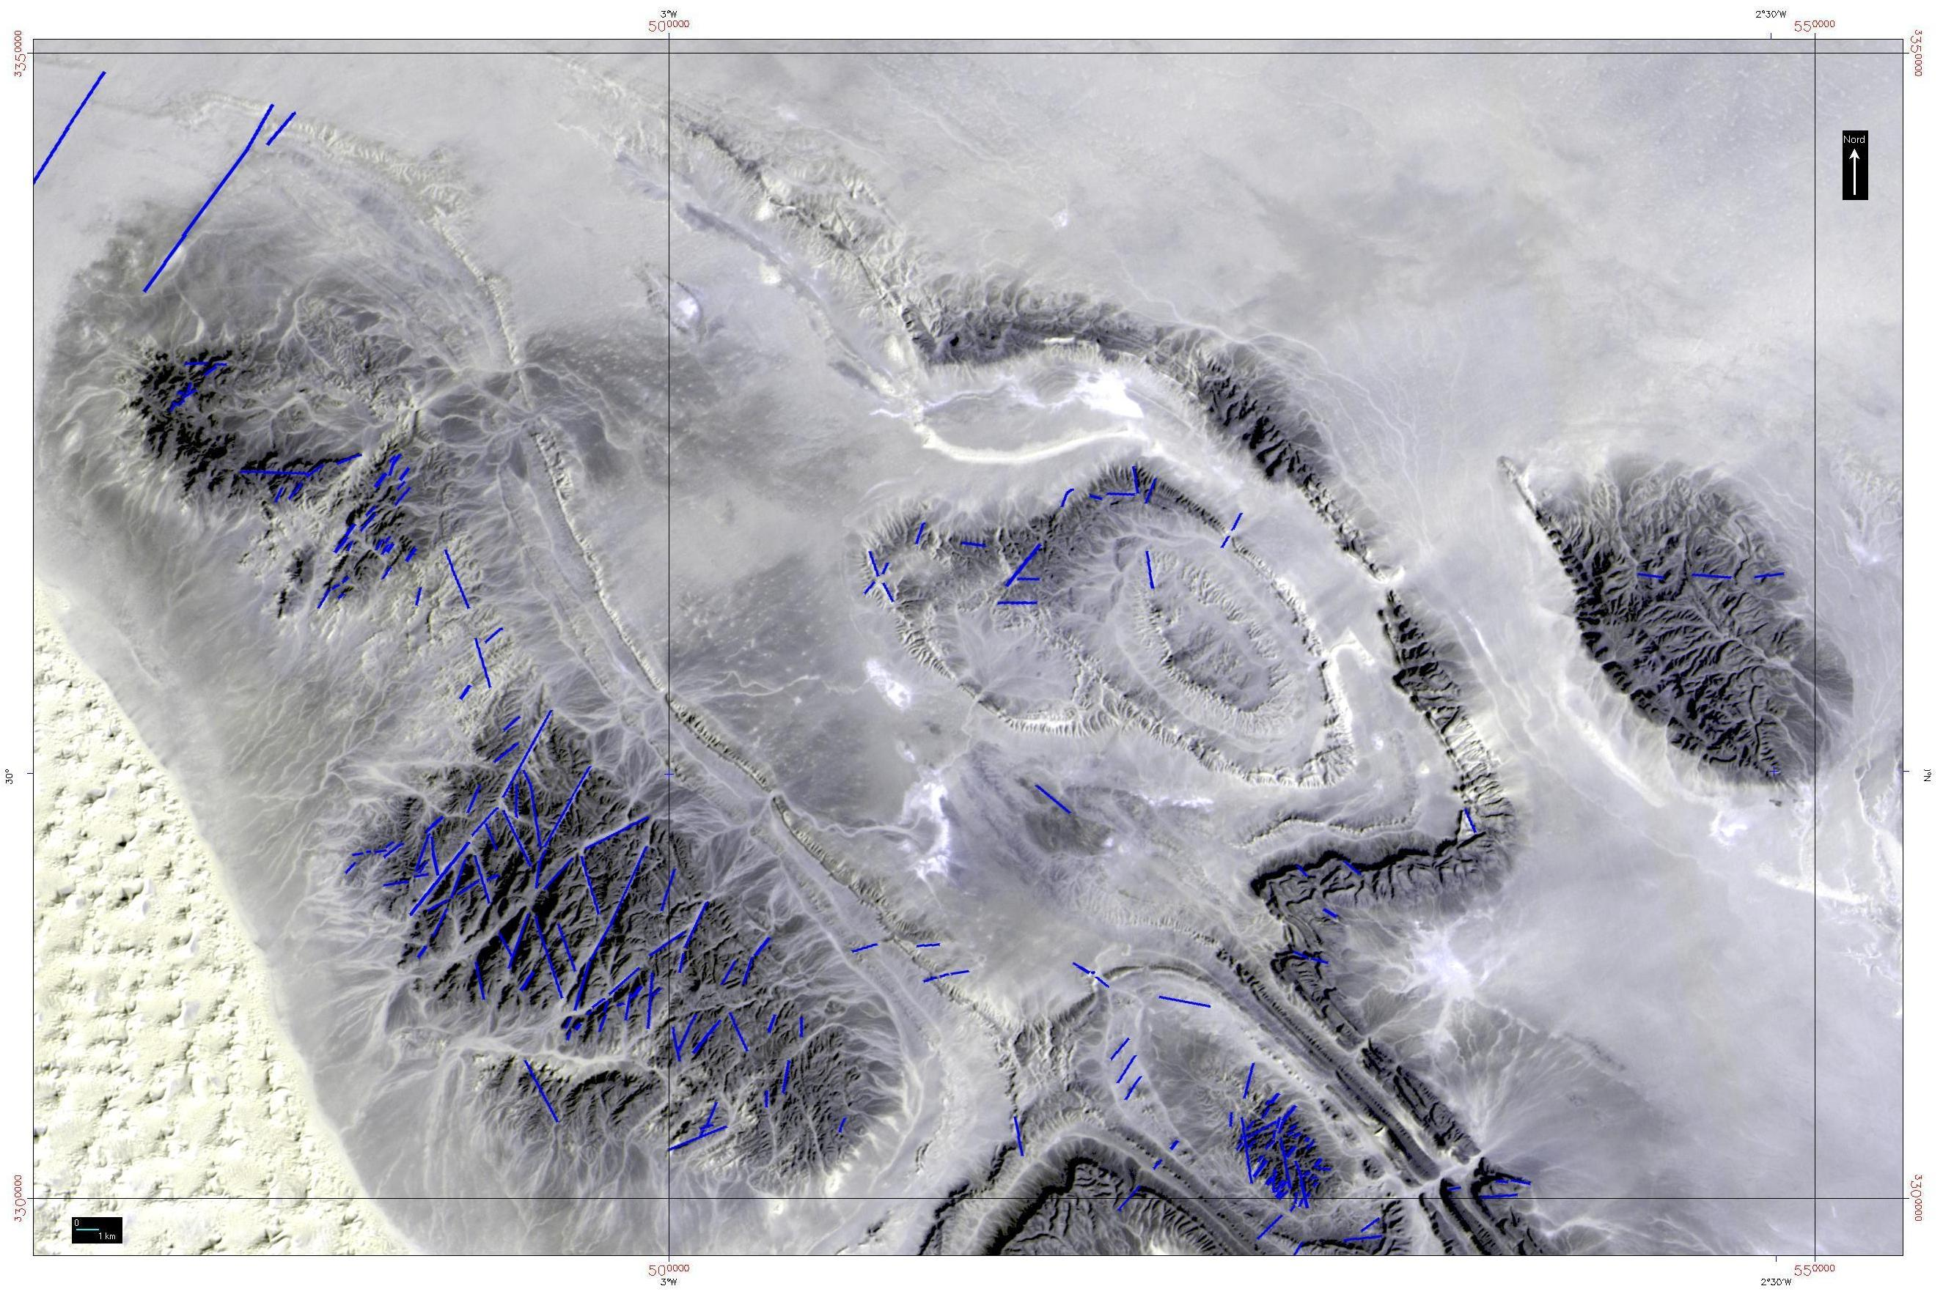
Figure 3. Characterization of the fracturing system of the structures of djebels Guettara, Bet-Touaris, Bou-Kbaïssat & Zehgamra

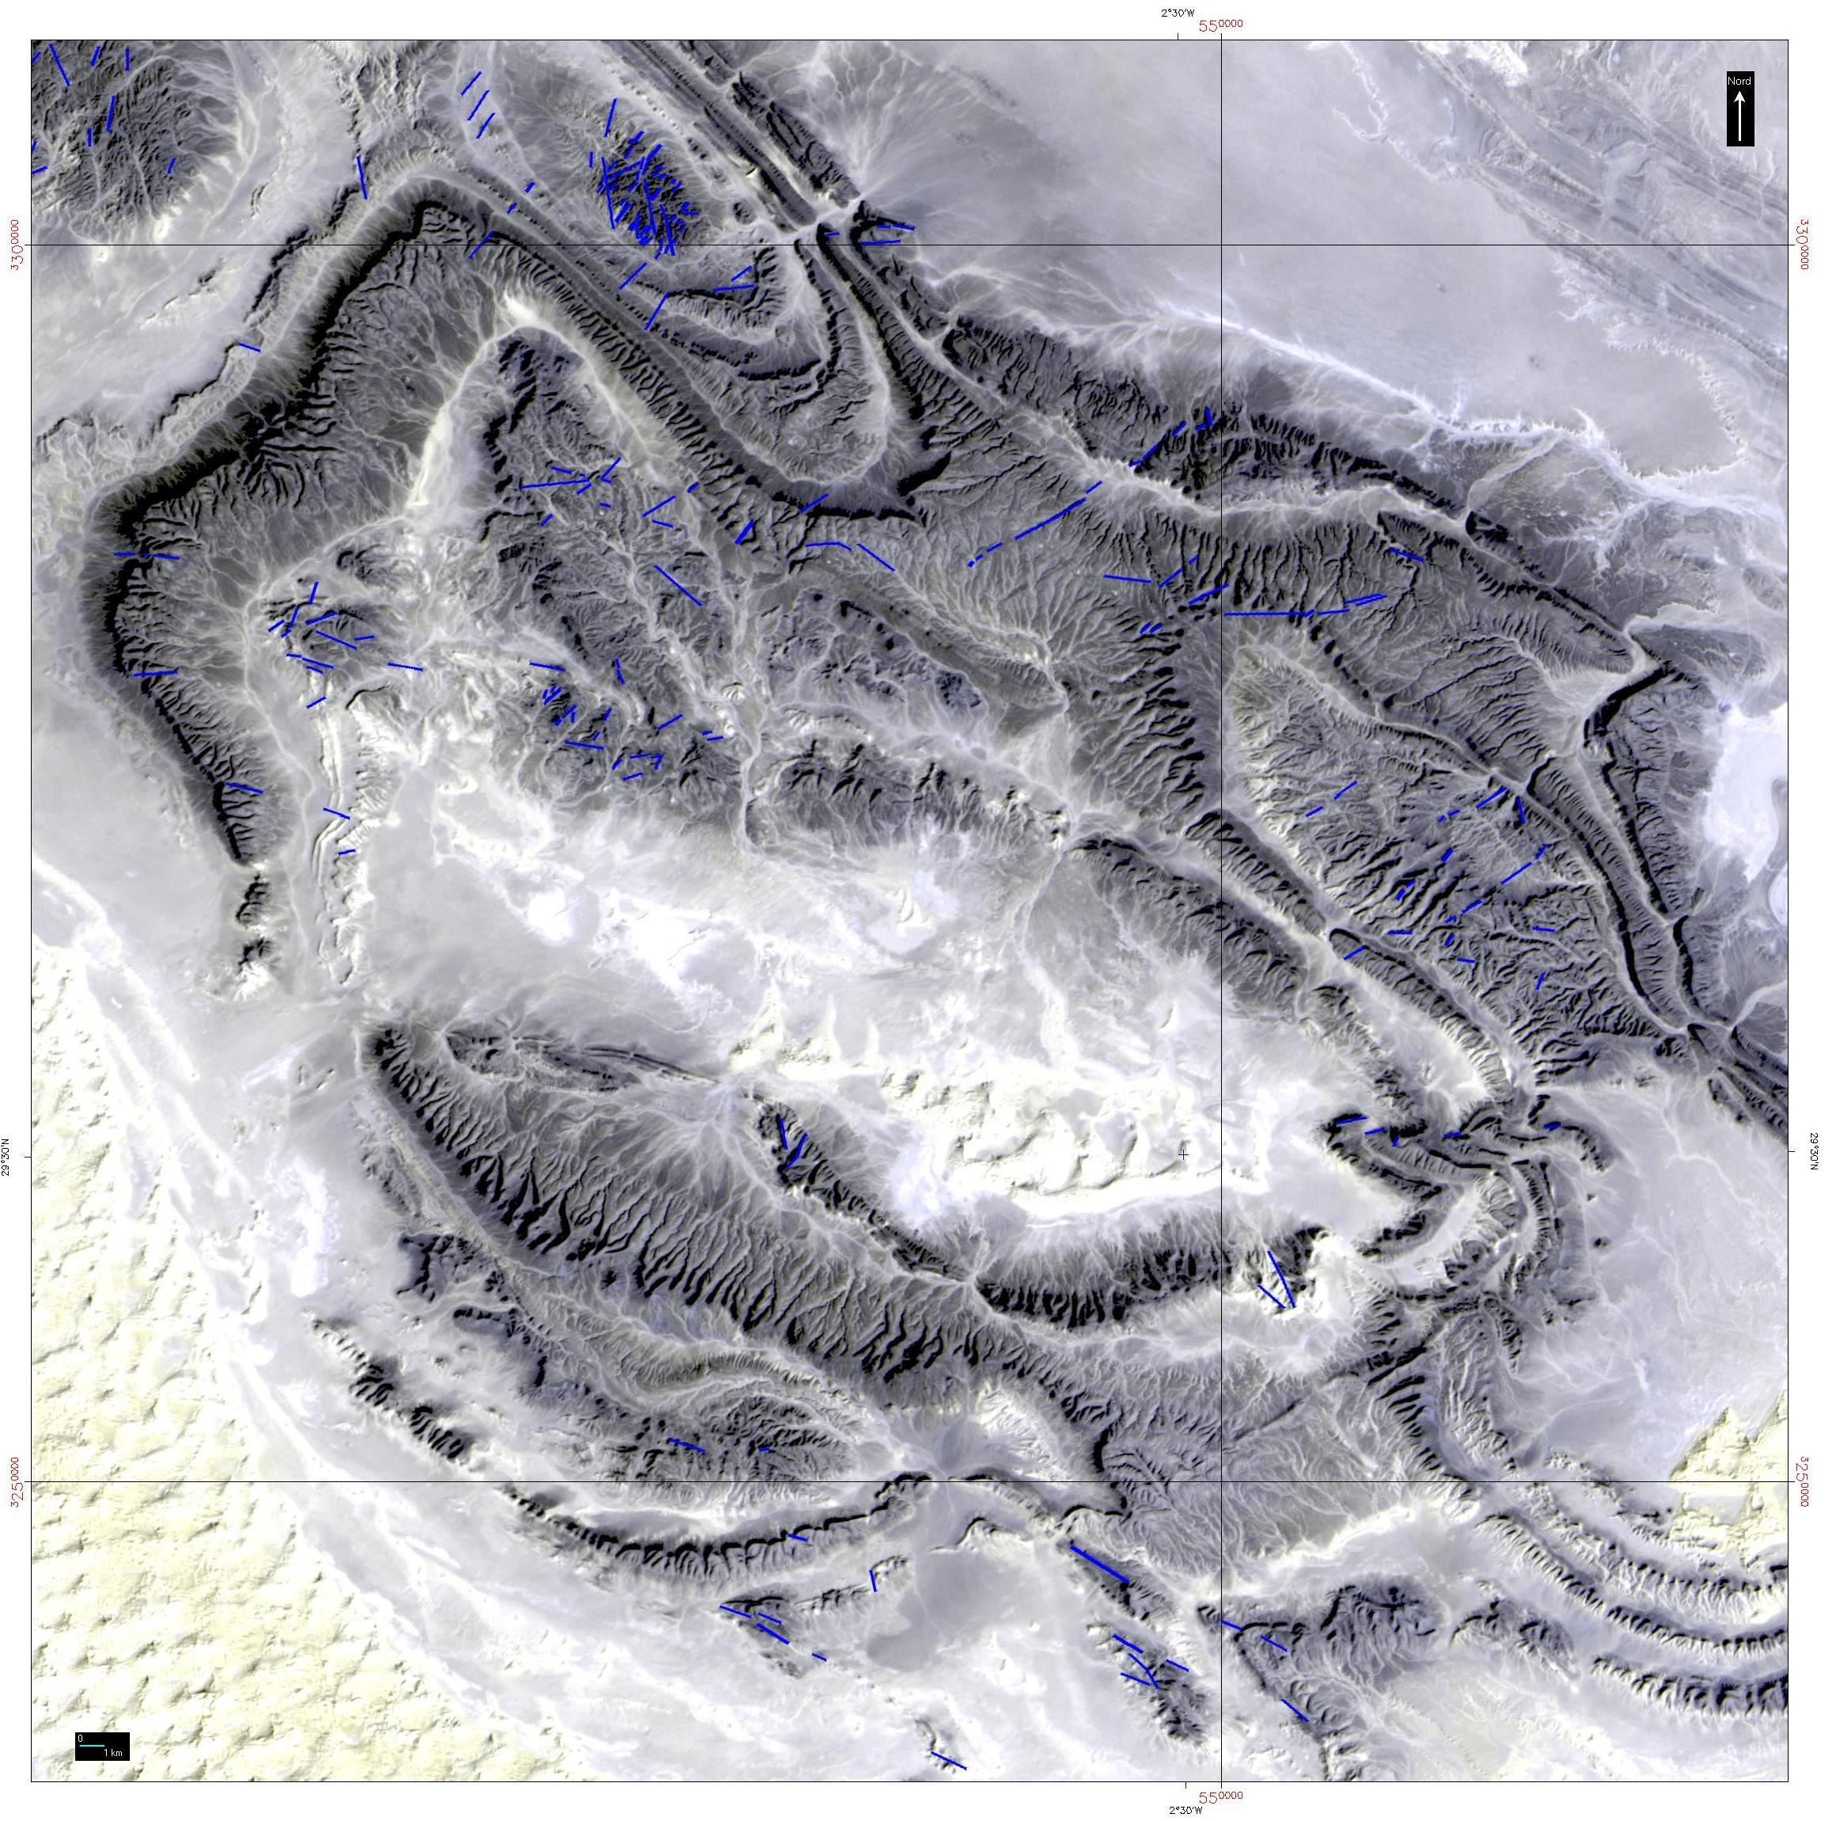
Figure 4. Characterization of the fracturing system of the structures of djebel Bou-Kbaïssat, of synclinal Bou- M'haoud, & Koudiat El M'daga and Oued Anchal

.

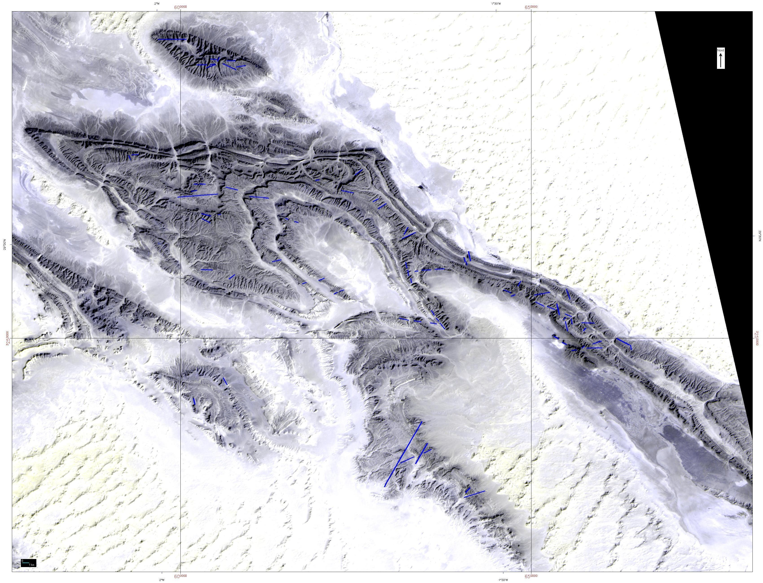
Figure 5. characterization of the fracturing system of the structures of djebels El Kahla, of synclinal of Ougarta & du Nif El Khaoufi

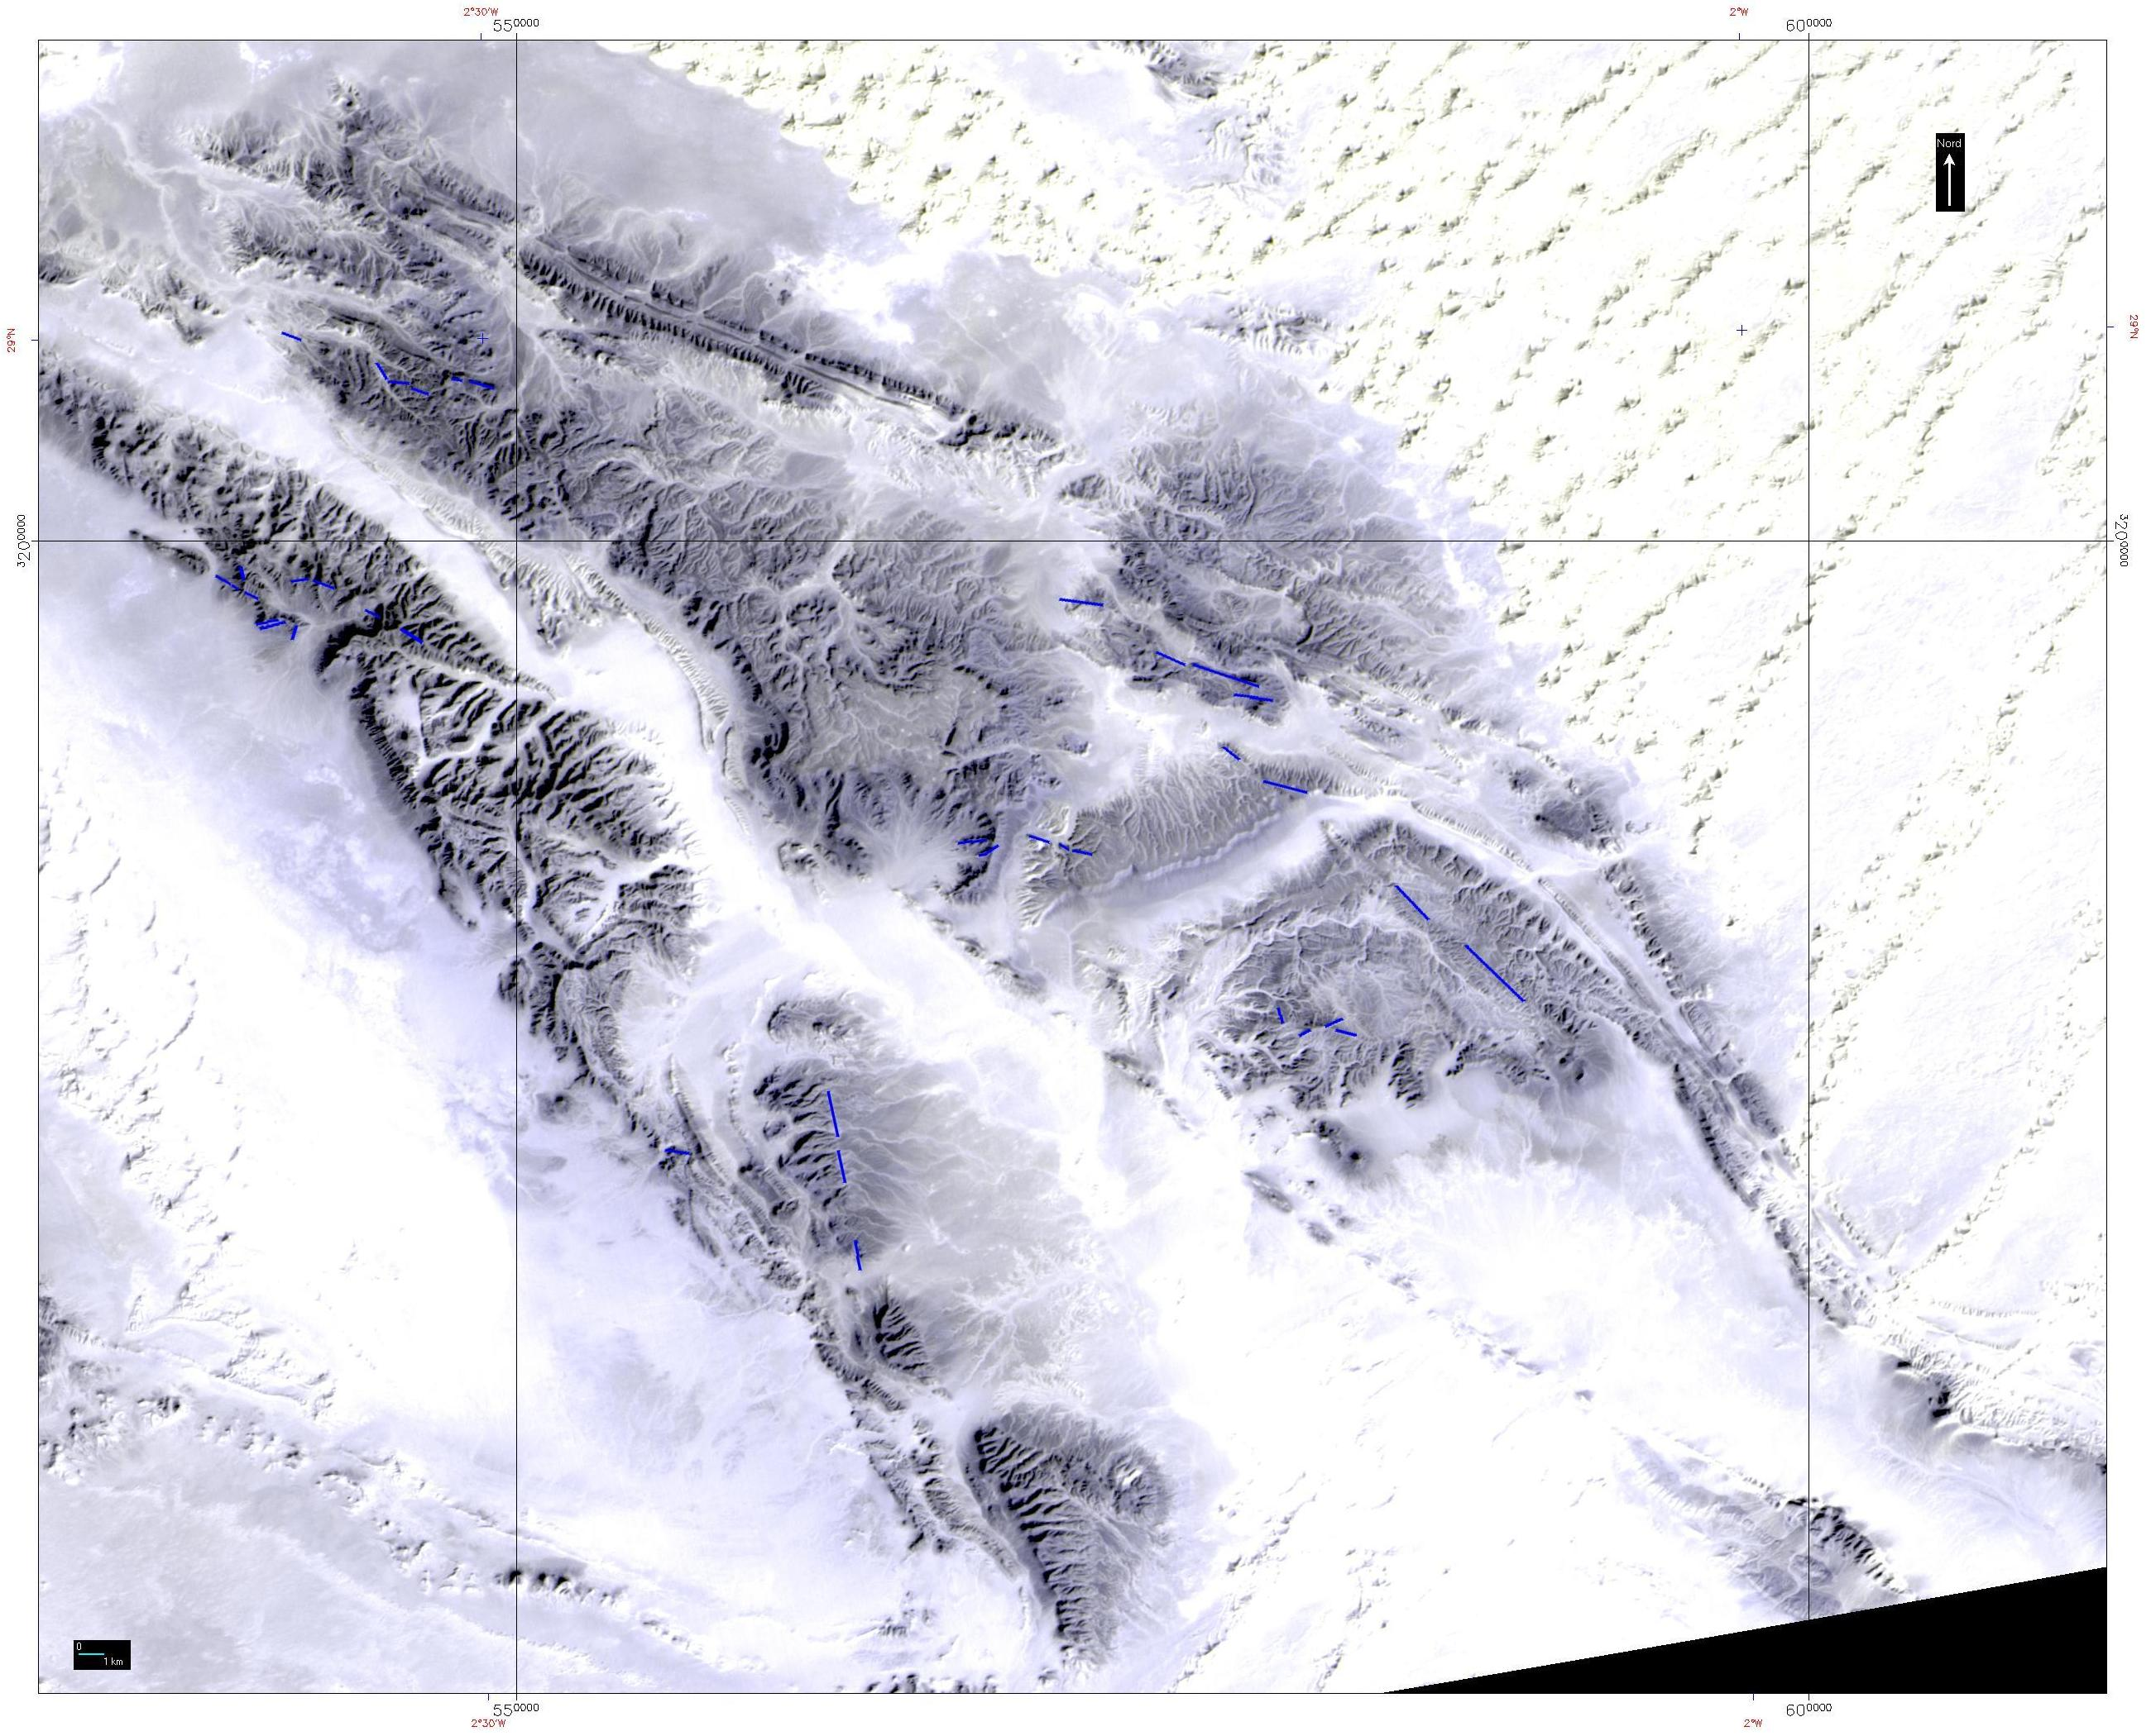
Figure 6. Characterization of the fracturing system of the structures of djebel Chbika, of synclinal Oglat Med & Anticlinal of Erg El Atinime

VII. Conclusion
The study of the lineamentary system of the chain of Ougarta, enabled us to put in evidence six families faults of direction: N140, N90, N45, N60, N20 and N00.
The first three families (N140, N90, N45) are the most frequent and described by several authors. The average faults of the direction N140 and N45 are oldest and are of superior Protérozoïque age. They acted in Hercynien (in T Bouima. 1986).
The N140 faults reflect the great fractures of the basement of superior Pre-Cambrian age. Their activation during the orogenèse Hercynienne is accompanied by the formation of breaches resulting from the ferruginisation and silicification, giving quartz lodes (in T, Bouima. 1986).
The N45 faults are the result of the activation of the great faults of the basement of superior Pre-Cambrian age. Some observations on the ground of this average direction present zones of fissuration and intense brechification with a ferruginisation and sometimes a mineralisation of manganese.
the average direction N90 which is of Hercynien age, and are more represented. These faults are the result of the geometrical component of the great faults, of direction NW-SE of the Précambrien terminal basement.
In the North of the chain (zone of junction Anti-Atlas-Ougarta), breakable phenomenons manage the relay of the structures. They are faults of the base with dextral set directed in N45 and especially in N60. They are long of several tens of kilometers slice or deform the structures Ougartiennes (M, Donzeau, 1974).
In the circumscribed grounds of Ougarta and their parts NW (the basin of Bechar and Abadla and the plate of Kem Kem), exists a great number of fractures of direction NNE which are more significant in the part of KemKem and present as a majority a dextral set of low amplitude. The setback probably create zones of dolerite weaknesses often injected of age post-Hercynien, (J, Fabre. 1961, 1971).
The average direction N00 is badly known on the whole of the chain. This direction of measurement affects the Précambrien grounds and the sedimentary cover. The majority of this direction is in the crystalline basement. It should be noted that the first observations show that this average direction is most recent of all the other features because they recut all the other families of faults. In the whole of the chain M, Donzeau, 1982, announce the existence of the faults of basement of orientation NS. The replay of these faults in depth are expressed by sometimes mineral-bearing faults.
With the Western edge of the shield Tergui exists great faults of setback NS sometimes extremely significant (up to 150 km). For Fabre 1971, these faults owed replay in Hercynien and have perhaps determined partly the architecture of Aulacaugène.
Donzeau in 1973, described of the same faults direction, with sinistral set in the zone of junction Anti-Atlas-Ougarta.

VII. Bibliography
Black, R. (1978). Propos sur le Pan-Africain. Bull. Soc. Géol. France (7) 20, p842-850.

Bouima, T. (1986). Le gîte de Rahmani (monts d’Ougarta, Algérie). Sédimentologie du Canbien inférieur et étude des minéralisations stratiformes cuprifères associées. Mise en évidence d’un processus de remobilisation de type Roll. Th. Doct. Ing., Orsay, Univ. Paris-sud, 211 p.

Chikhoui, M. (1974). Les Ignimbrites et les roches basiques du Précambrien supérieur des monts d’Ougarta (Saoura). Thèse. Doct. 3eme cycle. IST. USTHB, Alger.

Chikhoui, M. & Donzeau, M. (1972). Le passage Précambrien-Cambrien supérieur des monts d’Ougarta : le conglomérat du djebel Ben Tadjine (Saoura, Sahara algérien nord-occidental). Bull.Soc. Hist. Nat. Afr. Nord, Alger? 63, 1-2,pp 51-62

Donzeau, M. (1972). Les déformations hercyniennes dans le paléozoïque des monts d’Ougarta (Sahara occidental algérien). C.R. Acad. Sci., Paris, t.274, p3519-3522.

Donzeau, M. (1974). L’arc Anti-Atlas Ougarta (Sahara occidental Algérie-Maroc). C.R. Acad. Sci. Paris pp 417-420.

Fabre, J. (1971). Structure de l’Algérie Sahariènne. Elément pour une carte tectonique. Publ. Serv. Géol. Algérie (Nlle sér.) Bull. 41,p. 161-185.

Liégois, J. & Black, R. (1987). Alkaline magmatism subsequent to collision in the Pan Africain belt of the Adrar des Iforas (Mali). In J.G. Fitton et B.G.J. Upton EdS.,Alkaline Igneous Rocks. Geol.Soc.Sp.Publ. Londres, 30, pp381-402.

