calibration EXpierence with the DMC
J. Hefele

Intergraph Deutschland GmbH, 73431 Aalen, Germany, juergen.hefele@intergraph.com

EuroCow 2006

KEY WORDS: Digital mapping camera, geometric calibration, radiometric calibration

Abstract

This paper gives an overview over the complete calibration process of the DMC (Digital Mapping Camera). Starting with the radiometric and geometric calibration after camera head assembly, over generation of the camera calibration protocol and ending with the platform calibration applied during image post processing. The hardware and the used algorithms will be explained in detail as well as the change of the calibration procedure at the beginning of last year. This paper summarizes the calibration experience of more than 240 single camera heads.

- Introduction
The Digital Mapping Camera (DMC) from Intergraph is now for nearly 3 years on the market. At the moment there are more than 30 cameras operational. Because of the 8 different camera heads (4 high resolution cameras with a 7x4 k sensor and 4 low resolution sensor with 3x2 k sensor) for each DMC there is a calibration experience of more than 240 single camera heads. For the DMC the camera calibration is spilt in two main parts. First is to calibrate each single camera head in a calibration stand and to compute calibration parameters. Second is to compute the orientation of the individual camera head in the camera cone. The calibration is applied after the assembly of the camera electronics and optics in the factory and is done for each camera head separately. The second step, to measure the “relative” orientation of the individual camera head within the “platform”, is computed from real images taken during the factory acceptance test. Hereafter the calibration protocol is generated and the calibration parameters stored to a CD-ROM to be delivered to customer, together with the camera. At customer site the calibration parameters from the CD-ROM are used to setup the DMC images during post processing. At the beginning of 2005 the geometric calibration procedure was moved to Carl Zeiss Jena (in this paper called Jena-calibration). The former calibration was performed by Deutscher Kalibrierdienst (DKD) located at the Carl Zeiss factory in Germany, Oberkochen (in this paper called Oberkochen-Calibration). In the first chapter the new geometric calibration procedure is compared with the previous one. Because of the importance of the radiometric calibration the second chapter gives an overview over the actual radiometric calibration procedure. The information collected during the calibration procedure is considered helpful for the user of the cameras and therefore the last chapter describes how this information can be delivered to the customer in the calibration report.

- Geometric Camera Calibration
The new camera calibration stand at Jena was specially developed for the DMC camera heads while the calibration stand in Oberkochen was designed for analogue cameras and later on modified for calibration of DMC camera heads. Therefore there are some differences in the approaches.

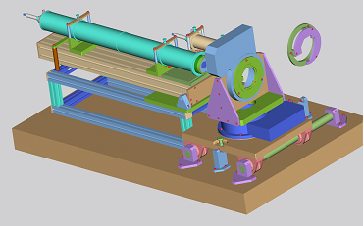
Figure 1. Jena Measurement Unit

While the new calibration stand in Jena (see Figure 1. Jena Measurement Unit) is using two rotation tables with a high accuracy the Oberkochen approach is using an optical bench with a collimator and a goniometer (Zeiss Theodolite TH2) as shown in Figure 2.
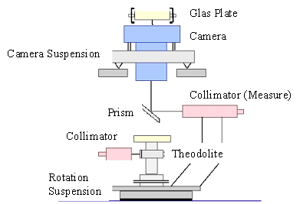
Figure 2 Oberkochen Measurement Units

With the goniometer we achieved a theoretical accuracy of 0.6 mgon while the rotation tables in the new calibration unit supply an accuracy of 0.3 mgon. The arrangement of the targets in both approaches is nearly equal. We measure several points along 4 lines as shown in the figures 3 and 4. The Oberkochen approach used 90 targets, while in the Jena approach 75 targets proofed to be sufficient.

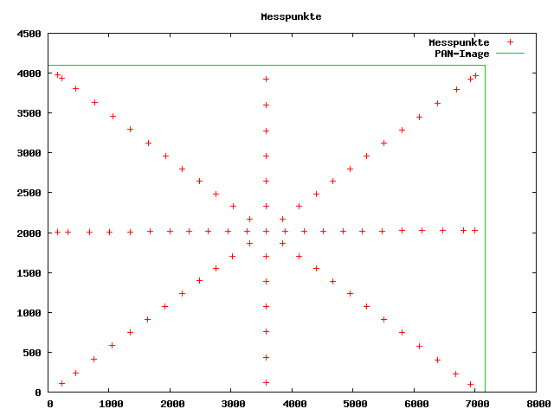 | 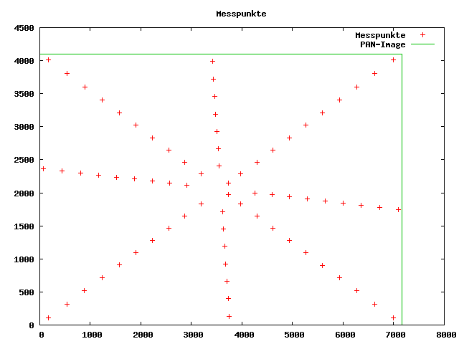
Figure 3 Measurement Points Oberkochen calibration | Figure 4 Measurement Points Jena calibration

The image data is read out at the 4 corners with own AD-converter therefore the sensor is split in 4 quadrants. To get the best accuracy it is necessary that a target is locate fully inside one quadrant. If not it can be possible that the quadrant border does influence the measurement because of slightly different sensitivity of the quadrants. The new approach uses less number of targets than the Oberkochen calibration because own tests with more than 100 targets do not show any improvement of the accuracy.
The new approach uses a circular while the old one uses a cross target. Therefore also different algorithms for getting the centre of the target are used. The old approach uses a least square matching with an accuracy of 1/20 pixel. With the new circular target the accuracy increases to better than 1/25 pixels for measuring the centre of the target. The reason for this improvement in accuracy is two folded. First, circular targets can be measured with higher accuracy (Ahn, 1996, Bose 1990, second the layout of a target with higher contrast was chosen because of the signal to noise ratio.

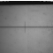 | 
Figure 5 Target Oberkochen | Figure 6 Target Jena

It is clear that a direct comparison of the 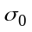 a posterior values for the different approaches is not possible. Sigma0 shows only how accurate the measurements fit the mathematical model. In this case there are only some minor changes.

 | Unknown | Description
Interior Orientation | 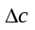 | Changes of the nominal focal length
Interior Orientation | 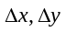 | Changes of the nominal principle point
Interior Orientation | 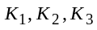 | Radial lens distrotion
Interior Orientation | 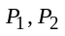 | Decentring Distortion
Interior Orientation | 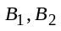 | In-Plane distortion
Exterior Orientation | 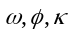 | Exterior Orientation of the Camera, Position x,y,z is fixed. 4 Sets for Oberkochen calibration and 6 for Jena calibration
Table 1 Unknowns camera calibration
For the Oberkochen approach we have to estimate the exterior orientation of 4 camera positions while for the Jena approach the orientation parameter for 6 positions is introduced. The number of unknowns increases from 22 to 28. Because of the minor changes we can compare the values here.
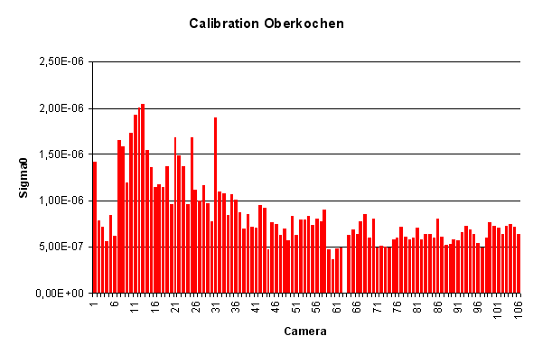
Figure 7 Oberkochen calibration Camera 0 - 110
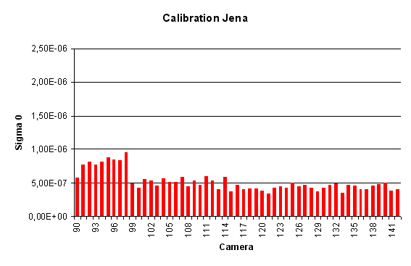
Figure 8 Jena Calibration Camera 90 -142

It is interesting that the Oberkochen calibration shows an improvement over the time without any changes in the calibration process. It is also obvious that the differences in the accuracy differs more from one camera to another camera in comparison to the Jena calibration. The reason for this circumstance is clear. One of the reasons is the higher accuracy of the rotation tables and the other one is the fully automated process of calibration. For the Oberkochen calibration the human observer needs some experience to get the best accuracy for the calibration.

The parameters show that we reach better internal accuracy with the new approach compared to the old one. Beginning with camera 98 with the Jena calibration an improvement of the calibration process was made. With this camera we started to measure in both directions.

With the Jena calibration we reduce with a factor of 2. Because of the higher number of unknowns a reduction can be expected. But here we reduce it with a factor of 2 so it is clear that the new approach reach a better internal accuracy as the Oberkochen calibration. It is also shown that the new approach generates a more stabilized solution because of the fully automated calibration process.

The next step to evaluate the new calibration approach is to compare the resulting accuracy of an Aerial Triangulation (AT). During Camera Factory Acceptance Tests every camera is flown after some initial burn in test over our test field at Elchingen near by Aalen (Figure 9 Elchingen test field).

The standard test flight after assembling is at a scale of 1:5000. The filed is well marked with 33 control points.

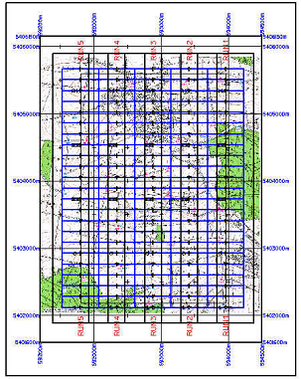
Figure 9 Elchingen test field

The standard test flight EL5000 has following parameters:

Photo Scale | 1:5000
Flying Height [m] | 600 AGL
Flying Altitude [m] | 1200 AMSL
Run-Spacing [m] | 539.1
Base-Length [m] | 161.3
Number of Exposures | 115
Side-lap [%] | 35
End-lap [%] | 65
Terrain Height [m] | 600
Number of strips | 5
Photos in one strip | 23
Photos Used | 115
Control Points Used | 33
GSD [cm] | 5
Table 2 test flight parameter

The next table shows the accuracy with the different calibrations.

 | Unit | Oberkochen calibration | Jena Calibration
RMS Control Points | X [m] | 0.030 | 0.028
RMS Control Points | Y [m] | 0.022 | 0.024
RMS Control Points | Z [m] | 0.056 | 0.050
Max ground Residuals | X [m] | 0.051 | 0.048
Max ground Residuals | Y [m] | 0.037 | 0.045
Max ground Residuals | Z [m] | 0.094 | 0.094
Mean StdDev. Photo Position | X [m] | 0.027 | 0.031
Mean StdDev. Photo Position | Y [m] | 0.024 | 0.027
Mean StdDev. Photo Position | Z [m] | 0.020 | 0.021
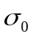 | - | 1.1 | 1.1
Table 3 Test flight 1:4000

EL5000 | Unit | Oberkochen calibration | Jena Calibration
RMS Control Points | X [m] | 0.052 | 0.055
RMS Control Points | Y [m] | 0.048 | 0.050
RMS Control Points | Z [m] | 0.105 | 0.076
Max ground Residuals | X [m] | 0.165 | 0.139
Max ground Residuals | Y [m] | 0.126 | 0.136
Max ground Residuals | Z [m] | 0.218 | 0.183
Mean StdDev Photo Position | X [m] | 0.013 | 0.016
Mean StdDev Photo Position | Y [m] | 0.017 | 0.020
Mean StdDev Photo Position | Z [m] | 0.012 | 0.013
 | - | 1.1 | 1.3
Table 4 Test flight 1:5000

EL10000 | Unit | Oberkochen calibration | Jena Calibration
RMS Control Points | X [m] | 0.049 | 0.040
RMS Control Points | Y [m] | 0.048 | 0.042
RMS Control Points | Z [m] | 0.070 | 0.043
Max ground Residuals | X [m] | 0.118 | 0.090
Max ground Residuals | Y [m] | 0.123 | 0.115
Max ground Residuals | Z [m] | 0.159 | 0.107
Mean StdDev. Photo Position | X [m] | 0.023 | 0.026
Mean StdDev. Photo Position | Y [m] | 0.030 | 0.033
Mean StdDev. Photo Position | Z [m] | 0.014 | 0.016
 | - | 1.4 | 1.6
Table 5 Test flight 1:10000

The overall result shows that the accuracy of the Aero Triangulation is equal between the Oberkochen and Jena calibration. There are no significant differences between these calibration procedures. Only the accuracy of the height shows significant differences. Here the Jena calibration reaches a higher accuracy.

- Radiometric Camera Calibration
A more and more important task is the “radiometric accuracy” of aerial cameras. The first goal of such a radiometric calibration is to eliminate the influence of the optics and the sensor and make sure that the resulting images will have the same sensitivity about whole project. As the geometric calibration the radiometric calibration is also split in two main parts. First (RCC) part is radiometric camera calibration, which is applied after assembly of the single camera heads. This calibration consists of the steps to measure the Photo Response Non Uniformity (PRNU), and the Dark Signal Non Uniformity (DSNU) just to mention some. In this step for each captured image the radiometric post-processing engine will apply the computed parameters. White balance calibration procedure or more general the Look-Up-Table (LUT) generation is the second step. For each project the user performs this type of calibration individually. After post processing some example images, which covers the typical surface the user, can set the white balance for this project.

Camera Radiometric Calibration
The manufacturing radiometric calibration eliminates the influence of the optics and sensor for each camera head:

- Defect pixels
- Individual sensitivity of each single CCD pixel
- Vignetting
- Influence of aperture
- Multi Spectral Images are corrected for filter influence

Caused by the manufacturing process of the CCD element, nearly all of the 7kx4k high-resolution sensors have some defect pixels. For the DMC a defect pixel is discovered if the pixels sensitivity differs more than 30 percent from the median value of a16 x 16 surrounding area at an illumination of 80 percent of the saturation. With this definition it is guarantee that all defect pixel will be covered.

Defect columns have a minimal length of 16 pixels and differ 5 percent from the neighbourhood. Because of the human eye sensitive here stronger criteria for defect pixel is used. The human eye is very sensitive to grey value difference along a line. Experience shows that a human observer can recognize a line in our DMC images if the line has at least a length of 16 pixels.

The implemented algorithm uses the information of the neighbour pixels to correct the defects.

With the normalization the individual sensitivity of each single CCD pixel (PRNU) is corrected. The calibration images (dark image and bright image) are taken by observing an Ulbricht sphere, which guarantees a homogenous lightning during measurement and from camera to camera.
The individual sensitivity can be interpreted as a part of the image noise. The next figure is showing the reduction of such noise after the normalization process.

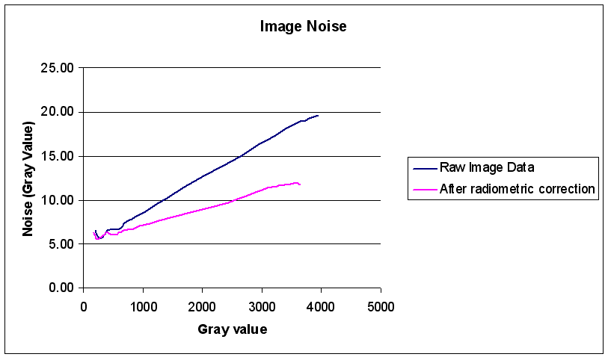
Figure 10 Noise Reductions after Normalization

After the normalization the noise is reduced to maximal 12 grey values or 0.3 % of the signal.

With the normalization process also the influence for a certain aperture is eliminated too. For the radiometric factory calibration we use the standard aperture of 5.6. The correction for other apertures is done by an additional polynomial approach that was computed based on measurements of all aperture settings. Because the aperture is stable over the production the parameter for the polynomial equation are identical for all PAN cameras. A separate set of corrections is applied to the multi spectral cameras due to different shutter design.

After applying all the correction we get nearly flat image as the following figures shows:

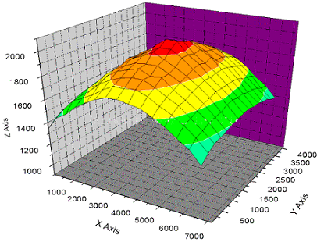 | 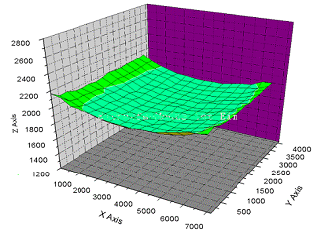
Figure 11 Before radiometric Correction | Figure 12 After radiometric Correction

At the corner we have maximal deviation of 5-10 percent from the flatness depending on the aperture. This change is for a human observer not visible (Schenk, 1999).

LUT Generation
The LUT generation gives the user the possibility to generate colour images, as the user wants to have (colour impression, brightness, contrast). The experience shows that different customer have different requirements to the appearance of the colour images. The real reason off course are the influences coming from the atmosphere and lightening direction which change the resulting colours / colour temperature from project to project:

- Weather conditions
- Flying Height
- Season (Position of the sun)
- Dust

Therefore the post processing software gives the possibility to make a colour calibration for each project separately.

The user has to identify some areas in the colour images where the reflection for all bands is nearly equal. The best choice for this is asphalt. The algorithm is measuring the grey values for each band at these locations. The white balance is performed in an equalisation process with the bands at the given areas.

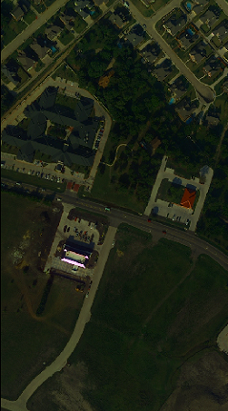 | 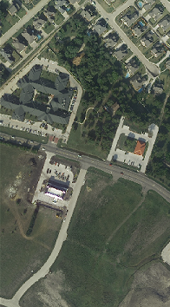
Figure 13 Before colour calibration | Figure 14 After colour calibration

- Calibration Protocol
Important information for the customer is the calibration protocol it holds all the necessary information about the accuracy of the system and the used algorithm including the used parameters. The “German Standardization Group (DIN) develops a new standard DIN 18740-4 “Photogrammetrische Produkte, Teil 4: Anforderungen an das Luftbild“ (Photogrammetric Products. Part 4: Requirements to digital aerial camera), the 1st draft will be published in spring 2006. In this standard it is well regulated which information must be delivered in such a protocol. The standardization is split in two parts: Geometric and Radiometric calibration.

Geometric Calibration Protocol
Most of the digital aerial camera vendors fulfil the requirements of this standard. The protocol requires:

- Geometric Calibration Protocol for each camera module or spectral channel
- Alignment of the IMU to the focal plane (line sensor)
- Relative position of multiple sensors in a focal plane
- For mosaicked images the relative orientation of the cameras for each exposure

Of course the DMC calibration protocol fulfil this standard too. The customer gets for each camera head a calibration protocol:

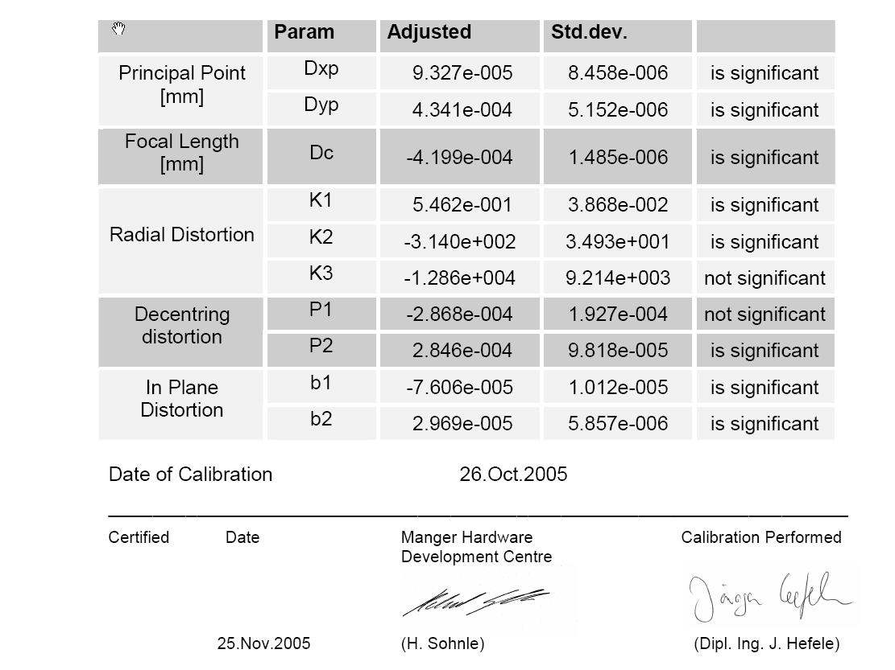
He gets also the information of the relative orientation of the camera heads for each exposure. This information is given in the standard log-file of the post processing software.

Additional to the requirements of the standard the customer get also the result of the test flight:
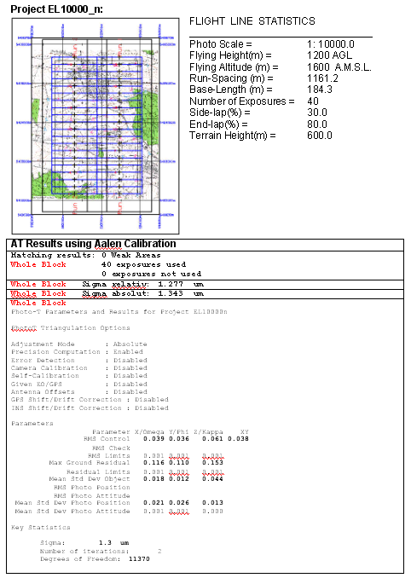

Radiometric Calibration Protocol
The main problem of the radiometric protocol is how can the customer use this information. For example printing the calibration images taken with an Ulbricht sphere on a sheet of paper does not help the customer in any way. Therefore the customer gets no printed calibration protocol about the radiometric calibration. But he can read out information from the calibration CD:

- Proportion of the Dark Current Noise
- Pixel sensitivity

Beside of this information some more information must be available for the customer to fulfil the requirements of the standard:

- Linearity of the Camera System
- Defect Pixel

Of course the Defect Pixel is also on the delivered calibration CD. As this information is in binary format on the CD-ROM it is part of the DMC calibration protocol as well.

We are planning for the near future to deliver with our cameras a radiometric calibration protocol to be fully compliant with the standard. Following data will be published in such a protocol:

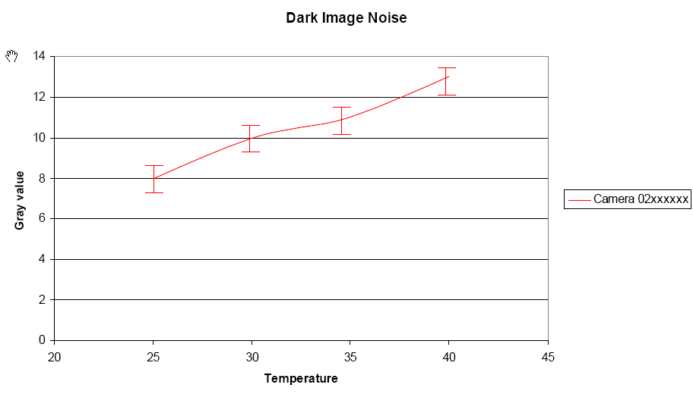
Figure 15 Dark current noise depending on temperature and displaying the standard deviation

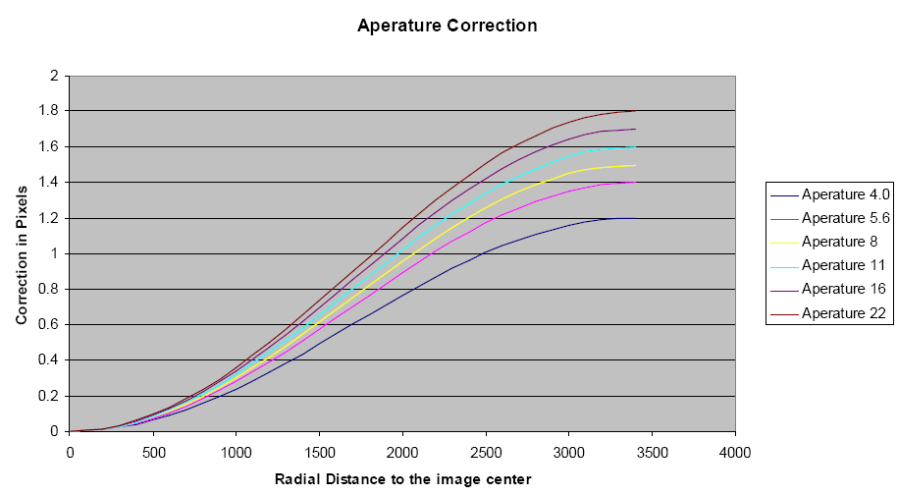
Figure 16 Aperture correction

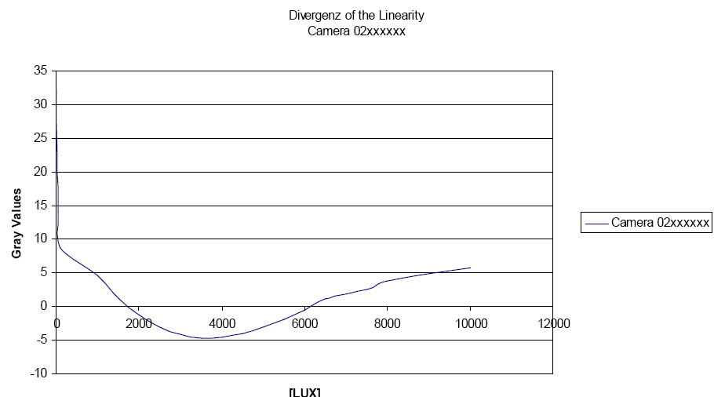
Figure 17 Camera System Linearity

- Conclusion
The paper shows the quality of the geometric and radiometric calibration procedure of the DMC camera. It explains in detail the difference between the new calibration procedure in Jena and the old procedure. It is shown that with the new procedure a higher accuracy for the height is reached.

The camera is up to the new standard DIN 18740-4. This standard requires a maximal noise of 20 grey values for a 12 bit images. It is shown that before the radiometric calibration the noise is below this value and after the radiometric calibration the maximal noise is 12 grey values.

The new standard gives also some requirements for the calibration protocol. At the moment the calibration protocol for the DMC camera fulfil only the requirements for the geometric calibration protocol. For the radiometric calibration protocol some information are missing. The paper shows which of them are missing and how they can be published in a new calibration protocol. It is planed to introduce this new calibration protocol in 2006.

- References
Ahn, S.J. Kreisförmige Zielmarken, ABW Workshop, Esslingen 1976
Bose, C.B. Amir, I. Design of Fiduicials for Accurate registration Using Machine Vision, IEEE Transactions on Pattern Analysis and Machine Intelligence Vol. 12, 1196 – 1200, 1990
DIN 18740-4 Photogrammetrische Produkte. Teil 4 Anforderungen an das digitale Luftbild, 1st draft will be published in Spring 2006
Doerstel C., Zeitler W., Jacobsen K., Geometric Calibration of the DMC: Method and Results, IntArchPhRS (34) Part 1 Com I, pp 324 – 333, Denver 2002
Schenk, T Digital Photogrammetry, Volume 1, 1999

